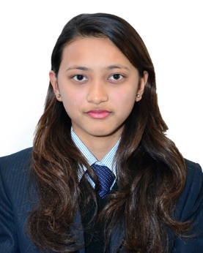

Leeza Shrestha

**Address**

Nakhipot-14, Lalitpur

Mobile: 9860121855

Email: **leezashrestha999@gmail.com**

**Career Objectives**

I am keen to gain full-time employment in the industry where I can apply my excellent organizational and communication skills, professionalism and enthusiasm. As a bright ambitious person, I enjoy working in a fast paced, highly motivating position where I can assist others while challenging and expanding my knowledge and understanding of the task on hand. I am seeking a position that will utilize my skills and offer the chance for advancement as well as allow me the opportunity to gain additional skills and experience.

**Education Qualifications:**

* **School Leaving Certificate :** Successfully completed in 2014 from

Dhading Boarding Higher Secondary School

Dhading, Nepal with Distinction (87.75 %)

* **+2 in Science :** Successfully completed in 2016 from

Moonlight Higher Secondary School

Kathmandu, Nepal in Science Faculty (69.10%)

* **Bachelor in CSIT :** Currently studying at Academia International

College on 7th semester

Gwarkhu, Nepal

**Professional Skills:**

* Good inter-personal skills dealing with people and good team work spirit as well as good capability of working independently
* Motivated, quick learner, honest, loyal, punctual, energetic, hardworking
* Sincere in work and can adjust to any new environment
* Excellent team skills
* Bears a good moral character

**Programming Skills:–**

Basic Knowledge of HTML, CSS, Python, Django

**Work Experience:–**

* Working in **Cloudfactory** since June 2017 in data entry
* Working under mentorship in **Cloudfactory** for small **Chatbot** project which gives information regarding **COVID-19** cases
* Worked as voice actor for **Alexa** children book reading