# A visual exploration of yearly trends of energy prices and enterprise deaths

## Abstract

Energy prices have been the centre of discussion in recent years. The impact on households has been a particular focus, with fewer investigations looking and comparing the trends of various businesses.

This experimental report gathered published data from several sources of ONS, in particular business demography, as well as non-domestic sector average gas and electricity prices to visualise the trajectories of different sectors.

The code to generate the visualisations and derive the indices, as well as the data utilised are available on github.

## Method and Data

The data brings together the average prices of gas and electricity (excluding the climate change levy) and the number of enterprise deaths by sector in the period of 2017 to 2023.

For the purposes of proportionating and improving visualisation, the absolute figures have been indexed to 2017 and is illustrated as percentage change. This means that any change in other years is in relation to 2017, not to the previous years.

The final dataset consists of a total of 416 observations over 16 industries addressing six years at a quarterly basis, with 2023 only featuring two quarters.

The data includes the years where pandemic lockdowns were initiated between March 2020 and December 2021. These are clearly marked by a section separated by vertical lines for reference.

The main question the visualisation seeks to answer is whether the trends of enterprise deaths alongside with the price energy hikes have been uniform over time.

## Results

The results indicate that overall, gas and electricity costs per kWh have been increasing throughout the six-year examination of trends to threefold the prices of 2017 with no indication of falling within expected trends.

Overall, enterprise deaths in their totality have remained in similar volatile levels as in the years prior to the energy price increases. However, 'Agriculture, Forestry and Fishing', as well as ‘Retail' and 'Real Estate' have reached previously unseen enterprise death peaks when the pandemic years are excluded.

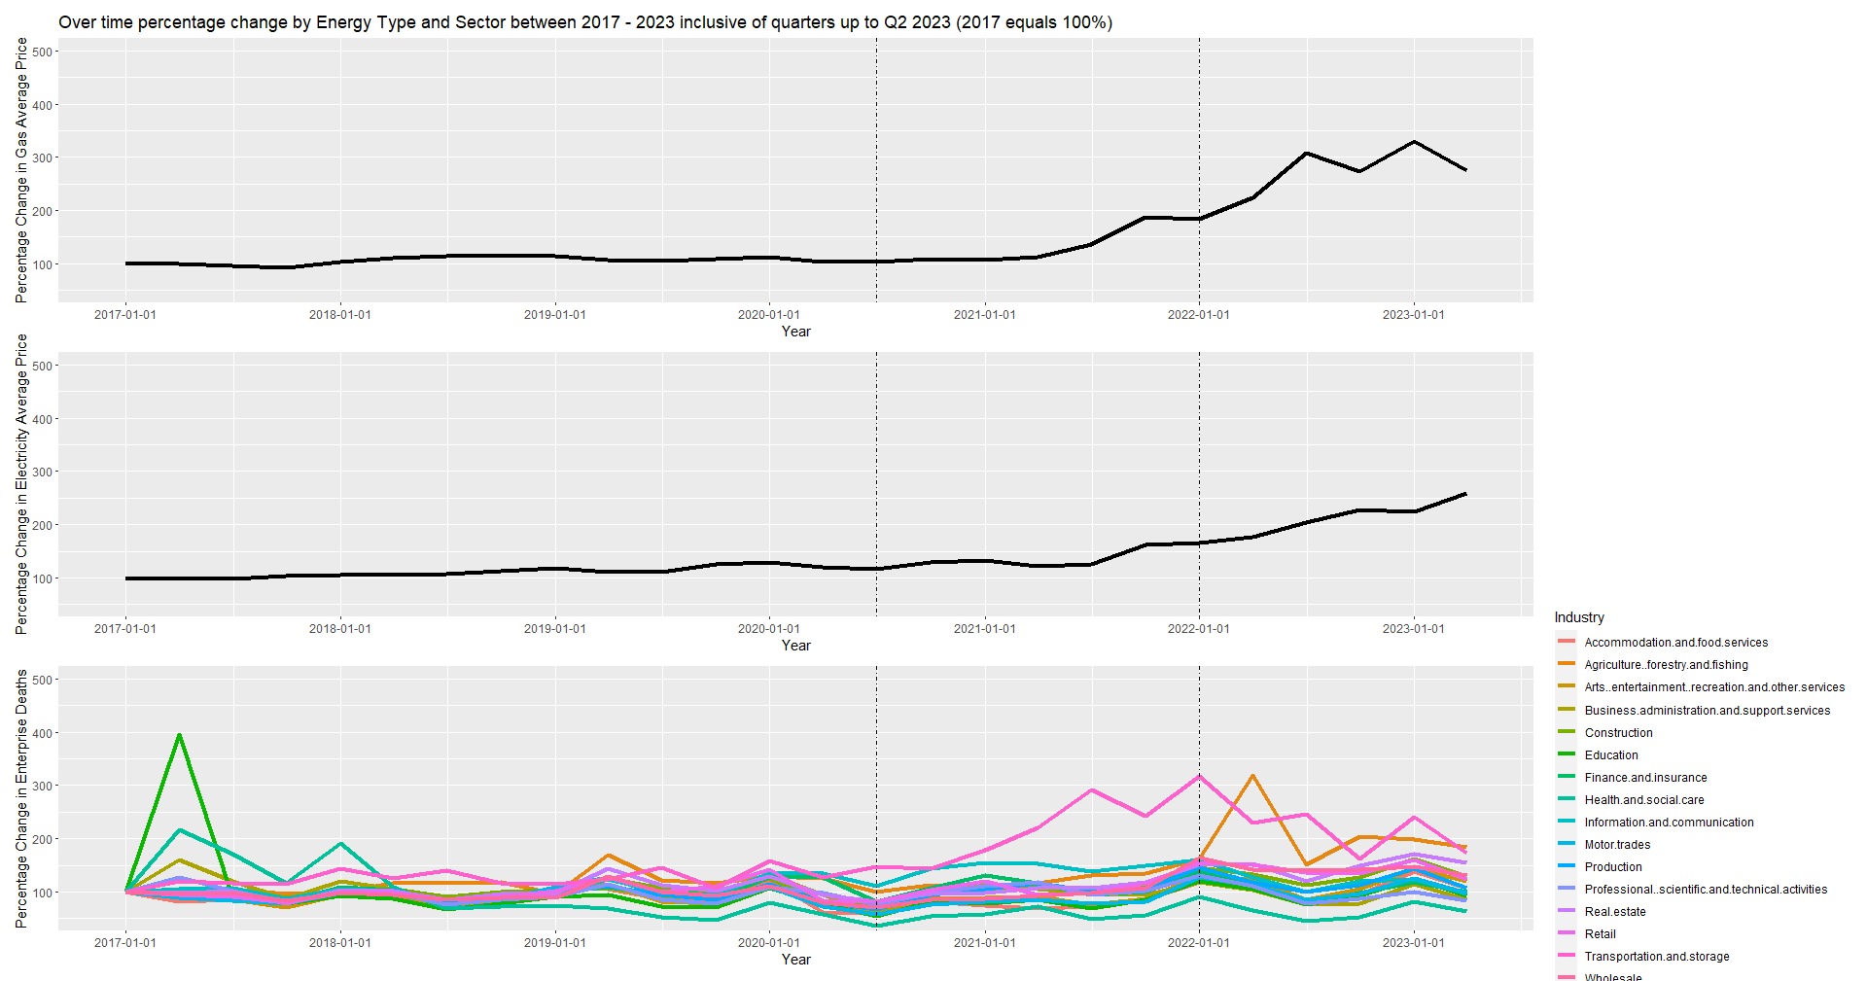

## Limitations and Conclusions

The lack of individual enterprise information to account for other factors, such as their size, profit, etc., limit the conclusions that can be drawn from examining the trends of energy and drawing robust conclusions from it.

Moreover, increases in enterprise deaths after the pandemic and energy price increases could still be attributed to the pandemic as companies could continue to collapse or be affected. A longer time period of examination further away from the years of the pandemic and the destabilisation of enterprises is required to assess the true impact of the energy price increases across sectors.

## Future Work

Future work should focus on disentangling deaths geographically to assess whether certain parts of the United Kingdom were affected disproportionately to others. Geographical data is available for this purpose and further data can be linked using Census Area Data to combine with energy price information into potential statistical models and/or further geographical visualisations. However, the lack of granularity in relation to the industry of those enterprise deaths can obscure underlying trends.

# References

Office for National Statistics, (2023)., Business Demography, Quarterly Experimental Statistics, UK. Retrieved from: <https://www.ons.gov.uk/businessindustryandtrade/business/activitysizeandlocation/datasets/businessdemographyquarterlyexperimentalstatisticsuk>

Office for National Statistics, (2023)., Quarterly Energy Prices., Retrieved from: <https://www.gov.uk/government/collections/quarterly-energy-prices#2022>

# Annexes

Github Repository - https://github.com/Lef-N/data-sci-mod-10