Demo Report: Remote Work Productivity Study (2026 Update)
Author: Demo Team Date: 2026-08-15 Version: 2.0

1. Overview
This report summarizes a six-month study of remote work productivity across four engineering teams. We measured output, meeting load, and employee satisfaction using weekly surveys and system logs.
Our key finding is that remote teams delivered 18% more commits per week than their in-office baseline, while reported focus time increased moderately.

2. Quarterly Sales Chart

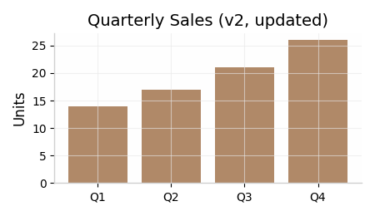

3. Survey Results
Team | Output Delta | Satisfaction
Alpha | +12% | 4.2 / 5
Beta | +8% | 3.9 / 5
Gamma | +15% | 4.3 / 5
Delta | +5% | 3.7 / 5

4. Conclusion
Remote work is a net positive for most teams we studied, but the effect varies by team size and project type. We therefore recommend a hybrid policy with team-level discretion rather than a blanket mandate.

5. Next Steps
In 2026 H2 we will extend the study to sales and support teams, and add calendar-metadata analysis to isolate collaboration effects.

