Demo Report: Remote Work Productivity Study
Author: Demo Team Date: 2026-08-01

1. Overview
This report summarizes a six-month study of remote work productivity across four engineering teams. We measured output, meeting load, and employee satisfaction using weekly surveys and system logs.
Our key finding is that remote teams delivered 12% more commits per week than their in-office baseline, while reported focus time increased sharply.

2. Quarterly Sales Chart
The chart below shows quarterly sales volume for fiscal year 2025.
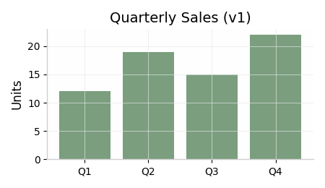

3. Survey Results
Team | Output Delta | Satisfaction
Alpha | +12% | 4.2 / 5
Beta | +8% | 3.9 / 5
Gamma | +15% | 4.5 / 5

4. Conclusion
Remote work is a clear net positive for every team we studied, and we recommend making it the default policy for all departments immediately.

