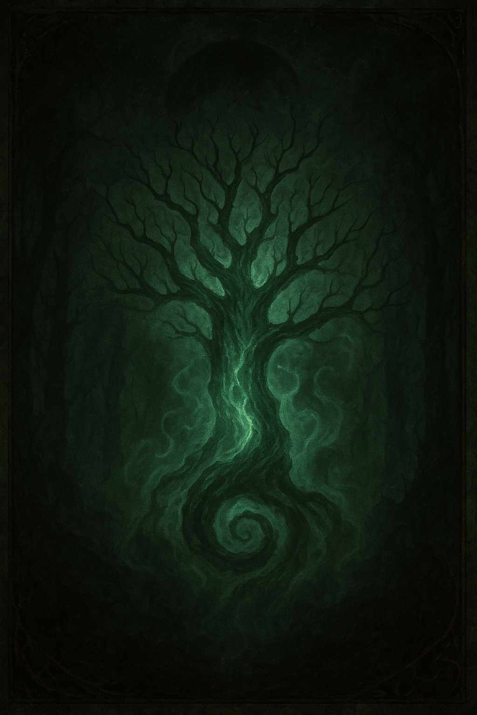
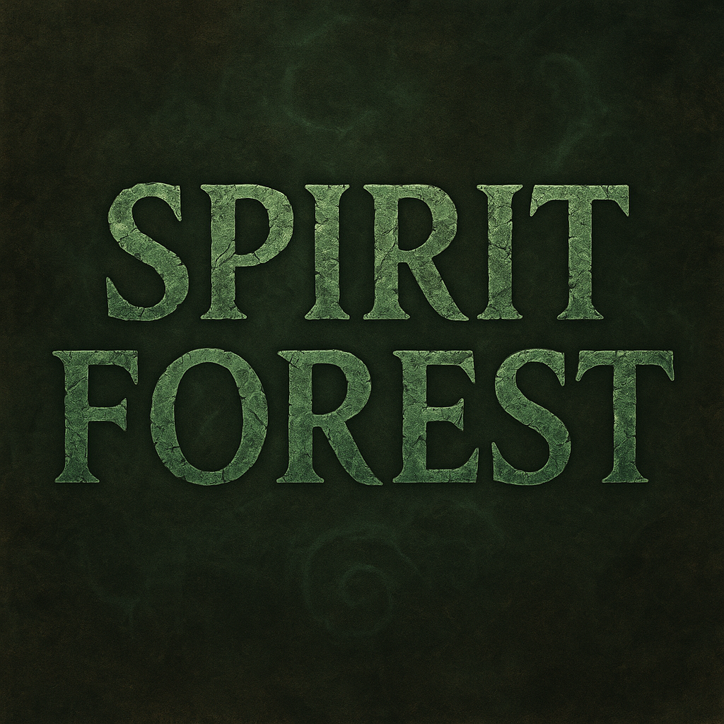

SPIRIT FOREST – ECHO FROM BEYOND
(Undead/Ethereal Team – LRB6 Homebrew Rules)

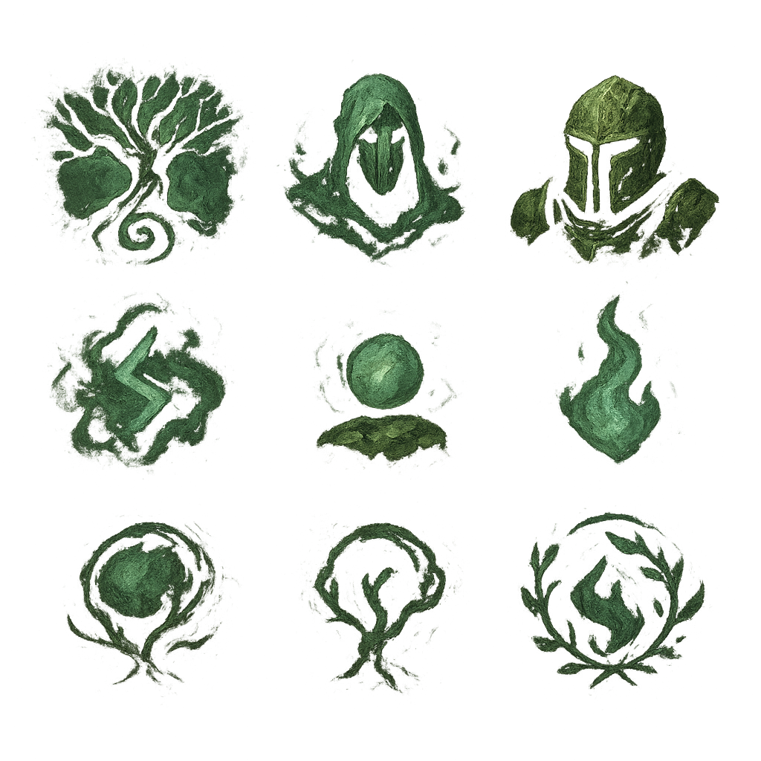
Background
They are not a team. They are a response.
When the blood spilled on the fields of Blood Bowl soaks the earth of an ancient forest, sometimes the forest… responds.
The Spirit Forest are ghosts of fallen players, primordial echoes: fragments of the game's very essence that awaken when the lines between life and spectacle blur.
They understand neither victory nor glory. They play driven by an impulse older than both: the echo of the roar from the stands, the smell of turned earth, the memory of a thousand forgotten games.
And at their center, a will-o'-the-wisp flickers, reminding them that even if they don't understand the rules, the spark of the game still burns within them.

Style of Play
The Spirit Forest don't "play" Blood Bowl, they bewitch it.
They interpret it as an ancient ritual, an echo of chaos that resonates in the wood and the mist.
The ball never stays still: each turn is a flash of spiritual energy that passes from specter to specter until it dissipates.
The opponent faces a disembodied wall, immune to pain but slow and clumsy, where each strike dissolves into thin air and each pass seems guided by the will of the forest.
Winning with them is mastering the rhythm of chaos.
They aren't physically blocking the way—there is no collision, no flesh, no bone—but the fog surrounds them, enveloping the field in a blanket of reflections and shadows that disorients opponents, returning them to the same point from which they started, as if the mist guarded the threshold between the living forest and the oblivion of the dead.
Losing against them is discovering that defeat, sometimes, also has roots.
Spirit Forest doesn't seek "conventional" victories: its strength lies in controlling chaos, forcing the opponent to react to forced passes, unpredictable movements, and the disembodied presence of your players. Every turn is a dance of chance and ritual: winning requires embracing clumsiness and turning it into advantage.

Equipment Rules
Race: Forest Ethereals / Spirit Forest
Category: Stunty Equipment (Undead / Sylvan)
Rerolls 0-4: 60,000 gp Apothecary: No
Wizard: No Hobby: 10,000 gp Maximum Fame: +2
Cheerleader / Assistant Coach Check: Allowed

Special Equipment Rules
Spectral Form
Players in Spectral Form can reroll a 1-point or skull die once per turn.
Players with this rule treat KO (8-9) results on the injury table as Stunned, while Casuality (10-12) results become KO. If they are pushed off the pitch, they are automatically KO'd.
KO's are only recovered in the second half of the match.
At the end of a team's turn, any downed players automatically get up without any rolls before the forced pass from Spectral Hands or Caproicious Nature, allowing the activation of Whispers of the Ball, while those Stunned out remain dispersed in the mist until the next turn.
Players in Spectral Form cannot declare fouls, but they have RightStuff skill.
Spectral Hands
The player is considered to have Fend + Sure Hands + Big Hand.
No pass may target an empty square or a player in a touchdown square.
Players with this ability cannot perform Throw or Hand-Off actions, except by using Divine Pass or Safe Throw. These abilities only apply to declared passes, not forced passes.
At the end of a team turn, if a player with Spectral Hands possesses the ball, they must attempt a forced pass (maximum 7 squares). If there is no valid receiver or the pass fails, the ball falls to the ground (as if it had failed a pass). Only one forced pass can be made per turn.
Caprocious Nature
It cannot be thrown by Throw-Team-Mate players despite having Spectral Form ('RightStuff').
The Capricious Nature cannot Throw or Hand-Off except with Divine Pass.
If it is in possession of the ball at the end of the team's turn, it must immediately attempt a Divine Pass (Hail Mary Pass). This action is considered a forced pass.
Whispers of the Ball
This ability adds +1 to pick-up, interception, catch, pass, and landing (Whisper of the Woods).
When a Fumble or Pass occurs (friend or opponent), it activates once per turn (either during your turn or the opponent's turn). For all players with the ability at the same time, these players can instantly move up to 3 spaces without Dodge rolls and cannot end up in the opponent's end zone (TD squares). A player with Pass-Block cannot use this ability.
Spectral Stripball
This ability works like StripBall + Juggernaut, but cannot be negated by SureHands.
When a Blitz action is declared against the ball carrier, it has the additional effect of being performed without Dodge rolls; however, it is always against 3 dice and cannot be rerolled.
Spectral Shadowing
A player with Spectral Shadow is considered to have Shadowing + Prehensile Tail + Jump Up.
It functions as Shadowing with a +10 modifier (Mv10 for this roll).
However, it requires a GoForIt roll to Block, even if the opponent is adjacent to it.
Whispers of the Woods
It cannot be thrown by Throw-Team-Mate players despite having Spectral Form ('RightStuff').
Allows a specter to be cast ('Throw-Team-Mate') through the mists that connect to the astral plane.
The "spectral shift" is resolved as a TTM within a maximum of 4 squares and requires an unmodified Agility roll for landing. It can be used once per turn by each player with this ability.
Spectral Aura
He may commit a Foul Action despite Spectral Form, but he cannot be sent off and cannot benefit from assists. He is considered to have Disturbing Presence and cannot declare Blocks or Blitzes. If he receives them, any Push is now treated as Both Down and ignores Block skill for both players.
Spectral Possession
Choose an adjacent opposing player and take control of them. The Poltergeist (possessed player) immediately and freely blitz action using that player's stats, gaining Spectral Stripball without causing turnover if it fails, and any knockdowns (both the possessed player and the target) suffer a direct Injury roll, ignoring armor.
Immediately after the blitz ends, the possessed player (if on the pitch) and the Poltergeist are KO'd.

Team Template
Player | MA | ST | AG | AV | Skills | Primary Access | Secondary Access | Cost | Max. Qty
The Ancient Trees | 2 | 6 | 1 | 10 | ★ Spectral Form,  ★ Whisper of the Woods,  Take Root, Stand Firm,  Thick Skull, Strong Arm,  Nerves of Steel | Strength | Passing, General, Agility | 120k | 0–2
The Ethereal Hunters | 4 | 2 | 2 | 7 | ★ Spectral Form,  ★ Spectral Hands,  ★ Spectral Stripball | Passing | General, Agility, Strength | 70k | 0–2
The Spirit Channelers | 4 | 2 | 2 | 9 | ★ Spectral Form,  ★ Spectral Hands,  ★ Whispers of the Ball,  Divine Catch | Passing | General, Agility, Strength | 90k | 0–3
The Spectral Stalker | 0 | 5 | 0 | 5 | ★ Spectral Form,  ★ Spectral Shadowing,  No-hands | Passing | General, Agility, Strength | 70k | 0–2
Will-o'-the-Wisp | 6 | 3 | 3 | 7 | ★ Spectral Form,  ★ Capricious Nature,  Block, Divine Pass | Passing | General, Agility, Strength | 70k | 0–1
Forest Poltergeist | 6 | 3 | 3 | 7 | ★ Spectral Form,  ★ Spectral Possession,  ★ Spectral Aura,  Stab, No-hands | General, Strength | Agility, Passing | 80k | 0–1

Unique Roster: Full Team + 1RR

“First there were footsteps. Then there were screams. And then there was silence.
When the last blood of a match soaked the floor of Nyrdris Forest, the trees stirred. Roots shifted underground, and something ancient awoke in the shadows.
They didn't remember their names, their bodies, or their purpose. Only the echo of the falling ball.
Thus was born the Spirit Forest: a procession of confused spirits mimicking the gestures of the living, trying to understand why a simple round object seems to contain all the urgency of the universe.
For them, the ball is neither leather nor air: it is a spark of the soul that has yet to find rest.
No one knows if they play out of instinct, out of penance... or because, deep down, they still remember what it feels like to win.”

Ancestral Forest Incentives
Team Rule: Spirit Forest cannot hire Star Players, Sorcerers, Medics, Apothecaries, or any other incentive not listed here.
The forest does not accept outside aid. Its players are disembodied echoes who understand nothing about medicine, magic, or star contracts. They respond only to the offerings that nourish the very essence of the forest.
1. Offering to the ancients
Cost: 150,000 gold pieces (Max Quantity: 1)
Effect: Once per match, at the start of any team turn, you may summon an Ancient Mist. Until the end of this drive, all opposing players suffer the following penalties: -1 to Pass, Catch, Intercept, Pickup, and Go for It (GFI), -1 to Movement (Mv). Spirit Forest players are immune to this effect.
A bloodstained relic of Bowl is buried. The forest responds by covering the field in a mist that hampers flesh beings, but not its own ghosts.
2. Twisted Roots
Cost: 40,000 gold pieces (Max Quantity: 2)
Effect: Once per match, when an opposing player declares a Blitz action, you can activate this incentive. The player must immediately succeed on an Agility roll with a -2 modifier, or their Blitz action is lost (although they can take another action).
The forest roots emerge and entangle the feet of the opponent preparing to charge, ruining their attack.
3. Spectral Mockery
Cost: 40,000 gold pieces (Max Quantity: 2)
Effect: Once per match, when an opposing player declares a Dodge action, you can activate this incentive. The opposing player must make the Dodge roll with a -2 modifier. If the Dodge action fails, it does not cause a Turnover.
Whispers from the mist distract and unbalance the opponent who attempts to dodge, causing them to stumble without consequences for the ghost team.
4. Whispers from the Spectral Stands
Cost: 60,000 gold pieces (Max Quantity: 1)
Effect: This incentive provides an additional +3 Fame (Fan Factor) for all Kick-Off table checks in this match. Additionally, when the Poltergeist performs a Foul action, it can ignore the rule that prevents it from receiving assists, benefiting from up to +2 on the Foul roll if this incentive is activated. And Spirit Channelers ignore the -2 interception penalty.
The spirits of ancient fans fill the stands. Their icy breath helps the Poltergeist concentrate its essence to commit dirtier fouls.
5. The Forest Awakens
Cost: 150,000 gold pieces (Max Quantity: 1)
Effect: Once per match, at the end of an opponent's team turn, you can activate this buff. All Spirit Forest players on the field (both Downed and Stunned) immediately stand up. Each of them can then instantly move up to 3 spaces. This movement does not provoke Dodge rolls, and the final space cannot be the goal line.
The forest exudes its power. All of its fallen specters rise and reposition themselves in the mist, ready to continue the ritual.
6. Minor Offering
Cost: 20,000 gold pieces (Max Quantity: 1)
Effect: Once per game, at the start of your turn, you can activate this boost. Choose a Spirit Forest player. If the player is Downed or Stunned, they get up for free. That player can instantly move up to 3 spaces. This movement does not provoke Dodge rolls, and the end space cannot be the goal line. Only one Minor Offering may be used per turn.
A small offering (blood, a memento) revitalizes a single specter, allowing it to get up and reposition itself in the mist.

Spirit Forest – A Typical Turn in the Fog
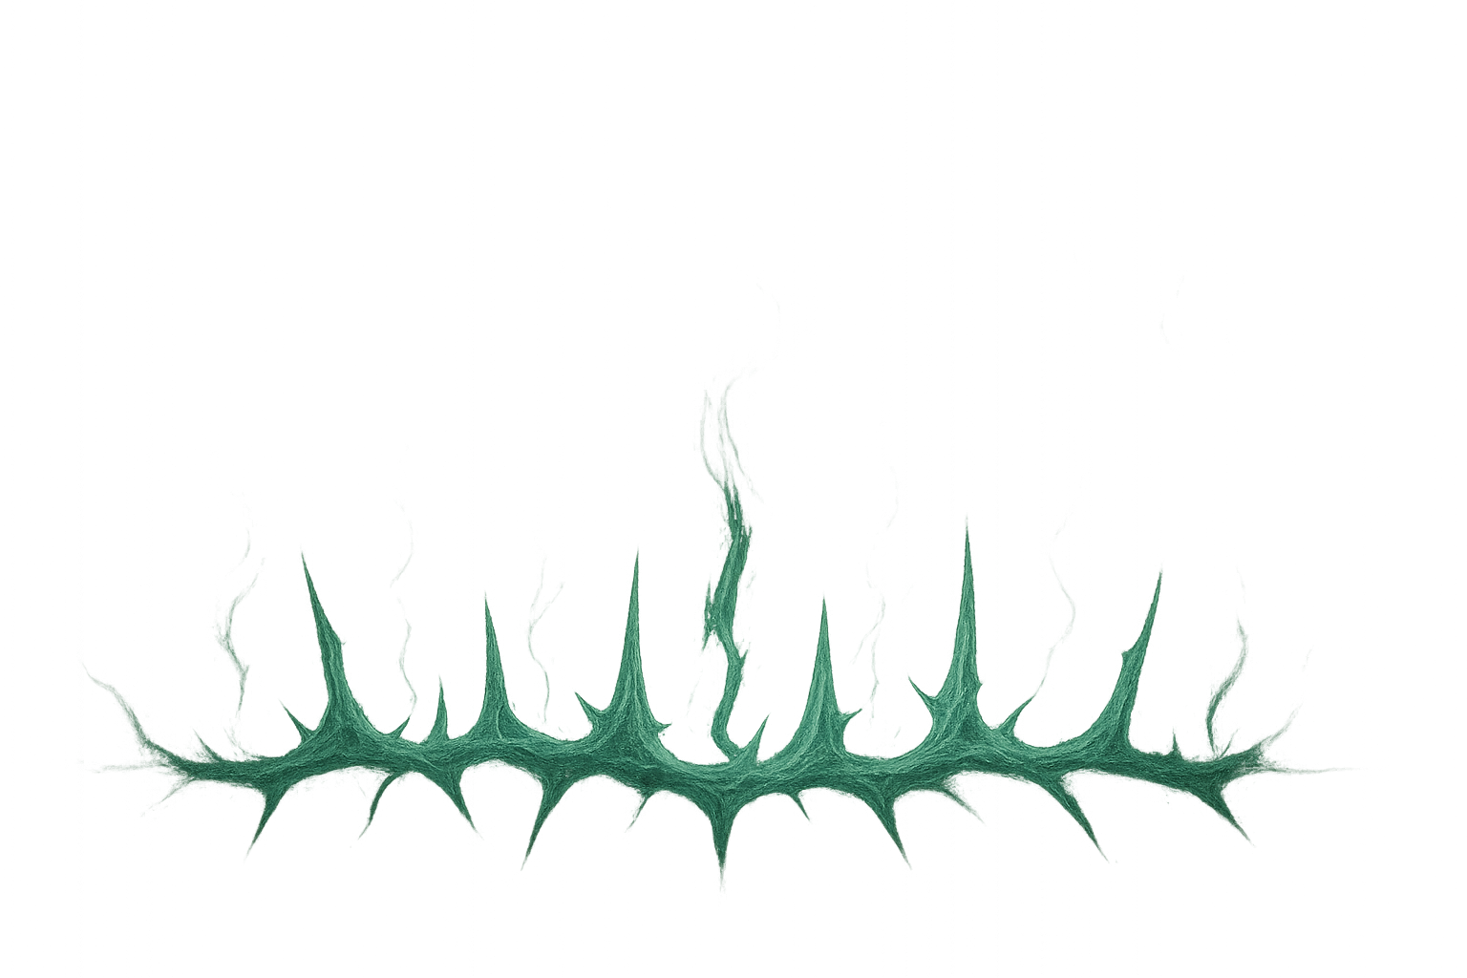
The whistle cuts through the mist like a moonlit blade, and the ancient trees whisper beneath the damp earth. In the center of the field, the ball seems to tremble with a life of its own, a small heart beating in the mist.
The Ethereal Hunters hesitantly advance. Every step is a risk: the earth is damp, their bodies light and clumsy. They dodge, vanish into the mist, recompose themselves, a ritual of balance and chance. One scatters at an elven blow, but rejoins as if the very essence of the forest calls for it: the echo of a young spirit that refuses to rest.
Meanwhile, the Ancient Trees extend their roots, imbuing the ground they glide across with white aether, supporting the field, whispering to it. One raises its arms and sends a Channeler forward through the astral plane; the air seems to bend, and the spirit trapped in the thin veil between the living and the dead is sent forth to cling to the ball. A flow of mist and erratic movements where it's unclear whether it spins or slides... and yet it still manages to bounce the ball toward a Will-o'-the-Wisp that floats like a flash in the middle of the field. Each pass is a gamble, but the will of the forest gently guides the trajectory, though nothing guarantees success.
The Spectral Stalker, almost invisible, watches. His feet are off the ground; he can barely move, but his presence is a disembodied wall. When an opponent dares to escape with the ball, the Spectral Shadow pursues them with a burst of ghostly speed, blocking their path. If they fail, their ethereal form disperses for a moment, but soon reappears, attentive to its role: to harass, to hinder, to live out their turn, stalking the living who dare to interfere.
The Poltergeist: The air cools, breath thickens, and shadows seem to move of their own accord. Wherever the Poltergeist manifests, the terrain becomes hostile even to the bravest. Opponents feel the weight of an invisible presence whispering from beyond. A spirit that manifests as an ethereal fire that enters the body of an opposing player. Under its control, the opponent's body acts like a spirit in rage, charging with the force of the forest and the spectral echo of the memory of being alive that fades into the mist, leaving only blood and memories.
And the Will-o'-the-Wisp, a living spark of chaos, receives the ball. She must throw it. She must pass it. Its brilliance wavers between intention and clumsiness. The forced pass emerges like a flash of capricious magic: sometimes it connects with a Channeler still rising from the ground; other times, it falls to the damp earth, like a sigh lost in the mist.
Each time the die lands showing a single white eye, it's not that the specter is "skillful," it's that the forest itself stirs and recomposes itself, refusing to let the error be final. What would be a fumble to a mortal is, to a ghost's echo, merely a whisper that can be corrected.
It's a constant reminder to your opponent that they're not playing against creatures of flesh and blood, but against echoes, memories, and shadows.
At the end of the turn, the fallen spirits rise from the earth, and the mist stirs. The dance of chaos continues, each player trying to participate despite the fragility of their forgotten flesh. The ball rolls, a moment of calm before another burst of chance and the forest's will send it leaping from one ghost to another.
Such is a typical Spirit Forest turn: a ballet of chaos and clumsiness, where every fall, every failed pass, and every risky shot builds the legend of a team that doesn't seek to win, but to exist in the memory of the game, like an echo that refuses to yield to the logic of the physical world.

