UK Expo (Operation)
- Create Event – UK Expo
Event Expo New
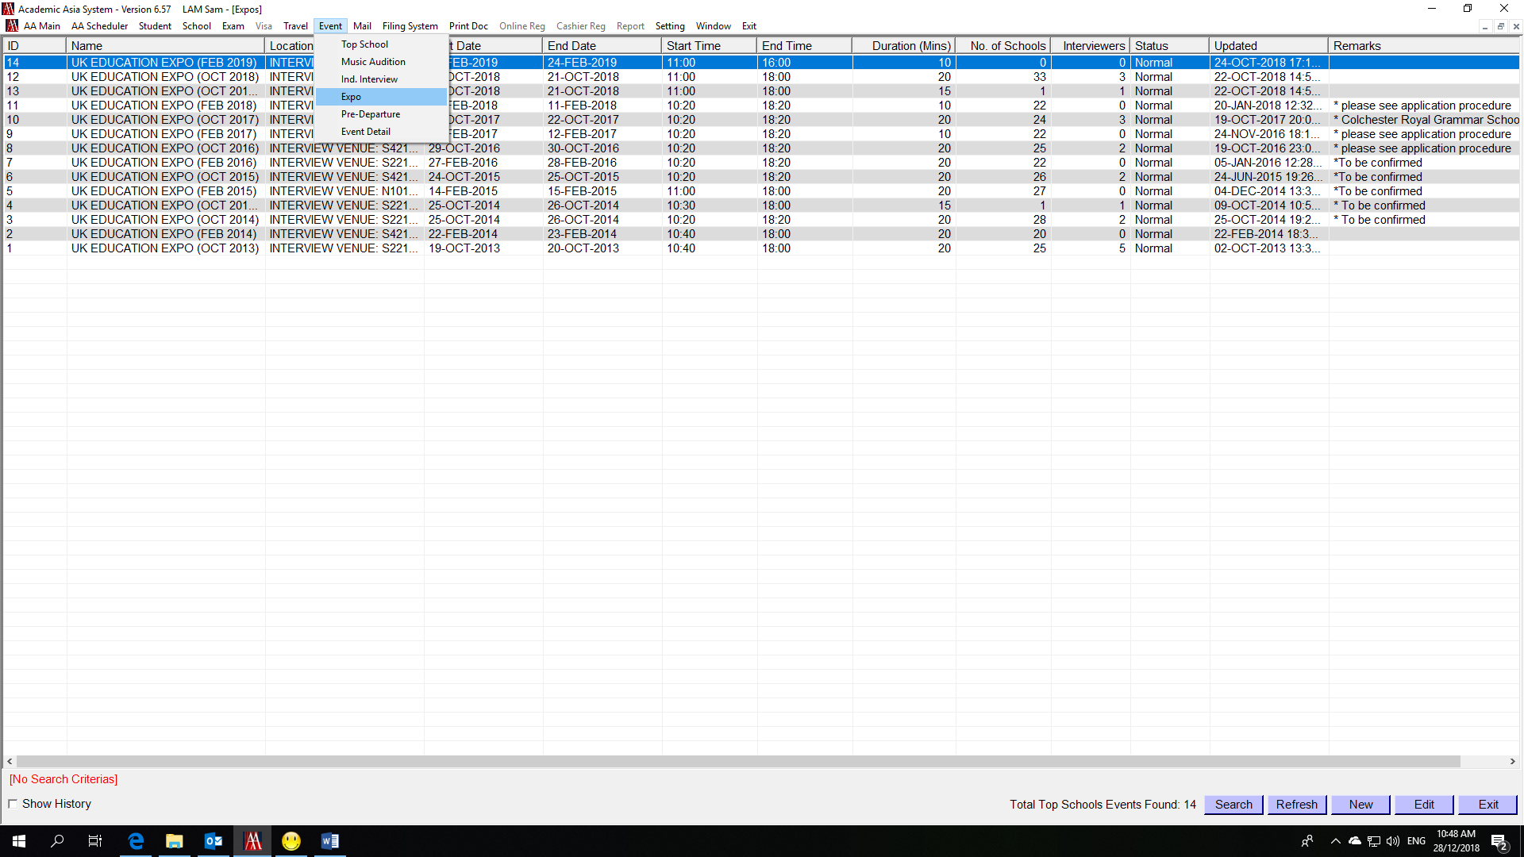
Input Event Name - e.g. UK EDUCATION EXPO (FEB 2019)
Input Location/Description – e.g. INTERVIEW VENUE: LEVEL 27 & 28, THE PARK LANE HONG KONG, A PULLMAN HOTEL, 310 GLOUCESTER ROAD, CAUSEWAY BAY, HONG KONG
面試地點:香港銅鑼灣告士打道310號 香港栢寧酒店 27及28樓全層
Start Date; End Date; Result Date(Important! Affecting bulk notification email); Status; Duration

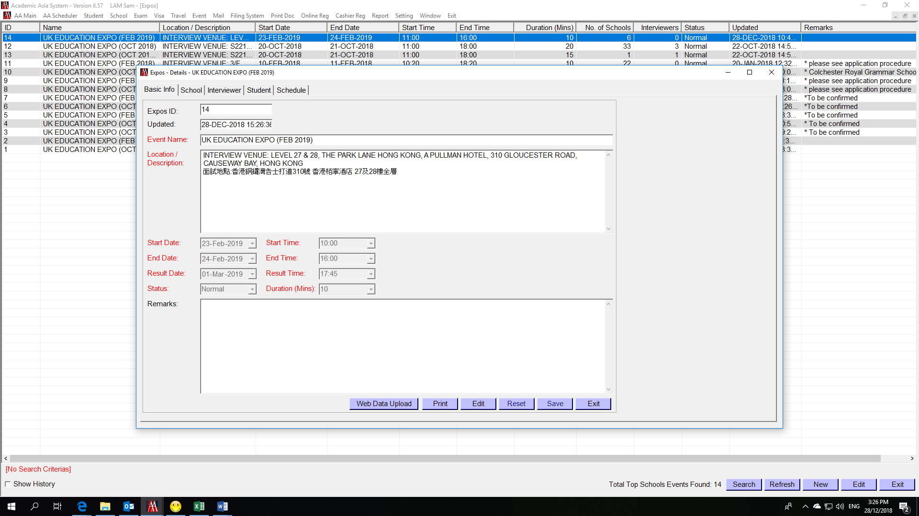

- Insert School
Select tag “School” Press “New” button
Select School Name Enter Reg Fee (i.e. 500) Press “Save” button
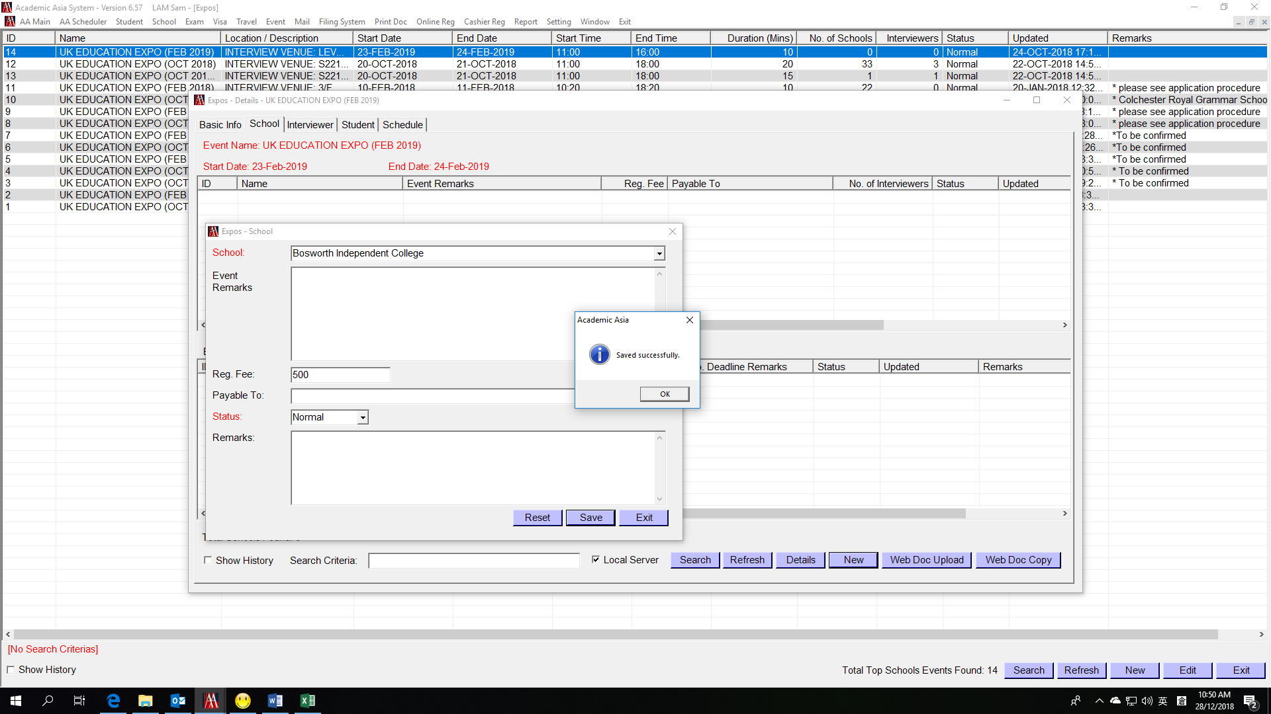

- Add summer course
Go to School Profile select tag “Course” Add Summer Course if any
Enter Year(YYYY-YY) - e.g. 2019-20
Enter Course Date – e.g. 1-Jul-2019
Select Course – Summer
Press “Save” button
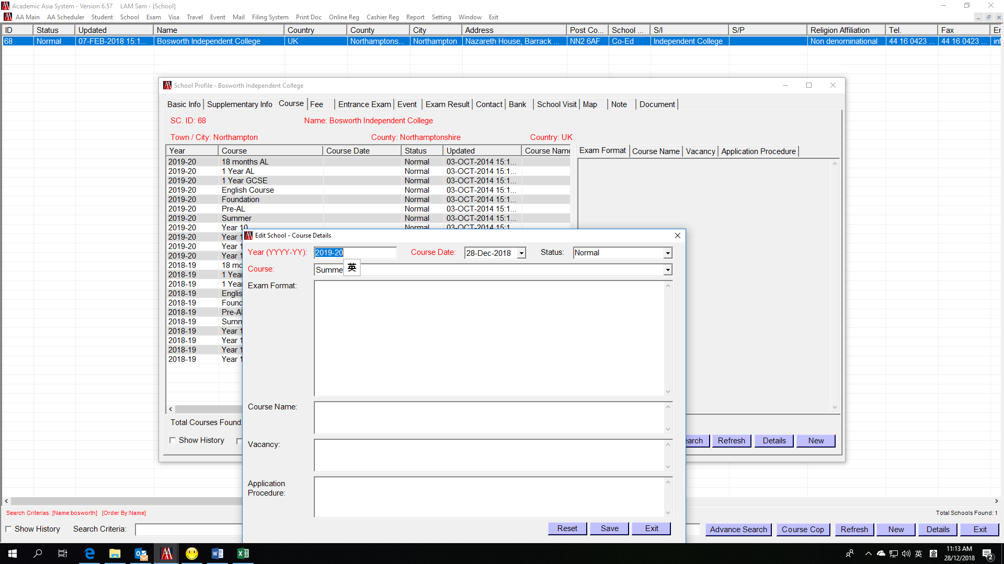

- Update School contact details
Go to School Profile select tag “Contact” Add/edit contact details if any
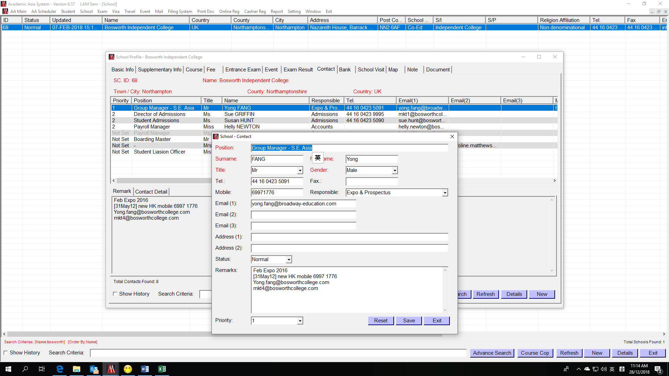

- Issue Web Login Letter
  - Prepare School list with login password
Assign Login ID and Password
e.g. School – Bosworth Independent College; Login: bosworth; Password: exw0068
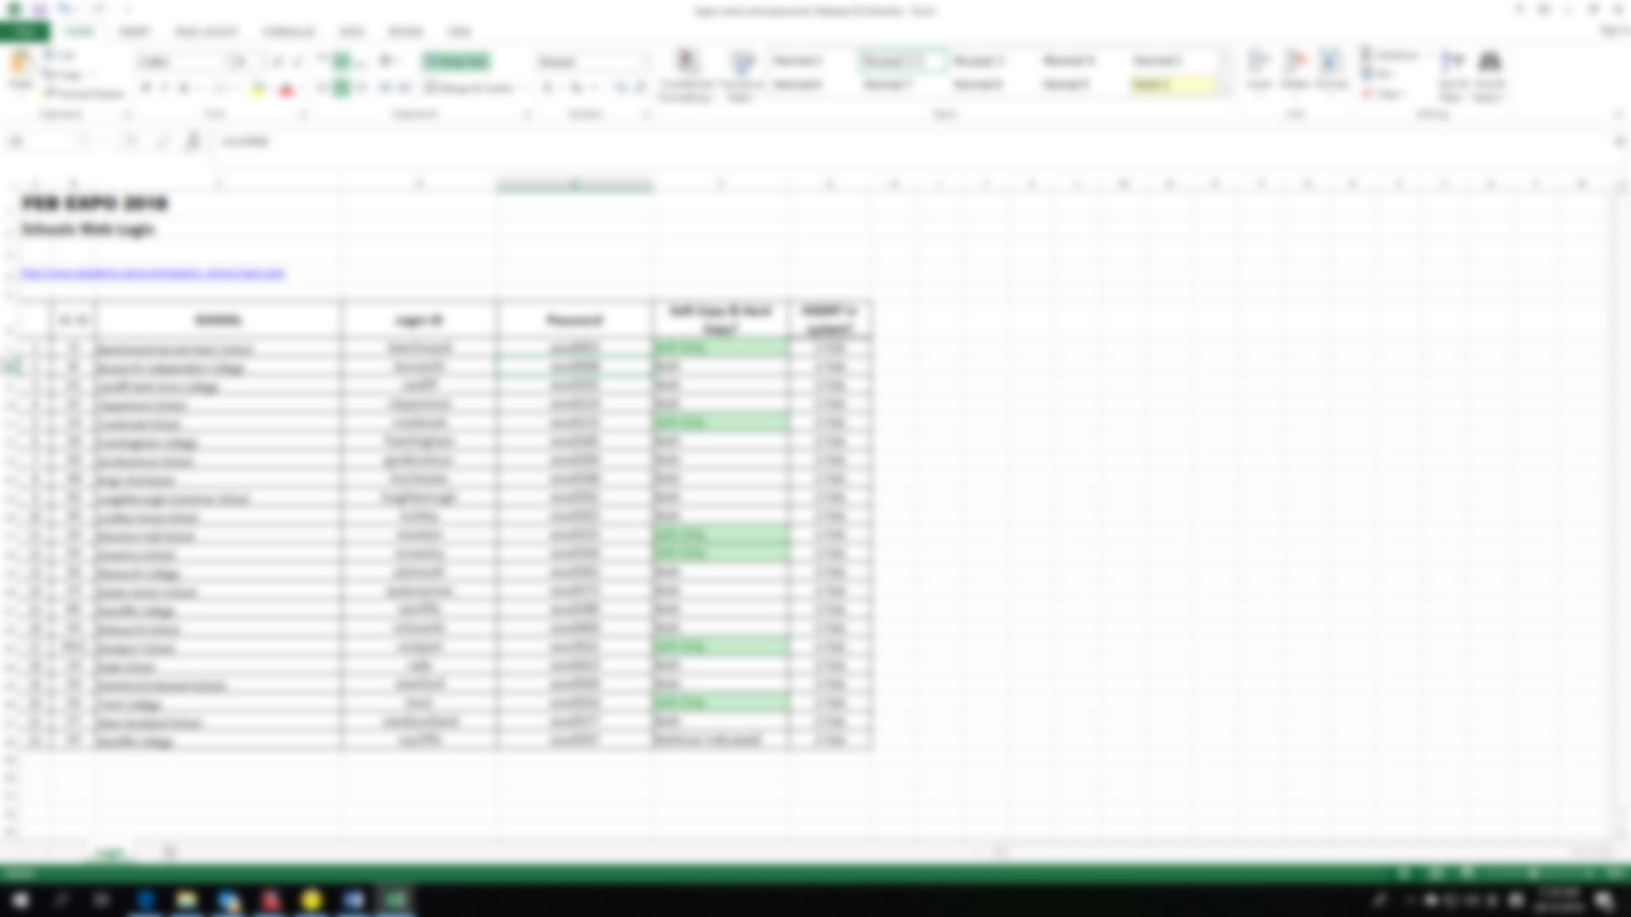

  - Update AAS according to the school list
School Profile select tag “Basic Info”
Update Login Name and Password Press “Save” button
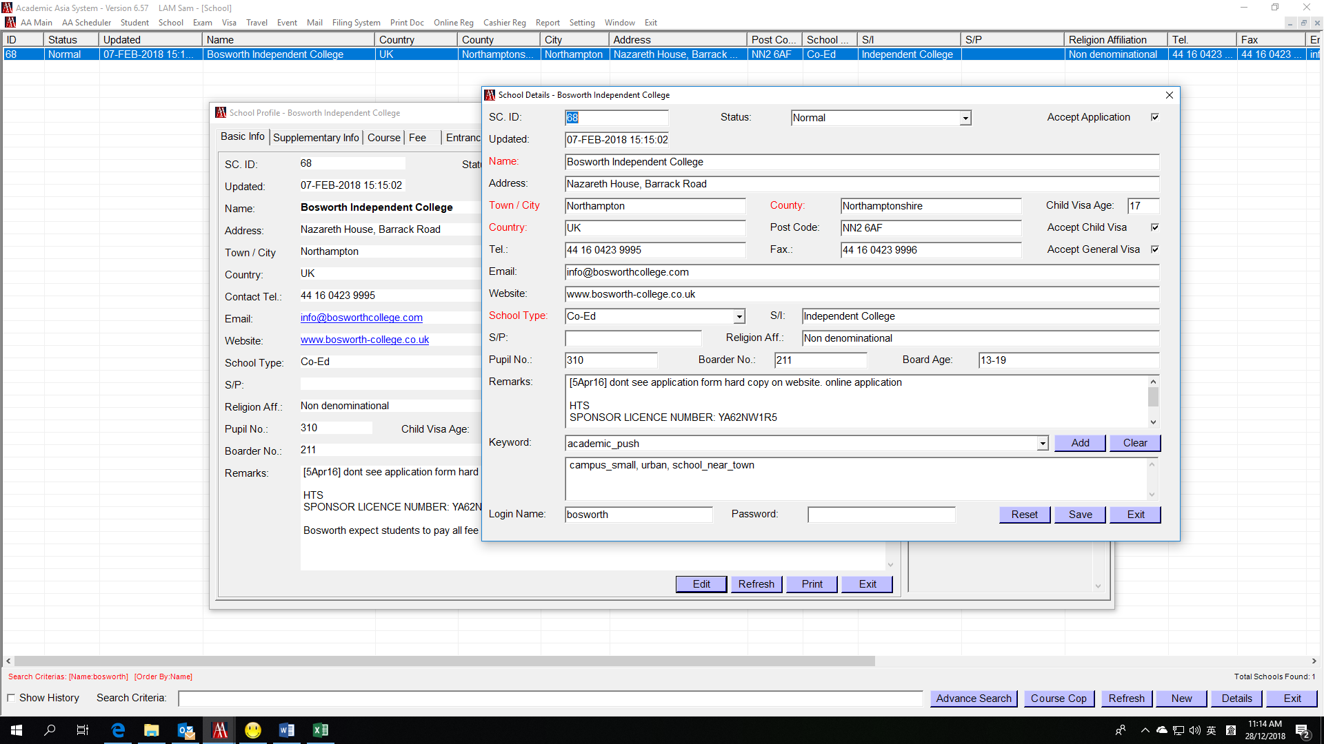
Ask Battie/PSC upload School login to web and then test in the following link
http://www.academic-asia.com/events_school/login.php
Report to PSC if there are any problems

  - Using mail merge to generate login letter to schools

