Create Interview Schedule
Event Ind.Interivew New
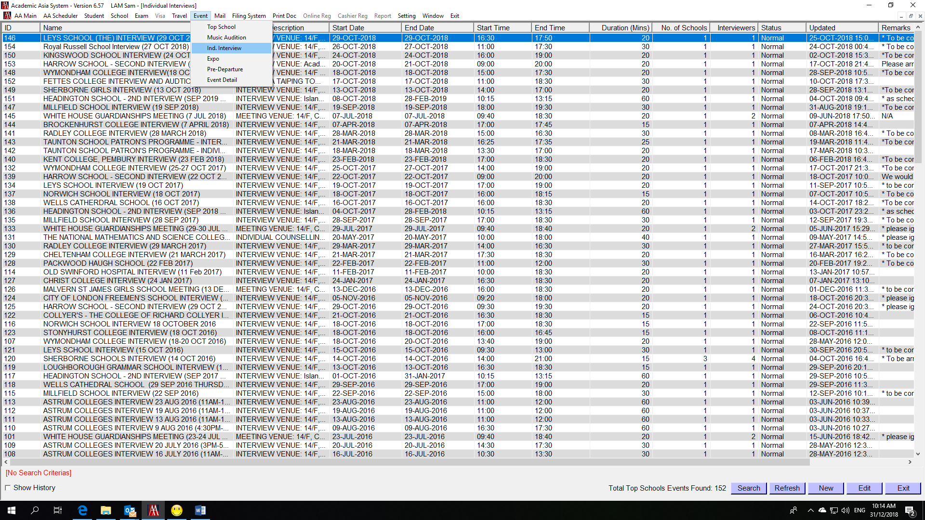

Select tag “Basic Info”
Input Event Name – e.g. LEYS SCHOOL (THE) INTERVIEW (29 OCT 2018)
Input Location/Description – e.g.
INTERVIEW VENUE: 14/F, China Taiping Tower Phase II, 8 Sunning Road, Causeway Bay, Hong Kong
面試地點：香港銅鑼灣新寧道8號中國太平大廈2期14樓
Input Start Date; Start Time; End Date; End Time; Result Date; Result Time; Status; Duration(Mins) – e.g.
29-Oct-2018; 16:30; 29-Oct-2018; 17:50; 5-Nov-2018; 17:00; Normal; 20
Click “Save” button
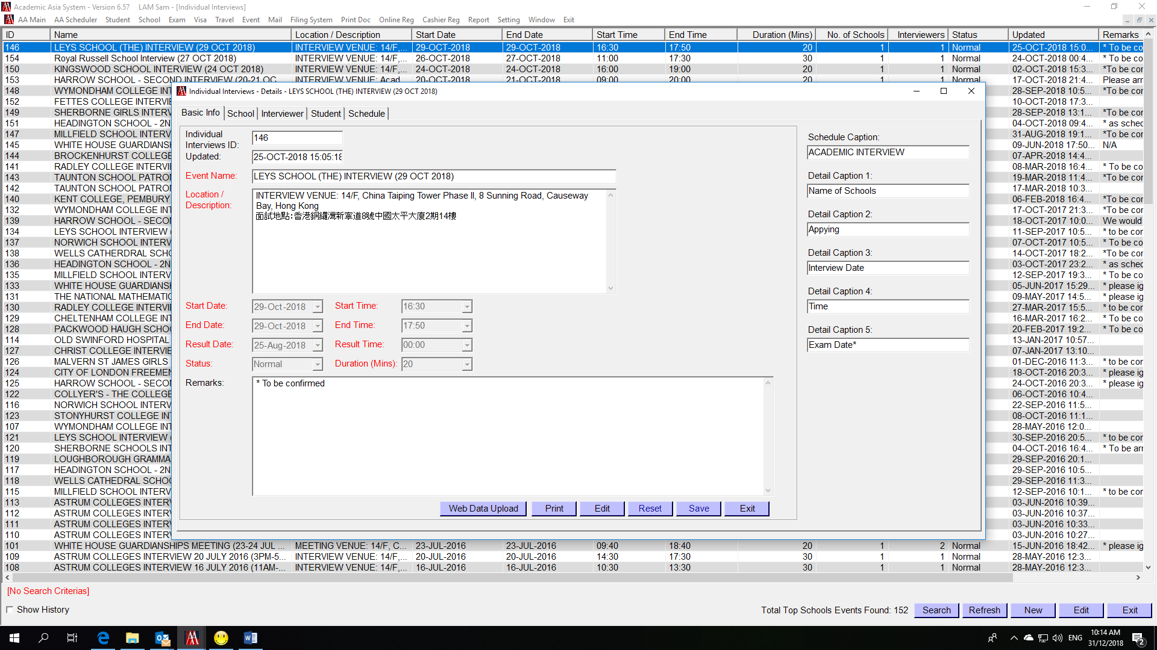

Select tag “School” Press “New” button
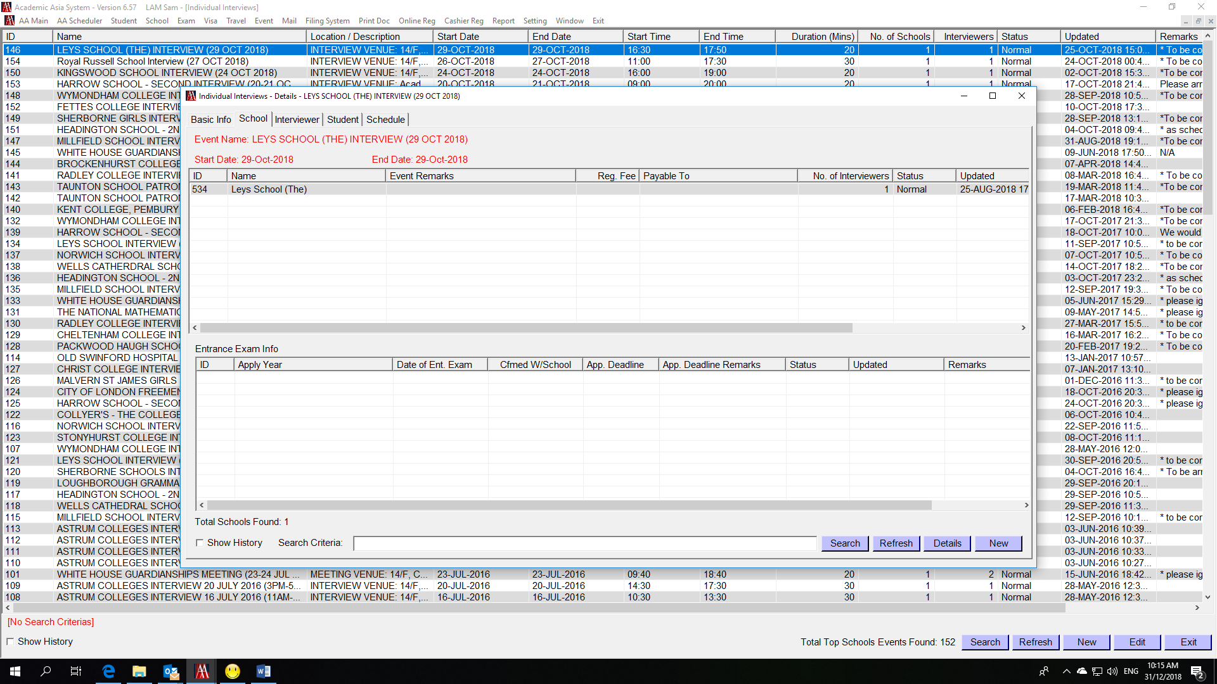
Select School – e.g. Leys School (The)
Select Status – Normal
Press “Save” button
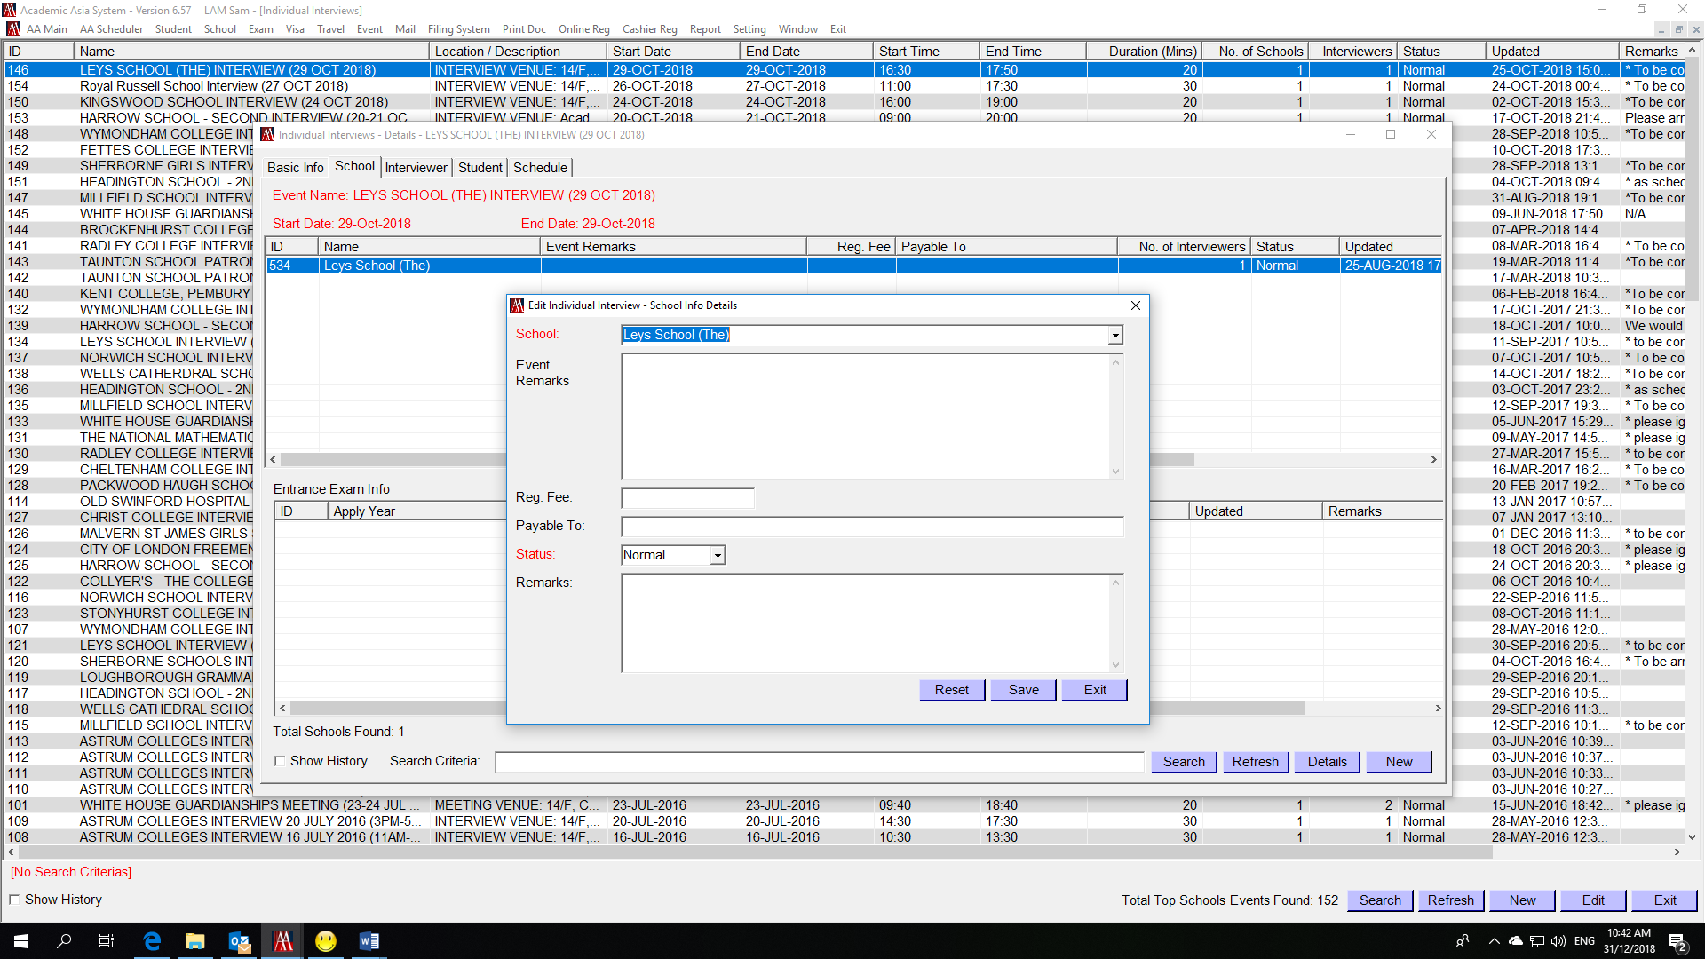

Select tag “Interviewer” Press “New” button
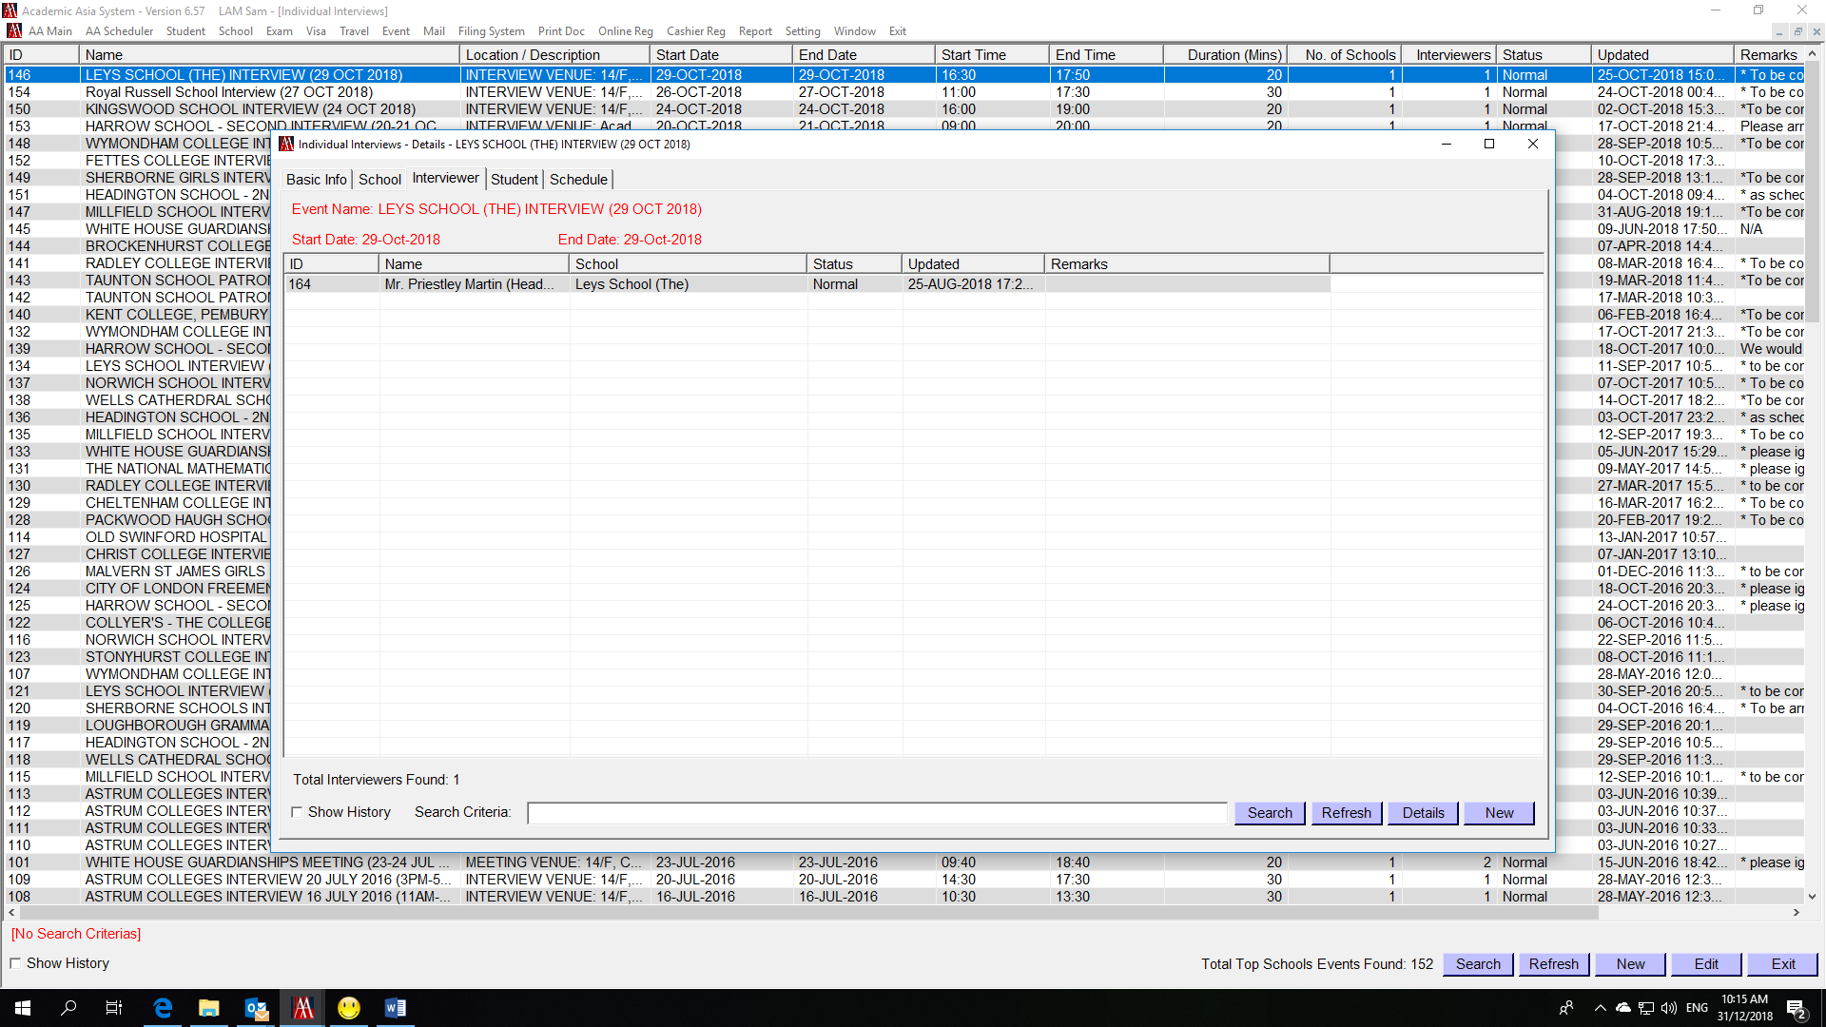
Select School – e.g. Leys School (The)
Select Interviewer – e.g. Mr. Priestley Martin (Headmaster)
P.S. Please add contact person under “School Profile” “Contact” if you cannot select he/she from the list
Press “Save” button
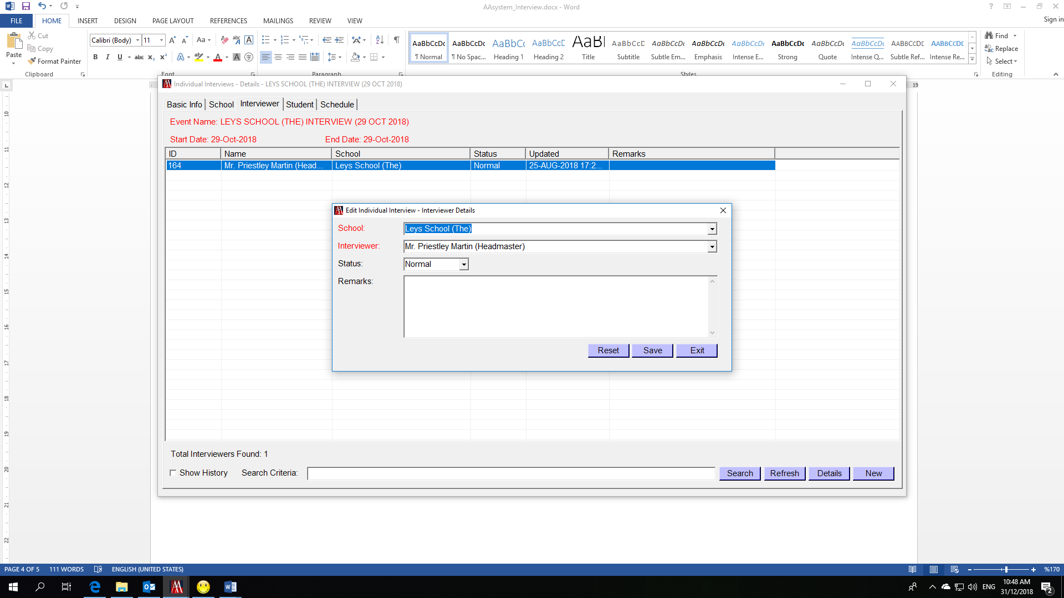

Select tag “Schedule” Check if the start time and end time are correct
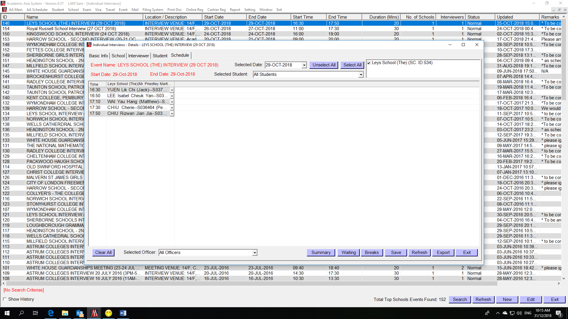
Add Breaks if neccessary
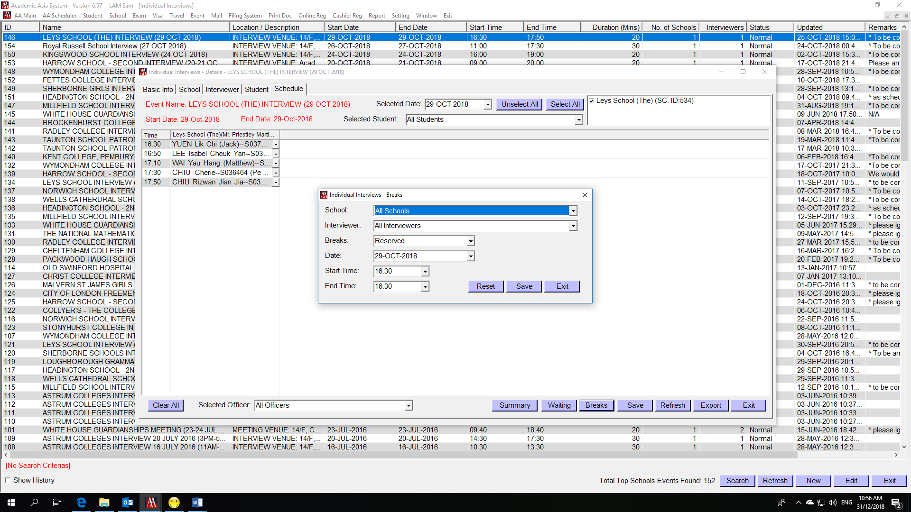

Inform CIC and they will add students accordingly.
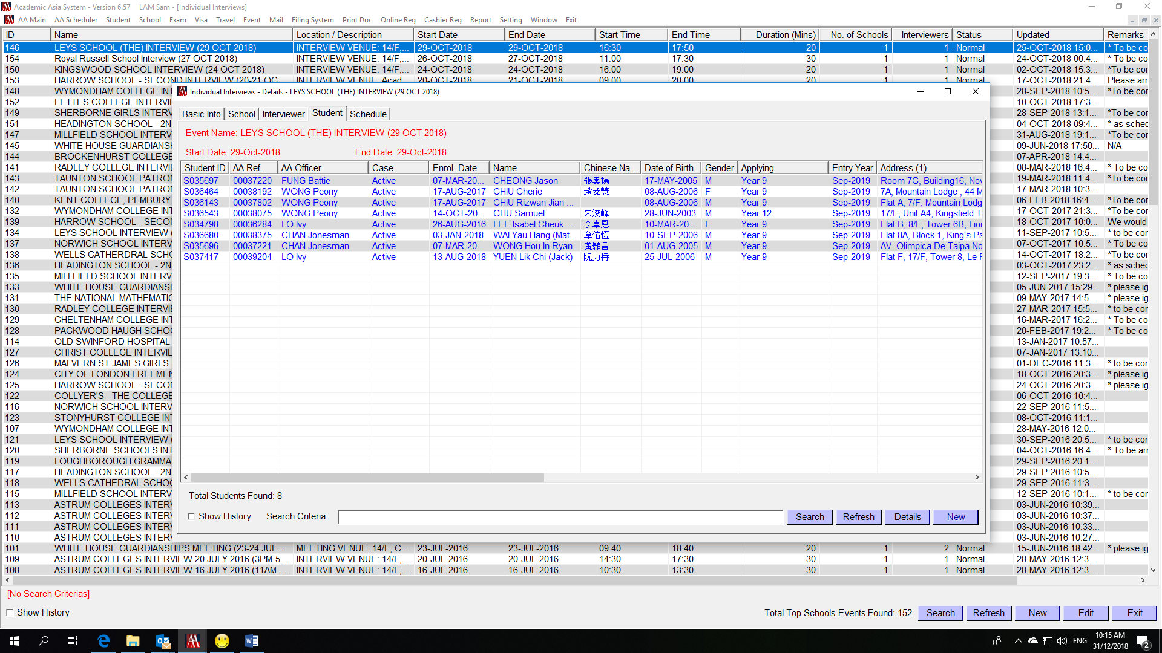

Print Interview Schedule (By interviewer)
Print Doc
Select Printing Type – School
Select Document – II – Interview Results Summary (Decision Form)
Select Event/Description: e.g. LEYS SCHOOL (THE) INTERVIEW (29 OCT 2018)
Select Name – e.g. Leys School (The) SCID: 534
Select Interviewer – e.g. Leys School (The) – Mr. Priestley Martin (Headmaster)
Press “Print” button
