- Export Student Details from AAS
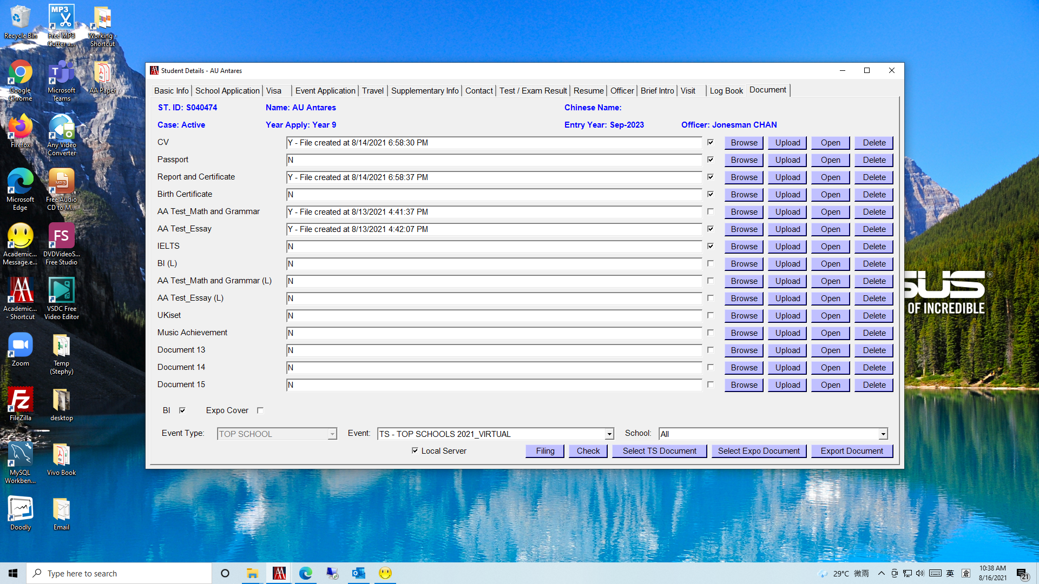
4
2
1
1
3

- Remove “temp” folder from Student folder under C:\PSC\student\[StudentID]_[StudentName]

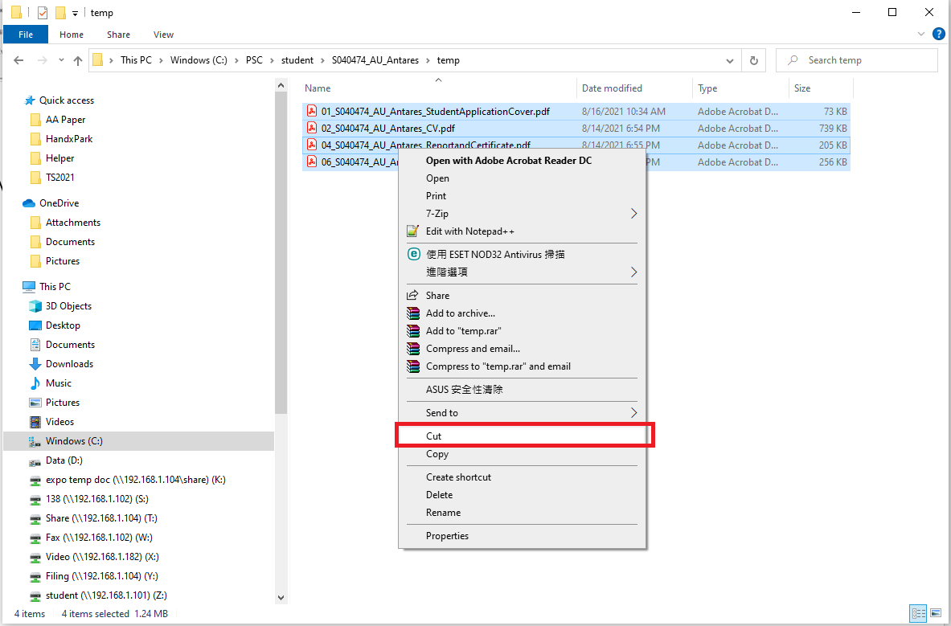
- Remove “temp” folder from Student folder
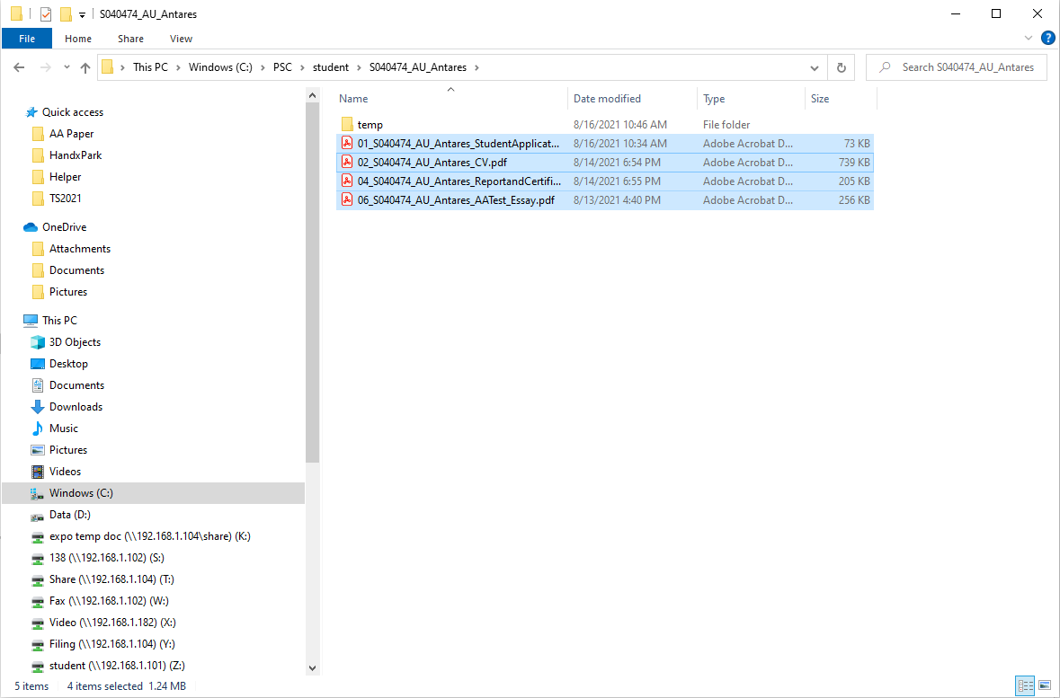
- Remove “temp” folder from Student folder
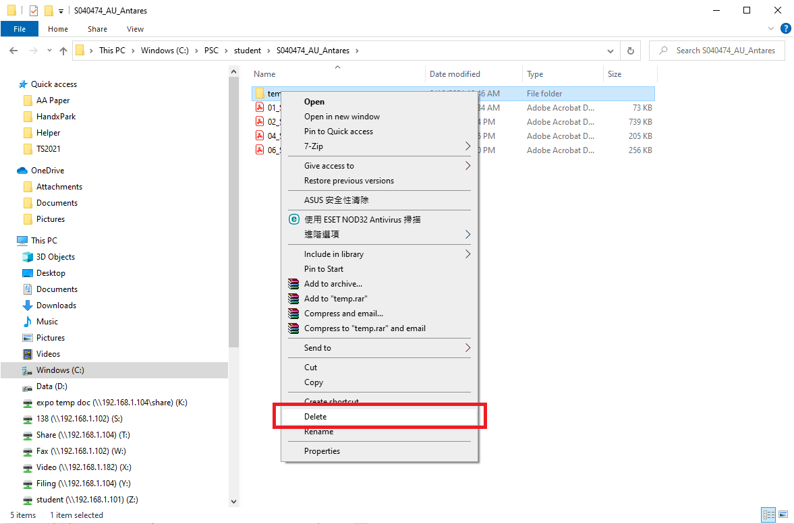
- Copy Student folder to share folder (T:\)
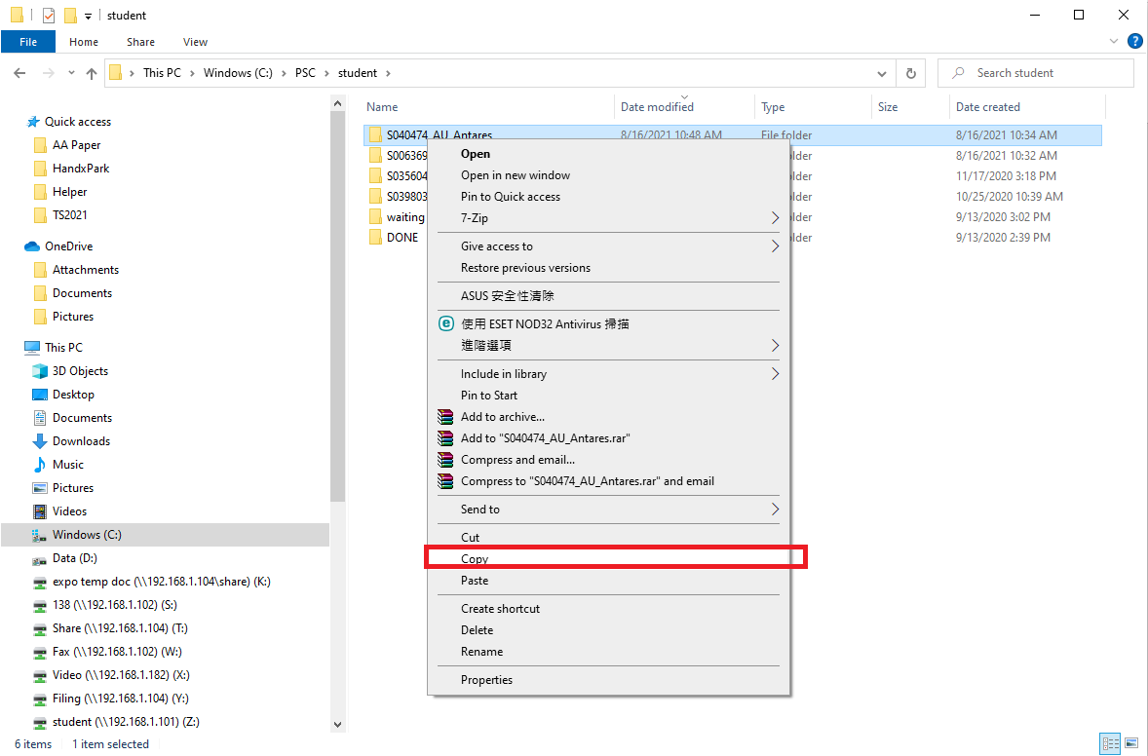
3. Copy Student folder to share folder (T:\TS2021_StudentDetails)
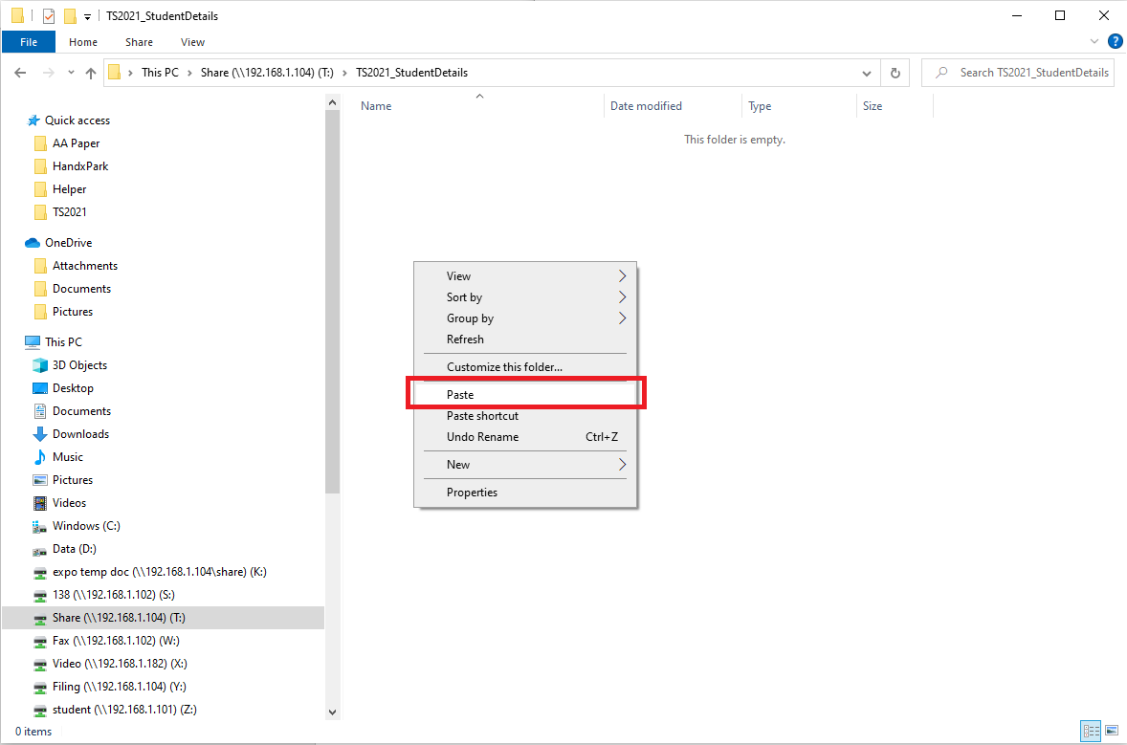
- Upload Student folder to ONE drive school links respectively.

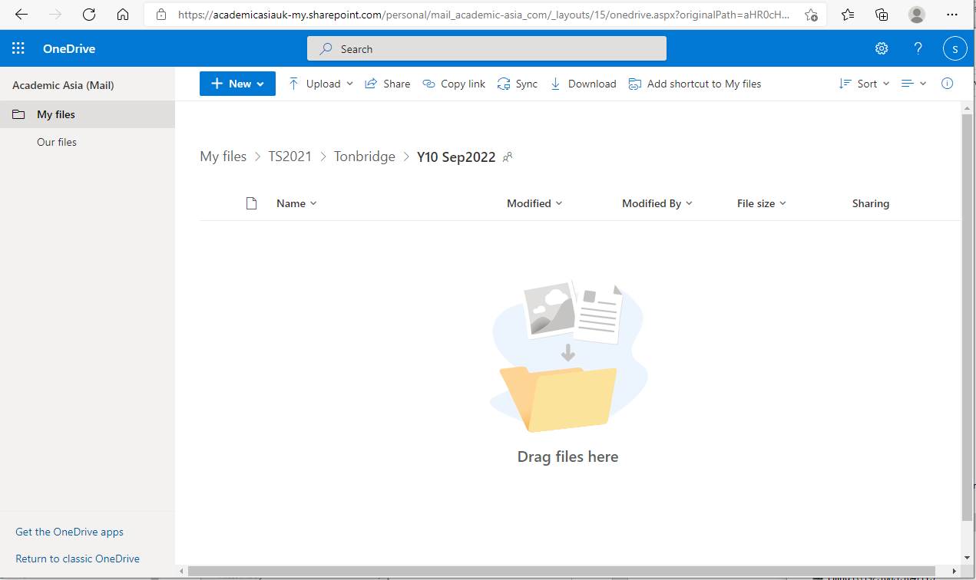
Full control of One drive
Login: mail@academic-asia.com
Password: AAema1782

