<User Guide of Cortina Boot Loader>

<29 Apr 209>

Revision <1.0>

Cortina Systems, Inc. Confidential
This document contains information proprietary to Cortina Systems, Inc. (Cortina). Any use or disclosure, in whole or in part, of this information to any unauthorized party, for any purposes other than that for which it is provided is expressly prohibited except as authorized by Cortina in writing. Cortina reserves its rights to pursue both civil and criminal penalties for copying or disclosure of this material without authorization.
INFORMATION IN THIS DOCUMENT IS PROVIDED IN CONNECTION WITH CORTINA SYSTEMS® PRODUCTS.
NO LICENSE, EXPRESS OR IMPLIED, BY ESTOPPEL OR OTHERWISE, TO ANY INTELLECTUAL PROPERTY RIGHTS IS GRANTED BY THIS DOCUMENT.
EXCEPT AS PROVIDED IN CORTINA’S TERMS AND CONDITIONS OF SALE OF SUCH PRODUCTS, CORTINA ASSUMES NO LIABILITY WHATSOEVER, AND CORTINA DISCLAIMS ANY EXPRESS OR IMPLIED WARRANTY RELATING TO THE SALE AND/OR USE OF CORTINA PRODUCTS, INCLUDING LIABILITY OR WARRANTIES RELATING TO FITNESS FOR A PARTICULAR PURPOSE, MERCHANTABILITY OR INFRINGEMENT OF ANY PATENT, COPYRIGHT OR OTHER INTELLECTUAL PROPERTY RIGHT.
Cortina products are not intended for use in medical, life saving, life sustaining, critical control or safety systems, or in nuclear facility applications.
CORTINA SYSTEMS®, CORTINA™, and the Cortina Earth Logo are trademarks of Cortina Systems, Inc. or its subsidiaries in the US and other countries. All rights reserved. Any other product and company names are the trademarks of their respective owners.
Copyright © 2008-xxxx Cortina Systems, Inc. All rights reserved.

Contents
1.0 Description 6
2.0 Functions 7
3.0 System Startup 8
4.0 Boot Menu Function 9
4.1 Reboot 9
4.2 Start the Kernel Code 9
4.3 List Image 10
4.4 Delete Image 10
4.5 Create New Image 11
4.6 Enter Command Line Interface 11
4.7 Set IP Address 11
4.8 Set MAC Address 12
4.9 Show Configuration 12
4.10 Set Booting File 12
4.11 Create Default FIS 13
4.12 Initialize IDE 13
4.13 Upgrade Boot 14
4.14 Upgrade Kernel 15
4.15 Upgrade Firmware 15
4.16 Upgrade Application 15
4.17 Upgrade RAM Disk 15
4.18 Upgrade Kernel #1 15
4.19 Upgrade RAM Disk #1 15
5.0 Command Line Interface 16
5.1 arp Command 16
Syntax 16
Description 16
Example 16
5.2 config Command 17
Syntax 17
Description 17
Example 17
5.3 dm Command 17
Syntax 17
Description 17
Example 17
5.4 exit Command 18
Syntax 18
Description 18
Example 18
5.5 go Command 18
Syntax 18
Description 18
Example 19
5.6 load Command 19
Syntax 19
Description 19
Example 19
5.7 mem Command 19
Syntax 19
Description 19
Example 19
5.8 ping Command 20
Syntax 20
Description 20
Example 20
5.9 quit Command 21
Syntax 21
Description 21
Example 21
5.10 sm Command 21
Syntax 21
Description 21
Example 21
5.11 Stat Command 22
Syntax 22
Description 22
Example 22
5.12 Tftp Command 22
Syntax 22
Description 23
Example 23
5.13 ls Command 23
Syntax 23
Description 23
Example 23
5.14 nand Command 24
Syntax 24
Description 24
Example 24
5.15 Timer Command 27
Syntax 27
Description 27
Example 27
6.0 Image Header Format for Upgrade 28
7.0 VCTL Format 29

Figures
(Insert→Reference→Index and Tables→Table of Figures tab; Options→Build from Style “Caption:Figure”)

Figure 1 System startup 8
Figure 2 Boot menuu 8
Figure 3 Fis Table 10
Figure 4 Delete Image 10
Figure 5 Create New Image 11
Figure 6 Set IP Address 11
Figure 7 Set Mac Address 12
Figure 8 Show Configuration 12
Figure 9 Set Booting File 12
Figure 10 Creste Default FIS 13
Figure 11 Initialize IDE 13
Figure 12 Download by X-Modem 14
Figure 13 Download by TFTP server 14
Figure 14 Arp Command 16
Figure 15 config 17
Figure 16 dm 17
Figure 17 exit 18
Figure 18 go 19
Figure 19 load 19
Figure 20 mem 19
Figure 21 ping 20
Figure 22 quit 21
Figure 23 sm 21
Figure 24 stat 22
Figure 25 tftp 23
Figure 26 ls 23
Figure 27 nand error command 24
Figure 28 nand info 24
Figure 29 nand erase 24
Figure 30 nand write 25
Figure 31 nand read 25
Figure 32 nand bad 25
Figure 33 nand markbad 26
Figure 34 timer 27

Tables
(Insert→Reference→Index and Tables→Table of Figures tab; Options→Build from Style “Caption:Table”; First instance = No, do not replace existing)

Table 1 <Boot Menu Function> 9
Table 2 <Command Line> 16
Table 3 <Image Header Format> 28
Table 4 < VCTL Location > 29
Table 5 < VCTL Block > 29
Table 6 <VCTL Header> 29
Table 7 < Parameter Header and Data > 29

Description
  - Cortina Boot Loader is designed for downloading and executing programs on an embedded target system with Cortina CS35xx processor.

Functions
- Control by console port (19200, N, 8, 1)
- Console Port Baud Rate 19200, Non-Parity, 8-bit, one stop bit
- Load and run images from Disk or Flash
- Load image by TFTP through Ethernet
- Load image or xMODEM protocol through Serial Port
- Support simple and user-friendly boot menu
- Support Command Line Interface
- Set Ethernet MAC Address and store in Flash
- Set IP Address and store in Flash
- Set Booting Files and store in Flash

System Startup
  - When the system is starting, the boot loader version and system configuration are prompted on the console port (19200, N, 8, 1) as below.
- System startup
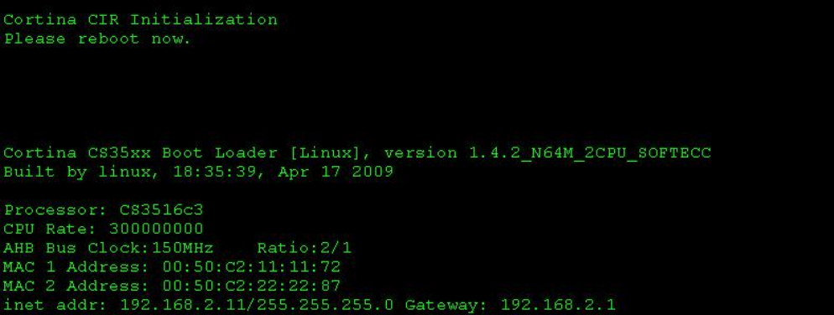

  - If no CTRL-C key is pressing, the boot loader will boot the images from Disk or Flash immediately. If the user enters CTRL-C key, the system will enter a friendly Boot Menu. Press a specified key to enter desired function. For an example, input ‘5’ character to enter command line interface.
- Boot menuu
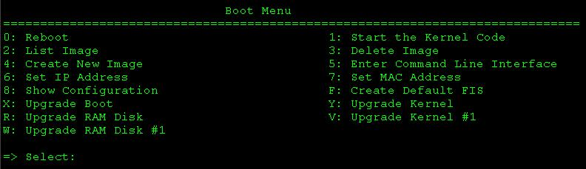

Boot Menu Function
- <Boot Menu Function>
Boot Menu
Key | Function | Description
0 | Reboot | Reset the target and restart the system.
1 | Start the Kernel Code | Load and execute the kernel images
2 | List Image(*1) | List FIS table
3 | Delete Image(*1) | Delete record of FIS table
4 | Create New Image(*1) | Cerate record of FIS table
5 | Enter Command Line Interface | Enter command line interface
6 | Set IP Address | Change IP Address
7 | Set MAC Address | Change Ethernet MAC Address
8 | Show Configuration | Display the system configuration
B | Set Booting File(*2) | Change the booting file and location
F | Create Default FIS (*1) | Create default FIS table
I | Initialize IDE(*2) | Re-initialize the IDE drive
X | Upgrade Boot | Upgrade Boot Loader
Y | Upgrade Kernel | Upgrade kernel image
Z | Upgrade Firmware(*3) | Upgrade whole flash image
A | Upgrade Application(*3) | Upgrade application(hddapp.bz2)
R | Upgrade RAM Disk | Upgrade ramdisk
V | Upgrade Kernel #1(*4) | Upgrade cpu2’s kernel image
W | Upgrade RAM Disk #1(*4) | Upgrade cpu2’s ramdisk

  - <Note 1 : If board support FIS table>.
  - <Note 2 : If board support IDE and >.
  - <Note 3 : Function not support when support nand boot>.
  - <Note 4 : If board support 2CPU>.

Reboot
  - Reset and restart the system.

Start the Kernel Code
  - Load Images from Flash or Disk and execute immediately.

List Image
  - List all partitions of FIS table.
- Fis Table
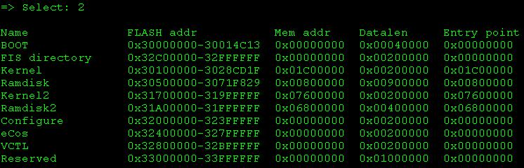

Delete Image
  - Delete record of FIS table
- Delete Image
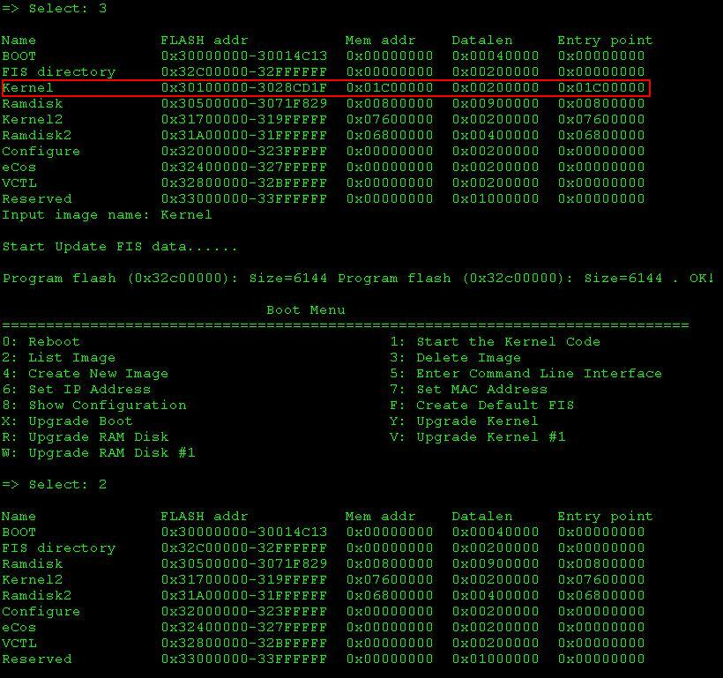

Create New Image
  - Cerate record of FIS table. Need input image name, flash address, memory address, entry point and max size. It will upgrade new partition image after input those data.
- Create New Image
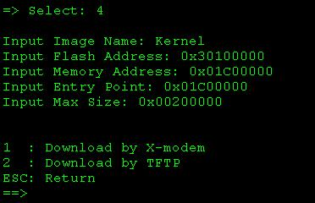

Enter Command Line Interface
  - Detailed commands are described in <Chapter Error: Reference source not found. Error: Reference source not found>

Set IP Address
  - A new IP address will be requested to input when select this function. Below messages are for an example to change IP address from 192.168.0.200 to 192.168.2.140. After changed, the new IP address will be saved in Flash VCTL Block. (See <Chapter 7. VCTL Format> for detailed format.)
- Set IP Address
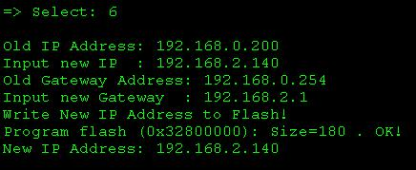

Set MAC Address
  - Select this function to change a new Ethernet MAC Address. The new MAC Address also is save in Flash VCTL Block. (See <Chapter 7. VCTL Format> for detailed format.)
- Set Mac Address
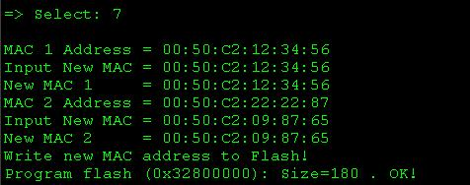

Show Configuration
  - Display the system configuration
- Show Configuration
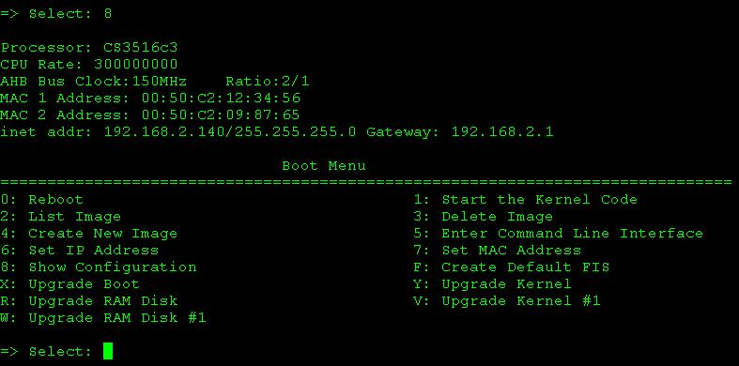

Set Booting File
  - Change the booting files. There are two booting should be set. One is the Kernel Program, and the other is the initrd file.
- Set Booting File
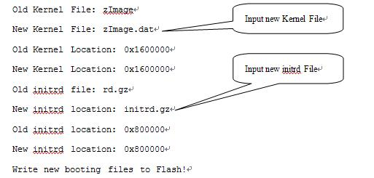

  - After changed, the new booting file configurations are stored in Flash VCTL Block. (See <7. VCTL Format> for detailed format.)

Create Default FIS
  - Create default FIS table
- Creste Default FIS
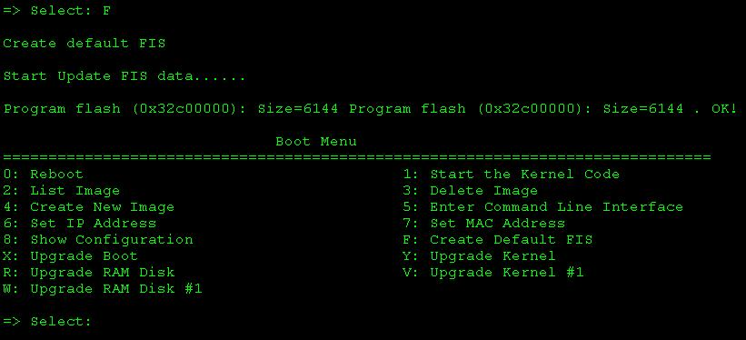

Initialize IDE
  - Sometimes the IDE is not initialized due to break by CTRL-C key, but you can re-initialize it by selecting this function.
- Initialize IDE
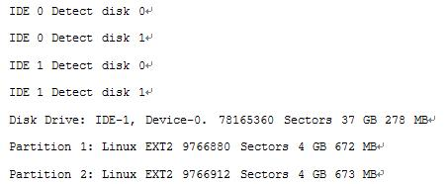

Upgrade Boot
  - Boot Loaded can upgrade itself by TFTP through Ethernet or Xmodem through Serial Interface.
- Download by X-Modem
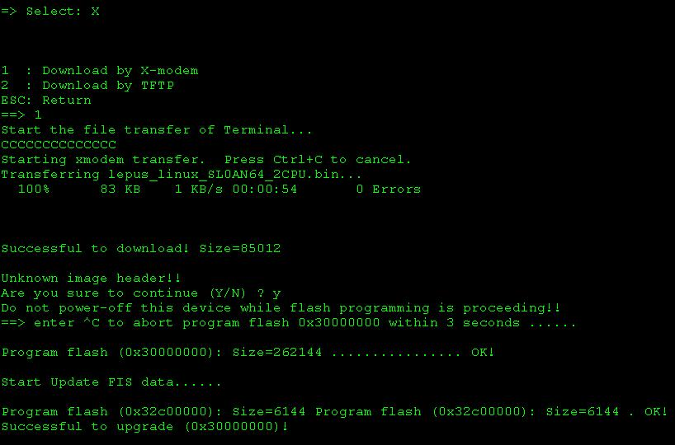
  - Start the File Transfer of your Terminal, e.g. Windows Hyper Terminal.
- Download by TFTP server
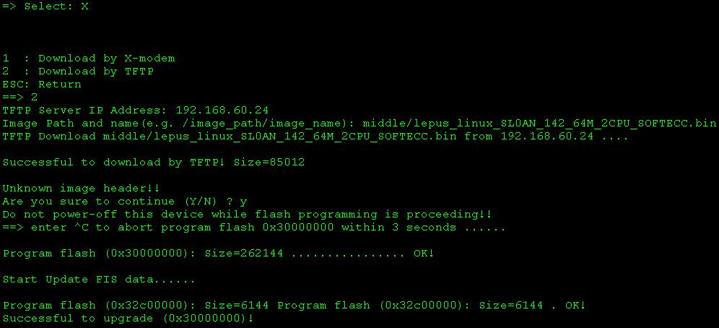
  - The download image can have an image header with checksum field or not. If the download file has no image header, the upgrade function will prompt a warning for you to confirm changing or not. The Image Head format is described in <Chapter 6. Image Header Format for Upgrade>. If the image header is correct, but the checksum is incorrect, the upgrade is also failed. Console will show “Checksum error!!!”. After successful to download file, the system will write the data into Flash chip. The programming operation is very serious, and the power should not be turned off. So a warning message is prompted for you to confirm. When the flash programming is in progress, the following messages are displayed. If failed to erase boot block, error messages are displayed to notify.” Erase flash (0x70000000): Size=262144 FAILED at [address]” If failed to programming boot block, error messages are displayed to notify. “Program flash (0x0x70000000): Size=68032 FAILED at [address]”

Upgrade Kernel
  - Same as 4.13 but with different image.

Upgrade Firmware
  - Same as 4.13 but with different image. And whole flash will be erased. Be sure the upgrade image include correct boot image.

Upgrade Application
  - Same as 4.13 but with different image.

Upgrade RAM Disk
  - Same as 4.13 but with different image.

Upgrade Kernel #1
  - Same as 4.13 but with different image.

Upgrade RAM Disk #1
  - Same as 4.13 but with different image.

Command Line Interface
  - Body
- <Command Line>
Command | Arguments | Description
arp |  | Display ARP table
config |  | Display System Configuration
dm | [-b <location>] [-l <length>] [-1|2|4] | Display (hex dump) a range of memory
exit |  | Exit
go | [location] | Execute code at a location
load | -m [tftp | xmodem | disk | flash]  -b [location] | Load code
mem |  | Display memory information
ping | host [-t] [-n count] [-l size]  [-w timeout] | Ping host by IP address
quit |  | Exit
sm | [-b <location>] [-1|2|4] [data] | Write data to specified location
Stat |  | Statistics
Tftp | host [get | put] filename [location] [size] | Get remote file by TFTP
Timer |  | timer
Ls |  | List files in boot partition
Nand | nand | show available NAND devices
Nand | erase [nobad|bad] <offset> <len> | erase from <addr> total size <len>
Nand | read <page_addr> | read a page data include oob
Nand | write <page_addr> <size> | write a page data
Nand | bad | show bad blocks
Nand | markbad <block_addr> | mark bad block at <block_addr>

arp Command

Syntax
  - arp

Description
  - Display ARP cache table

Example
- Arp Command
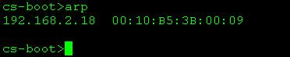

config Command

Syntax
  - config

Description
  - Display boot loader version and system configuration.

Example
- config
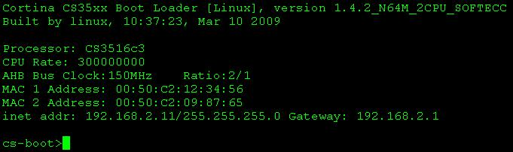

dm Command

Syntax
  - dm [-b <location>] [-l <length>] [-1|2|4]
  - -b location Specified the starting location to dump
  - -l length Total size to be displayed
  - -1 Display by BYTE format
  - -2 Display by WORD (2-byte) format
  - -3 Display by DWORD (4-byte) format
  - If no argument is specified, the location is followed by last command.

Description
  - Dump data form specified location.

Example
- dm
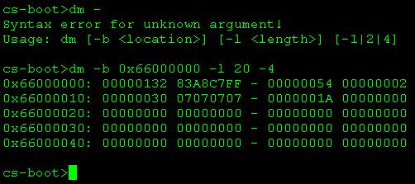

exit Command

Syntax
  - exit

Description
  - Quit from the command line interface and back to boot menu.

Example
- exit
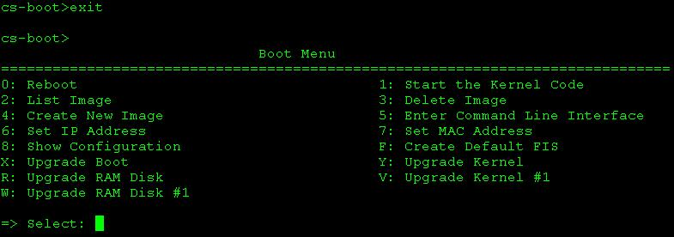

go Command

Syntax
  - Go [location]

Description
  - Execute code at a specified location. Before entering this command, you should load code by tftp or load command to download target program into RAM area.

Example
- go
cs-boot>tftp 192.168.2.140 get zImage 0x1600000
cs-boot>tftp 192.168.2.140 get rd.gz 0x800000
cs-boot>Go 0x1600000

load Command

Syntax
  - load -m [tftp | xmodem | disk | flash] -b [location]
  - -m tftp Load code by TFTP.
  - -m xmodem Load code through console by xmodem protocol
  - -m disk Load code from disk
  - -m flash Load code from flash area
  - -b location Destination location in DRAM area

Description
  - Load data to specified DRAM location.

Example
- load
cs-boot>load -m tftp -b 0x1600000
TFTP Server IP Address: 192.168.2.140
Image Path and name(e.g. /images/zImage): zImage
TFTP Download zImage from 192.168.2.140 ...............................

Successful to download by TFTP! Size=1416712

mem Command

Syntax
  - mem

Description
  - Display information of memory and buffer management.

Example
- mem
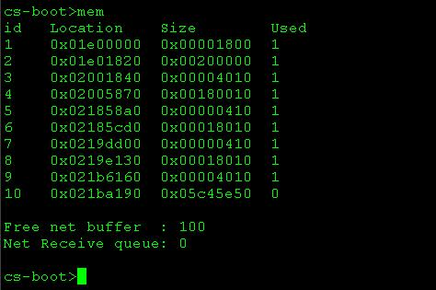

ping Command

Syntax
  - Usage: ping host [-t] [-n count] [-l size] [-w timeout]
  - host : IP address
  - -t : Ping forever until pressing <CTRL-C> key.
  - -n count : Total request number.
  - -l size : Send size (32 ~ 1472 bytes).
  - -w : Timeout Interval (milliseconds).

Description
  - Ping host with specified IP address.

Example
- ping
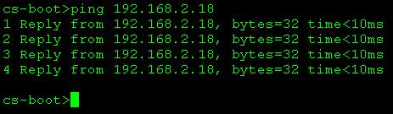

quit Command

Syntax
  - quit

Description
  - Quit from the command line interface and back to boot menu

Example
- quit
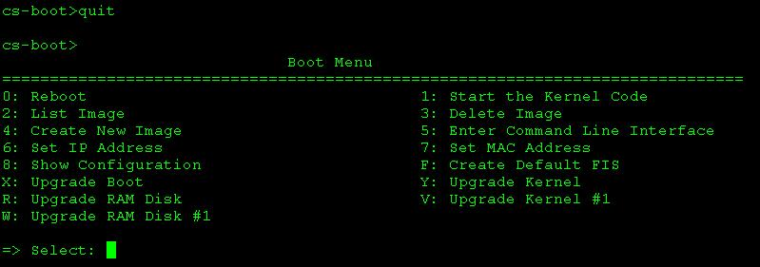

sm Command

Syntax
  - sm [-b <location>] [-1|2|4] [data]
  - -b <location> Destination Address
  - -1 Byte
  - -2 Word (2-byte)
  - -4 DWORD (4-byte)
  - data data

Description
  - Set data to a specified location by 1-byte, 2-bye, or 4-byte format.

Example
- sm
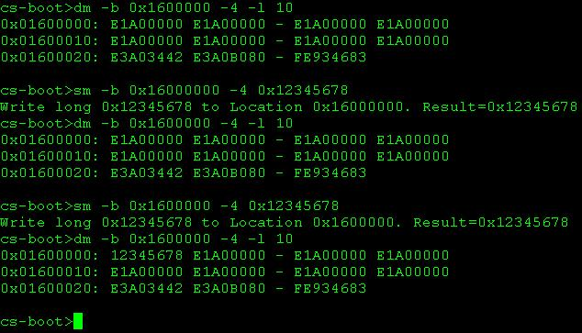

Stat Command

Syntax
  - stat

Description
  - Display the statistics for Ethernet Driver.

Example
- stat
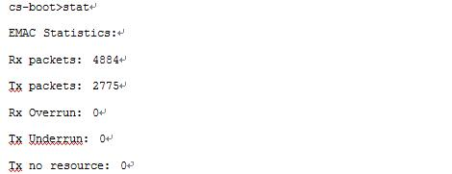
  - PS : Some version not support with message “Command not support this version!!

Tftp Command

Syntax
  - tftp host [get | put] filename [location] [size]
  - host IP address
  - filename Filename
  - location Destination for GET operation, or source for PUT
  - size total size for PUT operation

Description
  - Get data from a TFTP server or put data to a TFTP server.

Example
- tftp
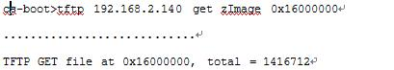

ls Command

Syntax
  - ls

Description
  - Display files in boot partition. The system will initialize the IDE if it is not initialized. (Press CTRL-C if you want to abort.)

Example
- ls
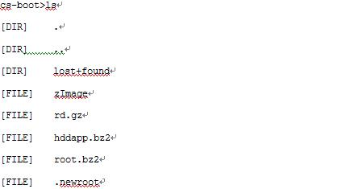

nand Command

Syntax
  - nand info - show available NAND devices
  - nand erase [nobad|bad] <offset> <len> - erase from <addr> total size <len>
  - nand read <page_addr> - read a page data include oob
  - nand write <page_addr> <size> - write a page data
  - nand bad - show bad blocks
  - nand markbad <block_addr> - mark bad block at <block_addr>

Description
  - Nand function support to show nand flash information, R/W flash, erase, read and mark bad block function.

Example
- nand error command
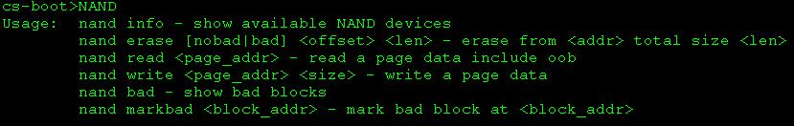

- nand info
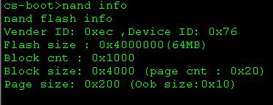
  - Show nand flash information.
- nand erase
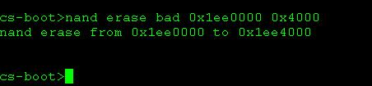
  - Erase nand flash with bad option to erase all block include bad block.
- nand write
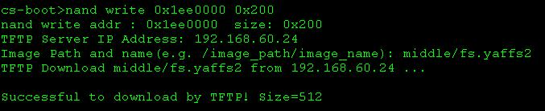
  - write data from tftp server to nand flash.
- nand read
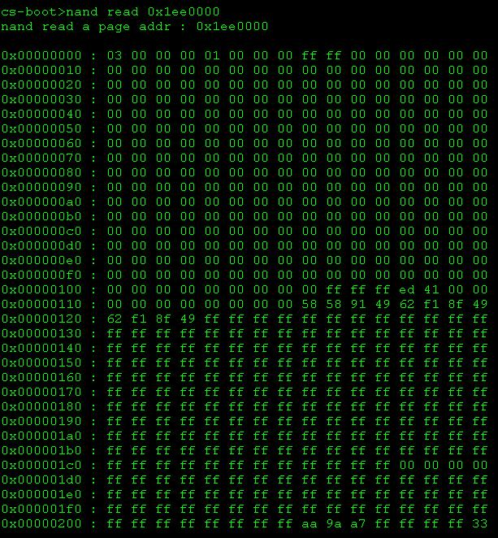
  - Read and show one page data form flash.
- nand bad
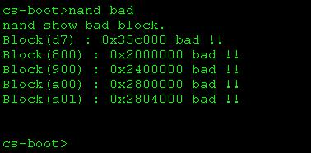
  - Scan and show bad block in flash.
- nand markbad
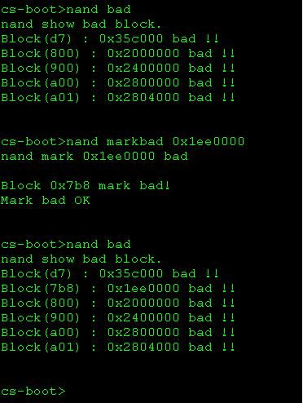
  - Mark a block bad.

Timer Command

Syntax
  - timer

Description
  - Display total ticks. (100 ticks per second)

Example
- timer
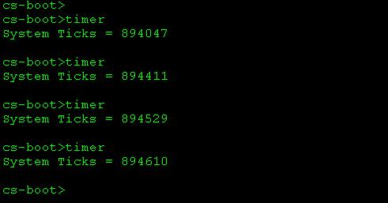

Image Header Format for Upgrade
  - Body
- <Image Header Format>
Offset | Name | Bytes | Description
0x00 | Header Name | 16 | “SL-BOOT-001”
0x10 | File Size | 4 | The original file size
0x14 | Reserved | 10 | Not used.
0x1E | Checksum | 2 | CRC-16 checksum
0x20 | Data Content | n | The raw data of the upgrade file.

VCTL Format
  - VCTL (version Control) Block is used to store board configuration and is located in Flash Chip. It’s size is 128K Bytes(Base on flash sector size).

- < VCTL Location >
Flash Size | Offset | Description
512K | 0x70000 | Booting files are in Disk.
8M | 0x7C0000 | Booting files are in Flash Chip.
16M | 0xFC0000 | Booting files are in Flash Chip.

  - < The VCTL location is dependent on Flash Size.>.
  - <Note 2 text>.

  - The VCTL block contains a VCTL header and several VCTL parameters. The VCTL parameters include Ethernet MAC Address setting, IP Address, Booting Files, and so on.

- < VCTL Block >
Offset | Description
0x00 | VCTL Header
0x08 | Parameter 1  (Include parameter header and data)
0x08 + Size of Parameter 1 | Parameter 2  (Include parameter header and data)
0x08 + Size of Parameter 1 & 2 | Parameter3  (Include parameter header and data)
 | …
0x08 + Size of Parameter 1~ n-1 | Parameter n

- <VCTL Header>
Offset | Description | Size | Data
0x00 | Magic Name of VCTL Header | 4 Bytes | “FLFM”
0x04 | Total Numbers of Parameter Entries | 4 Bytes | n

- < Parameter Header and Data >
Offset | Description | Size | Data
0x00 | Parameter Magic Name | 4 Bytes | “FLEN”
0x04 | Total bytes of this parameter | 4 Bytes | Multiple of 4 bytes  (Include parameter header and data)
0x08 | Parameter Type | 4 Bytes | 0x00~0x07: Reserved  0x08: VCT_VLAN  0x80 VCT_IP  0x81 VCT_BOOT_FILE
0x0C | Major Version | 4 Bytes | Default value is “0000”
0x10 | Minor Version | 4 Bytes | Default value is “0000”
0x14 | Data of Parameter | (n – 0x14)  Bytes | See below [Parameter Type and Data]

  - Parameter Type and Data:
  - 0x00 ~ 0x07: Reserved for internal use
  - 0x08: Ethernet VLAN & MAC Address Configuration
    - Format
MAC1:[MAC1-Address]:ID1:[VLAN1-ID]:MAP1:[PORT-MAP1]:MAC2:[MAC2-Address]:ID2: [VLAN2-ID]:MAP2:[PORT-MAP2]
      - [MAC1-Address] MAC 1 48-bit Address
      - [VLAN1-ID] VLAN ID for first VLAN
      - [PORT-MAP1] Port mapping for first VLAN
      - [MAC2-Address] MAC 3 48-bit Address
      - [VLAN2-ID] VLAN ID for secondary VLAN
      - [PORT-MAP1] Port mapping for secondary VLA
    - Example
MAC1:0x0050C200111111:ID1:1:MAP1:0x10:MAC2: 0x0050C200222222:ID2:2:MAP2: 0x0f

  - 0x80: IP Address Setting of Boot Loaded
    - Format
IP:[IP Address]ٱNetmask:[Subnet Mask]ٱGateway:[Default Gateway]
Notes: ٱ is space character. The space character is used to separate IP, Netmask, and Gateway fields.

    - Example
IP:192.168.2.140 Netmask:255.255.255.0 Gateway:192.168.2.254

  - 0x81: Booting Files Configuration of Boot Loader
    - Format
1:[Location of File 1]ٱ[Filename of File 1]ٱ2:[Location of File 2]ٱ[Filename of File 2]
Notes: ٱ is space character. The space character is used to separate each field.

    - Example
1:0x1600000 zImage 2:0x800000 rd.gz

Contact Information
Cortina Systems, Inc.
840 W. California Ave
Sunnyvale, CA 94086

408-481-2300

sales@cortina-systems.com
www.cortina-systems.com

To provide comments on this document:

documentation@cortina-systems.com

