Abstract

The purpose of this project was to design a signal analyzer and signal synthesizer using Matlab. The Objectives of the Design are as follows:

Design Objectives

Signal Analyzer

1. Read/Load the audio signal
2. Play the sound
3. Plot the magnitude and phase spectra
4. Store the values of the spectra as ASCII values

Signal Synthesizer

1. Load the magnitude and phase spectra from the file
2. Generate the equivalent audio signal
3. Play the sound
4. Plot part of the synthesized
5. Store the synthesized signal as a .wav file

Theory

1. Fourier analysis shifts a signal from the time domain to the frequency domain and vice versa. This is accomplished by disassembling any given signal into a summation of sinusoids, and then representing those sinusoids by their peak magnitude with respect to the frequency spectrum.
2. The frequency content of a signal can be found by performing a Fourier transform on the signal. The magnitude and phase angle can then be found by taking the absolute value and the angle of the data set.
3. The synthesizer reads in the sound file and samples the file at a certain rate. These samples are then sent through a Fourier transform function provided by Matlab. The magnitudes and phase angle for each frequency are determined then saved to a file. To synthesize the new sound, the file is loaded and all parameters are extracted. These parameters are then used to generate sinusoids that are then summated to form the final signal.

Results

Original Signal vs. Synthesized Signal

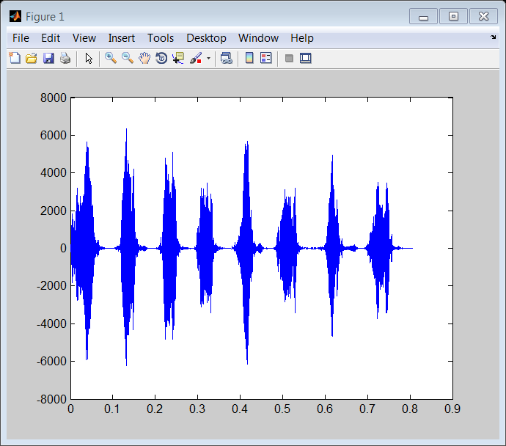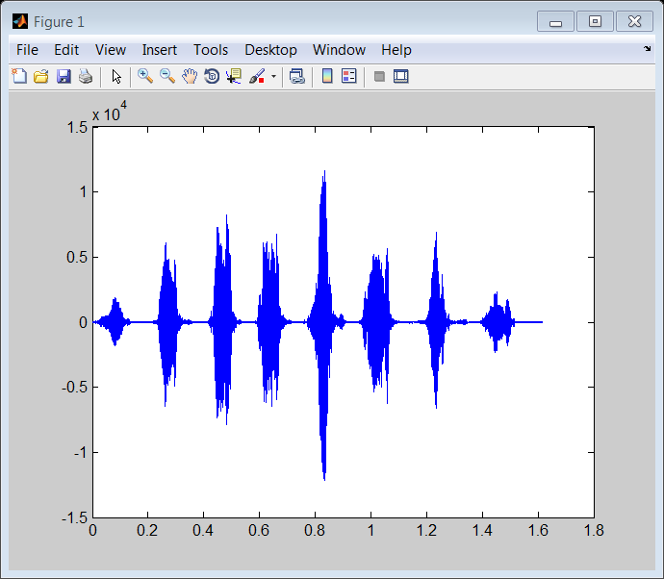

Fourier Transform of Original Signal

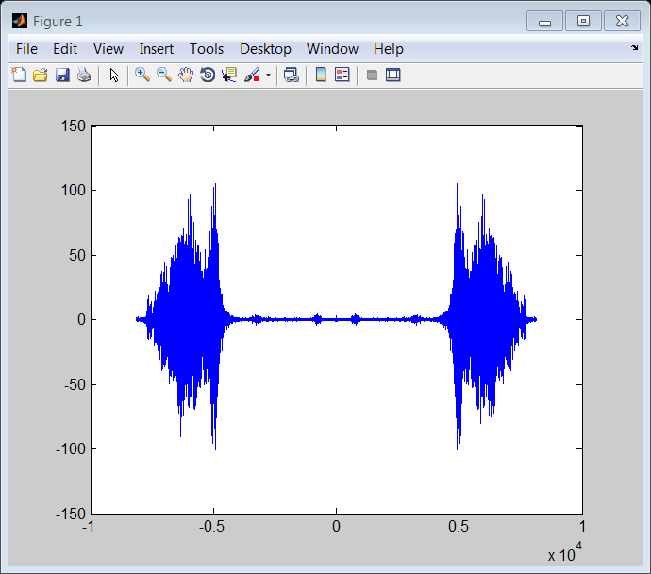

Flowchart for Signal Analyzer



Flowchart for Signal Synthesizer



Conclusion

The signal was successfully analyzed and synthesized. The synthesized signal, however, is very unexpectedly very noisy, despite the similarities in the plots. The noise must be occurring on a scale much smaller than what would be visibly noticeable. A higher sampling frequency might increase the resolution.