[1]

Texting with Frequency Encoding

Brian McRee, Jacob Sanchez, Stephanie Bello

*Abstract*—– For this project, the object was to design and implement the CODEC (Encoder/Decoder) part of a communication system using frequency encoding of the binary data for texting application. For this, the concept of convolution and correlation were used to complete this task.

*Index Terms*— Convolution, Correlation, Decoding, Encoding

# INTRODUCTION

T

he point of this project was to encode/decode a text message a person would get. In case, the minimum number of characters for the text message is 100. ‘0’ should be encoded as 20 MHz and ‘1’ should be encoded as 10 MHz sinusoid. In MATLAB, algorithms should be developed and implemented for the CODEC part (one at transmitter/one at receiver) which includes components for encoding/decoding text messages. The program should prompt the user for a text message, encode the message and store the encoded message as the frequency encoded message on the receiver screen. The main concept that will be used for this project is the convolution/correlation concept.

# Theory

## Convolution/Correlation

### Convolution

Convolution is a mathematical operation on two functions (f and g), producing a third function that is typically viewed as a modified version of one of the original functions, giving the area overlap between the two functions as a function of the amount that one of the original functions is translated. The convolution of f and g is written f*g. It is defined as the integral of the product of the two functions after one is reversed and shifted.

$$\left(f*g\right)\left(t\right)= \int_{-∞}^{∞}{f\left(T\right)g\left(t-T\right)dT}= \int_{-∞}^{∞}{f\left(t-T\right)g\left(T\right)dT}$$

### Correlation

Correlation is the degree to which two or more quantities are linearly associated.

## Method of how the program was made

## Synthesizer design

# Results analysis

The following results are from the text message “Hello! What’s up! How are you!”

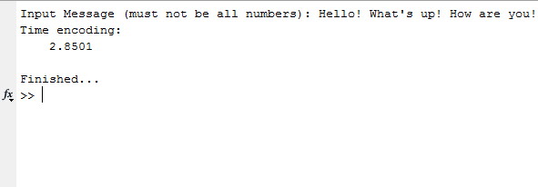

**Figure 1: Time of Encoding Message**

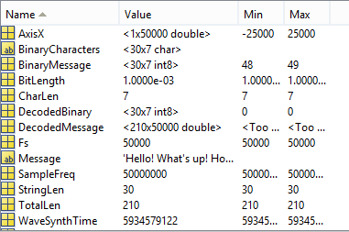

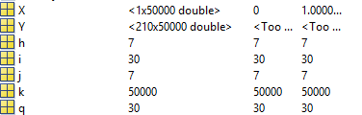

**Figure 2: Data results for the Encoding Process**

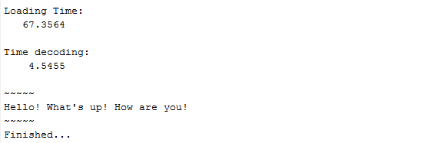

**Figure 3: Loading Time and Time of Decoding Message**

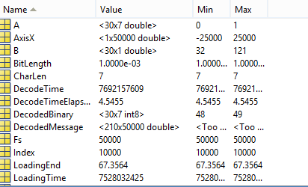

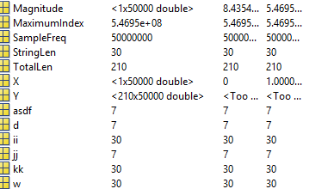

**Figure 4: Data results for Decoding Process**

# summary/conclusion

There was no need to use convolution or correlation theory during the implementation of the solution. Also, saving the data as ASCII values to a file is an inefficient method of transmitting, due to the large amount of static memory that is used. For example, saving 100 characters at 50000 samples resulted in a file size of 500MB. Also, lack of any noise present makes this program inapplicable to nearly all communications systems.

1.