1.Selected Tool by Loadrunner-

* Used Web_Custom_request function to Script in loadrunner(Vugen).
* Added Web_reg_Find function for Text check.
* Added 1 Vuser with 5 min in Controller Used Basic by Test Schedule by scenario.
* Parameter Setting Unique Each iteration.(To Test all parameter Values).
* Added 5 Vuser with 5 min in Controller Used Basic by Test Schedule By scenario.

1User5Mins Pacing 1 Sec:

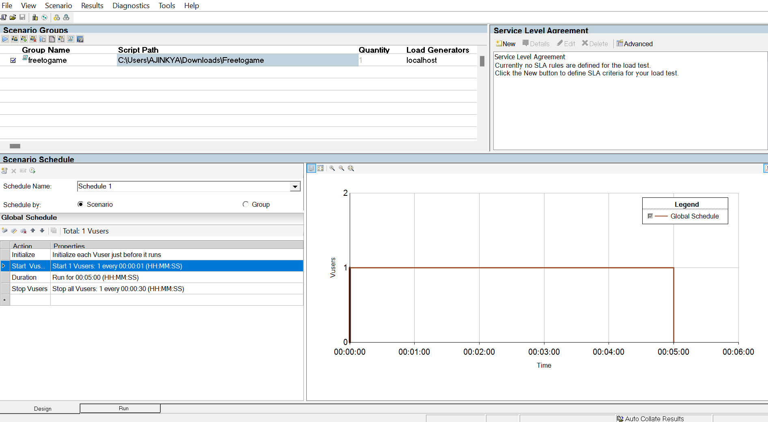

5User5Mins with Ramp up Each User 5 Sec:

