Result:

1User1Sec Pacing:

* Showing Consistent 1TPS.
* Avg Response time is slightly High at start of test and then consistent between 140ms-160ms.
* 90 Percentile 170ms and Std 0.052 Deviation
* 0 Errors observed.
* Consistent Download Over Time.

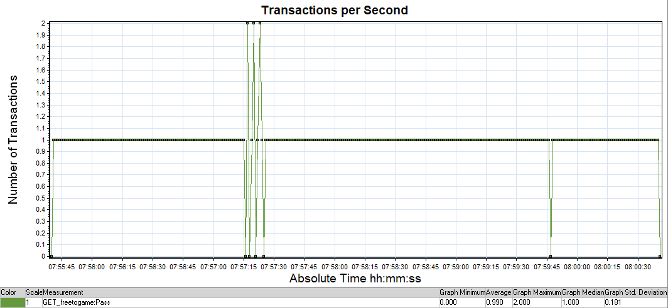

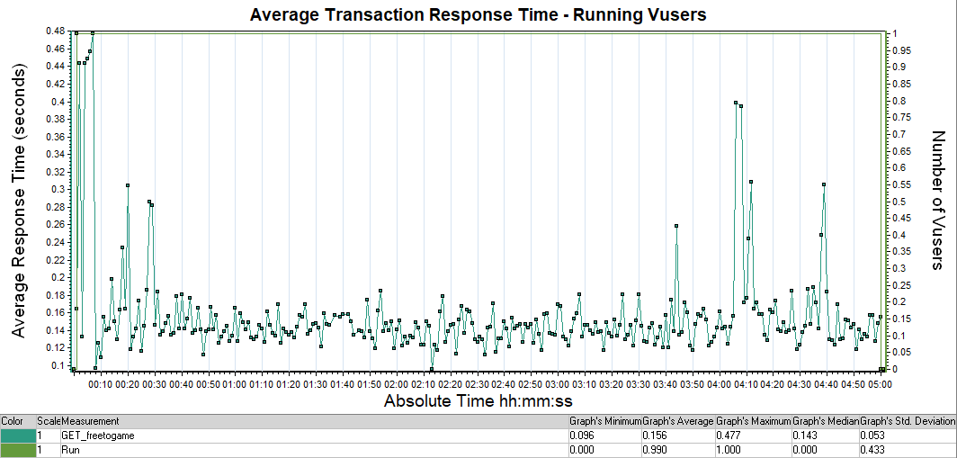

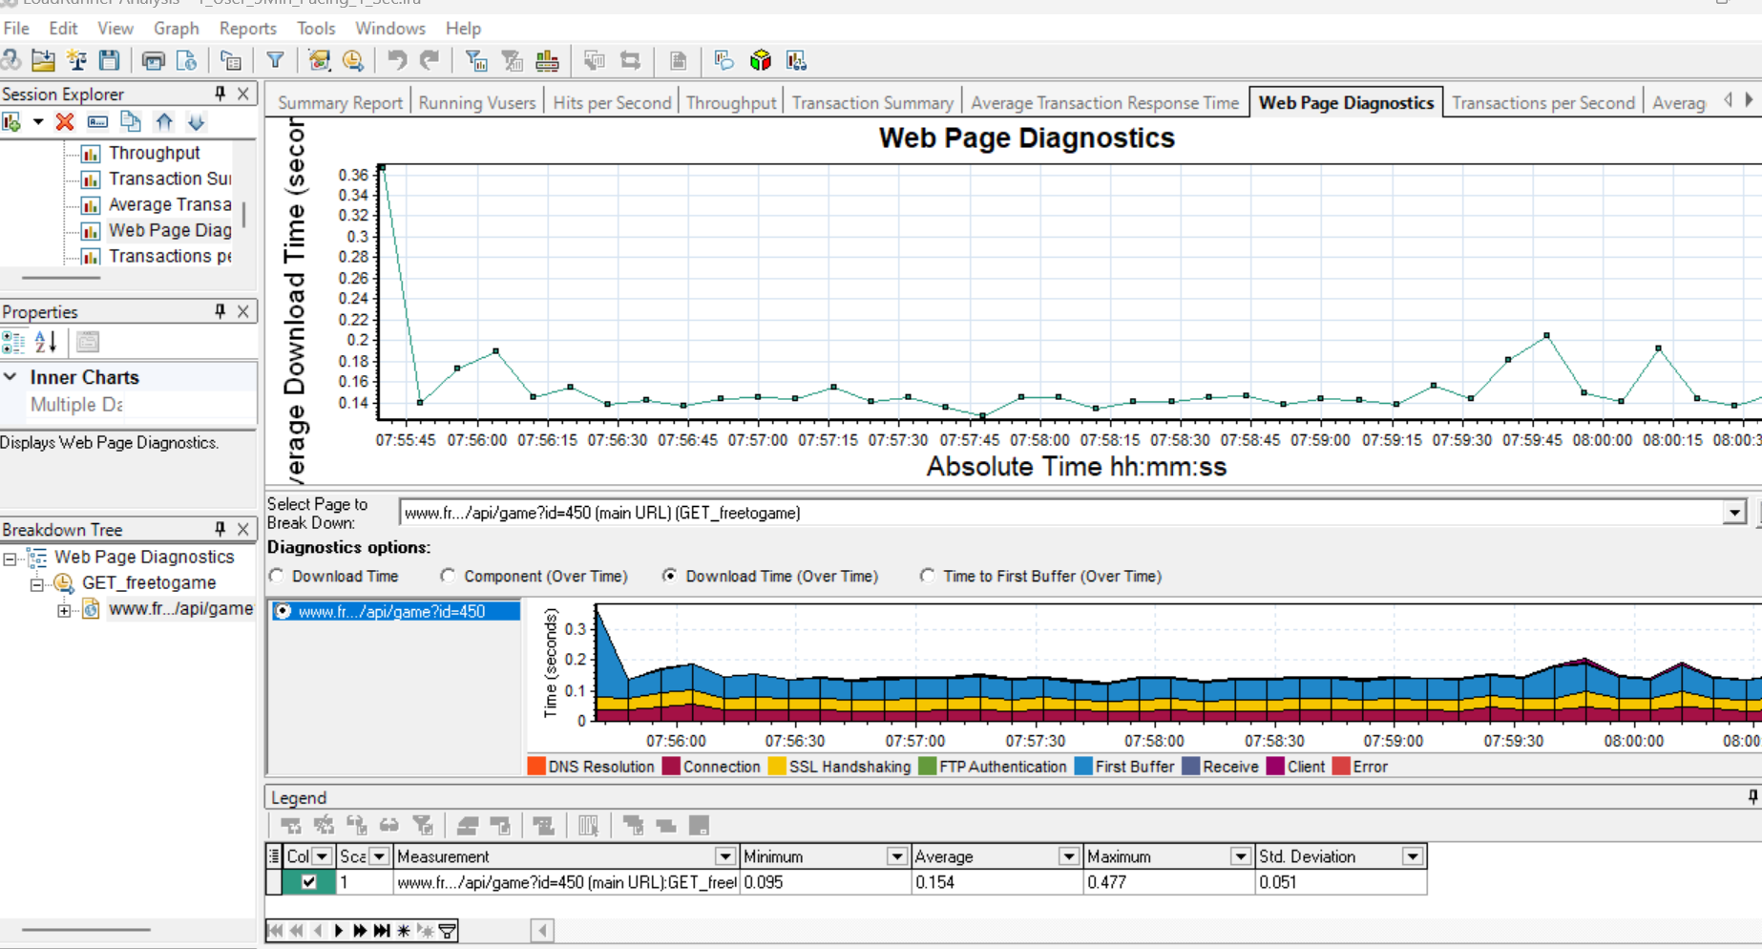

5User1Sec Pacing:

* Reached Upto 5TPS for 50Sec only after started getting Timeouts Errors .
* Avg Response time is consistent between 140ms-160ms for 50 sec after that due to Timeout avg response time went up to 20 sec.
* 90 Percentile 170ms and Std 0.052 Deviation
* 87 Errors observed All of them are Timeout errors.
  + Action.c(28): Error -27792: Failed to connect to server "www.freetogame.com:443": [10060] Connection timed out
* Recommendations:
  + Need to Check Connection pool.
  + Need to analyze Server CPU Utilization,Database connection count,Memory sizes and memory utlizations.

