Міністерство освіти і науки України

Національний університет «Львівська політехніка»

Кафедра ЕОМ



Звіт

до лабораторної роботи № 3

з дисципліни «Моделювання комп’ютерних систем»

на тему:

«Поведінковий опис цифрового автомата Перевірка роботи автомата за допомогою стенда Elbert V2 – Spartan 3A FPGA»

**Варіант №2**

Виконав:

ст. гр. КІ-201

Бовтач О.М

Прийняв:  
Козак Н. Б.

Львів 2024

**Мета роботи**: На базі стенда реалізувати цифровий автомат для обчислення значення виразів.

**Виконання роботи:**

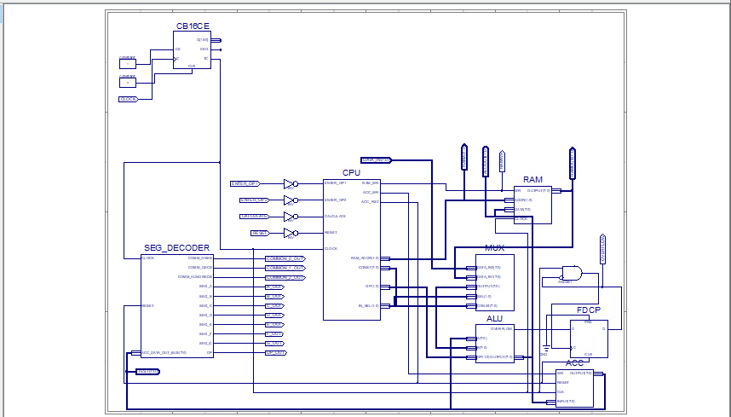

*Рис. 1 – Top Level*

|  |
| --- |
| Файл ACC.vhd   1. --------------------------------------------------------------------------------- 2. -- Company: 3. -- Engineer: 4. -- 5. -- Create Date: 17:16:45 04/29/2024 6. -- Design Name: 7. -- Module Name: ACC - Behavioral 8. -- Project Name: 9. -- Target Devices: 10. -- Tool versions: 11. -- Description: 12. -- 13. -- Dependencies: 14. -- 15. -- Revision: 16. -- Revision 0.01 - File Created 17. -- Additional Comments: 18. -- 19. ---------------------------------------------------------------------------------- 20. library IEEE; 21. use IEEE.STD_LOGIC_1164.ALL; 22. -- Uncomment the following library declaration if using 23. -- arithmetic functions with Signed or Unsigned values 24. --use IEEE.NUMERIC_STD.ALL; 25. -- Uncomment the following library declaration if instantiating 26. -- any Xilinx primitives in this code. 27. --library UNISIM; 28. --use UNISIM.VComponents.all; 29. entity ACC is 30. Port ( WR : in STD_LOGIC; 31. RESET : in STD_LOGIC; 32. CLK : in STD_LOGIC; 33. INPUT : in STD_LOGIC_VECTOR (7 downto 0); 34. OUTPUT : out STD_LOGIC_VECTOR (7 downto 0)); 35. end ACC; 36. architecture ACC_arch of ACC is 37. signal DATA : STD_LOGIC_VECTOR (7 downto 0); 38. begin 39. process (CLK) 40. begin 41. if rising_edge(CLK) then 42. if RESET = '1' then 43. DATA <= (others => '0'); 44. elsif WR = '1' then 45. DATA <= INPUT; 46. end if; 47. end if; 48. end process; 50. OUTPUT <= DATA; 51. end ACC_arch; |

|  |
| --- |
| Файл ALU.vhd   1. - Company: 2. -- Engineer: 3. -- 4. -- Create Date: 11:09:43 05/07/2024 5. -- Design Name: 6. -- Module Name: C:/Users/User/Documents/Lab_3_v6/ACCTest.vhd 7. -- Project Name: Lab_3_Example 8. -- Target Device: 9. -- Tool versions: 10. -- Description: 11. -- 12. -- VHDL Test Bench Created by ISE for module: ACC 13. -- 14. -- Dependencies: 15. -- 16. -- Revision: 17. -- Revision 0.01 - File Created 18. -- Additional Comments: 19. -- 20. -- Notes: 21. -- This testbench has been automatically generated using types std_logic and 22. -- std_logic_vector for the ports of the unit under test. Xilinx recommends 23. -- that these types always be used for the top-level I/O of a design in order 24. -- to guarantee that the testbench will bind correctly to the post-implementation 25. -- simulation model. 26. -------------------------------------------------------------------------------- 27. LIBRARY ieee; 28. USE ieee.std_logic_1164.ALL; 30. -- Uncomment the following library declaration if using 31. -- arithmetic functions with Signed or Unsigned values 32. --USE ieee.numeric_std.ALL; 34. ENTITY ACCTest IS 35. END ACCTest; 37. ARCHITECTURE behavior OF ACCTest IS 39. -- Component Declaration for the Unit Under Test (UUT) 41. COMPONENT ACC 42. PORT( 43. WR : IN std_logic; 44. RESET : IN std_logic; 45. CLK : IN std_logic; 46. INPUT : IN std_logic_vector(7 downto 0); 47. OUTPUT : OUT std_logic_vector(7 downto 0) 48. ); 49. END COMPONENT; 51. --Inputs 52. signal WR : std_logic := '0'; 53. signal RESET : std_logic := '0'; 54. signal CLK : std_logic := '0'; 55. signal INPUT : std_logic_vector(7 downto 0) := (others => '0'); 56. --Outputs 57. signal OUTPUT : std_logic_vector(7 downto 0); 58. -- Clock period definitions 59. constant CLKP: time := 2 ps; 61. BEGIN 63. -- Instantiate the Unit Under Test (UUT) 64. uut: ACC PORT MAP ( 65. WR => WR, 66. RESET => RESET, 67. CLK => CLK, 68. INPUT => INPUT, 69. OUTPUT => OUTPUT 70. ); 71. -- Clock process definitions 72. CLK_process :process 73. begin 74. CLK <= '0'; 75. wait for CLKP/2; 76. CLK <= '1'; 77. wait for CLKP/2; 78. end process; 80. -- Stimulus process 81. stim_proc: process 82. begin 83. RESET <= '1'; 84. wait for 4 * CLKP; 85. RESET <= '0'; 86. WR <= '0'; 87. INPUT <= "00001111"; 88. wait for CLKP; 89. assert OUTPUT = "00000000" severity failure; 90. WR <= '1'; 91. wait for CLKP; 92. assert OUTPUT = "00001111" severity failure; 93. INPUT <= "11110000"; 94. wait for CLKP; 95. assert OUTPUT = "11110000" severity failure; 97. wait; 98. end process; 99. END; |

|  |
| --- |
| Файл CPU.vhd   1. library IEEE; 2. use IEEE.STD_LOGIC_1164.ALL; 3. entity CPU is 4. port( ENTER_OP1 : IN STD_LOGIC; 5. ENTER_OP2 : IN STD_LOGIC; 6. CALCULATE : IN STD_LOGIC; 7. RESET : IN STD_LOGIC; 8. CLOCK : IN STD_LOGIC; 9. RAM_WR : OUT STD_LOGIC; 10. RAM_ADDR : OUT STD_LOGIC_VECTOR(1 DOWNTO 0); 11. CONST : OUT STD_LOGIC_VECTOR(7 DOWNTO 0); 12. ACC_WR : OUT STD_LOGIC; 13. ACC_RST : OUT STD_LOGIC; 14. IN_SEL : OUT STD_LOGIC_VECTOR(1 downto 0); 15. OP : OUT STD_LOGIC_VECTOR(1 DOWNTO 0)); 16. end CPU; 18. architecture CPU_arch of CPU is 19. type STATE_TYPE is (RST, IDLE, LOAD_OP1, LOAD_OP2, RUN_CALC0, RUN_CALC1, RUN_CALC2, RUN_CALC3, RUN_CALC4, FINISH); 20. signal CUR_STATE : STATE_TYPE; 21. signal NEXT_STATE : STATE_TYPE; 22. begin 23. SYNC_PROC: process (CLOCK) 24. begin 25. if (rising_edge(CLOCK)) then 26. if (RESET = '1') then 27. CUR_STATE <= RST; 28. else 29. CUR_STATE <= NEXT_STATE; 30. end if; 31. end if; 32. end process;  35. NEXT_STATE_DECODE: process (CLOCK, ENTER_OP1, ENTER_OP2, CALCULATE) 36. begin 37. NEXT_STATE <= CUR_STATE; 39. case(CUR_STATE) is 40. when RST => 41. NEXT_STATE <= IDLE; 42. when IDLE => 43. if (ENTER_OP1 = '1') then 44. NEXT_STATE <= LOAD_OP1; 45. elsif (ENTER_OP2 = '1') then 46. NEXT_STATE <= LOAD_OP2; 47. elsif (CALCULATE = '1') then 48. NEXT_STATE <= RUN_CALC0; 49. else 50. NEXT_STATE <= IDLE; 51. end if; 52. when LOAD_OP1 => 53. NEXT_STATE <= IDLE; 54. when LOAD_OP2 => 55. NEXT_STATE <= IDLE; 56. when RUN_CALC0 => 57. NEXT_STATE <= RUN_CALC1; 58. when RUN_CALC1 => 59. NEXT_STATE <= RUN_CALC2; 60. when RUN_CALC2 => 61. NEXT_STATE <= RUN_CALC3; 62. when RUN_CALC3 => 63. NEXT_STATE <= RUN_CALC4; 64. when RUN_CALC4 => 65. NEXT_STATE <= FINISH; 66. when FINISH => 67. NEXT_STATE <= FINISH; 68. when others => 69. NEXT_STATE <= IDLE; 70. end case; 71. end process; 72. OUTPUT_DECODE: process (CUR_STATE) 73. begin 74. case (CUR_STATE) is 75. when RST => 76. RAM_WR <= '0'; 77. RAM_ADDR <= "00"; 78. CONST <= "00000000"; 79. ACC_WR <= '0'; 80. ACC_RST <= '1'; 81. IN_SEL <= "00"; 82. OP <= "00"; 83. when LOAD_OP1 => 84. RAM_WR <= '1'; 85. RAM_ADDR <= "00"; 86. CONST <= "00000000"; 87. ACC_WR <= '0'; 88. ACC_RST <= '1'; 89. IN_SEL <= "00"; 90. OP <= "00"; 91. when LOAD_OP2 => 92. RAM_WR <= '1'; 93. RAM_ADDR <= "01"; 94. CONST <= "00000000"; 95. ACC_WR <= '0'; 96. ACC_RST <= '1'; 97. IN_SEL <= "00"; 98. OP <= "00"; 99. when RUN_CALC0 => 100. RAM_WR <= '0'; 101. RAM_ADDR <= "00"; 102. CONST <= "00000000"; 103. ACC_WR <= '1'; 104. ACC_RST <= '0'; 105. IN_SEL <= "01"; 106. OP <= "00"; 107. when RUN_CALC1 => 108. RAM_WR <= '0'; 109. RAM_ADDR <= "01"; 110. CONST <= "00000000"; 111. ACC_WR <= '1'; 112. ACC_RST <= '0'; 113. IN_SEL <= "01"; 114. OP <= "11"; 115. when RUN_CALC2 => 116. RAM_WR <= '0'; 117. RAM_ADDR <= "01"; 118. CONST <= "00000000"; 119. ACC_WR <= '1'; 120. ACC_RST <= '0'; 121. IN_SEL <= "01"; 122. OP <= "01"; 123. when RUN_CALC3 => 124. RAM_WR <= '0'; 125. RAM_ADDR <= "01"; 126. CONST <= "00001010"; 127. ACC_WR <= '1'; 128. ACC_RST <= '0'; 129. IN_SEL <= "10"; 130. OP <= "01"; 131. when RUN_CALC4 => 132. RAM_WR <= '0'; 133. RAM_ADDR <= "00"; 134. CONST <= "00000011"; 135. ACC_WR <= '1'; 136. ACC_RST <= '0'; 137. IN_SEL <= "10"; 138. OP <= "10"; 139. when IDLE => 140. RAM_WR <= '0'; 141. RAM_ADDR <= "00"; 142. CONST <= "00000000"; 143. ACC_WR <= '0'; 144. ACC_RST <= '0'; 145. IN_SEL <= "00"; 146. OP <= "00"; 147. when others => 148. RAM_WR <= '0'; 149. RAM_ADDR <= "00"; 150. CONST <= "00000000"; 151. ACC_WR <= '0'; 152. ACC_RST <= '0'; 153. IN_SEL <= "00"; 154. OP <= "00"; 155. end case; 156. end process; 157. end CPU_arch; |

|  |
| --- |
| Файл MUX.vhd   1. library IEEE; 2. use IEEE.STD_LOGIC_1164.ALL; 3. entity MUX is 4. PORT( 5. SEL: in STD_LOGIC_VECTOR(1 downto 0); 6. CONST: in STD_LOGIC_VECTOR(7 downto 0); 7. --CONST1: in STD_LOGIC_VECTOR() 8. DATA_IN0: in STD_LOGIC_VECTOR(7 downto 0); 9. DATA_IN1: in STD_LOGIC_VECTOR(7 downto 0); 10. OUTPUT: out STD_LOGIC_VECTOR(7 downto 0) 11. ); 12. end MUX; 13. architecture Behavioral of MUX is 14. begin 15. process (SEL, DATA_IN0, DATA_IN1, CONST) 16. begin 17. if (SEL = "00") then 18. OUTPUT <= DATA_IN0; 19. elsif (SEL = "01") then 20. OUTPUT <= DATA_IN1; 21. else 22. OUTPUT <= CONST; 23. end if; 24. end process; 25. end Behavioral; |

|  |
| --- |
| Файл RAM.vhd   1. ---------------------------------------------------------------------------------- 2. -- Company: 3. -- Engineer: 4. -- 5. -- Create Date: 02:03:24 04/21/2024 6. -- Design Name: 7. -- Module Name: RAM - RAM_arch 8. -- Project Name: 9. -- Target Devices: 10. -- Tool versions: 11. -- Description: 12. -- 13. -- Dependencies: 14. -- 15. -- Revision: 16. -- Revision 0.01 - File Created 17. -- Additional Comments: 18. -- 19. ---------------------------------------------------------------------------------- 20. library IEEE; 21. use IEEE.STD_LOGIC_1164.ALL; 22. use IEEE.NUMERIC_STD.ALL; 23. use IEEE.STD_LOGIC_UNSIGNED.ALL; 24. entity RAM is 25. port( 26. WR : IN STD_LOGIC; 27. ADDR : IN STD_LOGIC_VECTOR(1 DOWNTO 0); 28. DATA : IN STD_LOGIC_VECTOR(7 DOWNTO 0); 29. CLOCK: IN STD_LOGIC; 30. OUTPUT : OUT STD_LOGIC_VECTOR(7 DOWNTO 0) 31. ); 32. end RAM; 33. architecture RAM_arch of RAM is 34. type ram_type is array (3 downto 0) of STD_LOGIC_VECTOR(7 downto 0); 35. signal UNIT : ram_type; 36. begin 37. process(ADDR, CLOCK, UNIT) 38. begin 39. if(rising_edge(CLOCK)) then 40. if (WR = '1') then 41. UNIT(conv_integer(ADDR)) <= DATA; 42. end if; 43. end if; 44. OUTPUT <= UNIT(conv_integer(ADDR)); 45. end process; 46. end RAM_arch; |

|  |
| --- |
| Файл SEG_DECODER.vhd   1. ---------------------------------------------------------------------------------- 2. -- Company: 3. -- Engineer: 4. -- 5. -- Create Date: 02:34:19 04/21/2024 6. -- Design Name: 7. -- Module Name: BIN_TO_BCD - Behavioral 8. -- Project Name: 9. -- Target Devices: 10. -- Tool versions: 11. -- Description: 12. -- 13. -- Dependencies: 14. -- 15. -- Revision: 16. -- Revision 0.01 - File Created 17. -- Additional Comments: 18. -- 19. ---------------------------------------------------------------------------------- 20. library IEEE; 21. use IEEE.STD_LOGIC_1164.ALL; 22. use IEEE.STD_LOGIC_ARITH.ALL; 23. use IEEE.STD_LOGIC_UNSIGNED.ALL; 24. entity SEG_DECODER is 25. port( CLOCK : IN STD_LOGIC; 26. RESET : IN STD_LOGIC; 27. ACC_DATA_OUT_BUS : IN STD_LOGIC_VECTOR(7 DOWNTO 0); 28. COMM_ONES : OUT STD_LOGIC; 29. COMM_DECS : OUT STD_LOGIC; 30. COMM_HUNDREDS : OUT STD_LOGIC; 31. SEG_A : OUT STD_LOGIC; 32. SEG_B : OUT STD_LOGIC; 33. SEG_C : OUT STD_LOGIC; 34. SEG_D : OUT STD_LOGIC; 35. SEG_E : OUT STD_LOGIC; 36. SEG_F : OUT STD_LOGIC; 37. SEG_G : OUT STD_LOGIC; 38. DP : OUT STD_LOGIC); 39. end SEG_DECODER; 40. architecture Behavioral of SEG_DECODER is 41. signal ONES_BUS : STD_LOGIC_VECTOR(3 downto 0) := "0000"; 42. signal DECS_BUS : STD_LOGIC_VECTOR(3 downto 0) := "0001"; 43. signal HONDREDS_BUS : STD_LOGIC_VECTOR(3 downto 0) := "0000"; 44. begin 45. BIN_TO_BCD : process (ACC_DATA_OUT_BUS) 46. variable hex_src : STD_LOGIC_VECTOR(7 downto 0) ; 47. variable bcd : STD_LOGIC_VECTOR(11 downto 0) ; 48. begin 49. bcd := (others => '0') ; 50. hex_src := ACC_DATA_OUT_BUS; 51. for i in hex_src'range loop 52. if bcd(3 downto 0) > "0100" then 53. bcd(3 downto 0) := bcd(3 downto 0) + "0011" ; 54. end if ; 55. if bcd(7 downto 4) > "0100" then 56. bcd(7 downto 4) := bcd(7 downto 4) + "0011" ; 57. end if ; 58. if bcd(11 downto 8) > "0100" then 59. bcd(11 downto 8) := bcd(11 downto 8) + "0011" ; 60. end if ; 62. bcd := bcd(10 downto 0) & hex_src(hex_src'left) ; -- shift bcd + 1 new entry 63. hex_src := hex_src(hex_src'left - 1 downto hex_src'right) & '0' ; -- shift src + pad with 0 64. end loop ; 65. HONDREDS_BUS <= bcd (11 downto 8); 66. DECS_BUS <= bcd (7 downto 4); 67. ONES_BUS <= bcd (3 downto 0); 69. end process BIN_TO_BCD; 71. INDICATE : process(CLOCK) 72. type DIGIT_TYPE is (ONES, DECS, HUNDREDS); 74. variable CUR_DIGIT : DIGIT_TYPE := ONES; 75. variable DIGIT_VAL : STD_LOGIC_VECTOR(3 downto 0) := "0000"; 76. variable DIGIT_CTRL : STD_LOGIC_VECTOR(6 downto 0) := "0000000"; 77. variable COMMONS_CTRL : STD_LOGIC_VECTOR(2 downto 0) := "000"; 79. begin 80. if (rising_edge(CLOCK)) then 81. if(RESET = '0') then 82. case CUR_DIGIT is 83. when ONES => 84. DIGIT_VAL := ONES_BUS; 85. CUR_DIGIT := DECS; 86. COMMONS_CTRL := "001"; 87. when DECS => 88. DIGIT_VAL := DECS_BUS; 89. CUR_DIGIT := HUNDREDS; 90. COMMONS_CTRL := "010"; 91. when HUNDREDS => 92. DIGIT_VAL := HONDREDS_BUS; 93. CUR_DIGIT := ONES; 94. COMMONS_CTRL := "100"; 95. when others => 96. DIGIT_VAL := ONES_BUS; 97. CUR_DIGIT := ONES; 98. COMMONS_CTRL := "000"; 99. end case; 101. case DIGIT_VAL is --abcdefg 102. when "0000" => DIGIT_CTRL := "1111110"; 103. when "0001" => DIGIT_CTRL := "0110000"; 104. when "0010" => DIGIT_CTRL := "1101101"; 105. when "0011" => DIGIT_CTRL := "1111001"; 106. when "0100" => DIGIT_CTRL := "0110011"; 107. when "0101" => DIGIT_CTRL := "1011011"; 108. when "0110" => DIGIT_CTRL := "1011111"; 109. when "0111" => DIGIT_CTRL := "1110000"; 110. when "1000" => DIGIT_CTRL := "1111111"; 111. when "1001" => DIGIT_CTRL := "1111011"; 112. when others => DIGIT_CTRL := "0000000"; 113. end case; 114. else 115. DIGIT_VAL := ONES_BUS; 116. CUR_DIGIT := ONES; 117. COMMONS_CTRL := "000"; 118. end if; 120. COMM_ONES <= not COMMONS_CTRL(0); 121. COMM_DECS <= not COMMONS_CTRL(1); 122. COMM_HUNDREDS <= not COMMONS_CTRL(2); 124. SEG_A <= not DIGIT_CTRL(6); 125. SEG_B <= not DIGIT_CTRL(5); 126. SEG_C <= not DIGIT_CTRL(4); 127. SEG_D <= not DIGIT_CTRL(3); 128. SEG_E <= not DIGIT_CTRL(2); 129. SEG_F <= not DIGIT_CTRL(1); 130. SEG_G <= not DIGIT_CTRL(0); 131. DP <= '1'; 133. end if; 134. end process INDICATE; 135. end Behavioral; |

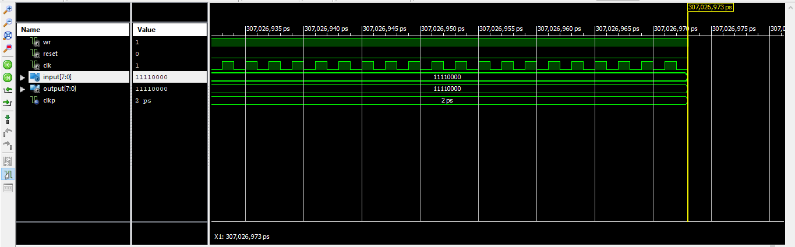

*Рис. 2 – Часова діаграма ACC*

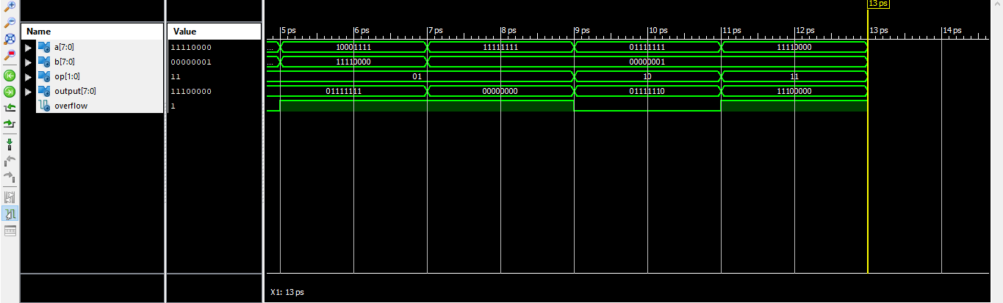

*Рис. 3 – Часова діаграма ALU*

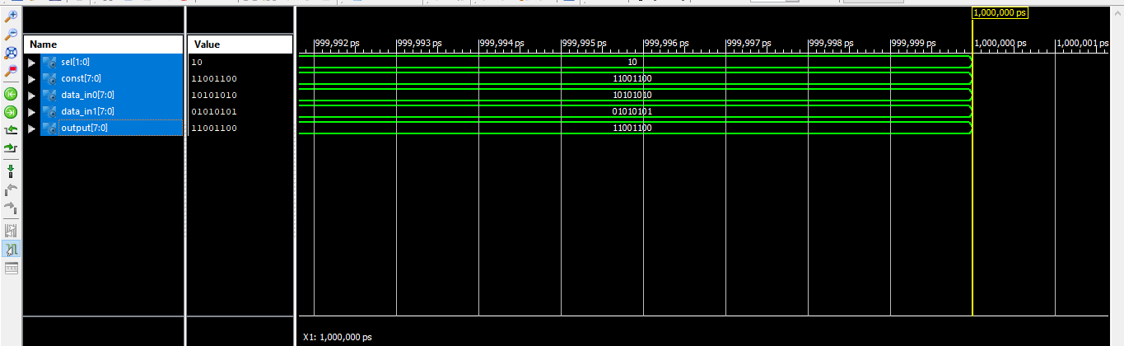

*Рис. 4 – Часова діаграма MUX*

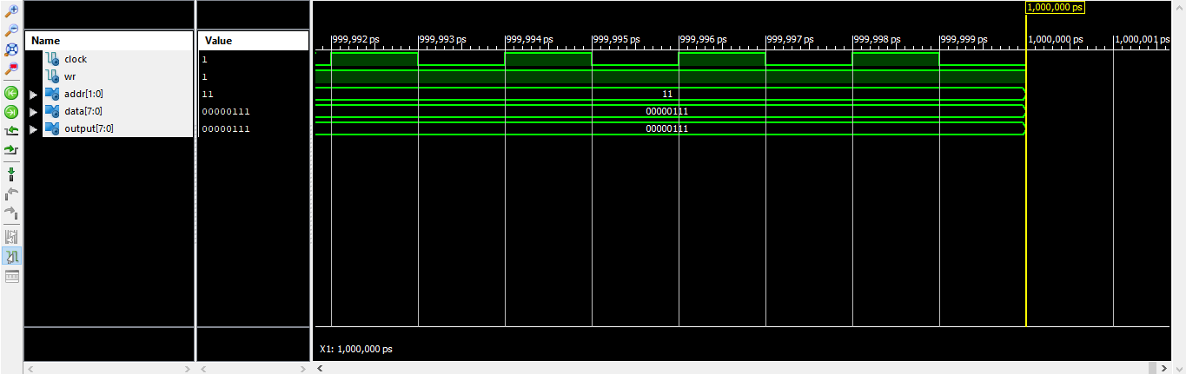

*Рис. 5 – Часова діаграма RAM*

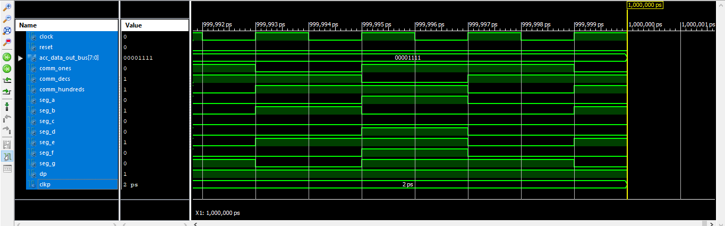

*Рис 6. – Часова діграма SEG_DECODER*

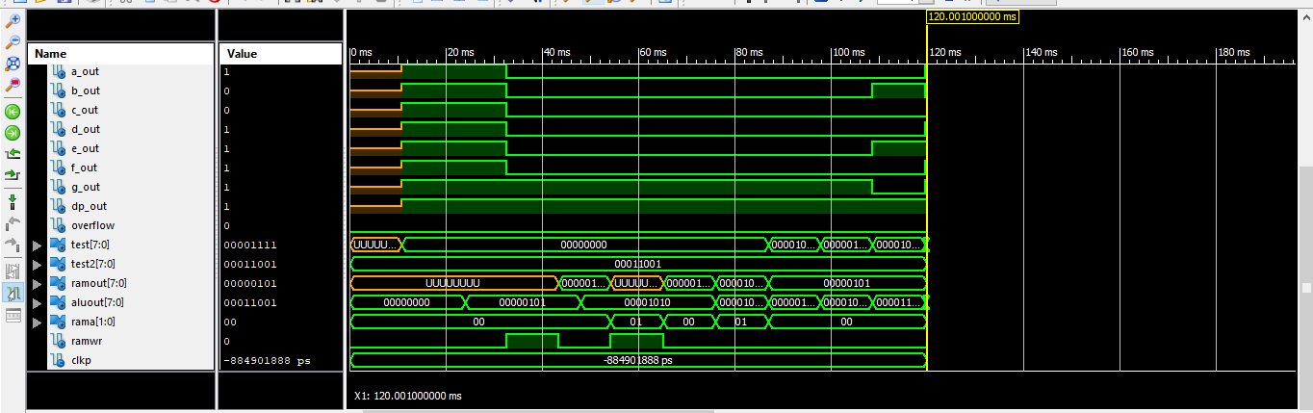

*Рис 7. – Часова діграма TopLevel*

|  |
| --- |
| *Файл TopLevelTest.vhd*   1. -- Vhdl test bench created from schematic C:\Users\User\Documents\Lab_3\TopLevel.sch - Mon Apr 29 19:00:56 2024 2. -- 3. -- Notes: 4. -- 1) This testbench template has been automatically generated using types 5. -- std_logic and std_logic_vector for the ports of the unit under test. 6. -- Xilinx recommends that these types always be used for the top-level 7. -- I/O of a design in order to guarantee that the testbench will bind 8. -- correctly to the timing (post-route) simulation model. 9. -- 2) To use this template as your testbench, change the filename to any 10. -- name of your choice with the extension .vhd, and use the "Source->Add" 11. -- menu in Project Navigator to import the testbench. Then 12. -- edit the user defined section below, adding code to generate the 13. -- stimulus for your design. 14. -- 15. LIBRARY ieee; 16. USE ieee.std_logic_1164.ALL; 17. USE ieee.numeric_std.ALL; 18. LIBRARY UNISIM; 19. USE UNISIM.Vcomponents.ALL; 20. ENTITY TopLevel_TopLevel_sch_tb IS 21. END TopLevel_TopLevel_sch_tb; 22. ARCHITECTURE behavioral OF TopLevel_TopLevel_sch_tb IS 23. COMPONENT TopLevel 24. PORT( CLOCK : IN STD_LOGIC; 25. RESET : IN STD_LOGIC; 26. ENTER_OP1 : IN STD_LOGIC; 27. ENTER_OP2 : IN STD_LOGIC; 28. CALCULATE : IN STD_LOGIC; 29. DATA_IN : IN STD_LOGIC_VECTOR (7 DOWNTO 0); 30. COMMON_0_OUT : OUT STD_LOGIC; 31. COMMON_1_OUT : OUT STD_LOGIC; 32. COMMON_2_OUT : OUT STD_LOGIC; 33. TEST: OUT STD_LOGIC_VECTOR(7 downto 0); 34. A_OUT : OUT STD_LOGIC; 35. B_OUT : OUT STD_LOGIC; 36. C_OUT : OUT STD_LOGIC; 37. D_OUT : OUT STD_LOGIC; 38. E_OUT : OUT STD_LOGIC; 39. F_OUT : OUT STD_LOGIC; 40. G_OUT : OUT STD_LOGIC; 41. DP_OUT : OUT STD_LOGIC; 42. RAMOUT: OUT STD_LOGIC_VECTOR(7 downto 0); 43. ALUOUT: OUT STD_LOGIC_VECTOR(7 downto 0); 44. RAMA: OUT STD_LOGIC_VECTOR(1 downto 0); 45. RAMWR: OUT STD_LOGIC; 46. OVERFLOW : OUT STD_LOGIC); 47. END COMPONENT; 48. SIGNAL CLOCK : STD_LOGIC := '0'; 49. SIGNAL RESET : STD_LOGIC; 50. SIGNAL ENTER_OP1 : STD_LOGIC; 51. SIGNAL ENTER_OP2 : STD_LOGIC; 52. SIGNAL CALCULATE : STD_LOGIC; 53. SIGNAL DATA_IN : STD_LOGIC_VECTOR (7 DOWNTO 0); 54. SIGNAL COMMON_0_OUT : STD_LOGIC; 55. SIGNAL COMMON_1_OUT : STD_LOGIC; 56. SIGNAL COMMON_2_OUT : STD_LOGIC; 57. SIGNAL A_OUT : STD_LOGIC; 58. SIGNAL B_OUT : STD_LOGIC; 59. SIGNAL C_OUT : STD_LOGIC; 60. SIGNAL D_OUT : STD_LOGIC; 61. SIGNAL E_OUT : STD_LOGIC; 62. SIGNAL F_OUT : STD_LOGIC; 63. SIGNAL G_OUT : STD_LOGIC; 64. SIGNAL DP_OUT : STD_LOGIC; 65. SIGNAL OVERFLOW : STD_LOGIC; 66. SIGNAL TEST: STD_LOGIC_VECTOR(7 downto 0); 67. SIGNAL TEST2: STD_LOGIC_VECTOR(7 downto 0); 68. signal RAMOUT: STD_LOGIC_VECTOR(7 downto 0); 69. signal ALUOUT: STD_LOGIC_VECTOR(7 downto 0); 70. signal RAMA: STD_LOGIC_VECTOR(1 downto 0); 71. signal RAMWR: STD_LOGIC; 73. -- constant CLOCK_period : time := 166ns; 74. constant CLKP: time := 12ms;--24ms; 75. BEGIN 76. UUT: TopLevel PORT MAP( 77. CLOCK => CLOCK, 78. RESET => RESET, 79. ENTER_OP1 => ENTER_OP1, 80. ENTER_OP2 => ENTER_OP2, 81. CALCULATE => CALCULATE, 82. DATA_IN => DATA_IN, 83. COMMON_0_OUT => COMMON_0_OUT, 84. COMMON_1_OUT => COMMON_1_OUT, 85. COMMON_2_OUT => COMMON_2_OUT, 86. A_OUT => A_OUT, 87. B_OUT => B_OUT, 88. C_OUT => C_OUT, 89. D_OUT => D_OUT, 90. E_OUT => E_OUT, 91. F_OUT => F_OUT, 92. G_OUT => G_OUT, 93. DP_OUT => DP_OUT, 94. OVERFLOW => OVERFLOW, 95. TEST => TEST, 96. RAMOUT => RAMOUT, 97. ALUOUT => ALUOUT, 98. RAMA => RAMA, 99. RAMWR => RAMWR 100. ); 102. CLOCK_process: process 103. begin 104. CLOCK <= '0'; 105. wait for 83ns; 106. CLOCK <= '1'; 107. wait for 83ns; 108. end process; 109. -- *** Test Bench - User Defined Section *** 110. tb : PROCESS 111. BEGIN 112. lp1: for i in 4 to 4 loop 113. lp2: for j in 2 to 2 loop 114. TEST2 <= std_logic_vector(to_unsigned(to_integer(signed(std_logic_vector(to_unsigned(j, 8)) or std_logic_vector(to_unsigned(i, 8)))) + j + 10 - 3, 8)); 115. ENTER_OP1 <= '1'; 116. ENTER_OP2 <= '1'; 117. CALCULATE <= '1'; 118. DATA_IN <= (others => '0'); 119. RESET <= '0'; 120. wait for CLKP; 121. RESET <= '1'; 122. wait for CLKP; 123. DATA_IN <= std_logic_vector(to_unsigned(i, 8)); -- A 124. ENTER_OP1 <= '0'; 125. wait for CLKP; 126. ENTER_OP1 <= '1'; 127. wait for CLKP; 128. DATA_IN <= std_logic_vector(to_unsigned(j, 8)); -- B 129. ENTER_OP2 <= '0'; 130. wait for CLKP; 131. ENTER_OP2 <= '1'; 132. wait for CLKP; 133. CALCULATE <= '0'; -- START CALCULATION 134. wait for CLKP* 7; 135. assert TEST = TEST2 severity FAILURE; 136. wait for CLKP; 137. end loop; 138. end loop; 140. WAIT; -- will wait forever 141. END PROCESS; 142. -- *** End Test Bench - User Defined Section *** 143. END; |

*Рис.8 – 7-сегментний індикатор*

*Рис.9 – Успішна прошивка*

**Висновок:** Виконуючи дану лабораторну роботу я навчився реалізовувати цифровий автомат для обчислення значення виразів використовуючи засоби VHDL.