DESIDIET AI
Nutritional Intelligence System
System Documentation with Visual Architecture Figures
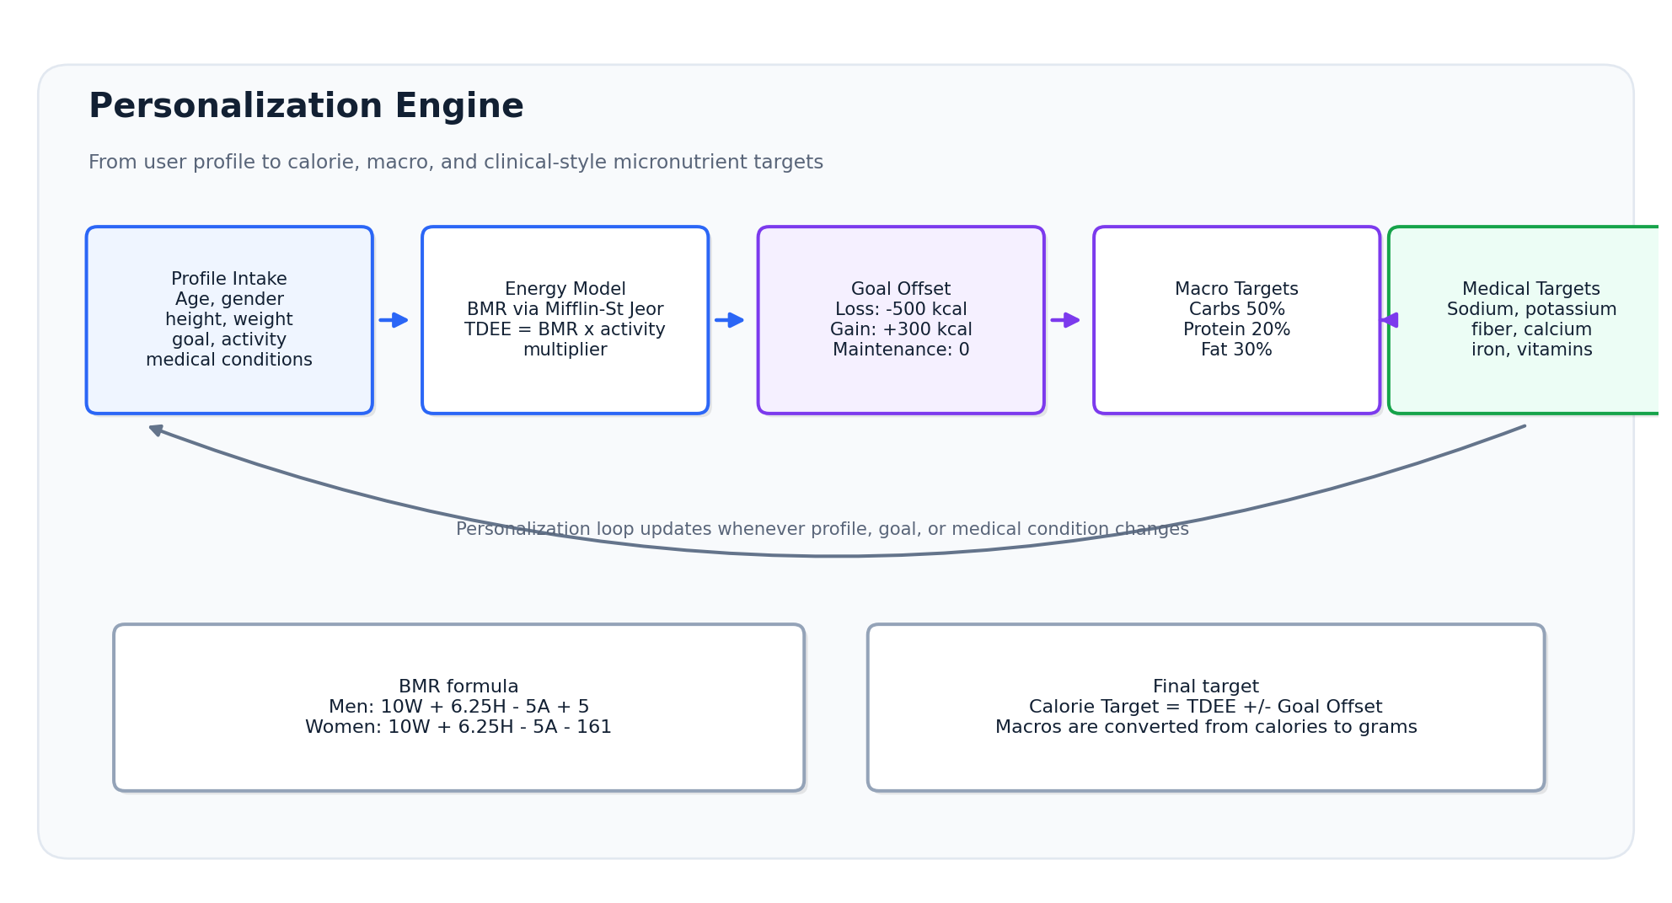
Figure 1. High-level personalization engine for DesiDiet.
This document describes the personalization engines, GraphRAG database structure, Neo4j schema, and automated meal retrieval/generation pipeline behind DesiDiet.

Contents
1. Executive Overview
2. Personalization and User Profiling
3. GraphRAG Knowledge Database in Neo4j
4. Retrieval and Meal Plan Personalization Pipeline
5. Key Platform Features and Technical Accomplishments
6. Implementation Notes and Suggested Next Steps
Figures are included throughout the document to make the system logic, graph schema, and meal generation workflow easier to understand.

1. Executive Overview
DesiDiet is a personalized nutritional intelligence system designed to generate localized meal plans using user profiles, clinical-style nutritional constraints, a Neo4j GraphRAG knowledge base, and LLM-based explanation streaming. Rather than relying on static one-size-fits-all calorie assumptions, the system computes energy needs, applies goal offsets, activates condition-specific nutrient guidance, and retrieves context-aware food recommendations from a graph database.
The system combines five main layers: profile intake, nutritional calculation, graph-based retrieval, meal assembly, and user-facing logging/explanation. The result is a pipeline that can support Bengali/local food naming, medical-condition constraints, meal slot logic, and premium daily logging experiences.
Component | Purpose / Stored Information
Primary objective | Generate personalized, localized meal plans using calculated calorie targets and graph-based clinical/nutritional constraints.
Core calculation | Mifflin-St Jeor BMR, activity multiplier-based TDEE, goal-specific calorie target, and a 50/20/30 macro split.
Knowledge system | Neo4j GraphRAG with Food, FoodGroup, MedicalCondition, and Nutrient nodes plus relationship-based restrictions and pairings.
Meal generation | Filters and scores foods, selects staples/proteins by meal slot, adjusts bilingual names, and streams an LLM rationale.
Reliability layer | Timezone-safe date locking, provider failover, null-safe event streaming, and redesigned single-day meal logging UI.

2. Personalization and User Profiling
DesiDiet starts with a granular user profile. The profile is used to calculate calorie needs, macro targets, and condition-driven micronutrient rules. This keeps the plan adaptive instead of static.

2.1 Profile Intake
The intake model captures biometric, goal, activity, and medical context. These data points become the base inputs for all downstream personalization logic.
Component | Purpose / Stored Information
Basic biometrics | Age, gender, height in centimeters, and weight in kilograms.
Goal selection | Weight loss, weight gain, or maintenance.
Activity multiplier | Sedentary x 1.2; lightly active x 1.375; moderately active x 1.55; highly active x 1.725.
Medical conditions | Examples include diabetes, hypertension, kidney disease, gout, osteoporosis, and anemia.

2.2 Calorie and Macro Calculation
The system calculates basal metabolic rate using the Mifflin-St Jeor equation, converts it to Total Daily Energy Expenditure using the activity multiplier, then applies the selected goal offset.
Formula / Rule | Definition
Men BMR | BMR = (10 x weight_kg) + (6.25 x height_cm) - (5 x age_y) + 5
Women BMR | BMR = (10 x weight_kg) + (6.25 x height_cm) - (5 x age_y) - 161
TDEE | TDEE = BMR x Activity Multiplier
Weight loss target | TDEE - 500 kcal
Weight gain target | TDEE + 300 kcal
Maintenance target | TDEE + 0 kcal
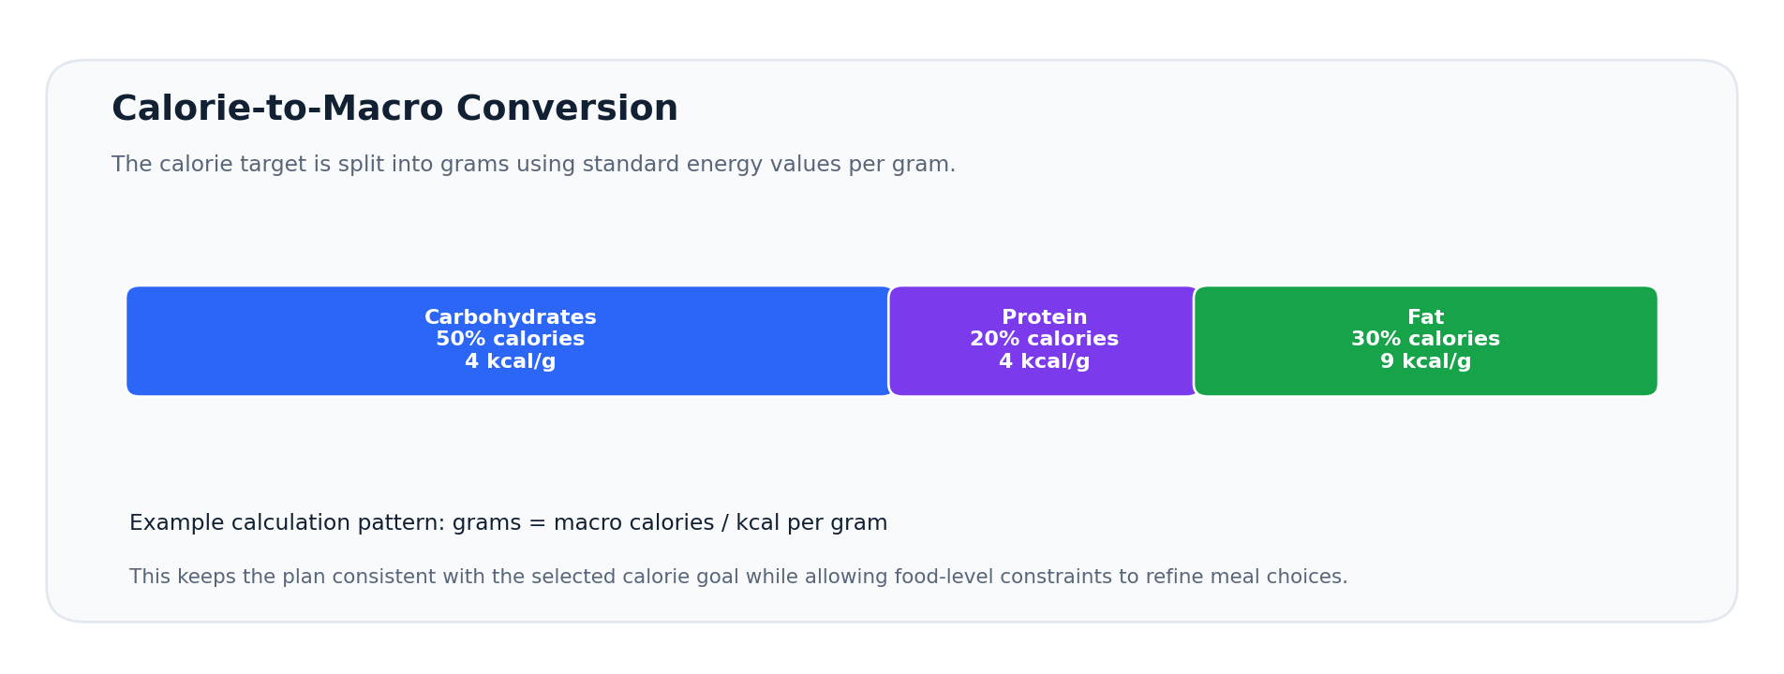
Figure 2. Calorie target conversion into carbohydrate, protein, and fat grams.

2.3 Medical-Grade Micronutrient Targets
Medical conditions activate nutrient-specific guidance. The system can reduce restricted nutrients, boost beneficial nutrients, and trigger special pairings where nutrient synergy matters.
Condition | Restricted / Controlled | Beneficial / Boosted
Hypertension | Sodium under 2,000 mg | Potassium support
Diabetes | High glycemic load | Dietary fiber
Osteoporosis | N/A | Calcium above 1,200 mg plus Vitamin D/E support
Anemia | N/A | Iron and Vitamin C synergy
Kidney disease | Excess potassium, sodium, and protein load | Controlled safe nutrient range

Figure 3. Profile-driven personalization loop from intake to clinical-style targets.

3. GraphRAG Knowledge Database in Neo4j
To support retrieval-augmented generation, DesiDiet models foods, clinical guidelines, nutrients, categories, and pairings as nodes and relationships in Neo4j. The graph structure allows the generation pipeline to retrieve relevant restrictions and beneficial signals before constructing a meal plan.
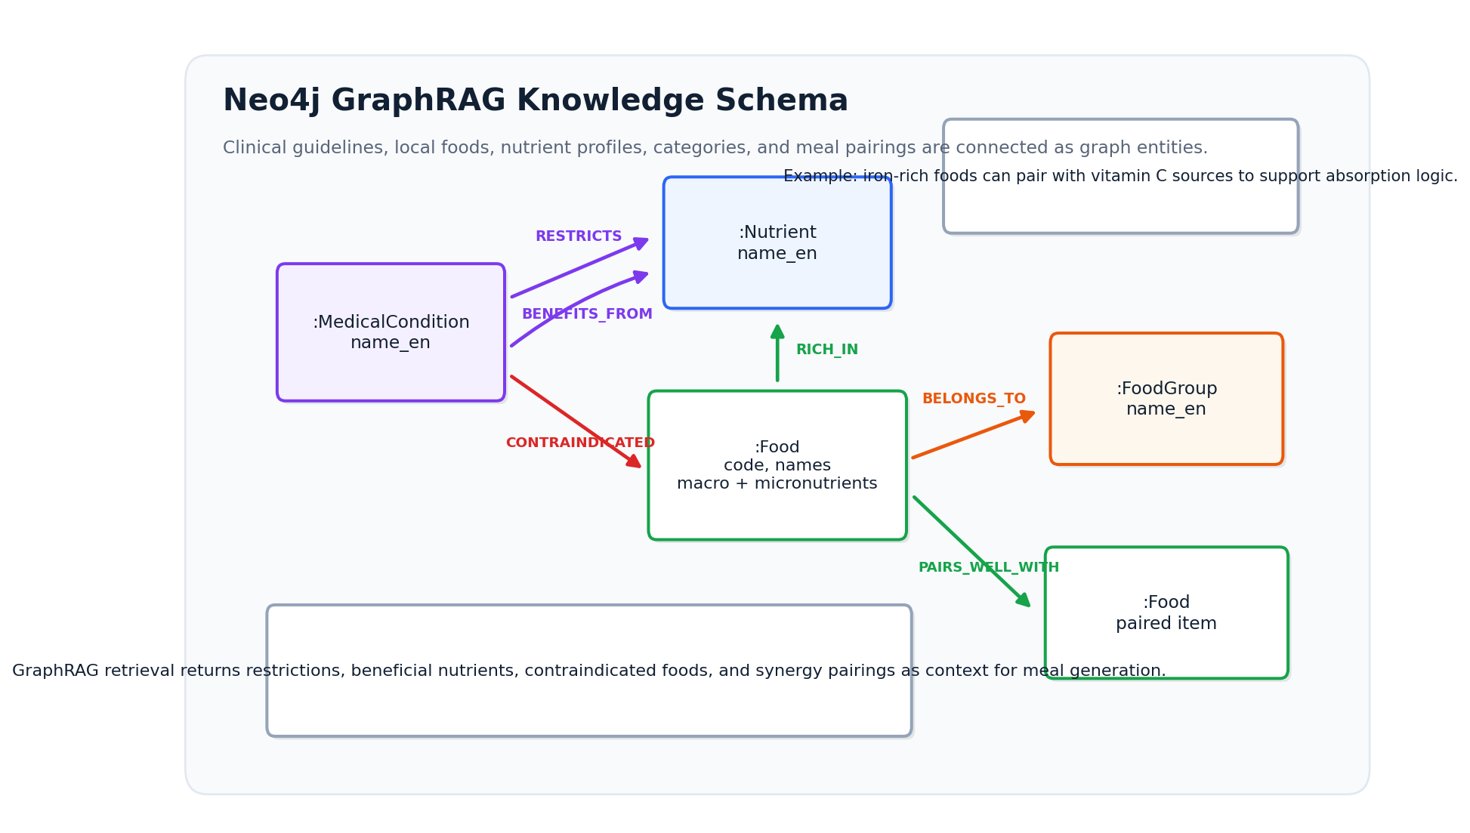
Figure 4. Neo4j GraphRAG schema showing nodes and relationship types.

3.1 Node Model
Node Label | Core Properties | Role in the System
:Food | Identity: code, name_en, name_bn; nutrition: energy, protein, carbohydrate, fat, fiber, sodium, potassium, calcium, iron, vitamins C/A/E, and folate. | Stores local food items and full nutrient profiles per 100g.
:FoodGroup | name_en | Groups foods into categories such as cereals, grains, fish, legumes, meat, or vegetables.
:MedicalCondition | name_en | Represents condition keys such as hypertension, diabetes, kidney disease, gout, osteoporosis, and anemia.
:Nutrient | name_en | Represents nutrients that can be restricted, boosted, or used for pairings.

3.2 Relationship Model
Component | Purpose / Stored Information
(:MedicalCondition)-[:RESTRICTS]->(:Nutrient) | Controls nutrients such as sodium, potassium, protein, or glycemic load based on the user condition.
(:MedicalCondition)-[:BENEFITS_FROM]->(:Nutrient) | Boosts nutrients that benefit the condition profile, such as fiber, calcium, iron, or vitamin C.
(:MedicalCondition)-[:CONTRAINDICATED]->(:Food) | Excludes or penalizes foods that should be avoided for a given condition.
(:Food)-[:RICH_IN]->(:Nutrient) | Links food items to strong nutrient sources.
(:Food)-[:BELONGS_TO]->(:FoodGroup) | Supports category-driven meal slot selection.
(:Food)-[:PAIRS_WELL_WITH]->(:Food) | Supports synergistic pairings such as iron-rich foods with vitamin C sources.

4. Retrieval and Meal Plan Personalization Pipeline
When a user requests or regenerates a meal plan, the engine executes a multi-stage retrieval and construction algorithm. Each stage narrows the decision space, improves safety, and improves local relevance.
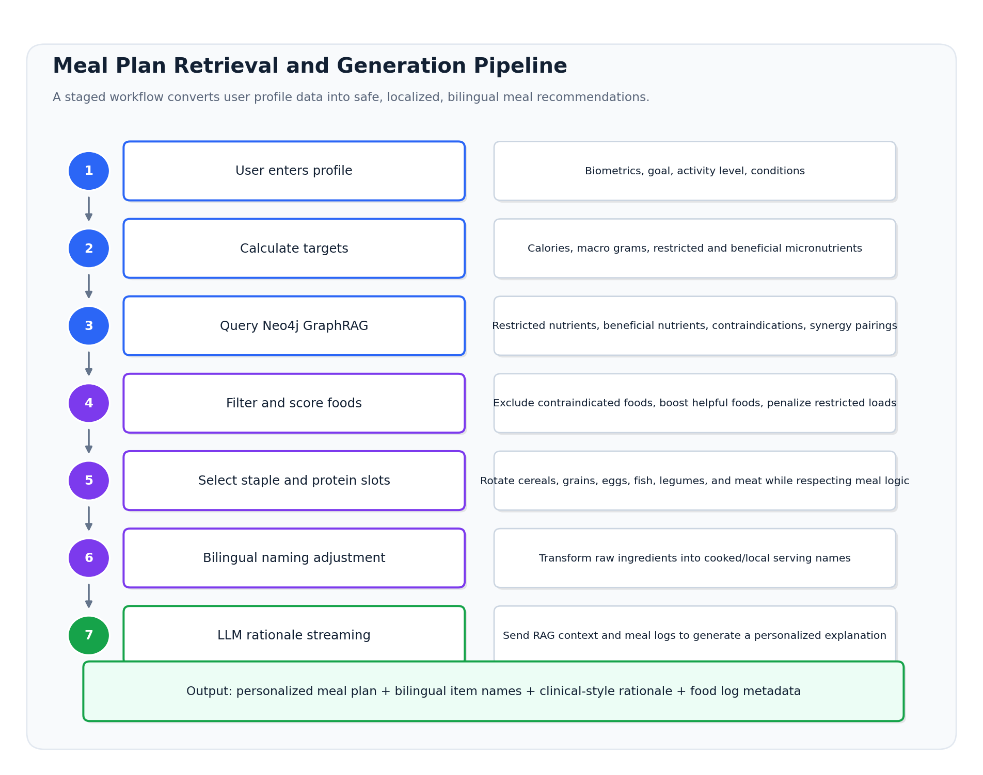
Figure 5. End-to-end meal plan retrieval and personalization pipeline.

4.1 Pipeline Stages
1. User enters a profile with biometrics, activity, goal, and medical condition information.
2. The calculation service computes calorie, macro, and micronutrient targets.
3. The GraphRAG service queries Neo4j for restricted nutrients, beneficial nutrients, contraindicated foods, and pairings.
4. The scoring engine excludes contraindicated items, boosts beneficial nutrient foods, and penalizes restricted nutrient foods.
5. The meal constructor selects staples and protein slots across cereals, grains, eggs, fish, legumes, and meat while respecting meal slot logic, such as avoiding meat at breakfast.
6. The bilingual naming adjuster converts raw food items into cooked/local names, for example turning boiled rice into rice meal naming and colocasia leaves into a mash-style item.
7. The LLM rationale layer streams a personalized explanation based on the generated meal logs and retrieved GraphRAG context.

4.2 Localized Naming Examples
The system preserves local food identity by converting raw item names into names that match how users think about cooked meals. Bengali examples should be rendered in a Bengali-capable font in production interfaces.
Raw Item | Adjusted Meal Name | Purpose
সিদ্ধ চাল | সিদ্ধ চালের ভাত | Turns an ingredient name into a cooked rice dish label.
কচু পাতা | কচু পাতার ভর্তা | Turns a leaf item into a familiar mash/preparation label.

5. Key Platform Features and Technical Accomplishments
Beyond meal generation, the platform includes reliability and user experience improvements that make daily usage safer and more polished.
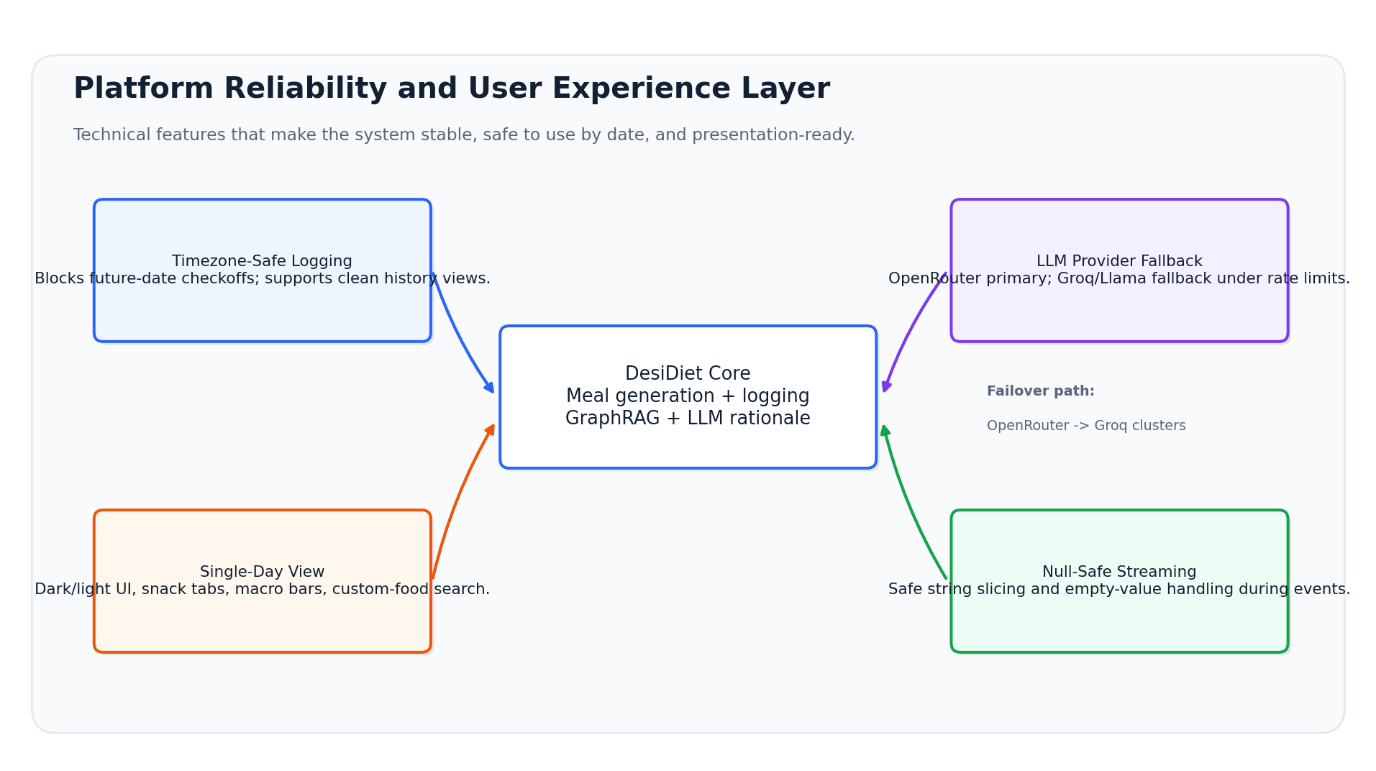
Figure 6. Reliability and experience layer around the DesiDiet core.

Feature | What It Does | Value
Timezone-safe logging and date locking | Prevents users from checking off future dates as eaten while allowing clean past-log history views. | Improves data integrity and prevents ahead-of-time completion errors.
Multi-provider LLM fallback | Uses OpenRouter free models for zero-cost operation and falls back to Groq Llama-3.3-70B clusters when the primary provider hits limits. | Improves uptime and protects streaming explanations from provider rate limits.
Redesigned single-day view | Adds dark/light themes, single-day calendar widgets, snack tabs, real-time macro progress bars, and custom food search. | Improves user engagement and makes daily nutrition tracking easier.
Database slicing null-safety | Uses safe string slicing and empty-value handling in streaming event logs. | Prevents crashes during active streaming chat and logging events.

6. Implementation Notes and Suggested Next Steps
The current design is strong for a personalized nutrition platform. The following steps can make the documentation and implementation even more production-ready:
- Define explicit validation rules for each medical condition, including threshold sources and clinical review status.
- Version the Neo4j schema so future food properties or relationships can be migrated safely.
- Track scoring weights for excluded, penalized, and boosted foods so recommendations remain explainable.
- Add a user-facing explanation template that separates calculation rationale, food selection rationale, and medical-condition rationale.
- Add QA tests for date-locking, provider fallback, empty values, and bilingual naming transformations.
The design can be extended into an engineering specification, investor/product pitch, or implementation README depending on the intended audience.

