Matt Brittan, Kevin Jacobs, Scott Aufderheide
Project Report
4/30/2012

Texas Hold'em

Our project was to create a Texas Hold’em poker game. Texas Hold’em is played with two facedown cards dealt to each player and five community cards being progressively dealt throughout the game with each round. The goal of the game is for a player to create the best combination of their cards with the community cards to make a winning hand. A round is where each player gets a chance to check, bet, raise, or fold. A player may only check if no bet has been made yet. The first player who doesn’t check can place a bet by placing a certain amount into the pot. After the first bet of a round, players can call to match the bet, raise, to increase the bet, or fold to give up the hand and any chance at winning the pot. If another player raises off of an initial bet, the first player has the option to call on the raise, raise again himself, or fold.
A game starts with the placing of the blinds. The person immediately clockwise of the dealer places the small blind and the next clockwise person places the big blind, which is twice the size of the small blind. This initializes the pot, and then the players’ cards are dealt. The first round of betting ensues, where players can call or raise from the big blind. Once this round of betting is over, the first three community cards, called the flop, are dealt. Based on these cards, players will make decisions as to how good their hands are and check, call, or raise accordingly. Once the second round of betting is over, the fourth community card, called the turn is dealt, and another round of betting ensues. After the third round of betting, the last community card, called the river, is dealt. After the final round of betting, if there is more than one player left, each player reveals their cards and a winner is determined by who has the best hand. The winner receives the entire pot, but in the case of a tie, the pot is split evenly. A new hand can be played, and the placing of the blinds moves one space over in a clockwise direction.
The poker hands in increasing order are: high cards, one pair, two pair, three of a kind, straight, flush, full house, four of a kind, and straight flush. High card is simply that the person with the highest value card wins. A straight is five cards in increasing value. A flush is five cards of the same suit. A full house is two cards of one value and three cards of another value. A straight flush is five cards of the same suit that are in increasing order. Should two people have a flush, straight, full house, or straight flush, the person with a higher card in their hand wins. If two people have identical hands in value, but different suits, the game is a tie, as suits are all equal in Texas Hold’em.
The goal of this project was to create a game that followed the standard rules of poker, as well as create a computer AI that would be able to play the game to an acceptable degree of intelligence. Our program uses a number of different classes: window, diagramscene, player, game, carddeck, and card. Window deals with presenting the information to the user and largely uses Qt code. Diagramscene updates the window based on what moves have been done and what round it is in the game. Game handles everything that is involved with the game itself including the round, the betting, and determining winners. Player uses polymorphism, and has two derived classes: human and AI. All the human functions are based on user input when buttons are pressed. AI runs its commands automatically after making a decision based on its current hand and the betting. CardDeck creates a deque of cards for use in the game. Card is a class for each card object in the deck which holds all the card's information such as value, suit, and it's image file reference. Card’s default constructor is also used by player and game to make decisions and comparisons.
Using C++'s ability to compartmentalize code into different classes allowed the project to easily be spit amongst the group members to work on different things individually. To keep everything up to date, no matter what was being worked on, we used GoogleCode to upload and share our files as we made progress.
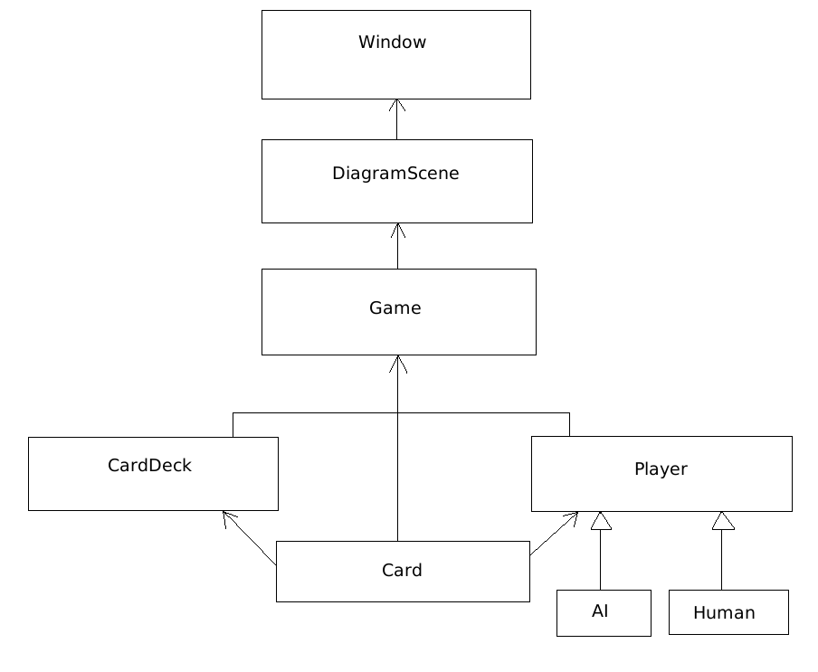
Figure 1: UML Diagram
A large part of our project involved the use of Qt for graphics and the user interface. Through the use of Qt functions, the user can click buttons to raise, check, call, or fold. After each event is done, the program switches to the AI, so that it can make a decision based on what the user just did. After each round, Qt commands are used to update the board by revealing new cards, or moving coins for the betting.
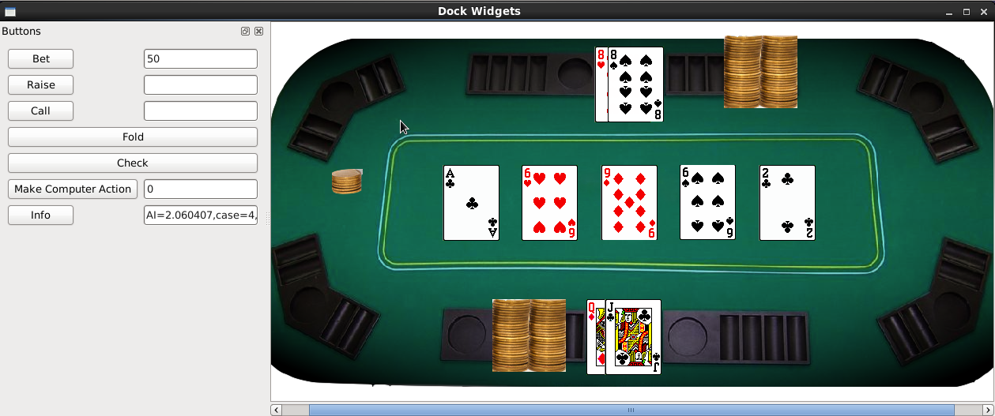
Figure 2: User Interface and Table
The basis of the AI's decisions is understanding what cards it has. There are functions that determine if the AI has a high card, a pair, a full house, a straight, etc., and depending on what the computer has, the hand is given a rank. The higher the rank is, the better the hand. With a better rank, the AI is more “confident” and is willing to bet more. The rank is recalculated after each round to compensate for the new cards that are revealed. How confident the AI is, along with how large the pot and current bet are effect what actions the AI will take. If the AI has a good hand, it will be more willing to raise and call if the pot is large, and more likely to fold if it has a bad hand.

