Lab 11:

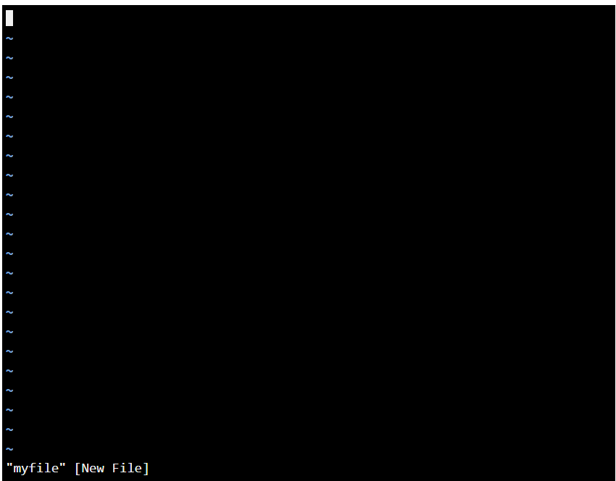

Overall this is mainly review for me. I don’t use Linux on a daily basis so most of the commands I don’t remember. Either way these exercises a fun even if it is a simulated terminal. Re-learning Linux commands is always fun, just for the fact that I forgot majority of what things meant.

Lab 13:

I couldn’t do this lab because it refused to let me type inside the terminal for the password. Having a virtual terminal inside a webpage, next to a lesson is good for learning, but it can have hiccups like I had and not want to function fully.