Krusader

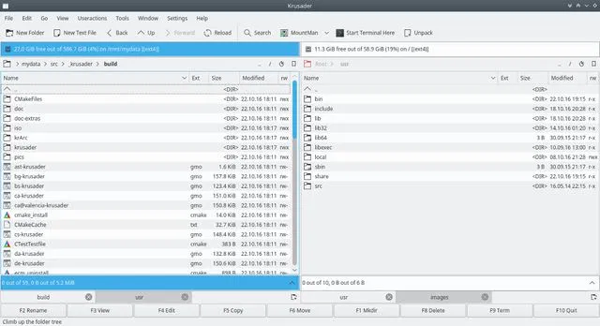Description:

A advance dual panel with archive handling, mounted filesystem support, advanced search module with an internal viewer and editor.

Dolphin

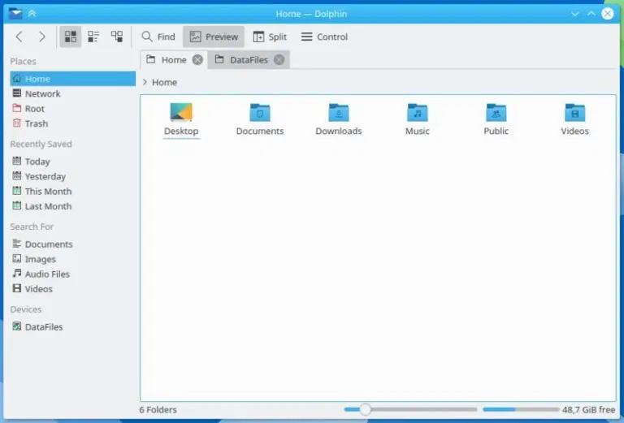Description:

Is able to show HTML pages, text documents, and directories.

Midnight Commander

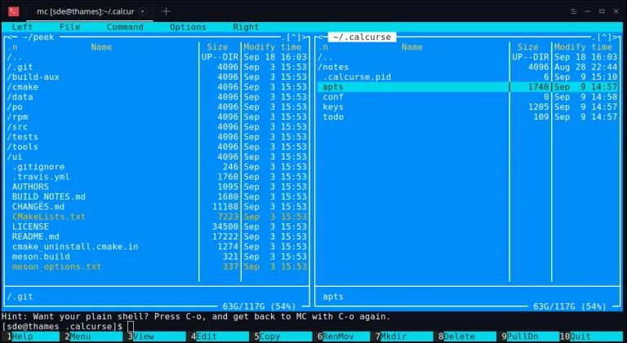Description:

Useful for novice to advanced users. Allows users to manage files while allowing for the most use of the screen. It’s divided into four parts: a two section panel, a shell command, and function key labels.

nnn

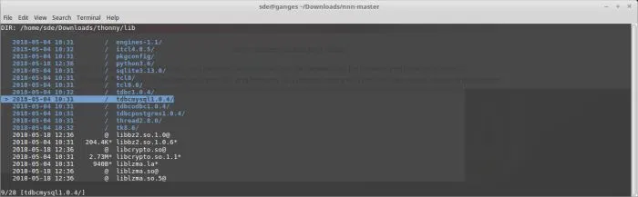Description:

Is easy use with optimized code with minimal resource usage. It is easy to navigate.

Ranger

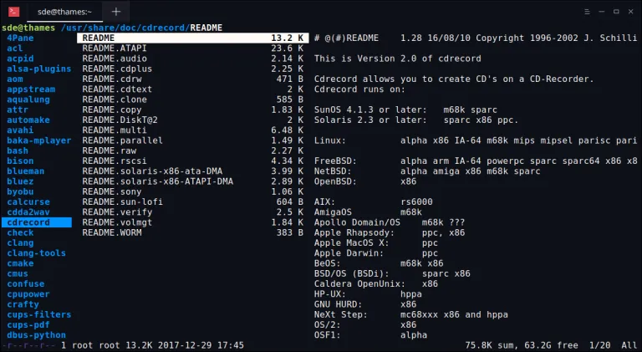Description:

Simple to use. The arrow keys are use to navigate, Enter key is used to open files, and the Q key is used to quit.

PCMan File Manager

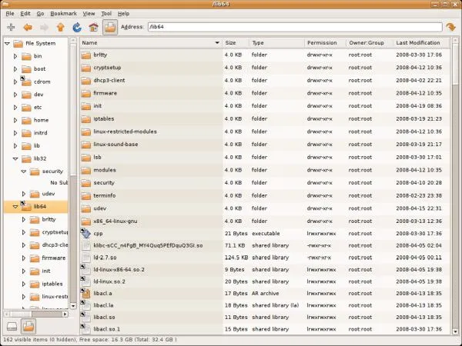Description:

Takes the appearance of a file explorer in Microsoft Windows and functions similar.

GNOME Files

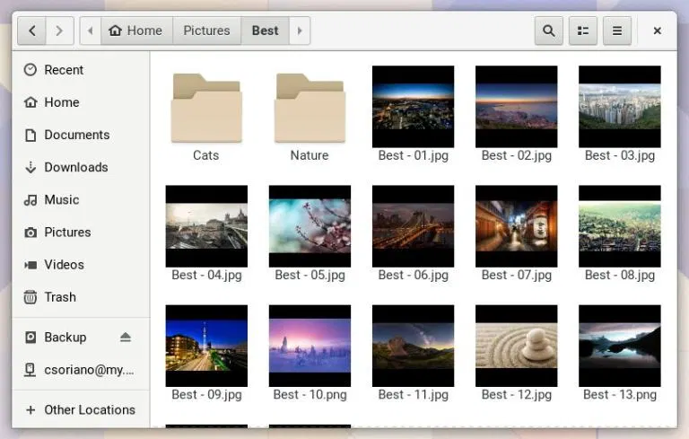Description:

Allows you to configure your desktop, configure your system, browse photos, and view network resources.

Double Commander

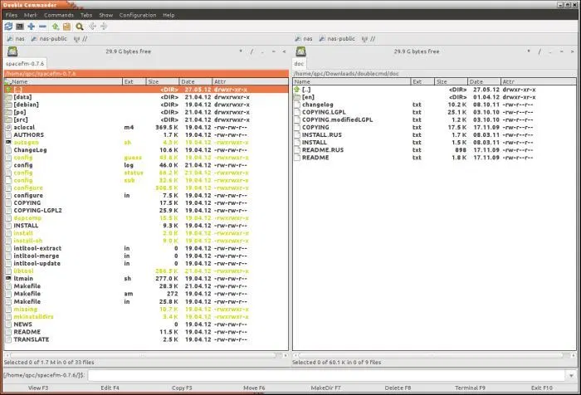Description:

Can run on several platforms and operating systems like Linux and Windows. This application has a built in file viewer, text editor, custom columns, and the ability to copy and move files and folders via the clipboard.

GNOME Commander

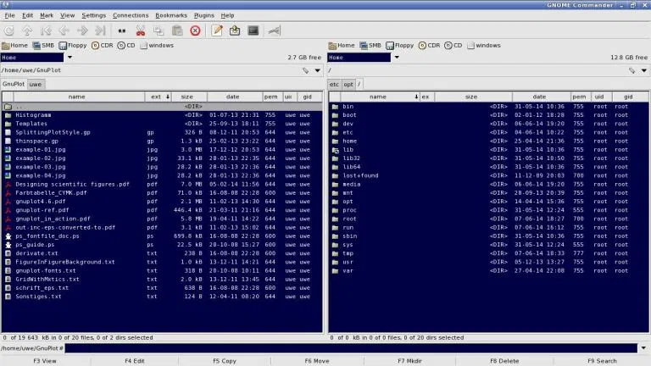Description:

This application has tab support, a fast file viewer, renaming of files, folder bookmarks, and file compression.

4Pane

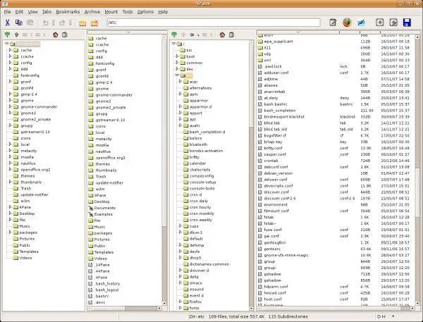Description:

Acts like a standard file manager, but with a minor twist. It also includes multiple undo and redo of most operations, can virtual browse inside the archives, renaming tools, and a terminal emulator.

# References

Emms, Steve. *Linux* . 05 March 2019. Web Article. Retrieved From: [http://www.linux .com/FileManagers/](http://www.linuxlinks.com/FileManagers/)