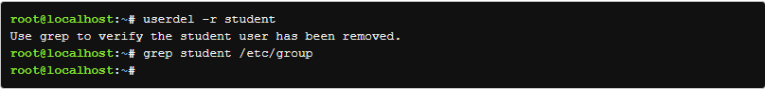

In this lab I learned how to create users and groups, switch users, retrieve information about the groups, set restrictions for each user and group, how to delete users and groups, and set parameters for users.