Lab 17

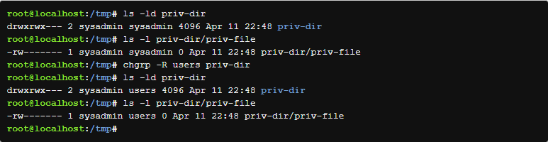

Creating directories

Make a private directory

Make a public directory

Remove permissions

Change permissions

Change the user owner

Lab 18

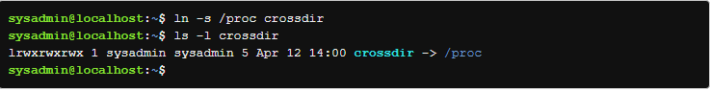

Show ownership and permissions of directory files

Create hard and soft links to files