# ID202712 Systemutvikling og modellering

**Obligatorisk oppgave 2, Student Hand-in**

**16.01.2017**

**Avdeling for ingeniør- og realfag**

**NTNU i Ålesund**

**Student name**: Kristoffer Martinsen

**Student email:** *Krimarti@stud.ntnu.no*

# Evaluation of <http://blinkee.com/>

Screenshots:

## Screenshot 1

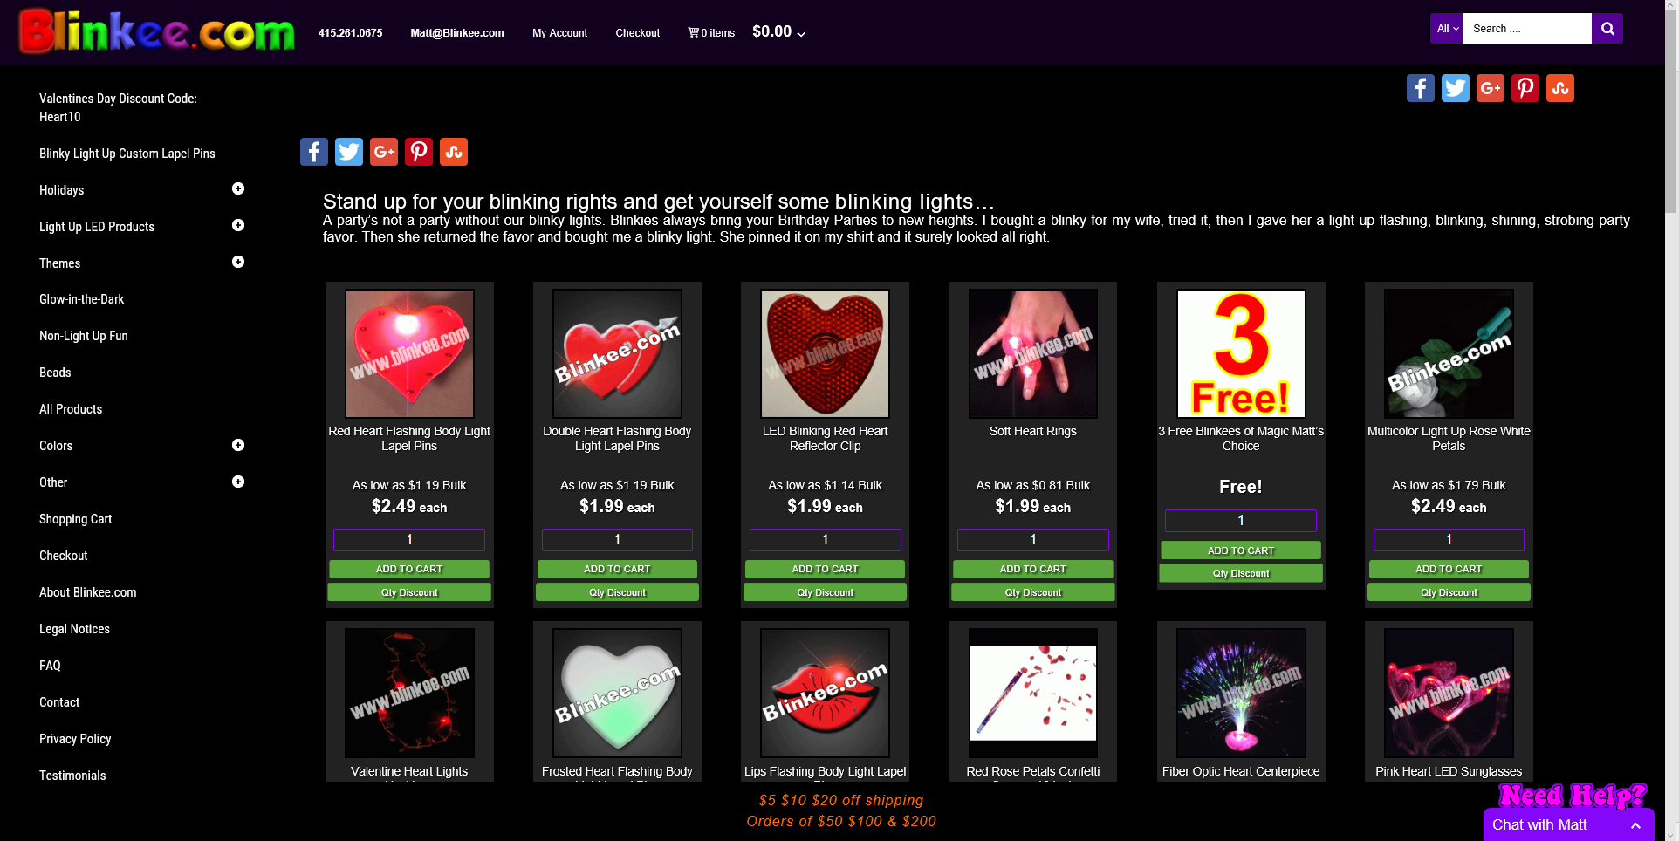

Evaluation

|  |  |  |
| --- | --- | --- |
|  | Positive | Negative |
| Consistency | The consistency is mostly fine. Similar elements on the page have the same color and usually have the same dimensions. | There are a few elements where the dimensions are wrong. An example is the “3 free” where the element is shorter than the rest. |
| Structure | The structure is alright. A grid-based structure is clean and easy to understand. |  |
| Gestalt principles | It follows the gestalt principles, kind of. Similarity and proximity is good. |  |
| Colors |  | A bit too saturated colors on a completely black background is a bit busy to look at. |
| Reading overload |  | The colors of the logo is a bit jarring to look at; way to saturated colors. It doesn’t help that it’s animated making it even more painful to look at. |
| Memory overload |  |  |
| Clear goals and navigation |  |  |
| Thinking overload |  |  |
| Attention, change blindness |  | The logo steals all the attention with it’s saturated colors and animation. |
| Other comments |  | The information about shipping prices covers about half of the footer. |

# Evaluation of <http://www.suzannecollinsbooks.com/>

Screenshots:

## Screenshot 1

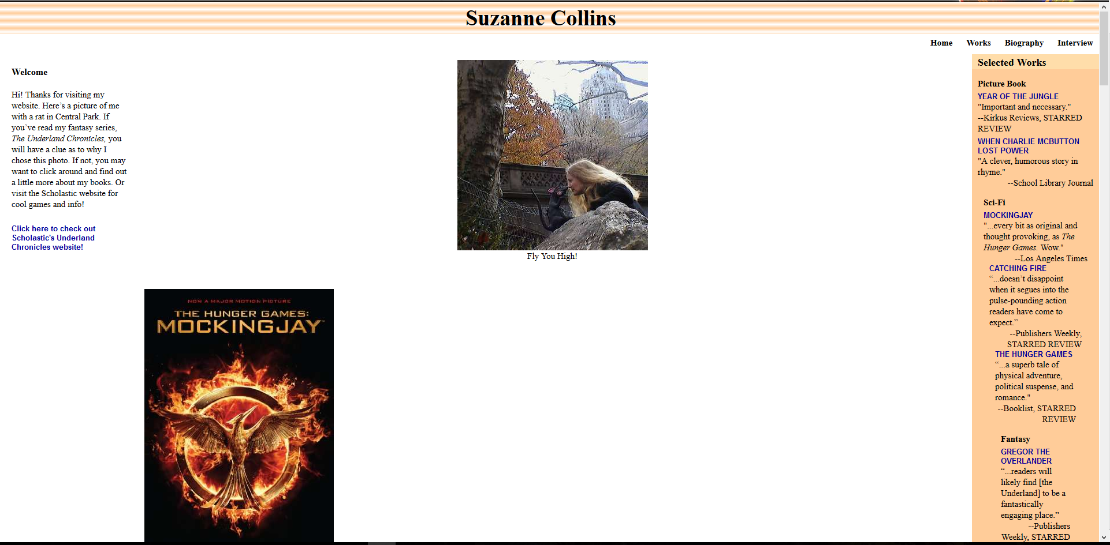

## Screenshot 2

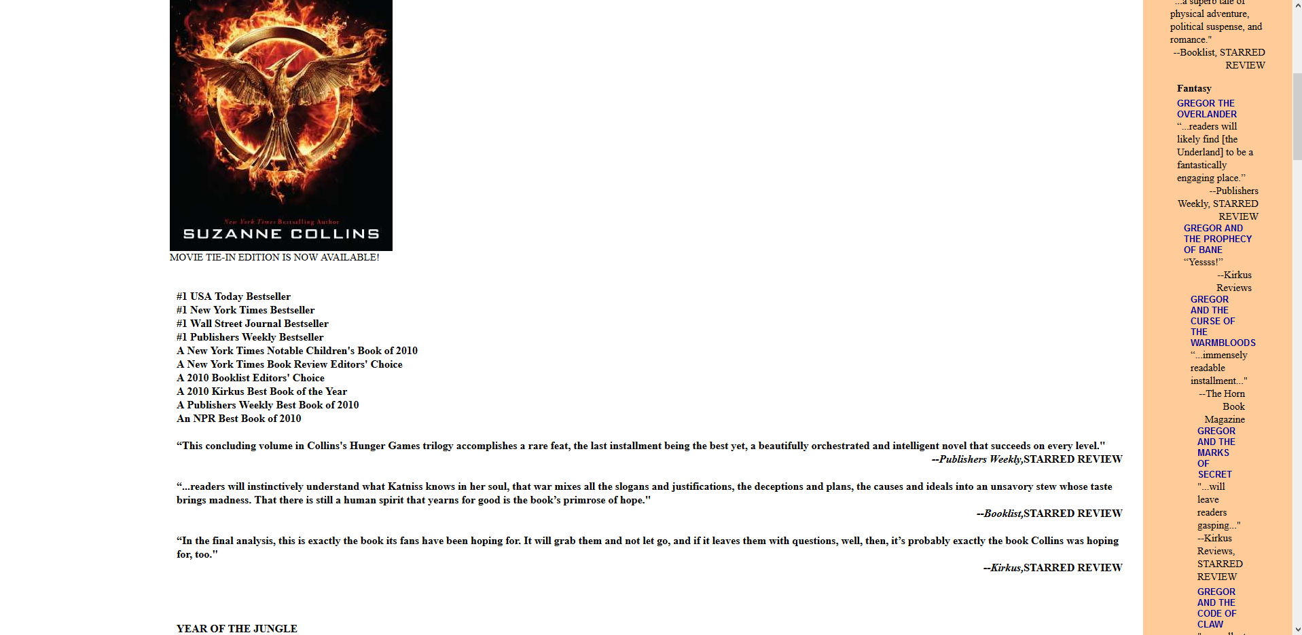

## Screenshot 3

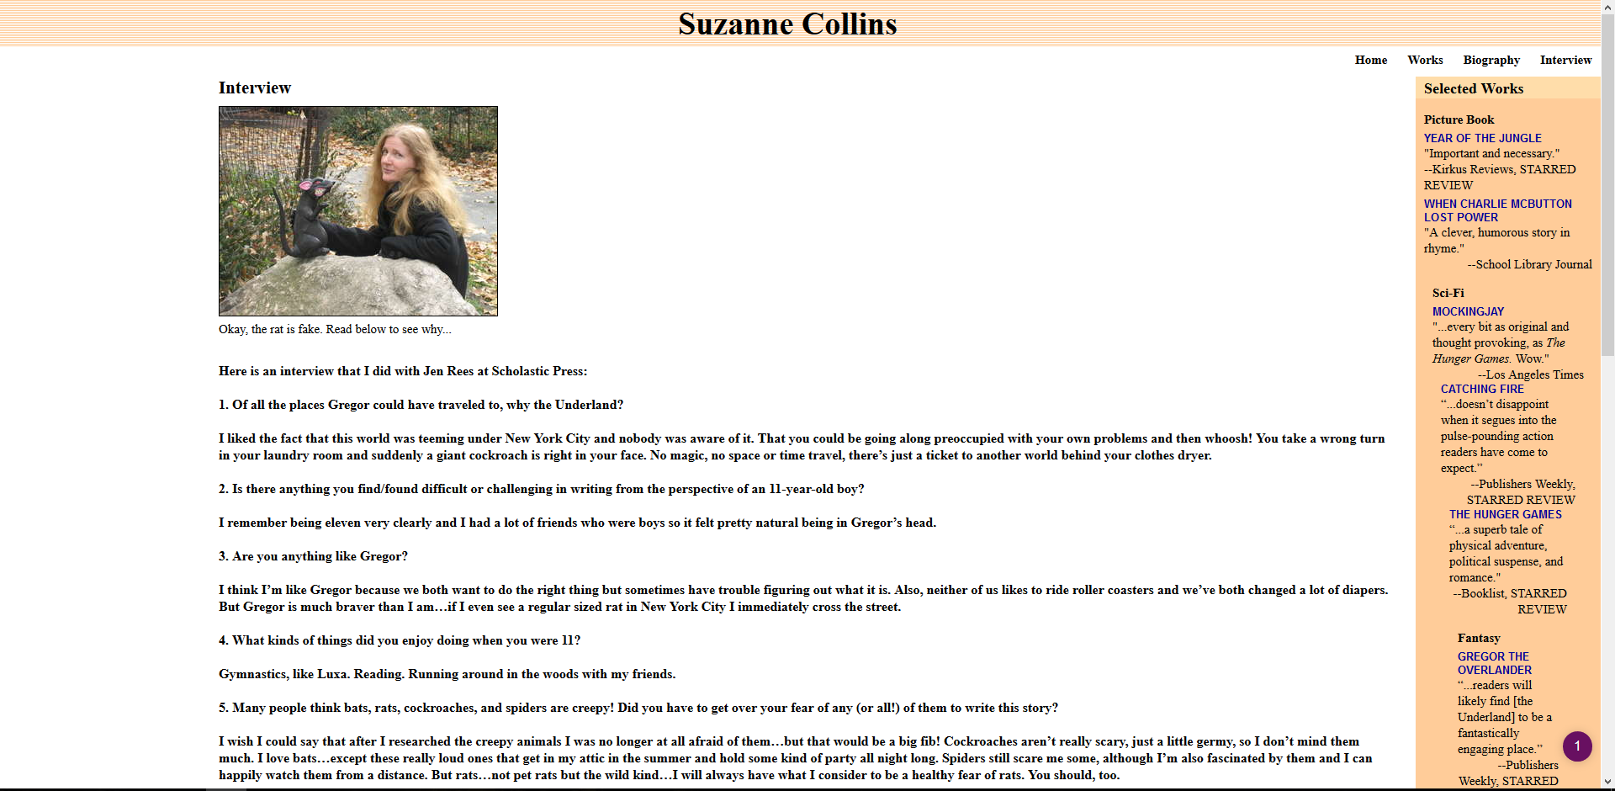

Evaluation

|  |  |  |
| --- | --- | --- |
|  | Positive | Negative |
| Consistency |  | The Pictures are not consistent at all. Some pictures are centered while others are positioned to the left. |
| Structure |  | There is no structure. The welcome text is all the way to the left. Some pictures are centered while others are not. The navigation bar at the top is all the way to the right. The “Selected works” section gets positioned more and more to the right. |
| Gestalt principles | There are some places where they have followed the proximity principle e.g. with the navigation bar. Similarity can be seen in the reviews for the books. | Seems like the person who designed this page have no idea what the Gestalt principles are. |
| Colors | Colors are acceptable. |  |
| Reading overload |  | The reviews of the books are way to close and everything is bold making it hard to read (Screenshot 2). The interview is the same; Every question and answer is bold making it difficult to distinguish between the two. |
| Memory overload |  |  |
| Clear goals and navigation | Finding what you are looking for is fairly straight forward. | The navigation bar should be centered. |
| Thinking overload |  |  |
| Attention, change blindness |  |  |
| Other comments |  | This page is a fucking disaster. Triggered. |

# Evaluation of <http://www.ntnu.no/studier/004da>

Screenshots:

## Screenshot 1

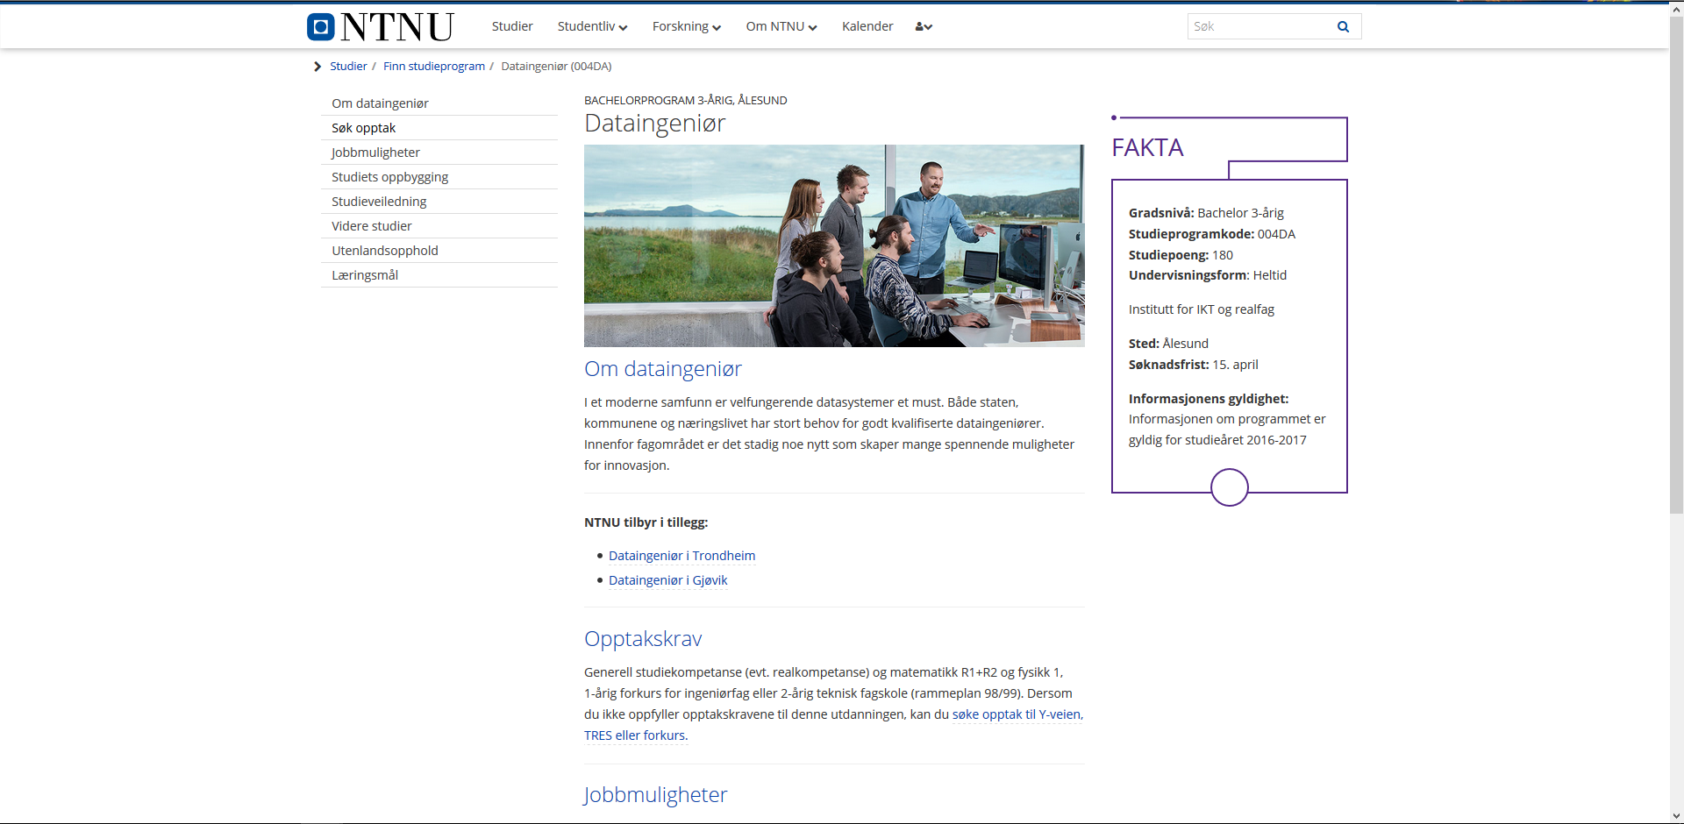

Evaluation

|  |  |  |
| --- | --- | --- |
|  | Positive | Negative |
| Consistency | The elements in this site is consistent. Headers have the same colors. When you go to another subpage the navigation menu has the same position. |  |
| Structure | The elements on the page are centered to the middle of the screen where our focus is. |  |
| Gestalt principles | They have used proximity to show where one paragraph ends and where another one begins. |  |
| Colors | The colors are not too saturated and fit well with the design of the page. |  |
| Reading overload | The information is well structured and concise. This makes the information easy to find. |  |
| Memory overload |  |  |
| Clear goals and navigation | Easy to navigate the page with the navigation menu. |  |
| Thinking overload |  |  |
| Attention, change blindness |  |  |
| Other comments |  |  |

# Evaluation of Fronter login

Screenshots:

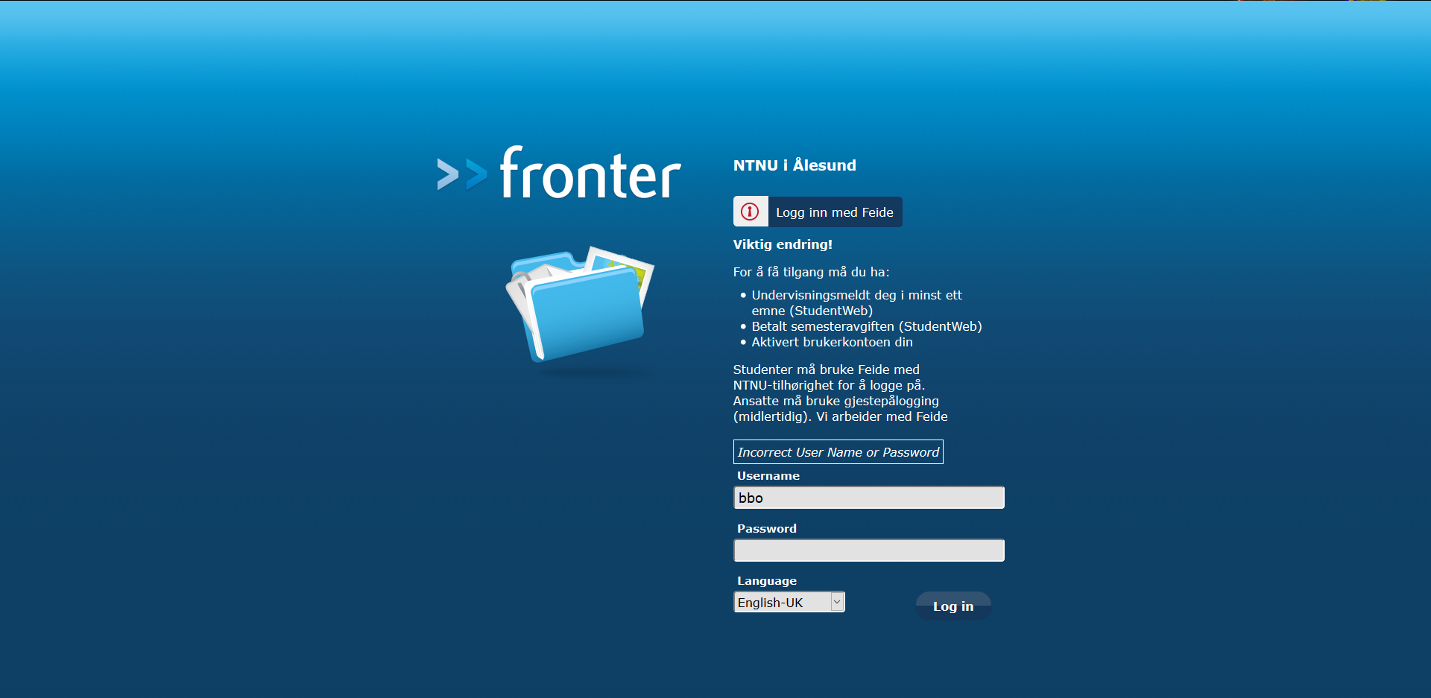

Evaluation

Positive:

* Things are centered on the page where our focus will be.
* The contrast between the color of the font and the background makes the text easy to read.
* They use proximity on the elements that are “grouped” together e.g. username and password. They also use this on the information about what you need to do to have access to fronter.
* When you write your username or password wrong you get a message right above where your focus is telling you that.

Negative:

* Maybe not immediately apparent that you need to log in with Feide if you are a NTNU student.