Citation (Group 2)

Driving question:

How can year7 students effectively build an informative website to empower youth in society with educational awareness?

Essential question:

How can we develop a non-profit recognition website which can support digital literacy to the youth community by sharing cyber-bullying awareness?

Color palette:

https://colorhunt.co/palette/f1eaffe5d4ffdcbfffd0a2f7



Information reference:

https://www.betterhelp.com/advice/bullying/what-is-verbal-bullying-and-how-does-it-happen/

https://www.stopbullying.gov/cyberbullying/cyberbullying-tactics

https://www.mcmillenhealth.org/tamtalks/verbal-bullying

https://www.wikihow.com/Help-Someone-Who-Is-Being-Bullied

https://www.realsimple.com/health/preventative-health/safety/4-essential-self-defense-moves-everyone-should-know

https://www.haterzstayback.com/blogs/news/the-10-types-of-cyberbullying

<https://www.healthline.com/health/how-to-calm-down>

Screenshot of our main two pages wireframe:

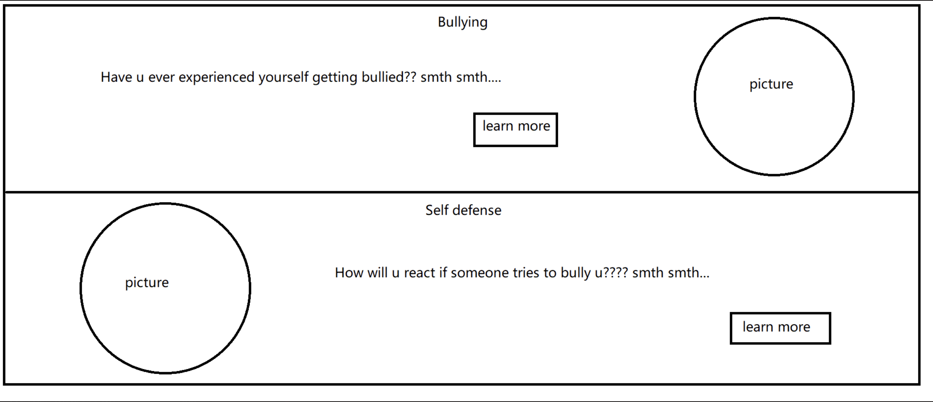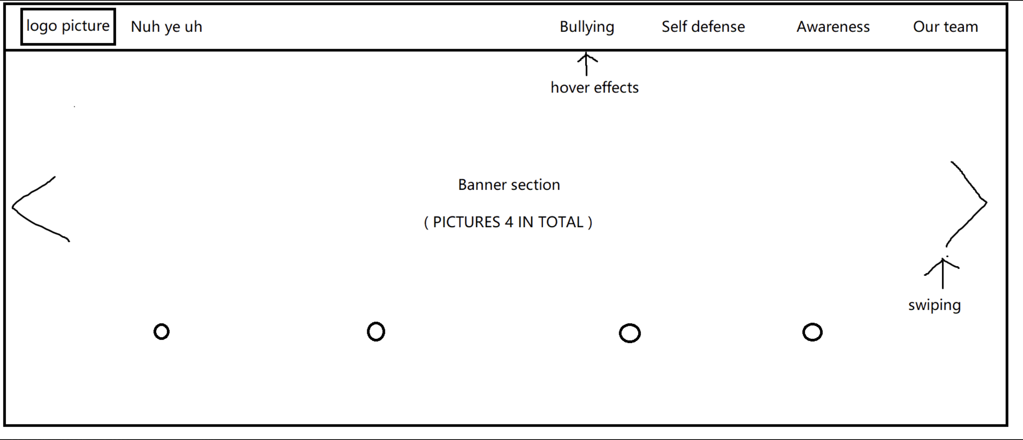

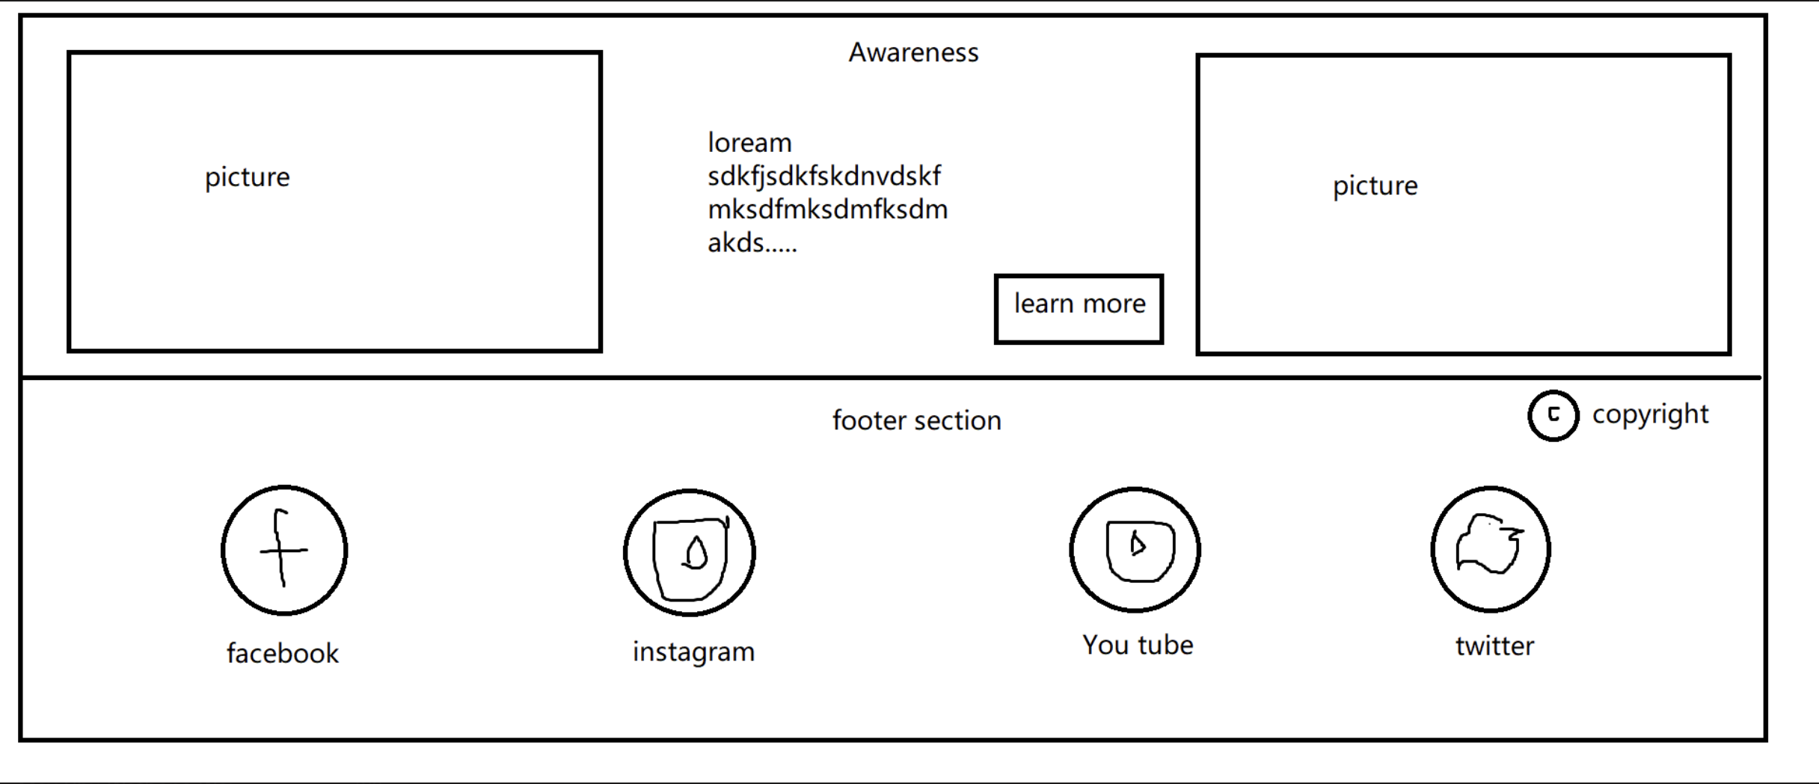

Second main page wireframe:

