4. Install wireshark in the VM? Draw a time diagram to show the protocols displayed in the captured file (save the .pcap file of wireshark) during a PING operation. List the L2, L3, L4 header fields that can be extracted from the .pcap file. (Marks: 10 + Number of fields shown by the group)

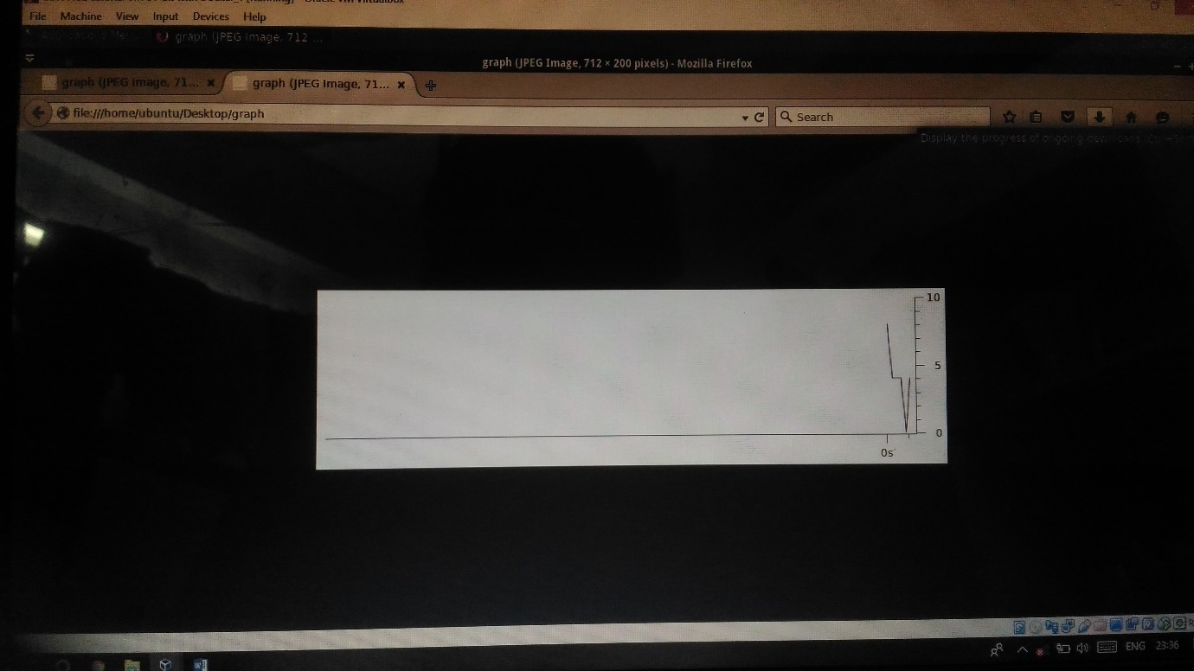

I/O graph

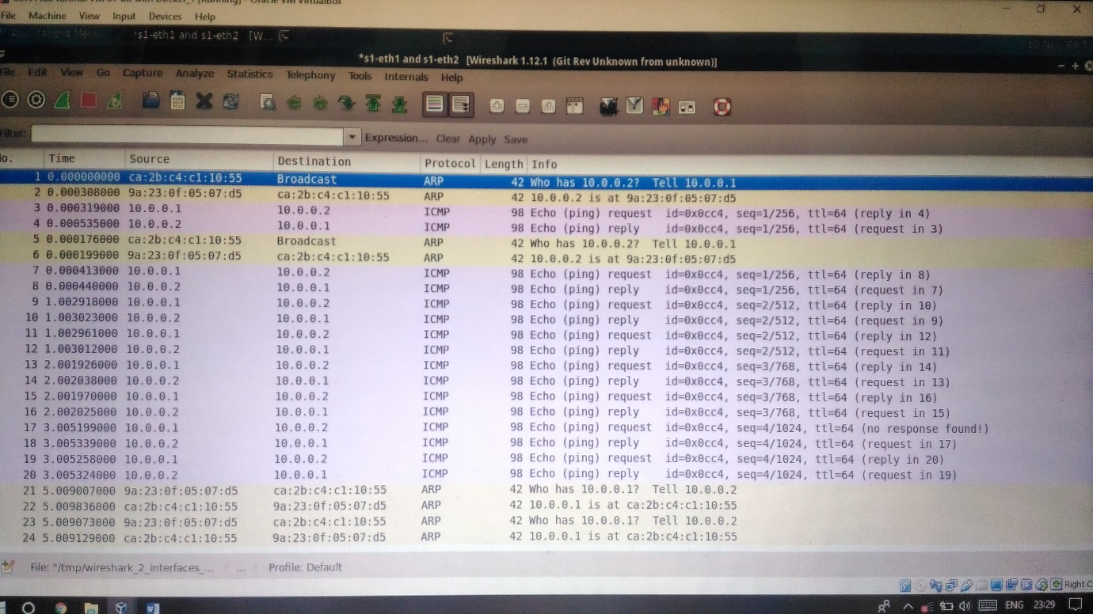

ICMP/ARP Messages