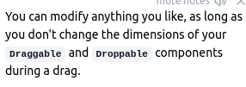
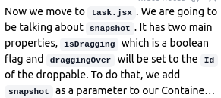
With react-beautiful-dnd, we have the ability to control what is able to be dragged and where it is able to be dropped. Controlling what is able to be dragged is done using the Draggable isDragDisabled prop

There are two mechanisms available to control where a draggable can be drop:

