Andrew Brick

ECE580 -Project 2

Changes to dns2proxy including line numbers:

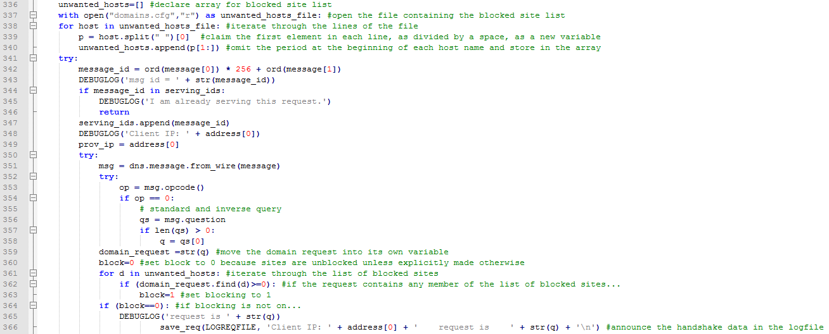

**Task 2**

DNS requests are being blocked by supplying the domain requests with local IPs, namely 192.168.127.127, instead of those that could traverse the internet. By providing only local network IPs, the client cannot escape its local network.

It was easy to test. Once I understood that domains.cfg was designed to supply custom IPs for any given domain name entered, it was simply a matter of adding the domain name to a new line in the file and trying to access it through the iceweasel browser. Typically I tested with amazon.com.

**Task 3**

In my code, beginning at line 336, domains.cfg is iterated through to make an array of blocked domain names. The period that makes the formatting in the .cfg is then removed. Then, the program searches for these names in the ‘question’ part of the message coming from the socket. If any of the unwanted domains can be found in the message, a block flag is set. The system is only allowed to log the data if the block flag is not set.

**Task 4**

This is a resubmission of my original Project 2, which was very incomplete when it came to task 4. I am happy to say I have completed task 4 here.  
I chose 6 news sites, which were all riddled with ads. Almost all of the requests that popped up during the dns2proxy process were blockable.