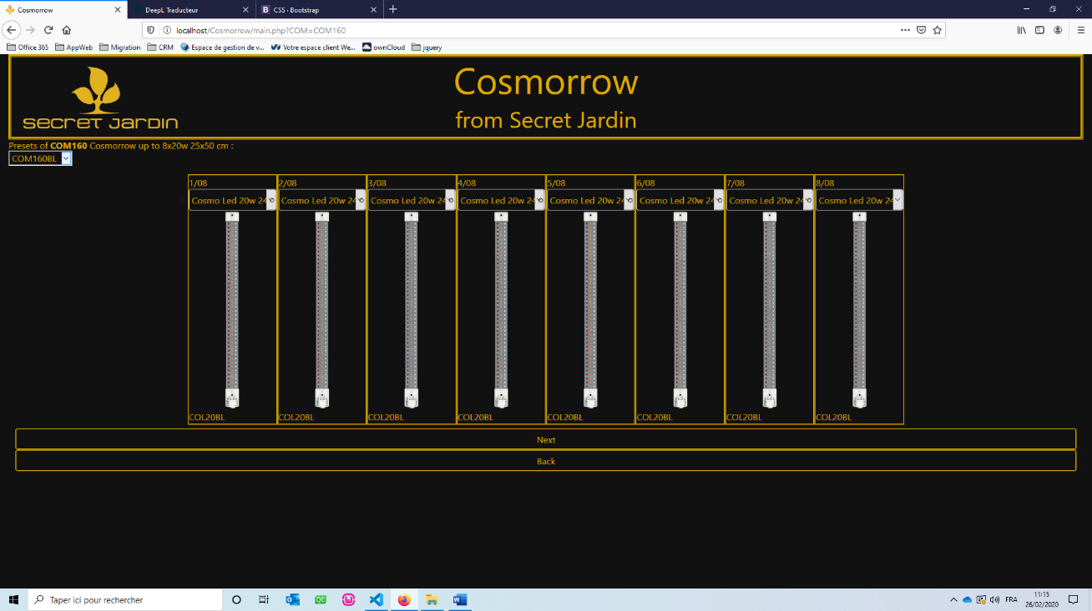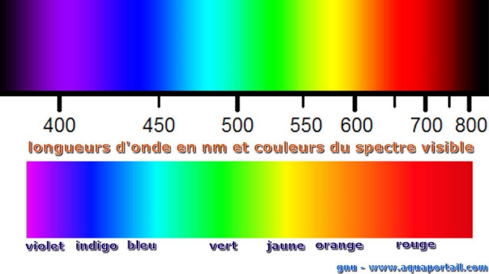

|  |  |
| --- | --- |
| **cosmorrow**  **Technical Documentation** | **from Secret Jardin**  *a web application solution that calculates the chromatic spectrum and light propagation of a set of lightnings.* |

*Titouan LE GOVIC*

*08/2019 – 03/2020*

**SUMMARY**

Cosmorrow (php)3

Introduction3

**Presentation4**

**Development7**

Tapez le titre du chapitre (niveau 3)7

**Hosting8**

Tapez le titre du chapitre (niveau 3)8

Irradiance Converter (C++)12

Introduction12

**Development13**

Tapez le titre du chapitre (niveau 3)13

**Link to FTP Explorer (modify source code or web site resources):** <https://net2ftp.cluster029.hosting.ovh.net/?username=cosmorroce>  
**Login :** *********  
**password :** ********  
**Path :** /www/Cosmorrow   
**source file path  :** /www/Cosmorrow/Resources/(COL, COM, Pics)  
**link to the web site :** http://www.cosmorrow.com/Cosmorrow/main.php

**51.91.236.255:80**

**INTRODUCTION:**

The company has launched a new range of products,   
we needed a solution, to simulate the performance of an installation,   
this will help the customers better choose the products they need.

**The application must show the following properties:**

* The resulting **chromatic spectrum**,
* the **P**hotosynthetic **P**hoton **F**lux **D**ensity **(PPFD**),
* the **P**hotosynthetical **A**ctive **R**adiation (**PAR**),
* the **energy consumption**,
* the **P**hotonic **E**fficiency (**PE**),
* the **P**hoton **F**lux (**PF**)**.**

*(Because of the complexity of the calculations, due to a too variable environment, we decided not to integrate the PPFD and the PAR in the application. We only work with PF, PE, consumption, and colour spectrum.)*

**Specification sheet:**

* The user will select the Cosmorrow (light holder) what he needs.
* The user will fill in Cosmoleds (lights) he has chosen with their wattages and colours specifications.
* The application must give the result of the equivalent colour spectrum, photon flux (PF), photonic efficiency (PE) and the power consumption of the whole of the lights.
* The user will be able to download the rendering of the simulation in PDF format.
* The app must be responsive, accessible everywhere, on every device, and must be as simple to use as possible.

**Some definitions:**

- **A light spectrum** is the distribution of light intensity as a function of the wavelength (or frequency) of the radiation it contains.   
from ultraviolet (350nm) to infrared (750nm).

**- An energy consumption (W)** is the electrical power (in W) consumed by the system during its use.

**- A photon flux (μmol.s-1)** is the number of photons of a beam (in mol) that pass through a surface (m²) during a given time (in s).

**- A photonic efficiency (μmol.s.W-1)** is the ratio between the photon flux emitted by that light source and   
the power absorbed by the source.

**Rendering calculations:**

* The **resultant light spectrum** is calculated by averaging the irradiances for each wavelength of each cosmoleds.
* The **resultant consumption** is calculated by summing the consumption of each cosmoleds.
* The **resultant photon flux** is calculated by summing the photon flux of each cosmoleds.
* The **resultant photonic efficiency** is calculated by averaging the photoninc efficiency of each cosmoleds.

**Equations:**

PFèq=   
PEèq=  
POWèq=

**PRESENTATION:**

**First Page : Cosmorrow selection**

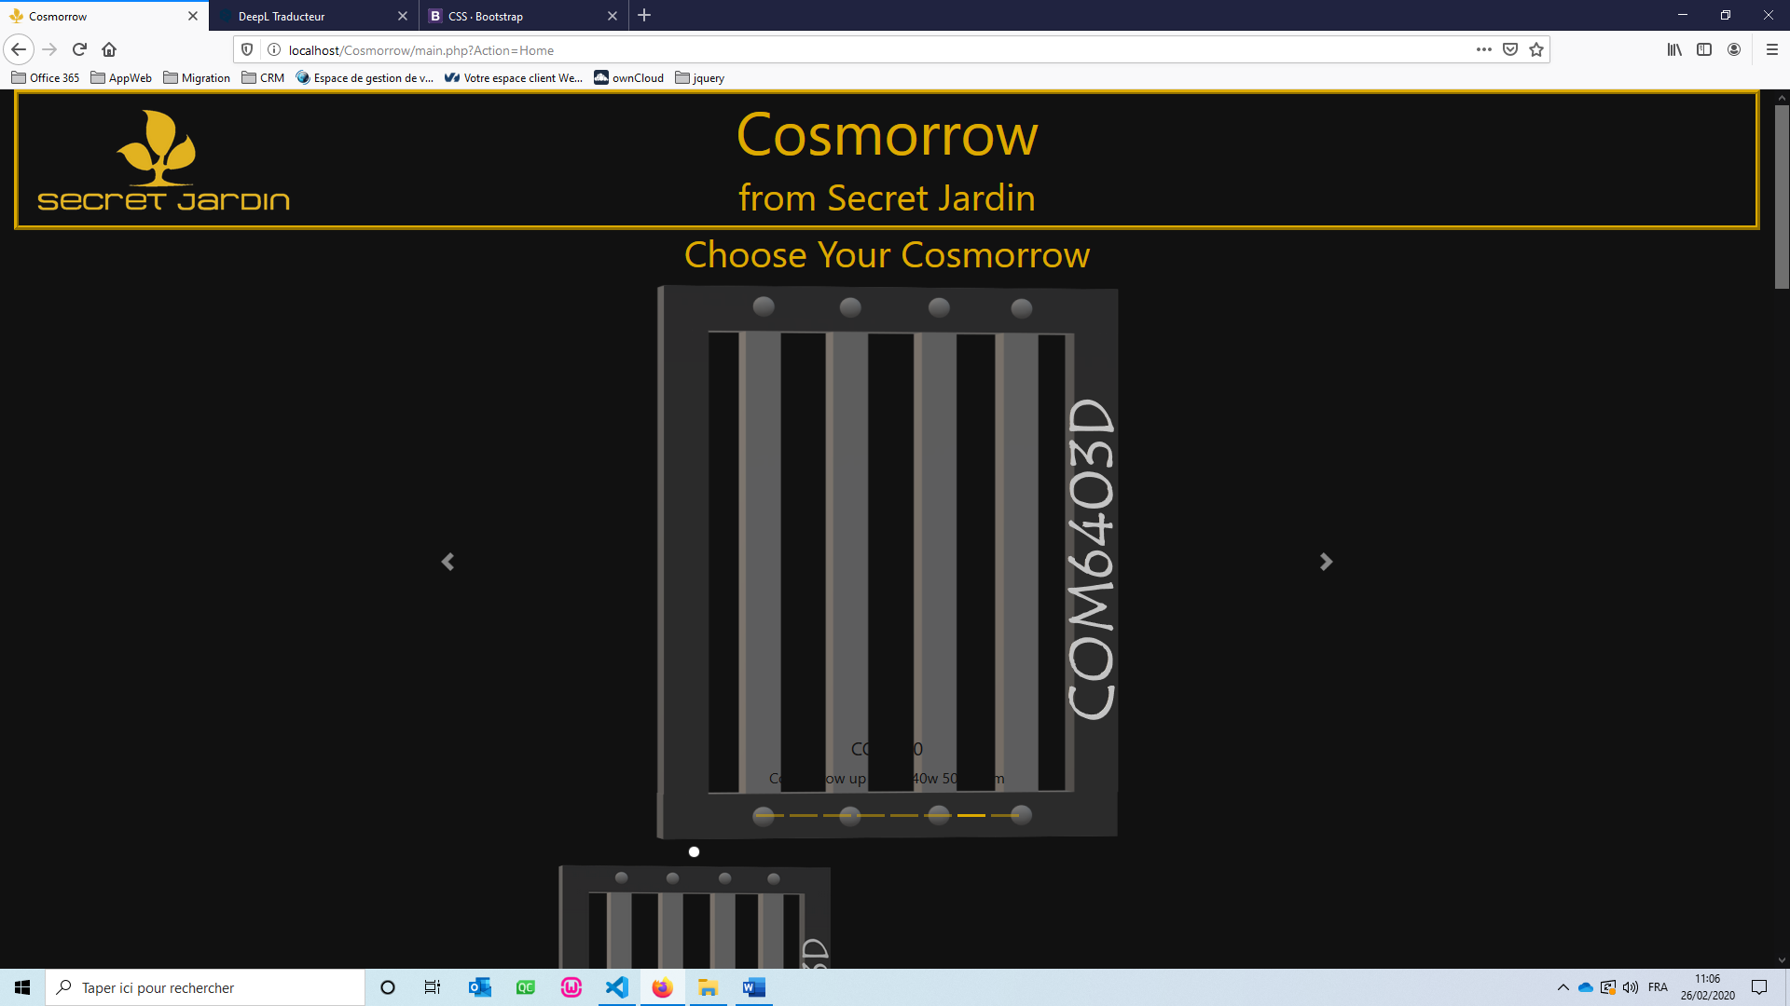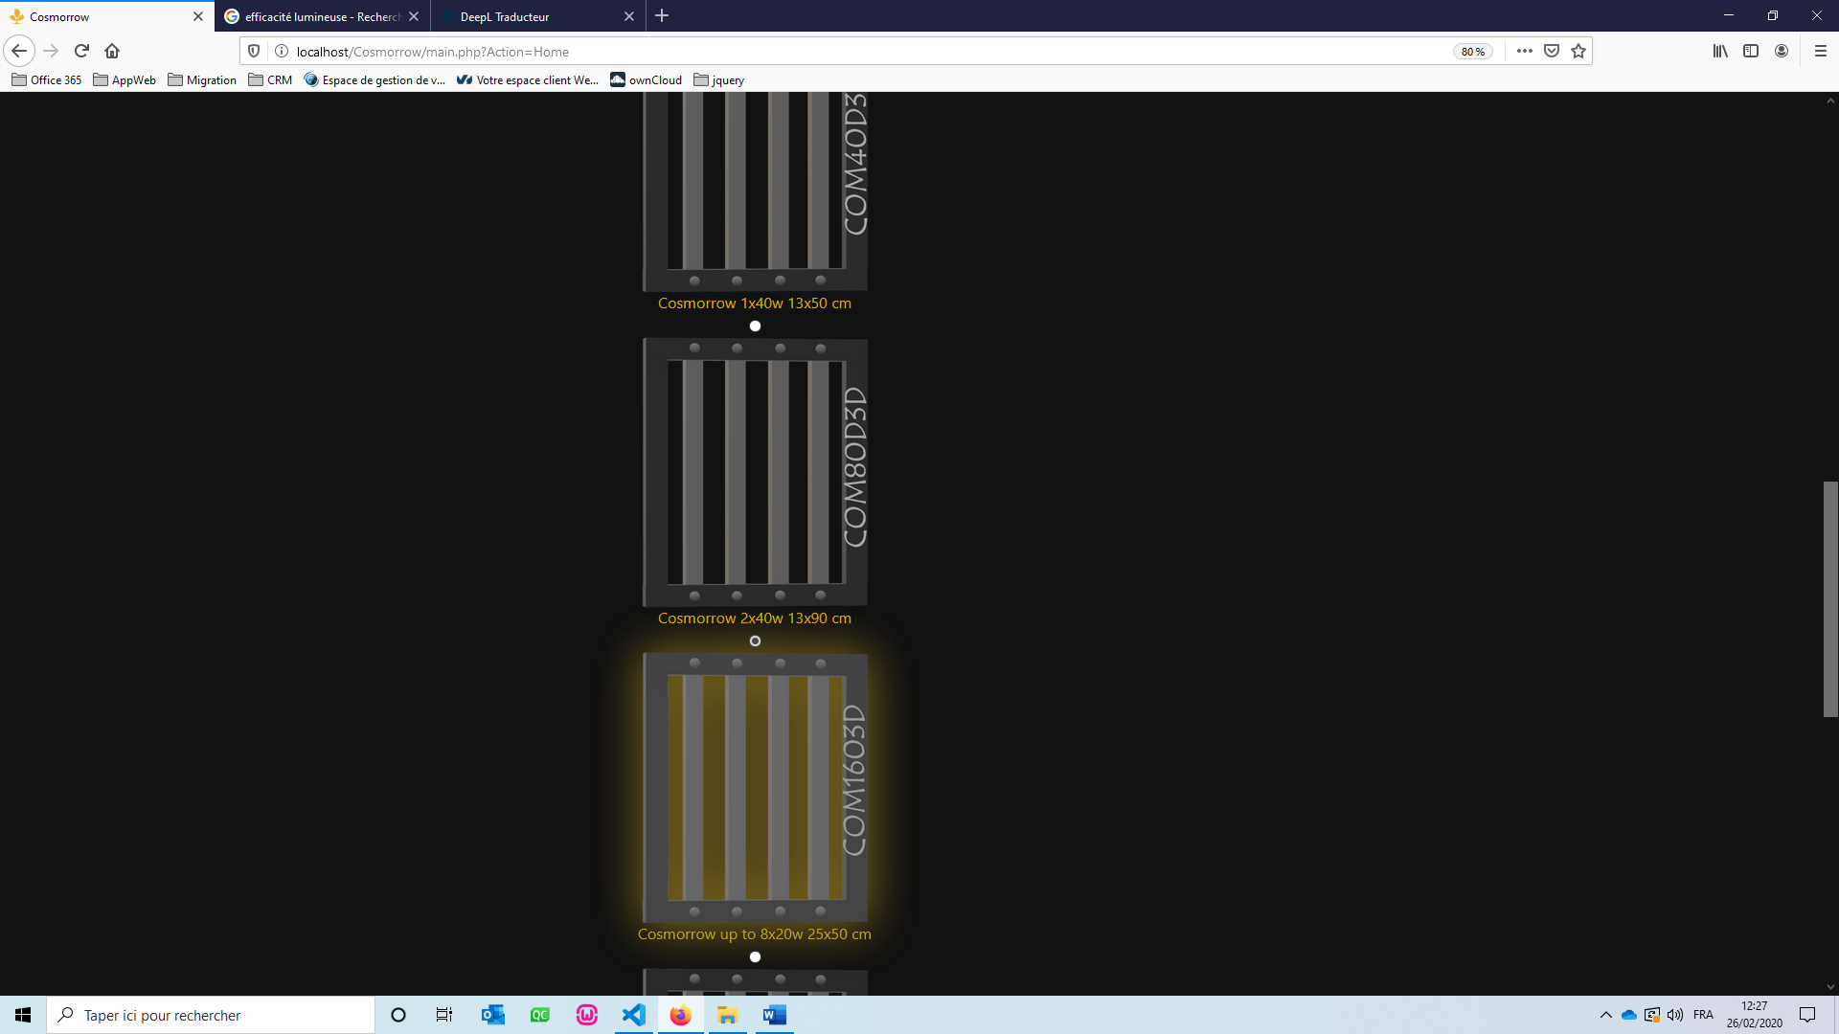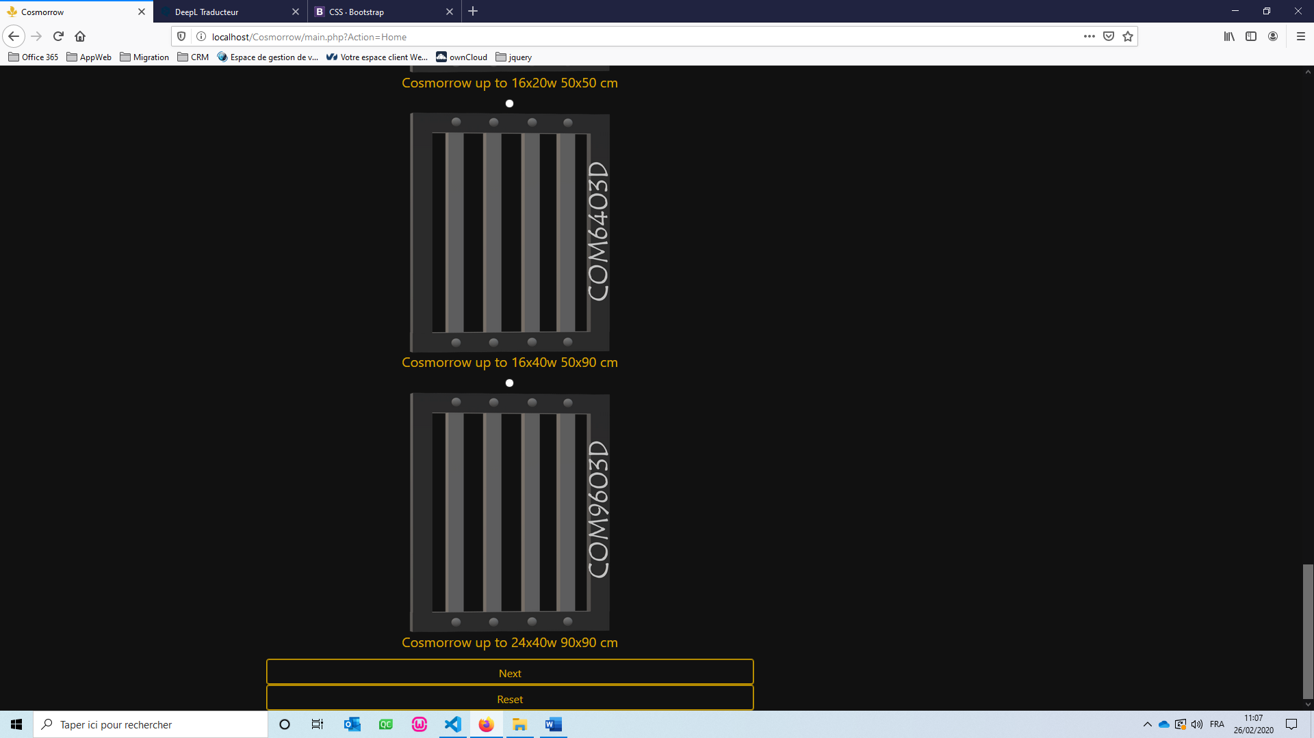

**Second Page : Cosmoleds selection**

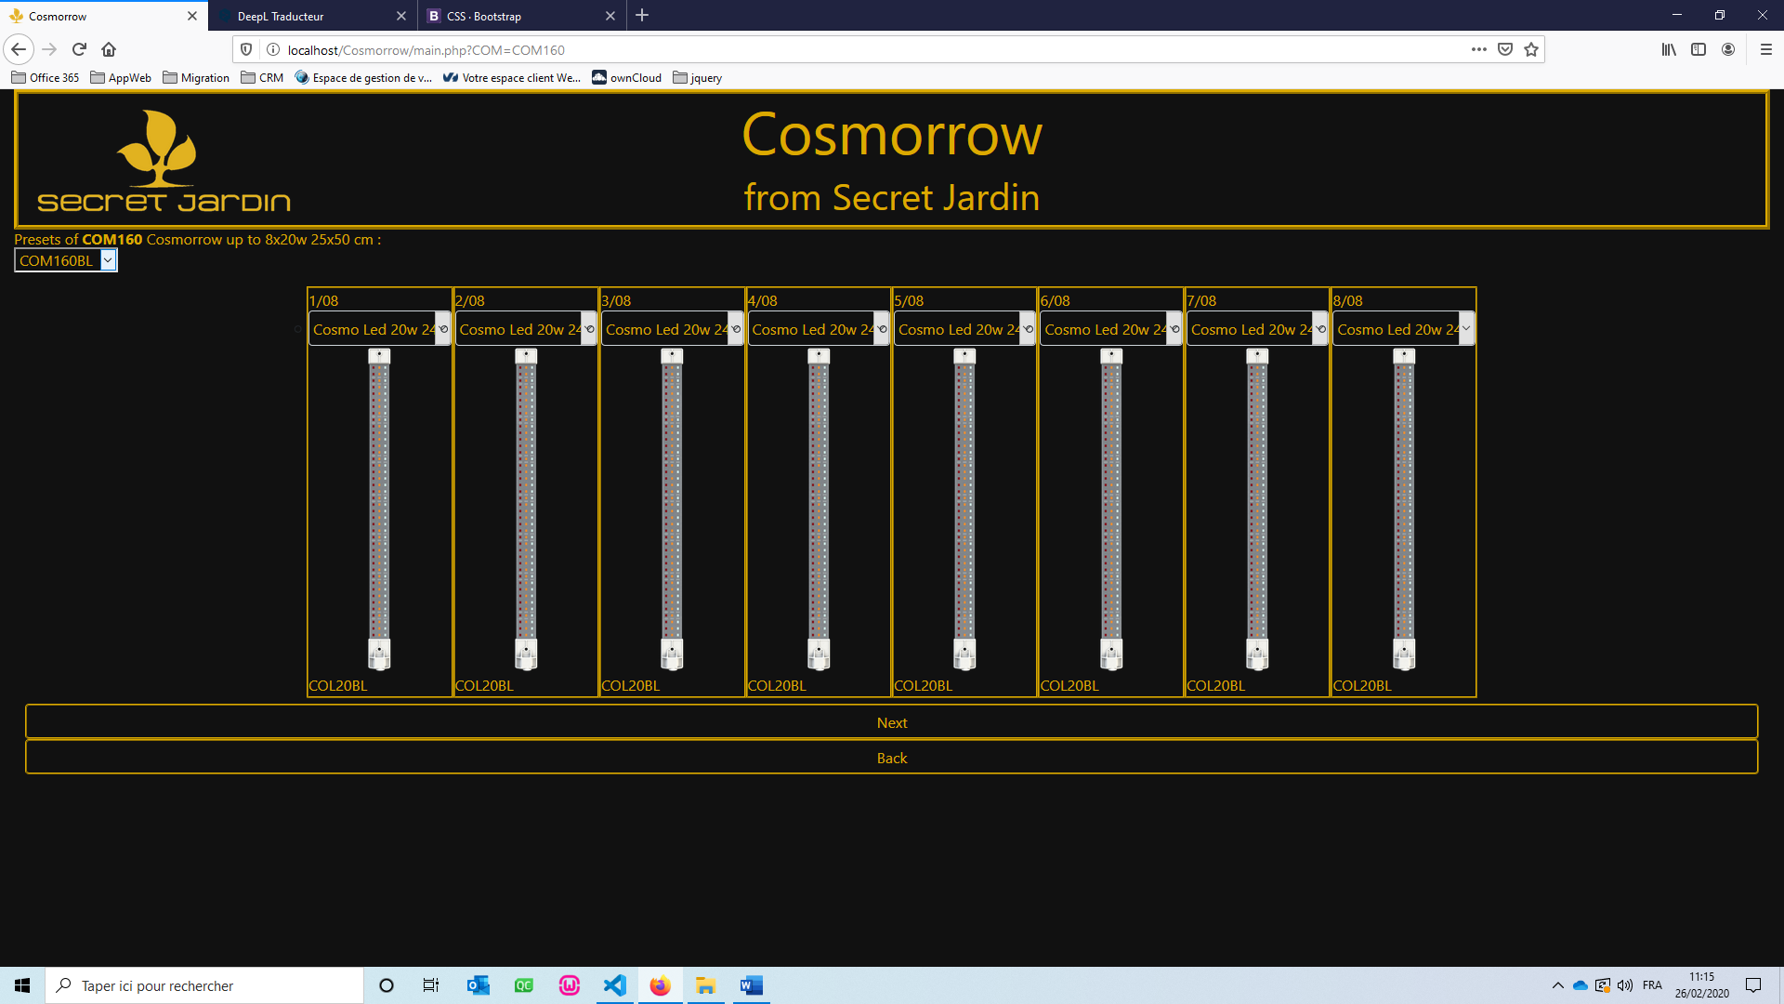

**Third Page: Rendering**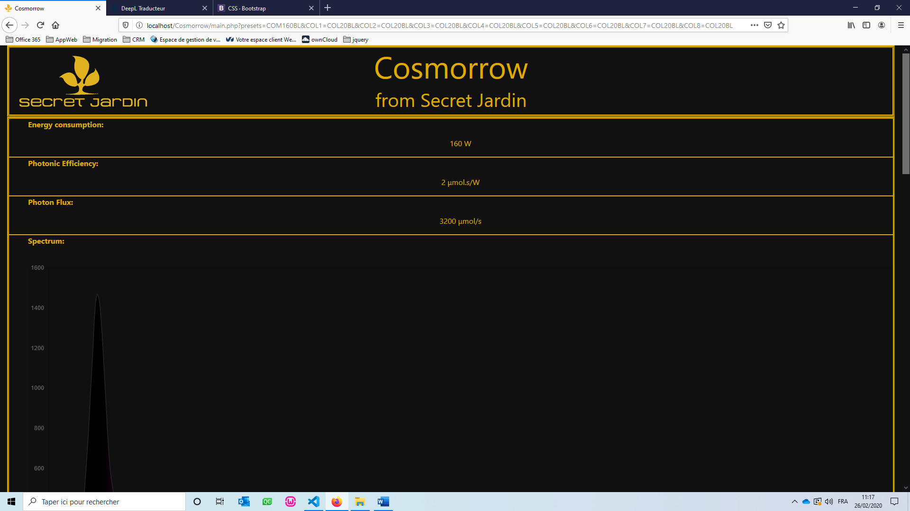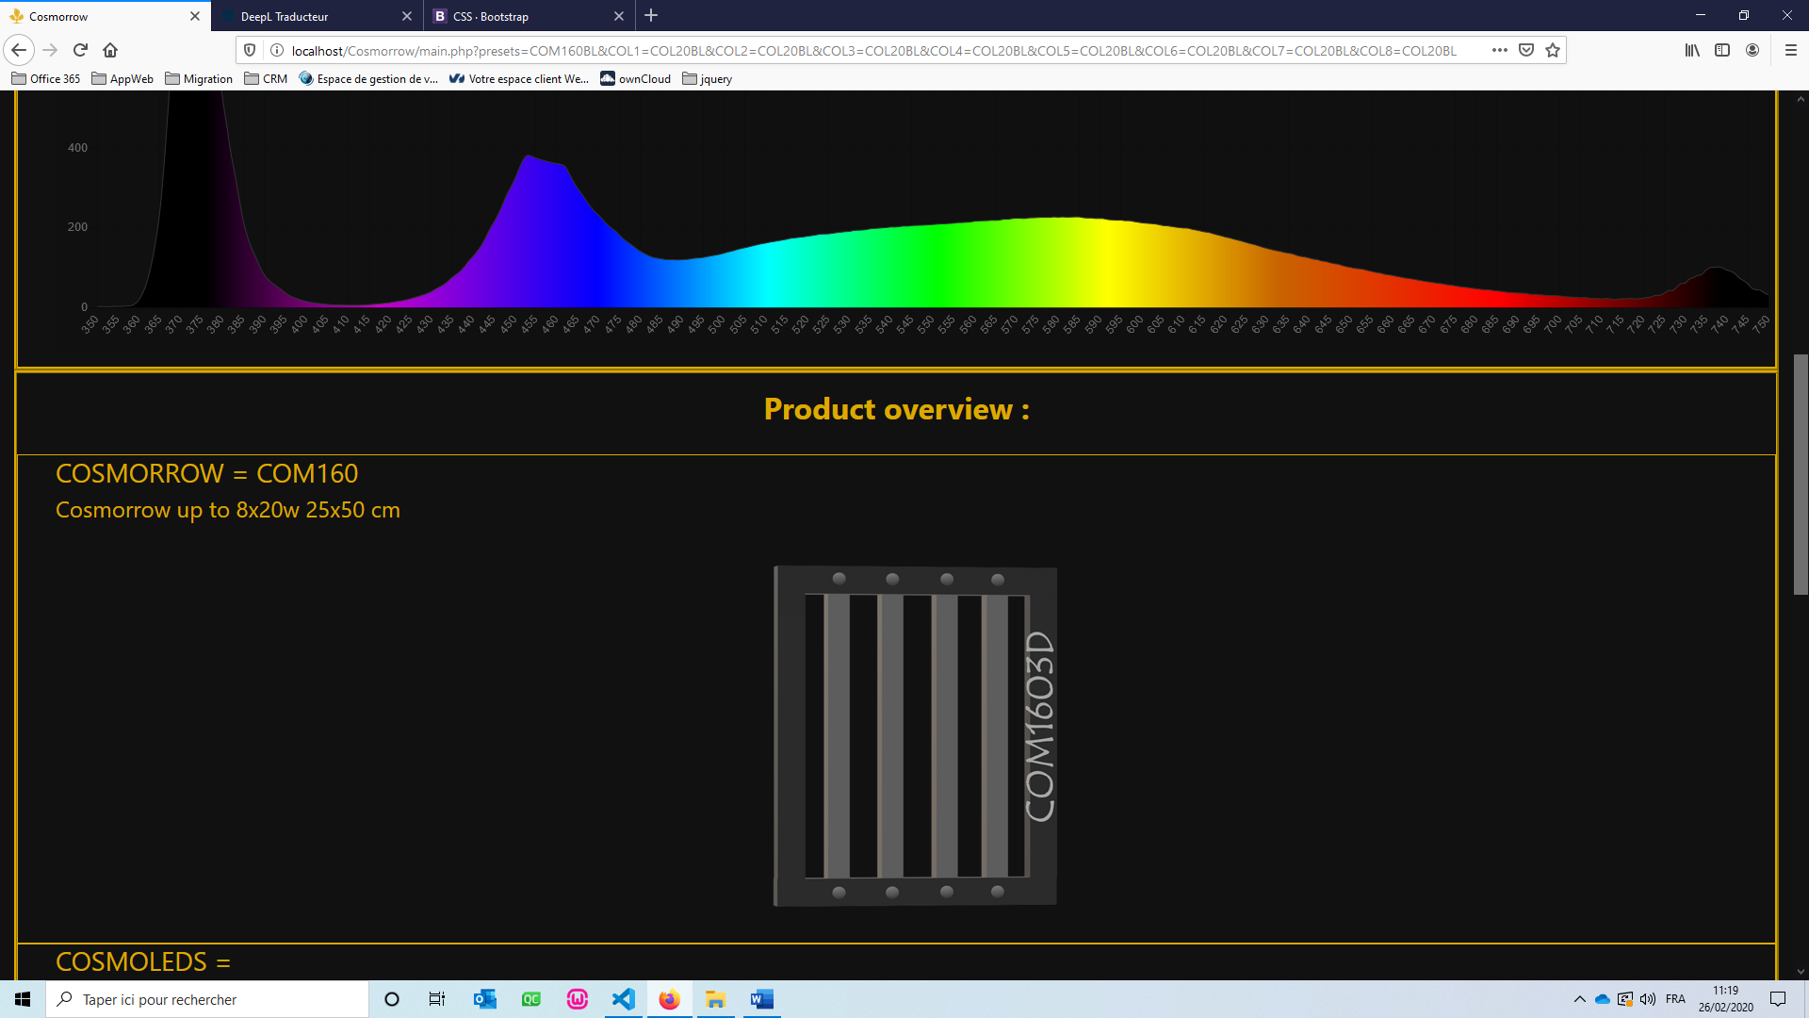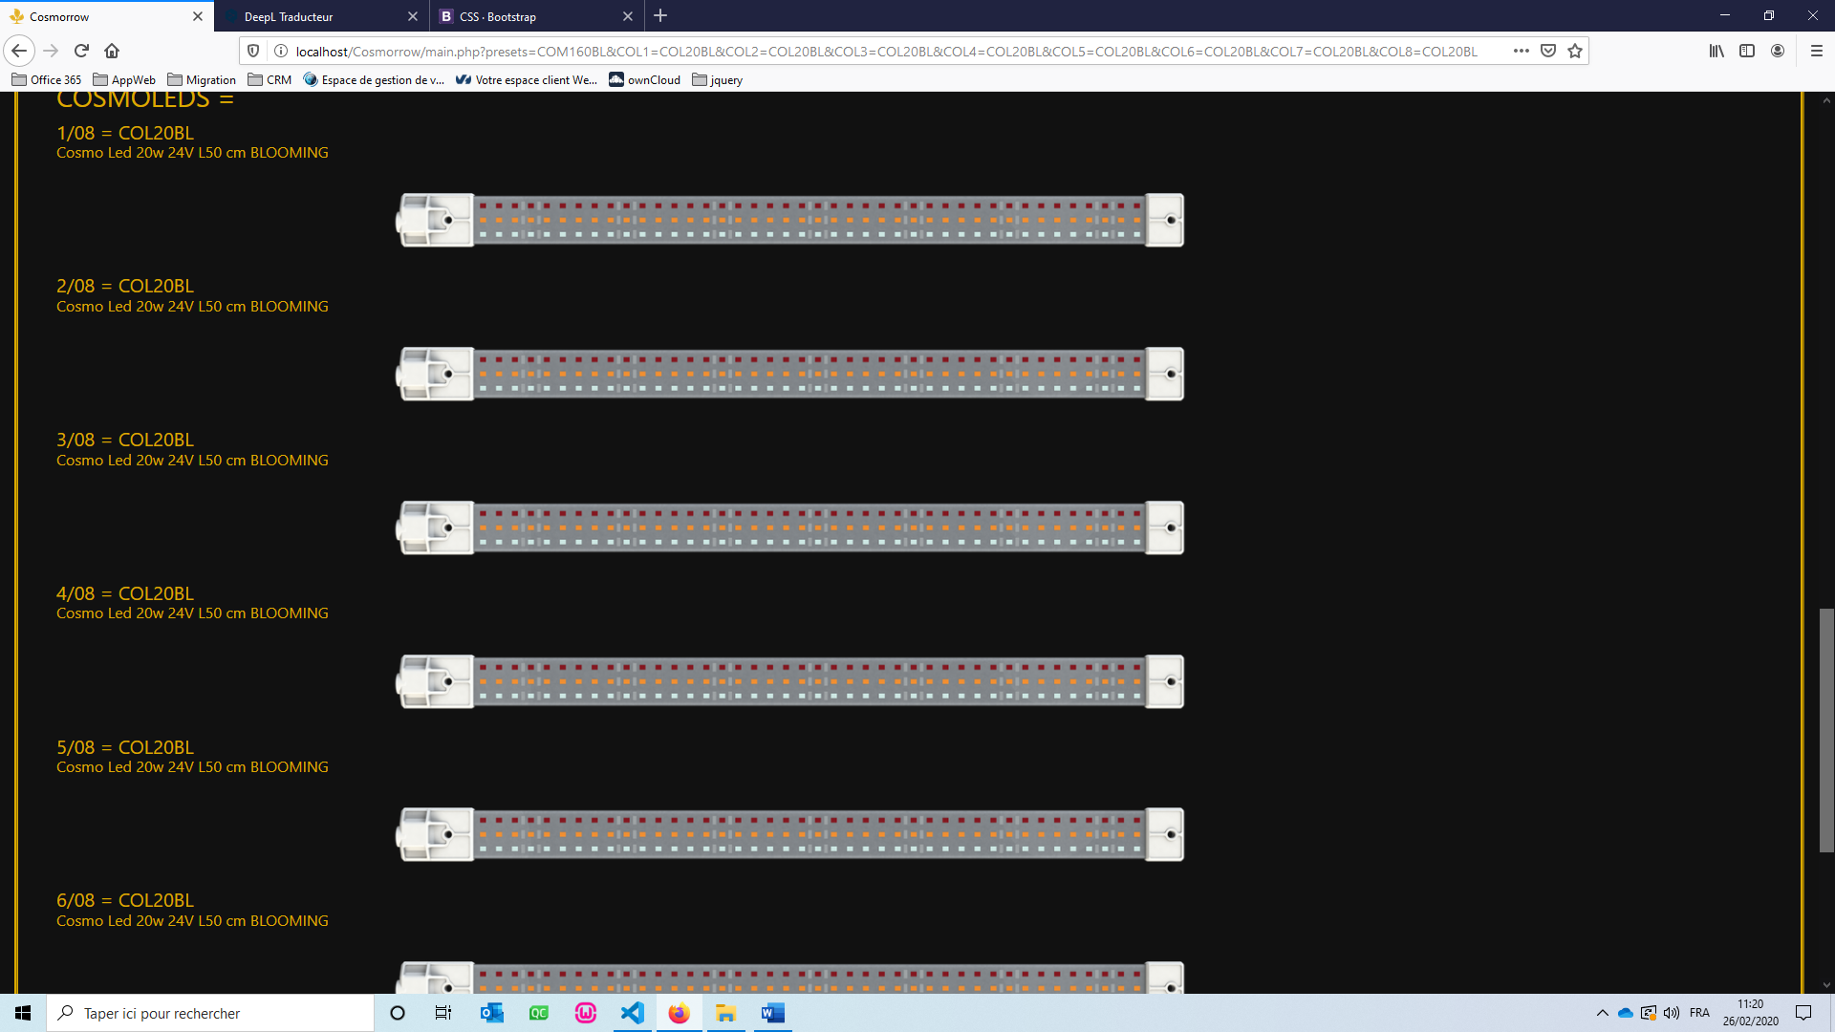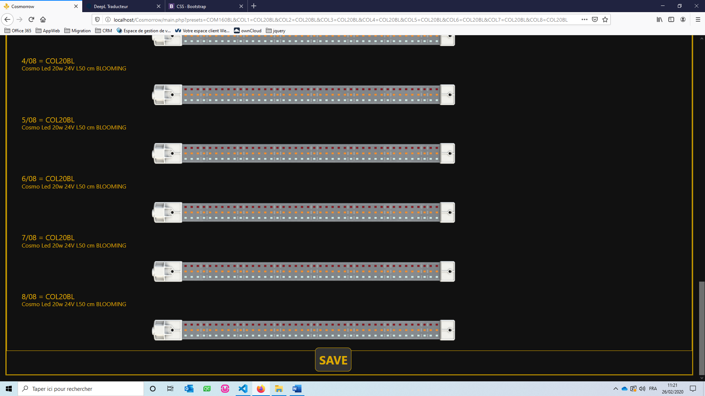

**PDF Rendering:**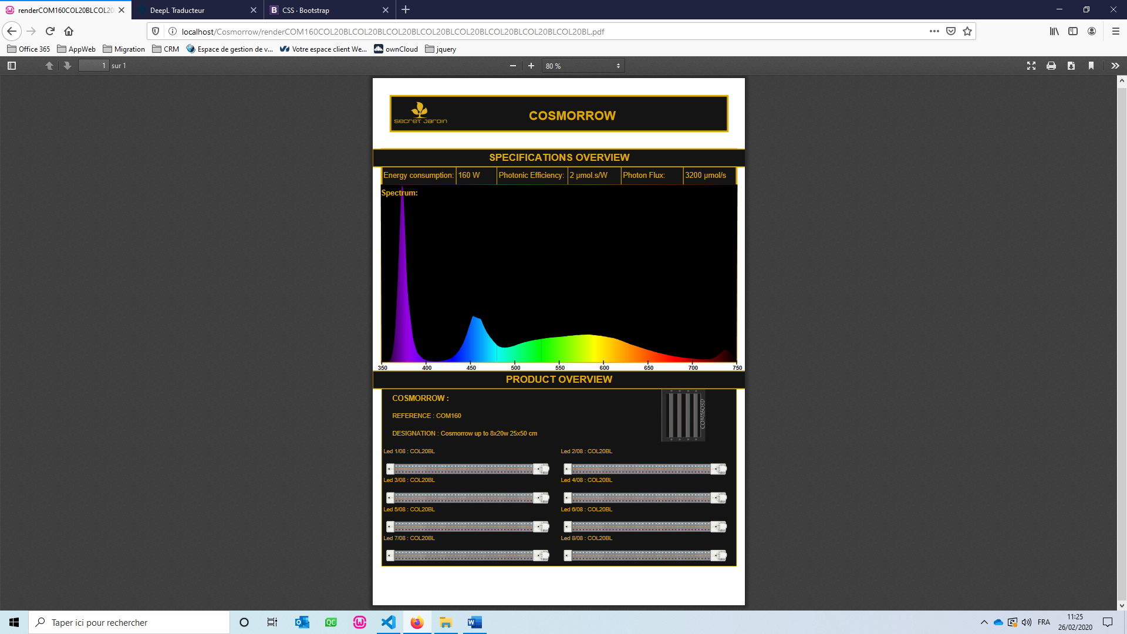

**DEVELOPMENT:**

**PATH TREE:**

**Cosmorrow**

main.php

**Controller**

controller.php

fileReader.php

**Resources**

**COL**

speccol.txt

COL20BL.txt

…

COL20BK.png

COL20BL.png

…

**COM**

speccom.txt

COM203D.png

COM403D.png

…

COM20BL.pre

COM20IR.pre

…

**fpdf182**

draw.php

fpdf.php

gradients.php

fpdf.css

**makefont**

…

**font**

…

**Pics**

BTNnext.png

BTNprev.png

misspix.png

SJhome.png

sjlogo.png

**Stylesheets**

cosmo.css

**Views**  
display.php  
pdfPage.php

**SYNTAX OF RESOURCES DOCUMENTS:**

**Cosmorrows referencing file:**

**Cosmorrow/resources/COM/speccom.txt:**

**<Reference1>;<Designation1>;<Pin1>;<Power1>;<Espacement1>;<PresetName1>,<PresetName2>;**

**<Ref2>;<Design2>;<Pin2>;...**

**Cosmorrows presets file:**

**Cosmorrow /resources/COM/*preset*.pre:**

**<ReferenceLED1>,<ReferenceLED2>,…**

**Cosmoleds referencing file:**

**Cosmorrow /resources/LED/specled.txt:**

**<ReferenceLED1>**

**<ReferenceLED2>**

**<ReferenceLED3>**

**…**

**Cosmoleds properties file:**

**Cosmorrow /resources/LED/*refled*.txt:**

**<ReferenceLED>**

**<DesignationLED>**

**<PowerLED>**

**<PELED>**

**<PFLED>**

**<SpectrumLED = <Lambda>,<Irradiance>;<Lambda>,<Irradiance>;...>**

**CODE DESCRIPTION:**

1. **Php files:**

main => calls the other pages, start sessions here, gets the data from the URL

display => generates the display of web pages

pdfPage => generates the PDF rendering

controller => manages the validity and processing of global data

fileReader => retrieve Cosmorrows and Cosmoleds properties from resource files and store the data in session variables

fpdf => library to generate PDF files

draw => extension of the fpdf library to generate graphics

gradients => extension of the fpdf library to generate gradients colours

1. **main.php:**

Includes class (display, fileReader and controller)

Instantiates those classes

Start session

Declares global variables

Initializes these variables by calling fileReader

retrieves and checks the validity of the data passed in the URL by sending it to controller

displays web pages

1. **display.php:**

Includes pdfPage

Creates class Display

Declares variables

Construct the class (initializes variables, Instantiates pdfPage)

Defines functions:

* getCOM() : To get the Cosmorrow selections form.
* getCOL() : To get the Cosmoleds selections form.
* getRender() : To get the rendering display
* setRender() : Returns the html code of the graph of the equivalent spectrum of the indicated LEDs.
* getPDF() : To generate and get the PDF
* printPage() : To get the html page

1. **controller.php:**

Creates class Controller

Declares variables

Construct the class (initializes variable)

Defines functions:

* verifAction() : To check the validity of the action passed in the URL
* verifCOM() : To check the validity of the selected Cosmorrow
* verifCOL() : To check the validity of the selected Cosmoleds

1. **fileReader.php:**

Defines functions:

* readCOMFile() : To read the Cosmorrows file and extract its properties
* getPresets() : To read the Cosmorrows presets and fill in the properties
* readCOMFile() : To read the Cosmoleds file and extract their names
* getCOLFiles() : To read and extract the Cosmoleds properties

1. **pdfPage.php:**

Includes the fpdf library and its extensions

Creates class PDFPage

Declares variables

Defines functions:

* Header() : To generate the PDF header
* Body() : To generate the PDF body
* Footer() : To generate the PDF footer
* Some of Html interpreter functions: WriteHTML(), OpenTag(), CloseTag(), SetStyle(), PutLink()
* setMatterial() : To get Cosmorrow and Cosmoleds Used
* setParamettrers() : To get properties of the system
* setSpectrum() : To get the spectrum light data

**(main) Session variables:**

    /************** Variables de session : ********************

    *  Action       =>              tableau des actions

    *   - Home          =>  affiche le formulaire des cosmorrows

    *   - Reset         =>  affiche le formulaire des cosmorrows

    *   - FormCOM       =>  affiche le formulaire des cosmorrows

    *   - ValideCOM     =>  verifie le cosmorrow selectionné

    *   - FormCOL       =>  affiche le formulaire des cosmoleds

    *   - ValideCOL     =>  verifie les cosmoleds selectionnées

    *   - Rendering     =>  affiche le rendu (nom des elements choisis, valeur de consomation, valeur de PF, valeur de PE, graphique du spectre d'absorbtion, schema du montage)

    *   - Download      =>  telecharge le PFD du rendu pour le client

    *

    *  COM          =>              cosmorrows selectionné

    *   - ref           =>  reference du cosomorrow

    *   - design        =>  designation du cosomorrow

    *   - pin           =>  nombres de pines du cosomorrow

    *   - pow           =>  puissance de consomation du cosomorrow

    *   - spacing       =>  espacement du cosomorrow

    *   - img3D         =>  chemin de l'image 3D du cosomorrow

    *   - img2D         =>  chemin de l'image 2D du cosomorrow

    *   - preset        =>  noms des presets du cosomorrow

    *       - col           =>  reference des cosmoleds du preset du cosomorrow

    *

    *  COL          =>              tableau des cosmoleds selectionnées

    *   - ref           =>  references des cosmoleds selectionnées

    *   - design        =>  designations des cosmoleds selectionnées

    *   - pow           =>  puissances de consomation des cosmoleds selectionnées

    *   - PF            =>  flux de photons des cosmoleds selectionnées

    *   - PE            =>  efficacités lumineuses des cosmoleds selectionnées

    *   - img           =>  chemins des images des cosmoleds selectionnées

    *   - spectrum      =>  spectres d'absorbtions des cosmoleds selectionnées

    *       - waveLength    =>  longueurs d'ondes des spectres

    *       - irradiance    =>  irradiances des spectres

    *

    *  COMList      =>              tableau des cosmorrows disponibles

    *

    *  COLList      =>              tableau des cosmoleds disponibles

    */

**Display class variables:**

//VARIABLES

    private $_html ; //Code html a afficher                      (String)

    private $_head;            //Entete de la page html                    (String)

    private $_style;           //Chaines de charactere des styles css      (String)

    private $_script;          //Chaines de charactere des javascript      (String)

    private $_header;          //Haut du corps de la page html             (String)

    private $_section;         //Section du corps de la page html          (String)

    private $pdf;              //Classe qui gere la creation d'un pdf      (PDFPage)

    public  $spectrumEQ;       //Tableau de données du spectre équivalant  (Array)

    public  $maxIrrad;         //Valeur d'irradiance la plus élevée        (Float)

**PDFPage variables :**

//VARIABLES

    protected   $_cosmorrow; //nom du cosmorrow

    protected   $_designCOM;         //designation du cosmorrow

    protected   $_cosmoleds;         //tableau des noms des cosmoleds

    protected   $_designCOL;         //tableau des designation des cosmoleds

    protected   $_COLref;            //ref des cosmoleds separes par des ', '

    protected   $_COLdesign;         //design des cosmoleds separes par des ', '

    protected   $_conso;             //texte de consommation en w

    protected   $_pe;                //texte de l'efficatite photonique

    protected   $_pf;                //texte du flux lumineux

    protected   $_spectrum = array();//tableau 1 du spectre d'absorption

    protected   $_spectrum2;         //tableau 2 du spectre d'absorption

    protected   $_spectrum3;         //tableau 3 du spectre d'absorption

    protected   $_spectrum4;         //tableau 4 du spectre d'absorption

    protected   $_spectrum5;   //tableau 5 du spectre d'absorption

    protected   $_spectrum6;         //tableau 6 du spectre d'absorption

    protected   $_spectrum7;         //tableau 7 du spectre d'absorption

    protected   $_spectrum8;         //tableau 8 du spectre d'absorption

    protected   $_spectrum9;         //tableau 1 du spectre d'absorption

    protected   $_spectrum10;        //tableau 2 du spectre d'absorption

    protected   $_spectrum11;        //tableau 3 du spectre d'absorption

    protected   $_spectrum12;        //tableau 4 du spectre d'absorption

    protected   $_spectrum13;        //tableau 5 du spectre d'absorption

    protected   $_spectrum14;        //tableau 6 du spectre d'absorption

    protected   $_spectrum15;        //tableau 7 du spectre d'absorption

    protected   $_spectrum16;        //tableau 8 du spectre d'absorption

    protected   $_imageCOM;          //image du cosmorrow avec les cosmoleds montées dessus

    protected   $_imageCOL = array();//images des cosmoleds

    protected   $_linkSJWeb = 'https://www.secretjardin.com';

//lien vers le site secret jardin

    protected   $_linkCosmoWeb = 'http://www.cosmorrow.com/Cosmorrow/main.php';

//lien vers le site cosmorrow