Jorge Ramirez

January 30, 2020

Lab 0, Section 0401

**Part A**

**QUESTION 1:** How would you create an array of all odd numbers up to 99?

odd_numbers = [1:2:99]

**QUESTION 2**: The example above is for only 10 numbers, and if you run the commands again you will get a slightly different answer. What values do the mean and standard deviation approach in the limit of a large number of random variables evenly distributed between 0 and 1?

The mean approaches 0.5, and the standard deviation approaches 0.2887.

**QUESTION 3**: Print your plot to an image file:

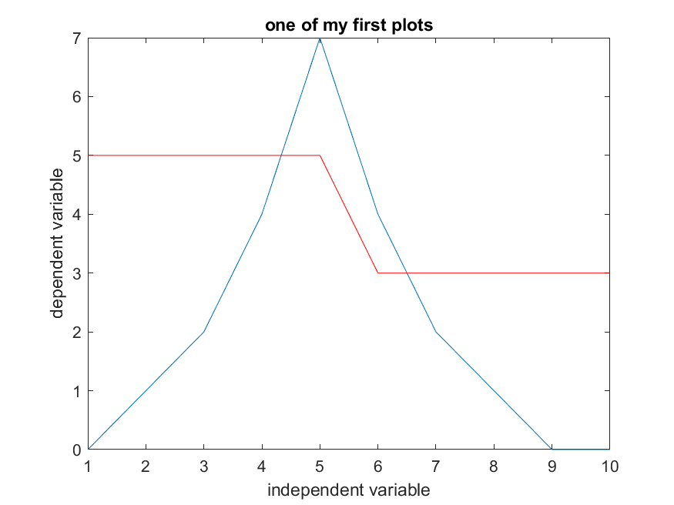

**QUESTION 4:** How can you construct an array of squares, like the one above, with a **one-line command** (i.e. without using a loop)?

Squares = [1:10].^2

**QUESTION 5**: What is the mean value of ii after this code executes a large number of times? Write a function and a script which calls the function to determine this.

clear

trials = 50000;

test = 0;

values = [];

while test < trials

ii=1;

while rand<0.9

ii=ii+1;

end

values = [values; ii];

test = test + 1 % print to show progress

end

mean_val = mean(values)

std_val = std(values)

The mean value of ii is 9.9291 and the st dev is 9.4782.

**Part B**

%script to move 2mm

clear;

h=load_labjack;

counter = 0

mm_movement = 2; % how many mm to move

conversion = 10000; % 10,000 steps per mm

while (counter < (mm_movement * conversion))

lj_step(h)

counter = counter + 1

end

**Part C**

The output saturates on the “30” setting, so I will keep it on the “20” setting to prevent saturation.

When you block the laser or close the aperture, then the signal drops to almost 0. The signal is not 0 because of noise intrinsic to the photodiode’s internal circuits.

The RMS value of the voltage signal at the peak represents the most trustworthy value for what voltage signal the photodiode is trying to report.

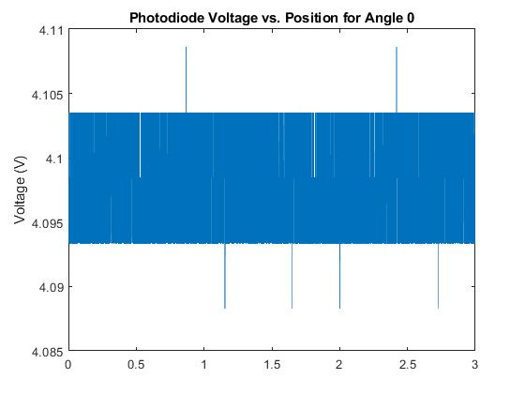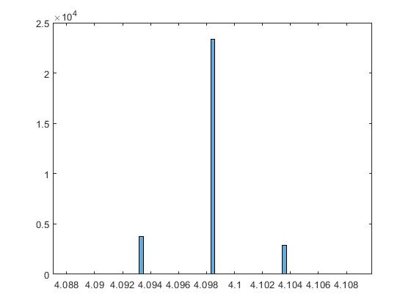

**Part D**