Jorge Ramirez

Lab 1, Section 0401

**Part A**

**A.6 & A.7 …find θC and from that calculate n2…then redo from opposite direction.**

These are the first values I obtained. The decimal place was determined using the Vernier scale.

CCW Rotation

About 42.5°

n2 = 1.481

CW Rotation

About 41.5°

n2 = 1.509

**A.8 …What are possible uncertainties? Estimate the two largest sources**

My expected uncertainties, in order from highest to lowest, with my plan for the highest two

1. Nonzero starting angle (±0.5°)
   * I addressed this by spending copious time aligning the beam and mount. First, I set the mount to some random angle and locked the mount to face me, then I placed the prism and let the beam pass through the prism. I then noted where the reflected beam was, and then I rotated the **top half of the** **mount** until the reflected beam was shining directly back onto the laser source. Once they were aligned (vertically for the laser tilt, horizontally for the nonzero starting angle), I locked the mount into place and then set the zero back so that the zero/zero reading had the reflected beam go back into the laser. After this process, the reflected beam would stay on the laser to within ±0.5°
2. Fuzziness that affects determining θC
   * I addressed this by taking two measurements for each θC. In this process, I took a **low** measurement where I measured the critical angle for when the reflected beam *mostly disappeared* **(Low)**, and when the beam has *completely 100% disappeared* **(High)**. Since I expect the true θC to be somewhere in this range, I decided that the final reported value should be the average of these two values, and then the uncertainty to be difference in these two values divided by the square root of two.
3. Laser vertical tilt was addressed by the procedure for (1) but making sure the laser beam was vertically aligned with the reflected beam in addition to horizontally.
4. Glass imperfections would certainly play a role in the difference between CW & CCW measurements, but measuring this would be time consuming since I would need to take several prisms and then compile a list of data to then statistically determine the variance in values.

**A.9 & A.10 …implement your plan… do your values of θC agree within uncertainty?**

After implementing my plan for minimizing uncertainty from (1) and (2), I received these values for θC. The Vernier scale was used to measure the angle to a precision of a tenth of a degree, and the uncertainty was determined by

**CCW Rotation**

Low θC – 42.1°

High θC – 42.7°

**Uncertainty in Measurements**

1. Nonzero angle - ± 0.5°
2. Fuzziness
   * Low/High Avg – 42.4°
   * Uncertainty – (0.5/sqrt(2)) = 0.35°

**Final Value**

42.4° ± 0.35°

n = 1.483 ± 0.35°

**CW Rotation**

Low θC – 41.5°

High θC – 43.1°

**Uncertainty in Measurements**

1. Nonzero angle - ± 0.5°
2. Fuzziness
   * Low/High Avg – 42.3°
   * Uncertainty – (0.5/sqrt(2)) = 0.35°

**Final Value**

42.3° ± 0.35°

n = 1.486 ± 0.35°

My final values for CW and CCW agree within uncertainty given the precision of the experiment, however given that I only made four measurements and only analyzed two sources of uncertainty, the range of acceptable values given my uncertainty of ±0.35° is quite large, so the fact that these two values almost exactly match is dubious.

**Part B**

**B.5 How should the iris be set to get the best measurement? Why? How should the aperture and gain be set?**

I set the iris to the smallest setting where I still received a measurable signal when the laser beam passed over the photodiode. The smallest setting of the iris lowered the aperture to the point where the laser profile was a visible Lorentzian when plotted against time. This was critical to measuring the peak critical angle, since a very wide Lorentzian with a well-defined peak will lower my uncertainty of what x-value should be taken as the highest intensity.

I monitored the gain and increased it when the incident angle caused the transmitted beam to lose a significant amount of power. By increasing the time the beam spends inside the prism, more and more of the beam is scattered due to imperfections in the prism. Therefore, as a part of my recalibration between measurements, I checked the laser profile and made sure that the gain was set high enough to have a visible beam profile (and of course, that the beam was not oversaturated).

**B.9D How will you make sure the translation stage doesn’t wander during the run due to the mechanical jiggling due to the motor?**

I used a script called move_motor() to fine-tune the starting position of the motor. I noted where the first angle and last angle had their transmitted beam, and then chose a starting position and ending position that encompassed all angles so that every laser profile for every measurement can lie on the same interval.

As a part of this, I made sure that the matlab code I used to take data would return the photodiode to the starting position. In order to combat hysteresis causing the starting position to wander, I assigned the starting position to be the same for every single measurement (14.0cm) using the ruler. I then generously assigned the uncertainty in the starting position to be about 1/4th of a cm since I was centering the photodiode’s position marker directly onto the 14.0cm tick mark.

**B.10 Calculate the distance D**

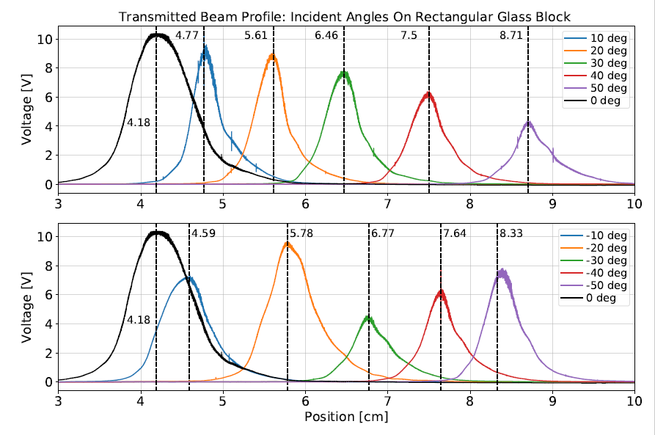



The final laser profiles for each angle are shown above, with the first plot containing the CW angles, and the second plot containing the CCW angles. The voltages tend to vary since the gain on the photodiode was switched around and the intensity dropped as I went to higher incident angles. This loss of intensity should not affect the peak detection since all peaks have a relatively well-defined peak, which was detected using scipy.signal.find_peaks() function.

The second image shows the actual x-position values for the peak at each angle, and the values for d can be calculated by subtracting each peak position from the 0 deg reference.

|  |  |
| --- | --- |
| Difference | Variation |
| 0.3759 | 8.31% |
| -0.1414 | -4.26% |
| -0.3042 | -13.35% |
| -0.1713 | -12.03% |
| 0.1762 | 30.22% |

|  |  |
| --- | --- |
| CW Angle | Distance d [cm] |
| 50 deg | 4.5225 |
| 40 deg | 3.3186 |
| 30 deg | 2.2791 |
| 20 deg | 1.4235 |
| 10 deg | 0.5831 |

|  |  |
| --- | --- |
| CCW Angle | Distance d [cm] |
| -50 deg | 4.1466 |
| -40 deg | 3.4600 |
| -30 deg | 2.5833 |
| -20 deg | 1.5948 |
| -10 deg | 0.4609 |

**B.11 Calculate the angle of refraction**

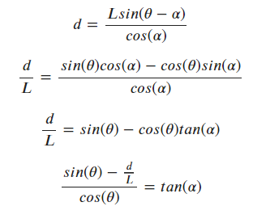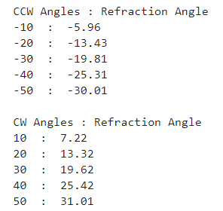

**B.12 Calculate n. Is it what you expected?**

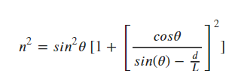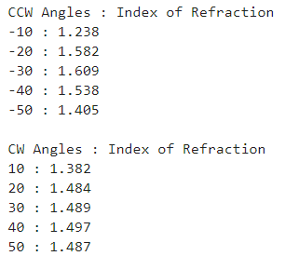

These values are mostly what I expected. A google search told me that a glass prism has anywhere from 1.4 to 1.6 index of refraction. The CW seem to be in good agreement with that range, but the CCW angles are much more spread out.

The average value for n is 1.4708, and the standard deviation is 0.1074.

**B.13 & B.14 What are possible random and systematic uncertainties? Calculate the uncertainty on n.**

1. Nonzero starting angle (±0.5°)

* This was the same uncertainty from part A that I minimized by aligning the rotating mount very carefully. This uncertainty is systematic and propagates through to my calculation of n.

1. Imperfections in the glass (±0.1074 in n)

* I measured this by taking the standard deviation of n from section **B.12**. The standard deviation in n for all CW and CCW values was 0.1074. This is a systematic error since the glass has a “true” value for n, and the value that I calculate will fluctuate around that true value.

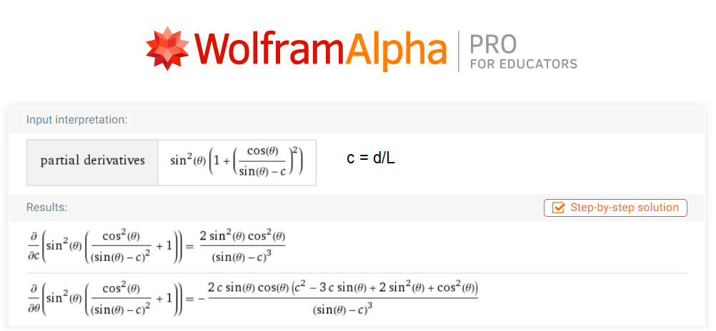

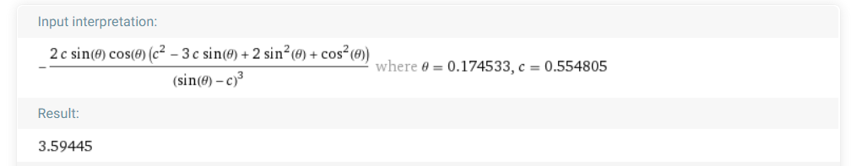For c = d/L = (0.5831 cm) / (10.51 mm) = 0.5548, the partial evaluated at 10 degrees has a value of 3.59445. Taking this and multiplying by the uncertainty in θ gives an error of about 1.79, which is much too high for an n of 1.4708.

**B.18 Make a plot of the sine of the angle of refraction versus the sine of the angle of incidence for at least four angles and use this to determine the index of refraction for the block and its uncertainty.**

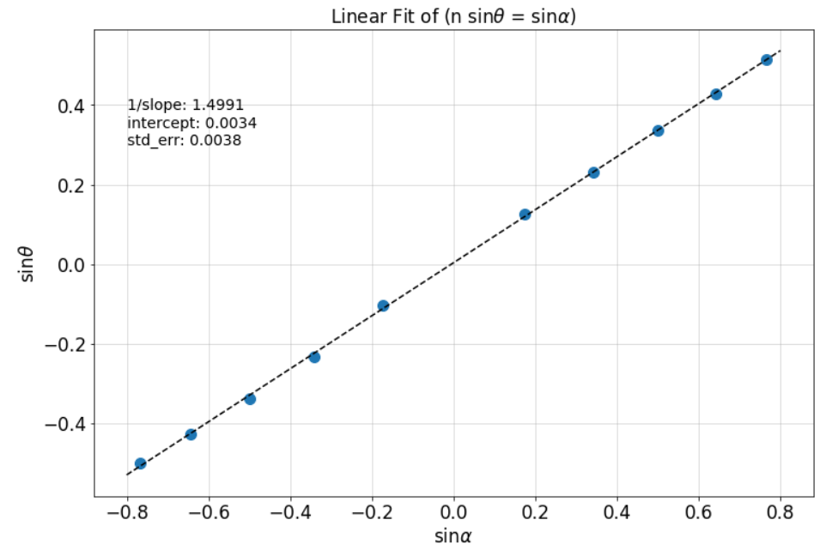

My value of n is 1.4991, since it is the inverse of the slope. This is in relatively good agreement with my previous value of n, but the uncertainty is much too small. The linear fit did not account for the error in my data.

**B.19 Compare your result to what you got in earlier. How do the values compare? Their uncertainties?**

The values seem to be very close to each other in regards to the standards of the equipment, 1.4991 vs 1.4708, but the uncertainties are no where near in agreement, since the linear fit has an error of 0.0038 and the error propagation of the angle through the equation for n gives 1.79.