Site-Level Analysis of HEMS Data

Hans Lehndorff

# Site level analysis of Site 1046.

Site 1046 is located near Snohomish County, Washington.

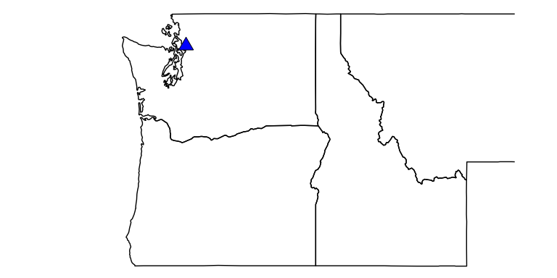

## This is the typical load profile for this site.

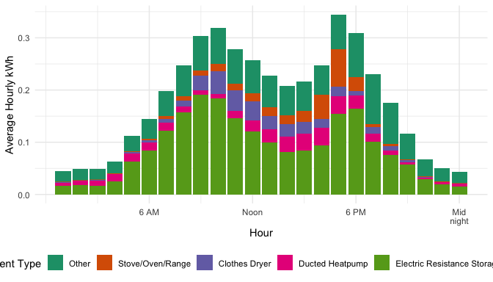

## Change in March to October energy usage between 2019 and 2020 (non-weather normalized).

### Dishwasher usage increased by 38.13%

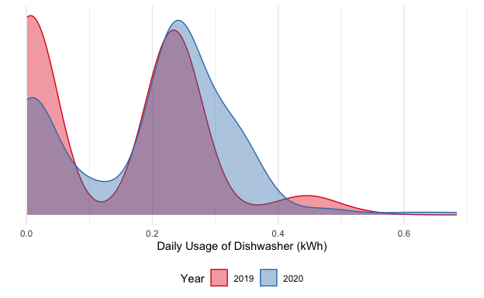

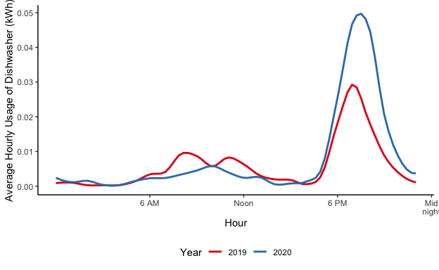

### Stove/Oven/Range usage increased by 29.48%

