Site-Level Analysis of HEMS Data

Hans Lehndorff

# Site level analysis of Site 4141.

Site 4141 is located near Deschutes County, Oregon.

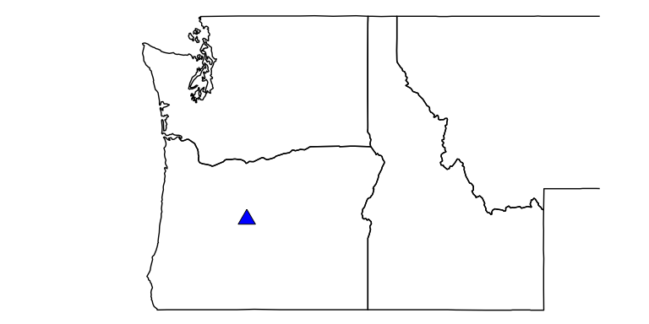

## This is the typical load profile for this site.

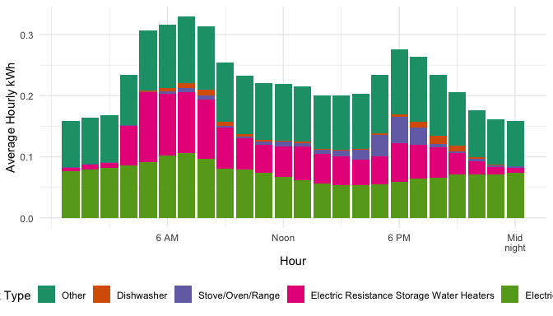

## Change in March to October energy usage between 2019 and 2020 (non-weather normalized).

### Electric Resistance Storage Water Heaters usage decreased by 12.40%

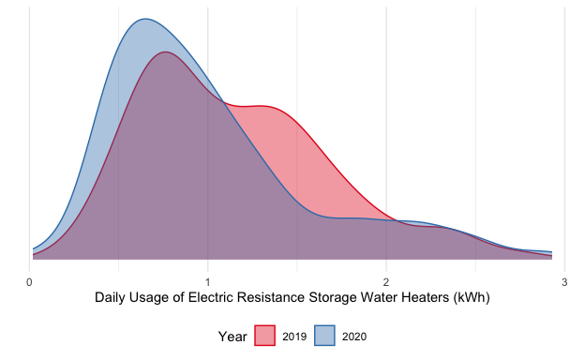

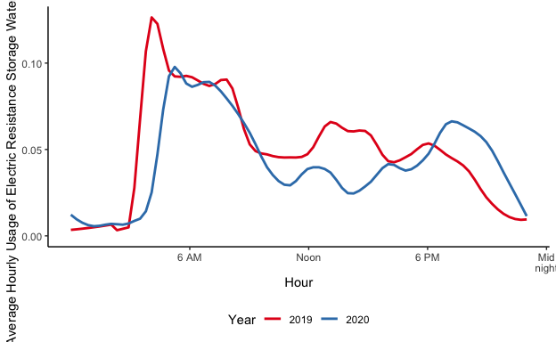

### Electric Baseboard Heaters usage increased by 4.46%

