Site-Level Analysis of HEMS Data

Hans Lehndorff

# Site level analysis of Site 8271.

Site 8271 is located near Multnomah County, Oregon.

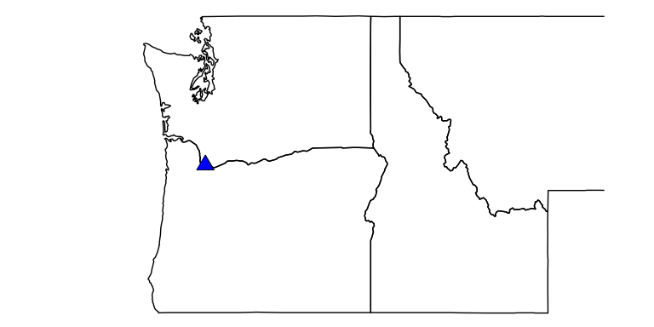

## This is the typical load profile for this site.

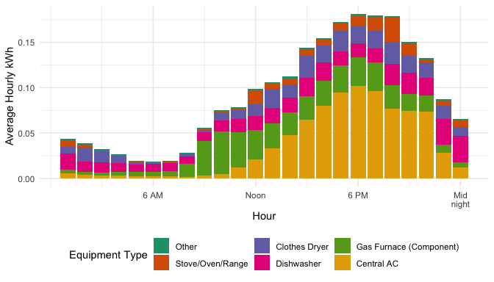

## Change in March to October energy usage between 2019 and 2020 (non-weather normalized).

### Clothes Dryer usage decreased by 58.62%

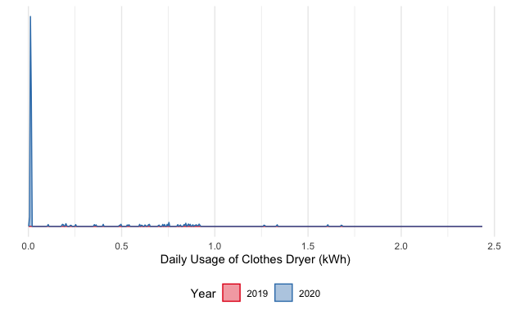

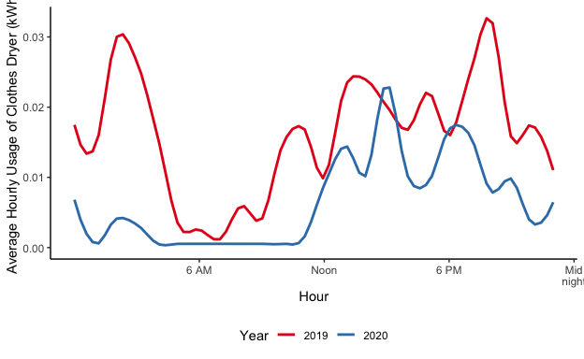

### Stove/Oven/Range usage decreased by 44.21%

