Site-Level Analysis of HEMS Data

Hans Lehndorff

# Site level analysis of Site 9251.

Site 9251 is located near King County, Washington.

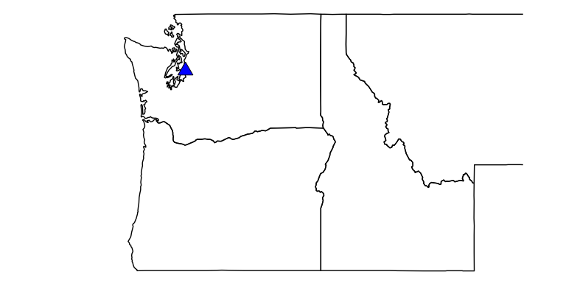

## This is the typical load profile for this site.

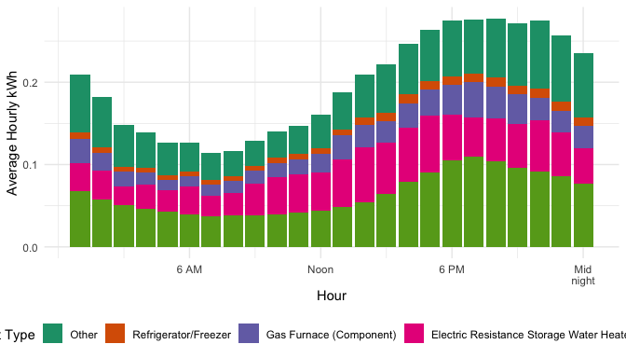

## Change in March to October energy usage between 2019 and 2020 (non-weather normalized).

### Electric Resistance Storage Water Heaters usage decreased by 59.99%

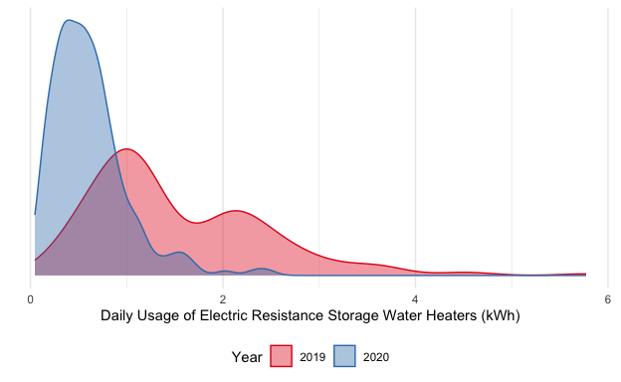

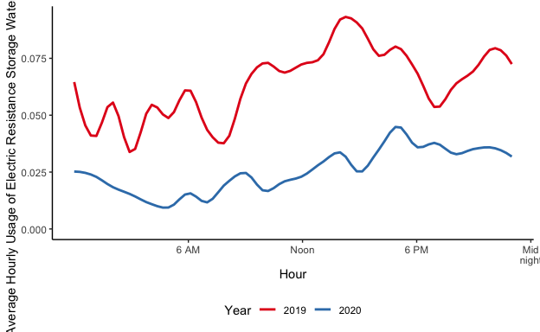

### Clothes Dryer usage decreased by 37.93%

