Site-Level Analysis of HEMS Data

Hans Lehndorff

# Site level analysis of Site 9896.

Site 9896 is located near Clark County, Washington.

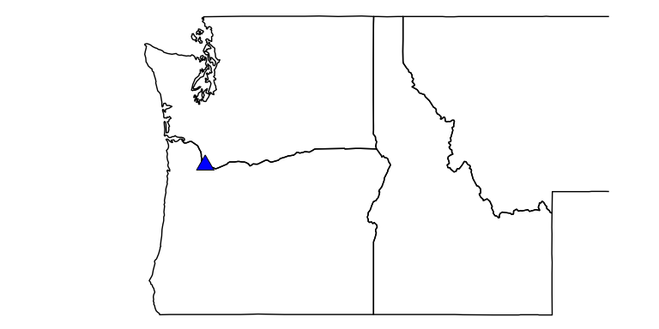

## This is the typical load profile for this site.

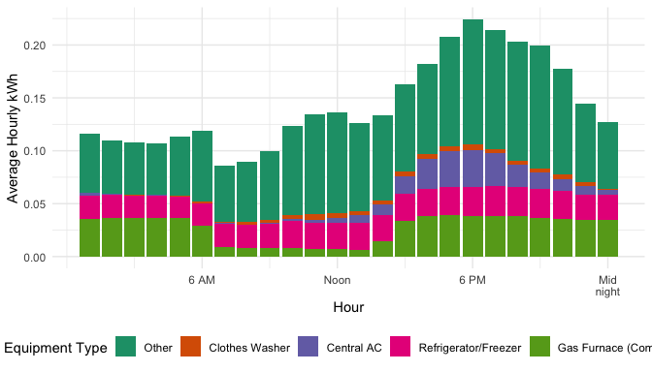

## Change in March to October energy usage between 2019 and 2020 (non-weather normalized).

### Central AC usage increased by 88.05%

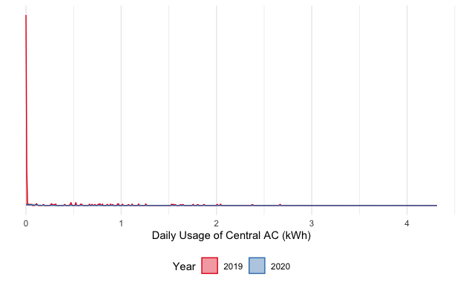

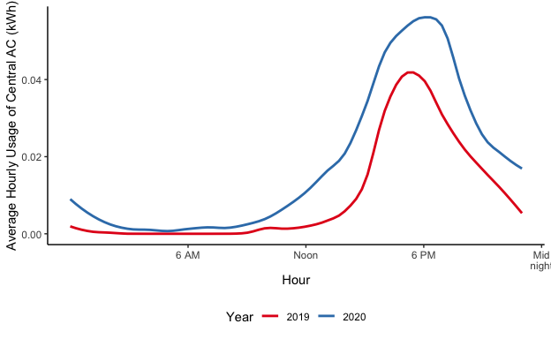

### Gas Furnace (Component) usage increased by 20.66%

