LAB 7
Tên: Lê Huyền Thục
Lớp: 11_CNPM2
MSSV: 1150080119

Bài thực hành 1: Hiển thị dữ liệu trên Control DataGridView
Tạo 1 project mới trong VisualStudioCode
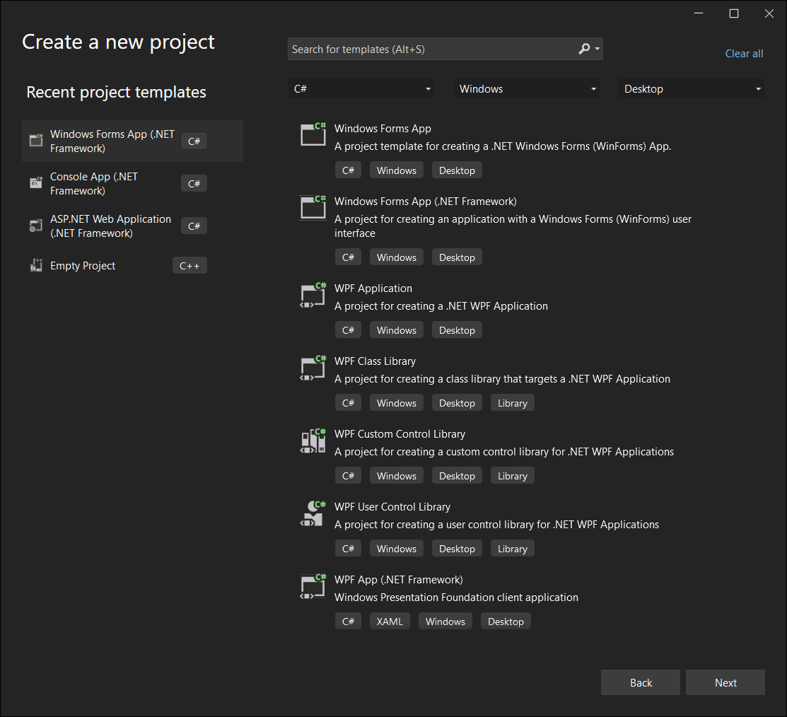
Thiết kế WinForm cho giống bài lab
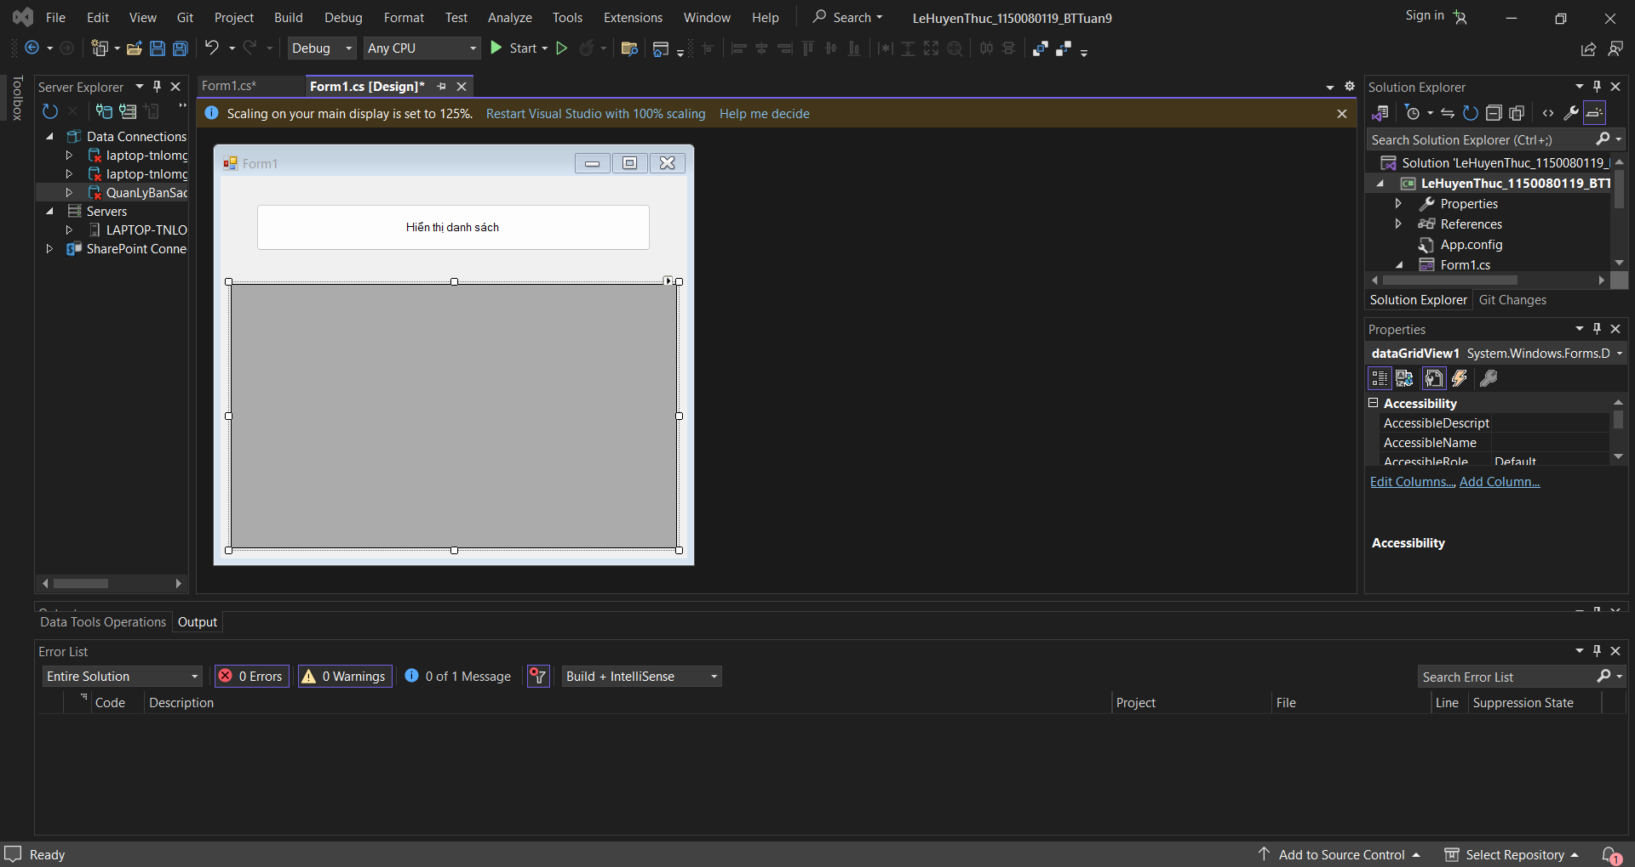

Nhấp chuột phải vào Project Add New Item Data Service-based Database
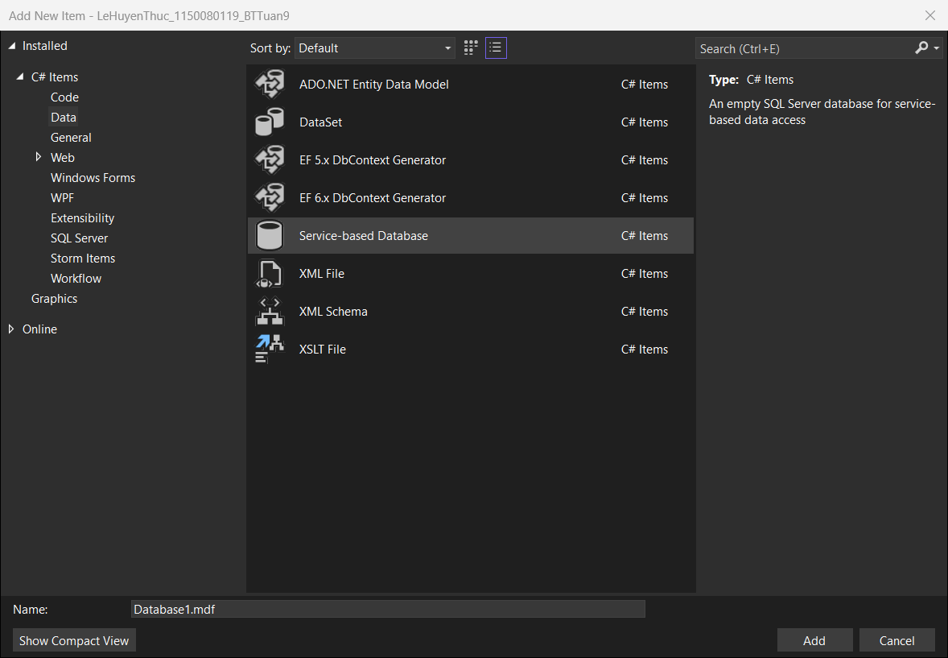
Đặt tên là QuanLyBanSach.mdf
Sau đó copy Connect String rồi bỏ vào Form1.cs
Form1.cs:
using System;
using System.Data;
using System.Data.SqlClient;
using System.Windows.Forms;

namespace LeHuyenThuc_1150080119_BTTuan9
{
public partial class Form1 : Form
{
// Dùng |DataDirectory| để tránh lỗi đường dẫn khi run
private readonly string strCon =
@"Data Source=(LocalDB)\MSSQLLocalDB;AttachDbFilename=|DataDirectory|\QuanLyBanSach.mdf;Integrated Security=True";

private SqlConnection sqlCon = null;

public Form1()
{
InitializeComponent();
}

private void Form1_Load(object sender, EventArgs e)
{
// TODO: This line of code loads data into the 'quanLyBanSachDataSet.NhaXuatBan' table. You can move, or remove it, as needed.
this.nhaXuatBanTableAdapter.Fill(this.quanLyBanSachDataSet.NhaXuatBan);
// Có thể dùng để load dữ liệu mặc định nếu muốn
}

// Mở kết nối
private void MoKetNoi()
{
if (sqlCon == null)
sqlCon = new SqlConnection(strCon);

if (sqlCon.State == ConnectionState.Closed)
sqlCon.Open();
}

// Đóng kết nối
private void DongKetNoi()
{
if (sqlCon != null && sqlCon.State == ConnectionState.Open)
sqlCon.Close();
}

// Sự kiện nhấn nút hiển thị dữ liệu
private void btnHienThi_Click(object sender, EventArgs e)
{
try
{
MoKetNoi();

// Lấy tất cả dữ liệu từ bảng NhaXuatBan
string sql = "SELECT * FROM NhaXuatBan";

SqlDataAdapter adapter = new SqlDataAdapter(sql, sqlCon);
DataSet ds = new DataSet();
adapter.Fill(ds, "NhaXuatBan");

// Gán DataTable vào DataGridView
dgvDanhSach.DataSource = ds.Tables["NhaXuatBan"];

DongKetNoi();
}
catch (Exception ex)
{
MessageBox.Show("Lỗi: " + ex.Message);
}
}
}
}
Form1.Designer.cs:
namespace LeHuyenThuc_1150080119_BTTuan9
{
partial class Form1
{
private System.ComponentModel.IContainer components = null;

protected override void Dispose(bool disposing)
{
if (disposing && (components != null))
{
components.Dispose();
}
base.Dispose(disposing);
}

#region Windows Form Designer generated code

private void InitializeComponent()
{
this.components = new System.ComponentModel.Container();
this.btnHienThi = new System.Windows.Forms.Button();
this.dgvDanhSach = new System.Windows.Forms.DataGridView();
this.quanLyBanSachDataSet = new LeHuyenThuc_1150080119_BTTuan9.QuanLyBanSachDataSet();
this.nhaXuatBanBindingSource = new System.Windows.Forms.BindingSource(this.components);
this.nhaXuatBanTableAdapter = new LeHuyenThuc_1150080119_BTTuan9.QuanLyBanSachDataSetTableAdapters.NhaXuatBanTableAdapter();
this.maNXBDataGridViewTextBoxColumn = new System.Windows.Forms.DataGridViewTextBoxColumn();
this.tenNXBDataGridViewTextBoxColumn = new System.Windows.Forms.DataGridViewTextBoxColumn();
this.diaChiDataGridViewTextBoxColumn = new System.Windows.Forms.DataGridViewTextBoxColumn();
this.dienThoaiDataGridViewTextBoxColumn = new System.Windows.Forms.DataGridViewTextBoxColumn();
((System.ComponentModel.ISupportInitialize)(this.dgvDanhSach)).BeginInit();
((System.ComponentModel.ISupportInitialize)(this.quanLyBanSachDataSet)).BeginInit();
((System.ComponentModel.ISupportInitialize)(this.nhaXuatBanBindingSource)).BeginInit();
this.SuspendLayout();
//
// btnHienThi
//
this.btnHienThi.Font = new System.Drawing.Font("Microsoft Sans Serif", 12F);
this.btnHienThi.Location = new System.Drawing.Point(181, 12);
this.btnHienThi.Name = "btnHienThi";
this.btnHienThi.Size = new System.Drawing.Size(416, 60);
this.btnHienThi.TabIndex = 0;
this.btnHienThi.Text = "Hiển thị danh sách";
this.btnHienThi.UseVisualStyleBackColor = true;
this.btnHienThi.Click += new System.EventHandler(this.btnHienThi_Click);
//
// dgvDanhSach
//
this.dgvDanhSach.AutoGenerateColumns = false;
this.dgvDanhSach.ColumnHeadersHeightSizeMode = System.Windows.Forms.DataGridViewColumnHeadersHeightSizeMode.AutoSize;
this.dgvDanhSach.Columns.AddRange(new System.Windows.Forms.DataGridViewColumn[] {
this.maNXBDataGridViewTextBoxColumn,
this.tenNXBDataGridViewTextBoxColumn,
this.diaChiDataGridViewTextBoxColumn,
this.dienThoaiDataGridViewTextBoxColumn});
this.dgvDanhSach.DataSource = this.nhaXuatBanBindingSource;
this.dgvDanhSach.Location = new System.Drawing.Point(50, 110);
this.dgvDanhSach.Name = "dgvDanhSach";
this.dgvDanhSach.RowHeadersWidth = 51;
this.dgvDanhSach.Size = new System.Drawing.Size(700, 350);
this.dgvDanhSach.TabIndex = 1;
//
// quanLyBanSachDataSet
//
this.quanLyBanSachDataSet.DataSetName = "QuanLyBanSachDataSet";
this.quanLyBanSachDataSet.SchemaSerializationMode = System.Data.SchemaSerializationMode.IncludeSchema;
//
// nhaXuatBanBindingSource
//
this.nhaXuatBanBindingSource.DataMember = "NhaXuatBan";
this.nhaXuatBanBindingSource.DataSource = this.quanLyBanSachDataSet;
//
// nhaXuatBanTableAdapter
//
this.nhaXuatBanTableAdapter.ClearBeforeFill = true;
//
// maNXBDataGridViewTextBoxColumn
//
this.maNXBDataGridViewTextBoxColumn.DataPropertyName = "MaNXB";
this.maNXBDataGridViewTextBoxColumn.HeaderText = "MaNXB";
this.maNXBDataGridViewTextBoxColumn.MinimumWidth = 6;
this.maNXBDataGridViewTextBoxColumn.Name = "maNXBDataGridViewTextBoxColumn";
this.maNXBDataGridViewTextBoxColumn.ReadOnly = true;
this.maNXBDataGridViewTextBoxColumn.Width = 125;
//
// tenNXBDataGridViewTextBoxColumn
//
this.tenNXBDataGridViewTextBoxColumn.DataPropertyName = "TenNXB";
this.tenNXBDataGridViewTextBoxColumn.HeaderText = "TenNXB";
this.tenNXBDataGridViewTextBoxColumn.MinimumWidth = 6;
this.tenNXBDataGridViewTextBoxColumn.Name = "tenNXBDataGridViewTextBoxColumn";
this.tenNXBDataGridViewTextBoxColumn.Width = 125;
//
// diaChiDataGridViewTextBoxColumn
//
this.diaChiDataGridViewTextBoxColumn.DataPropertyName = "DiaChi";
this.diaChiDataGridViewTextBoxColumn.HeaderText = "DiaChi";
this.diaChiDataGridViewTextBoxColumn.MinimumWidth = 6;
this.diaChiDataGridViewTextBoxColumn.Name = "diaChiDataGridViewTextBoxColumn";
this.diaChiDataGridViewTextBoxColumn.Width = 125;
//
// dienThoaiDataGridViewTextBoxColumn
//
this.dienThoaiDataGridViewTextBoxColumn.DataPropertyName = "DienThoai";
this.dienThoaiDataGridViewTextBoxColumn.HeaderText = "DienThoai";
this.dienThoaiDataGridViewTextBoxColumn.MinimumWidth = 6;
this.dienThoaiDataGridViewTextBoxColumn.Name = "dienThoaiDataGridViewTextBoxColumn";
this.dienThoaiDataGridViewTextBoxColumn.Width = 125;
//
// Form1
//
this.AutoScaleDimensions = new System.Drawing.SizeF(8F, 16F);
this.AutoScaleMode = System.Windows.Forms.AutoScaleMode.Font;
this.ClientSize = new System.Drawing.Size(800, 500);
this.Controls.Add(this.dgvDanhSach);
this.Controls.Add(this.btnHienThi);
this.Name = "Form1";
this.Text = "Lab 7 - Hiển thị dữ liệu";
this.Load += new System.EventHandler(this.Form1_Load);
((System.ComponentModel.ISupportInitialize)(this.dgvDanhSach)).EndInit();
((System.ComponentModel.ISupportInitialize)(this.quanLyBanSachDataSet)).EndInit();
((System.ComponentModel.ISupportInitialize)(this.nhaXuatBanBindingSource)).EndInit();
this.ResumeLayout(false);

}

#endregion

private System.Windows.Forms.Button btnHienThi;
private System.Windows.Forms.DataGridView dgvDanhSach;
private QuanLyBanSachDataSet quanLyBanSachDataSet;
private System.Windows.Forms.BindingSource nhaXuatBanBindingSource;
private QuanLyBanSachDataSetTableAdapters.NhaXuatBanTableAdapter nhaXuatBanTableAdapter;
private System.Windows.Forms.DataGridViewTextBoxColumn maNXBDataGridViewTextBoxColumn;
private System.Windows.Forms.DataGridViewTextBoxColumn tenNXBDataGridViewTextBoxColumn;
private System.Windows.Forms.DataGridViewTextBoxColumn diaChiDataGridViewTextBoxColumn;
private System.Windows.Forms.DataGridViewTextBoxColumn dienThoaiDataGridViewTextBoxColumn;
}
}
Code Query1:
CREATE TABLE NhaXuatBan (
MaNXB INT IDENTITY(1,1) PRIMARY KEY,
TenNXB NVARCHAR(100) NOT NULL,
DiaChi NVARCHAR(200),
DienThoai NVARCHAR(20)
);
INSERT INTO NhaXuatBan (TenNXB, DiaChi, DienThoai) VALUES
('NXB Kim Đồng', 'Hà Nội', '0123456789'),
('NXB Trẻ', 'TP.HCM', '0987654321');
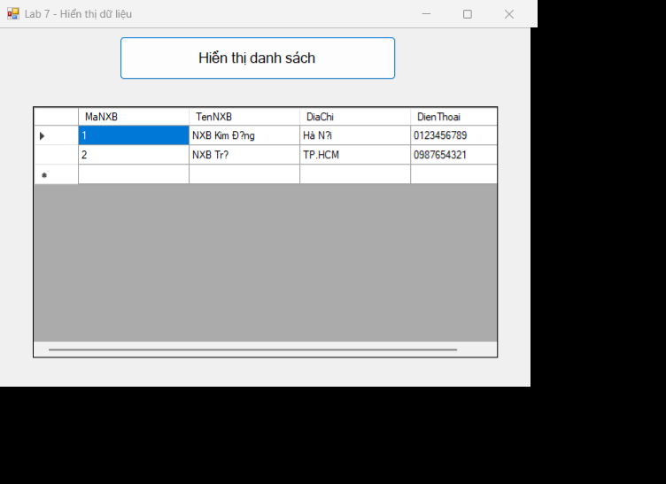

Bài thực hành 2: Thêm dữ liệu cho bảng Nhà Xuất Bản
Trong Project, tạo 1 new item mới là Form2.cs
Form2.Designer.cs:
namespace LeHuyenThuc_1150080119_BTTuan9
{
partial class Form2
{
private System.ComponentModel.IContainer components = null;

protected override void Dispose(bool disposing)
{
if (disposing && (components != null))
{
components.Dispose();
}
base.Dispose(disposing);
}

#region Windows Form Designer generated code

private void InitializeComponent()
{
this.dgvDanhSach = new System.Windows.Forms.DataGridView();
this.lblDanhSach = new System.Windows.Forms.Label();
this.lblInfo = new System.Windows.Forms.Label();
this.lblMaXB = new System.Windows.Forms.Label();
this.lblTenXB = new System.Windows.Forms.Label();
this.lblDiaChi = new System.Windows.Forms.Label();
this.txtMaXB = new System.Windows.Forms.TextBox();
this.txtTenXB = new System.Windows.Forms.TextBox();
this.txtDiaChi = new System.Windows.Forms.TextBox();
this.btnThemDL = new System.Windows.Forms.Button();
this.splitBar = new System.Windows.Forms.Label();
((System.ComponentModel.ISupportInitialize)(this.dgvDanhSach)).BeginInit();
this.SuspendLayout();
//
// dgvDanhSach
//
this.dgvDanhSach.ColumnHeadersHeightSizeMode = System.Windows.Forms.DataGridViewColumnHeadersHeightSizeMode.AutoSize;
this.dgvDanhSach.Location = new System.Drawing.Point(20, 60);
this.dgvDanhSach.Name = "dgvDanhSach";
this.dgvDanhSach.RowHeadersWidth = 51;
this.dgvDanhSach.RowTemplate.Height = 24;
this.dgvDanhSach.Size = new System.Drawing.Size(430, 360);
this.dgvDanhSach.TabIndex = 0;
//
// lblDanhSach
//
this.lblDanhSach.AutoSize = true;
this.lblDanhSach.Location = new System.Drawing.Point(17, 25);
this.lblDanhSach.Name = "lblDanhSach";
this.lblDanhSach.Size = new System.Drawing.Size(139, 16);
this.lblDanhSach.TabIndex = 1;
this.lblDanhSach.Text = "Danh sách nhà xuất bản:";
//
// lblInfo
//
this.lblInfo.AutoSize = true;
this.lblInfo.Location = new System.Drawing.Point(495, 25);
this.lblInfo.Name = "lblInfo";
this.lblInfo.Size = new System.Drawing.Size(97, 16);
this.lblInfo.TabIndex = 2;
this.lblInfo.Text = "Nhập thông tin:";
//
// lblMaXB
//
this.lblMaXB.AutoSize = true;
this.lblMaXB.Location = new System.Drawing.Point(495, 80);
this.lblMaXB.Name = "lblMaXB";
this.lblMaXB.Size = new System.Drawing.Size(54, 16);
this.lblMaXB.TabIndex = 3;
this.lblMaXB.Text = "Mã NXB:";
//
// lblTenXB
//
this.lblTenXB.AutoSize = true;
this.lblTenXB.Location = new System.Drawing.Point(495, 140);
this.lblTenXB.Name = "lblTenXB";
this.lblTenXB.Size = new System.Drawing.Size(59, 16);
this.lblTenXB.TabIndex = 4;
this.lblTenXB.Text = "Tên NXB:";
//
// lblDiaChi
//
this.lblDiaChi.AutoSize = true;
this.lblDiaChi.Location = new System.Drawing.Point(495, 200);
this.lblDiaChi.Name = "lblDiaChi";
this.lblDiaChi.Size = new System.Drawing.Size(50, 16);
this.lblDiaChi.TabIndex = 5;
this.lblDiaChi.Text = "Địa chỉ:";
//
// txtMaXB
//
this.txtMaXB.Location = new System.Drawing.Point(575, 77);
this.txtMaXB.Name = "txtMaXB";
this.txtMaXB.Size = new System.Drawing.Size(220, 22);
this.txtMaXB.TabIndex = 6;
//
// txtTenXB
//
this.txtTenXB.Location = new System.Drawing.Point(575, 137);
this.txtTenXB.Name = "txtTenXB";
this.txtTenXB.Size = new System.Drawing.Size(220, 22);
this.txtTenXB.TabIndex = 7;
//
// txtDiaChi
//
this.txtDiaChi.Location = new System.Drawing.Point(575, 197);
this.txtDiaChi.Name = "txtDiaChi";
this.txtDiaChi.Size = new System.Drawing.Size(220, 22);
this.txtDiaChi.TabIndex = 8;
//
// btnThemDL
//
this.btnThemDL.Font = new System.Drawing.Font("Microsoft Sans Serif", 10F);
this.btnThemDL.Location = new System.Drawing.Point(575, 250);
this.btnThemDL.Name = "btnThemDL";
this.btnThemDL.Size = new System.Drawing.Size(220, 45);
this.btnThemDL.TabIndex = 9;
this.btnThemDL.Text = "Thêm dữ liệu";
this.btnThemDL.UseVisualStyleBackColor = true;
this.btnThemDL.Click += new System.EventHandler(this.btnThemDL_Click);
//
// splitBar
//
this.splitBar.BackColor = System.Drawing.SystemColors.ControlDark;
this.splitBar.Location = new System.Drawing.Point(470, 10);
this.splitBar.Name = "splitBar";
this.splitBar.Size = new System.Drawing.Size(2, 440);
this.splitBar.TabIndex = 10;
//
// Form2
//
this.ClientSize = new System.Drawing.Size(830, 450);
this.Controls.Add(this.splitBar);
this.Controls.Add(this.btnThemDL);
this.Controls.Add(this.txtDiaChi);
this.Controls.Add(this.txtTenXB);
this.Controls.Add(this.txtMaXB);
this.Controls.Add(this.lblDiaChi);
this.Controls.Add(this.lblTenXB);
this.Controls.Add(this.lblMaXB);
this.Controls.Add(this.lblInfo);
this.Controls.Add(this.dgvDanhSach);
this.Controls.Add(this.lblDanhSach);
this.Name = "Form2";
this.Text = "Thêm dữ liệu cho bảng NXB";
this.Load += new System.EventHandler(this.Form2_Load);
((System.ComponentModel.ISupportInitialize)(this.dgvDanhSach)).EndInit();
this.ResumeLayout(false);
this.PerformLayout();
}

#endregion

private System.Windows.Forms.DataGridView dgvDanhSach;
private System.Windows.Forms.Label lblDanhSach;
private System.Windows.Forms.Label lblInfo;
private System.Windows.Forms.Label lblMaXB;
private System.Windows.Forms.Label lblTenXB;
private System.Windows.Forms.Label lblDiaChi;
private System.Windows.Forms.TextBox txtMaXB;
private System.Windows.Forms.TextBox txtTenXB;
private System.Windows.Forms.TextBox txtDiaChi;
private System.Windows.Forms.Button btnThemDL;
private System.Windows.Forms.Label splitBar;
}
}
Form2.cs:
using System;
using System.Data;
using System.Data.SqlClient;
using System.Windows.Forms;

namespace LeHuyenThuc_1150080119_BTTuan9
{
public partial class Form2 : Form
{
string strCon = @"Data Source=(LocalDB)\MSSQLLocalDB;AttachDbFilename=C:\Users\Mi\Documents\ĐH_CNTT3\OOD\Lab_ThucHanh\LeHuyenThuc_1150080119_BTTuan9\QuanLyBanSach.mdf;Integrated Security = True";

SqlConnection sqlCon = null;
SqlDataAdapter adapter = null;
DataSet ds = null;

public Form2()
{
InitializeComponent();
}

private void MoKetNoi()
{
if (sqlCon == null)
sqlCon = new SqlConnection(strCon);
if (sqlCon.State == ConnectionState.Closed)
sqlCon.Open();
}

private void DongKetNoi()
{
if (sqlCon != null && sqlCon.State == ConnectionState.Open)
sqlCon.Close();
}

private void LoadData()
{
MoKetNoi();
string sql = "SELECT * FROM NhaXuatBan";

adapter = new SqlDataAdapter(sql, sqlCon);
adapter.MissingSchemaAction = MissingSchemaAction.AddWithKey;

SqlCommandBuilder builder = new SqlCommandBuilder(adapter);

ds = new DataSet();
adapter.Fill(ds, "NXB");

dgvDanhSach.DataSource = ds.Tables["NXB"];

DongKetNoi();
}

private void ClearForm()
{
txtMaXB.Text = "";
txtTenXB.Text = "";
txtDiaChi.Text = "";
txtMaXB.Focus();
}

private void Form2_Load(object sender, EventArgs e)
{
LoadData();
ClearForm();
}

private void btnThemDL_Click(object sender, EventArgs e)
{
if (string.IsNullOrWhiteSpace(txtMaXB.Text))
{
MessageBox.Show("Vui lòng nhập Mã NXB");
return;
}

DataTable tbl = ds.Tables["NXB"];

DataRow found = tbl.Rows.Find(txtMaXB.Text.Trim());
if (found != null)
{
MessageBox.Show("Mã NXB đã tồn tại!");
return;
}

DataRow row = tbl.NewRow();
row["MaXB"] = txtMaXB.Text.Trim();
row["TenXB"] = txtTenXB.Text.Trim();
row["DiaChi"] = txtDiaChi.Text.Trim();
tbl.Rows.Add(row);

int result = adapter.Update(tbl);
if (result > 0)
{
MessageBox.Show("Thêm thành công!");
LoadData();
ClearForm();
}
else
{
MessageBox.Show("Thêm thất bại!");
}
}
}
}
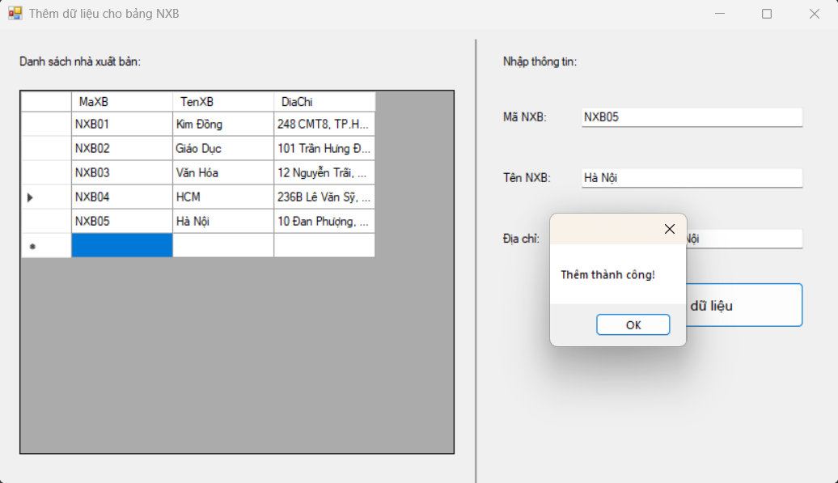

Bài thực hành 3: Cập nhật dữ liệu cho bảng Nhà Xuất Bản
Form3.cs:
using System;
using System.Data;
using System.Data.SqlClient;
using System.Windows.Forms;
namespace LeHuyenThuc_1150080119_BTTuan9

{
public partial class Form3 : Form
{
private readonly string strCon =
@"Data Source=(LocalDB)\MSSQLLocalDB;AttachDbFilename=C:\Users\Mi\Documents\ĐH_CNTT3\OOD\Lab_ThucHanh\LeHuyenThuc_1150080119_BTTuan9\QuanLyBanSach.mdf;Integrated Security=True";

private SqlConnection sqlCon;
private SqlDataAdapter adapter;
private DataSet ds;

public Form3()
{
InitializeComponent();
}

// ===== Helpers =====
private void MoKetNoi()
{
if (sqlCon == null) sqlCon = new SqlConnection(strCon);
if (sqlCon.State == ConnectionState.Closed) sqlCon.Open();
}

private void DongKetNoi()
{
if (sqlCon != null && sqlCon.State == ConnectionState.Open)
sqlCon.Close();
}

private void LoadData()
{
MoKetNoi();
string sql = "SELECT * FROM NhaXuatBan";
adapter = new SqlDataAdapter(sql, sqlCon);

adapter.MissingSchemaAction = MissingSchemaAction.AddWithKey;

SqlCommandBuilder builder = new SqlCommandBuilder(adapter);

ds = new DataSet();
adapter.Fill(ds, "NXB");

dgvDanhSach.DataSource = ds.Tables["NXB"];
DongKetNoi();
}

private void ClearEdit()
{
txtMaXB.Text = "";
txtTenXB.Text = "";
txtDiaChi.Text = "";
}

// ===== Events =====
private void Form3_Load(object sender, EventArgs e)
{
LoadData();
ClearEdit();
txtMaXB.ReadOnly = true;
}

private void dgvDanhSach_CellClick(object sender, DataGridViewCellEventArgs e)
{
if (e.RowIndex < 0) return;
var rowView = dgvDanhSach.Rows[e.RowIndex].DataBoundItem as DataRowView;
if (rowView == null) return;

txtMaXB.Text = rowView["MaXB"].ToString();
txtTenXB.Text = rowView["TenXB"].ToString();
txtDiaChi.Text = rowView["DiaChi"].ToString();
}

private void btnChinhSua_Click(object sender, EventArgs e)
{
if (string.IsNullOrWhiteSpace(txtMaXB.Text))
{
MessageBox.Show("Hãy chọn 1 dòng ở danh sách để chỉnh sửa.");
return;
}

try
{
DataTable tbl = ds.Tables["NXB"];
DataRow row = tbl.Rows.Find(txtMaXB.Text.Trim());
if (row == null)
{
MessageBox.Show("Không tìm thấy bản ghi cần cập nhật.");
return;
}

row.BeginEdit();
row["TenXB"] = txtTenXB.Text.Trim();
row["DiaChi"] = txtDiaChi.Text.Trim();
row.EndEdit();

int kq = adapter.Update(tbl);
if (kq > 0)
{
MessageBox.Show("Cập nhật thành công!");
LoadData();
}
else
{
MessageBox.Show("Cập nhật không thành công!");
}
}
catch (Exception ex)
{
MessageBox.Show("Lỗi khi cập nhật:\n" + ex.Message,
"Lỗi", MessageBoxButtons.OK, MessageBoxIcon.Error);
}
}
}
}
Form3.Designer.cs:
namespace LeHuyenThuc_1150080119_BTTuan9
{
partial class Form3
{
private System.ComponentModel.IContainer components = null;

protected override void Dispose(bool disposing)
{
if (disposing && (components != null)) components.Dispose();
base.Dispose(disposing);
}

#region Windows Form Designer generated code

private void InitializeComponent()
{
this.lblTitle = new System.Windows.Forms.Label();
this.lblDanhSach = new System.Windows.Forms.Label();
this.dgvDanhSach = new System.Windows.Forms.DataGridView();
this.sep = new System.Windows.Forms.Label();
this.lblPanel = new System.Windows.Forms.Label();
this.lblMa = new System.Windows.Forms.Label();
this.lblTen = new System.Windows.Forms.Label();
this.lblDiaChi = new System.Windows.Forms.Label();
this.txtMaXB = new System.Windows.Forms.TextBox();
this.txtTenXB = new System.Windows.Forms.TextBox();
this.txtDiaChi = new System.Windows.Forms.TextBox();
this.btnChinhSua = new System.Windows.Forms.Button();
((System.ComponentModel.ISupportInitialize)(this.dgvDanhSach)).BeginInit();
this.SuspendLayout();
//
// lblTitle
//
this.lblTitle.Anchor = System.Windows.Forms.AnchorStyles.Top;
this.lblTitle.AutoSize = true;
this.lblTitle.Font = new System.Drawing.Font("Microsoft Sans Serif", 11F, System.Drawing.FontStyle.Bold);
this.lblTitle.Location = new System.Drawing.Point(250, 12);
this.lblTitle.Name = "lblTitle";
this.lblTitle.Size = new System.Drawing.Size(214, 24);
this.lblTitle.TabIndex = 0;
this.lblTitle.Text = "Chỉnh sửa thông tin dữ liệu";
//
// lblDanhSach
//
this.lblDanhSach.AutoSize = true;
this.lblDanhSach.Location = new System.Drawing.Point(20, 50);
this.lblDanhSach.Name = "lblDanhSach";
this.lblDanhSach.Size = new System.Drawing.Size(139, 16);
this.lblDanhSach.TabIndex = 1;
this.lblDanhSach.Text = "Danh sách nhà xuất bản:";
//
// dgvDanhSach
//
this.dgvDanhSach.AllowUserToAddRows = false;
this.dgvDanhSach.AllowUserToDeleteRows = false;
this.dgvDanhSach.ColumnHeadersHeightSizeMode = System.Windows.Forms.DataGridViewColumnHeadersHeightSizeMode.AutoSize;
this.dgvDanhSach.Location = new System.Drawing.Point(23, 75);
this.dgvDanhSach.MultiSelect = false;
this.dgvDanhSach.Name = "dgvDanhSach";
this.dgvDanhSach.ReadOnly = true;
this.dgvDanhSach.RowHeadersWidth = 51;
this.dgvDanhSach.RowTemplate.Height = 24;
this.dgvDanhSach.SelectionMode = System.Windows.Forms.DataGridViewSelectionMode.FullRowSelect;
this.dgvDanhSach.Size = new System.Drawing.Size(430, 330);
this.dgvDanhSach.TabIndex = 2;
this.dgvDanhSach.CellClick += new System.Windows.Forms.DataGridViewCellEventHandler(this.dgvDanhSach_CellClick);
//
// sep
//
this.sep.BackColor = System.Drawing.SystemColors.ControlDark;
this.sep.Location = new System.Drawing.Point(470, 45);
this.sep.Name = "sep";
this.sep.Size = new System.Drawing.Size(2, 370);
this.sep.TabIndex = 3;
//
// lblPanel
//
this.lblPanel.AutoSize = true;
this.lblPanel.Location = new System.Drawing.Point(495, 50);
this.lblPanel.Name = "lblPanel";
this.lblPanel.Size = new System.Drawing.Size(110, 16);
this.lblPanel.TabIndex = 4;
this.lblPanel.Text = "Chỉnh sửa thông tin:";
//
// lblMa
//
this.lblMa.AutoSize = true;
this.lblMa.Location = new System.Drawing.Point(495, 95);
this.lblMa.Name = "lblMa";
this.lblMa.Size = new System.Drawing.Size(54, 16);
this.lblMa.TabIndex = 5;
this.lblMa.Text = "Mã NXB:";
//
// lblTen
//
this.lblTen.AutoSize = true;
this.lblTen.Location = new System.Drawing.Point(495, 145);
this.lblTen.Name = "lblTen";
this.lblTen.Size = new System.Drawing.Size(59, 16);
this.lblTen.TabIndex = 6;
this.lblTen.Text = "Tên NXB:";
//
// lblDiaChi
//
this.lblDiaChi.AutoSize = true;
this.lblDiaChi.Location = new System.Drawing.Point(495, 195);
this.lblDiaChi.Name = "lblDiaChi";
this.lblDiaChi.Size = new System.Drawing.Size(50, 16);
this.lblDiaChi.TabIndex = 7;
this.lblDiaChi.Text = "Địa chỉ:";
//
// txtMaXB
//
this.txtMaXB.Location = new System.Drawing.Point(575, 92);
this.txtMaXB.Name = "txtMaXB";
this.txtMaXB.ReadOnly = true;
this.txtMaXB.Size = new System.Drawing.Size(220, 22);
this.txtMaXB.TabIndex = 8;
//
// txtTenXB
//
this.txtTenXB.Location = new System.Drawing.Point(575, 142);
this.txtTenXB.Name = "txtTenXB";
this.txtTenXB.Size = new System.Drawing.Size(220, 22);
this.txtTenXB.TabIndex = 9;
//
// txtDiaChi
//
this.txtDiaChi.Location = new System.Drawing.Point(575, 192);
this.txtDiaChi.Name = "txtDiaChi";
this.txtDiaChi.Size = new System.Drawing.Size(220, 22);
this.txtDiaChi.TabIndex = 10;
//
// btnChinhSua
//
this.btnChinhSua.Font = new System.Drawing.Font("Microsoft Sans Serif", 10F);
this.btnChinhSua.Location = new System.Drawing.Point(575, 240);
this.btnChinhSua.Name = "btnChinhSua";
this.btnChinhSua.Size = new System.Drawing.Size(220, 45);
this.btnChinhSua.TabIndex = 11;
this.btnChinhSua.Text = "Chỉnh sửa thông tin";
this.btnChinhSua.UseVisualStyleBackColor = true;
this.btnChinhSua.Click += new System.EventHandler(this.btnChinhSua_Click);
//
// Form3
//
this.AutoScaleDimensions = new System.Drawing.SizeF(8F, 16F);
this.AutoScaleMode = System.Windows.Forms.AutoScaleMode.Font;
this.ClientSize = new System.Drawing.Size(830, 430);
this.Controls.Add(this.btnChinhSua);
this.Controls.Add(this.txtDiaChi);
this.Controls.Add(this.txtTenXB);
this.Controls.Add(this.txtMaXB);
this.Controls.Add(this.lblDiaChi);
this.Controls.Add(this.lblTen);
this.Controls.Add(this.lblMa);
this.Controls.Add(this.lblPanel);
this.Controls.Add(this.sep);
this.Controls.Add(this.dgvDanhSach);
this.Controls.Add(this.lblDanhSach);
this.Controls.Add(this.lblTitle);
this.Name = "Form3";
this.Text = "Cập nhật dữ liệu cho bảng NXB";
this.Load += new System.EventHandler(this.Form3_Load);
((System.ComponentModel.ISupportInitialize)(this.dgvDanhSach)).EndInit();
this.ResumeLayout(false);
this.PerformLayout();
}

#endregion

private System.Windows.Forms.Label lblTitle;
private System.Windows.Forms.Label lblDanhSach;
private System.Windows.Forms.DataGridView dgvDanhSach;
private System.Windows.Forms.Label sep;
private System.Windows.Forms.Label lblPanel;
private System.Windows.Forms.Label lblMa;
private System.Windows.Forms.Label lblTen;
private System.Windows.Forms.Label lblDiaChi;
private System.Windows.Forms.TextBox txtMaXB;
private System.Windows.Forms.TextBox txtTenXB;
private System.Windows.Forms.TextBox txtDiaChi;
private System.Windows.Forms.Button btnChinhSua;
}
}

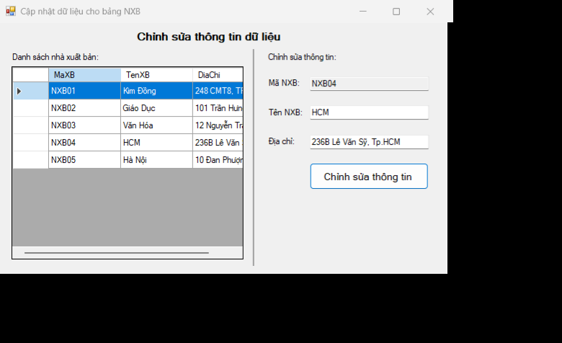
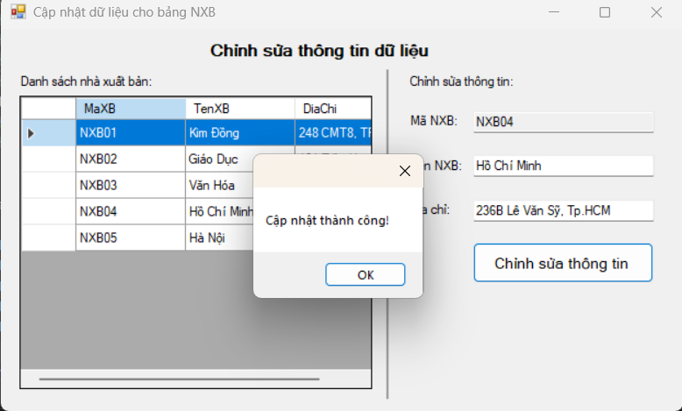

Bài thực hành 4: Xóa dữ liệu cho bảng NXB

Form4.cs:
using System;
using System.Data;
using System.Data.SqlClient;
using System.Windows.Forms;

namespace LeHuyenThuc_1150080119_BTTuan9
{
public partial class Form4 : Form
{
private readonly string strCon =
@"Data Source=(LocalDB)\MSSQLLocalDB;AttachDbFilename=C:\Users\Mi\Documents\ĐH_CNTT3\OOD\Lab_ThucHanh\LeHuyenThuc_1150080119_BTTuan9\QuanLyBanSach.mdf;Integrated Security=True";

private SqlConnection sqlCon;
private SqlDataAdapter adapter;
private DataSet ds;

public Form4()
{
InitializeComponent();
}

// ===== Helpers =====
private void MoKetNoi()
{
if (sqlCon == null) sqlCon = new SqlConnection(strCon);
if (sqlCon.State == ConnectionState.Closed) sqlCon.Open();
}

private void DongKetNoi()
{
if (sqlCon != null && sqlCon.State == ConnectionState.Open)
sqlCon.Close();
}

private void LoadData()
{
MoKetNoi();
adapter = new SqlDataAdapter("SELECT * FROM NhaXuatBan", sqlCon);
adapter.MissingSchemaAction = MissingSchemaAction.AddWithKey; // lấy PK

// Tự sinh Insert/Update/Delete
var builder = new SqlCommandBuilder(adapter);

ds = new DataSet();
adapter.Fill(ds, "NXB");

dgvDanhSach.DataSource = ds.Tables["NXB"];
DongKetNoi();
}

private DataRow GetSelectedRow()
{
if (dgvDanhSach.CurrentRow == null) return null;
var drv = dgvDanhSach.CurrentRow.DataBoundItem as DataRowView;
return drv?.Row;
}

// ===== Events =====
private void Form4_Load(object sender, EventArgs e)
{
LoadData();
}

private void btnXoa_Click(object sender, EventArgs e)
{
try
{
var tbl = ds.Tables["NXB"];
var rowUI = GetSelectedRow();
if (rowUI == null)
{
MessageBox.Show("Vui lòng chọn 1 dòng trong danh sách để xóa.");
return;
}

// tìm theo PK để chắc chắn
var ma = rowUI["MaXB"].ToString();
var row = tbl.Rows.Find(ma);
if (row == null)
{
MessageBox.Show("Không tìm thấy bản ghi cần xóa.");
return;
}

if (MessageBox.Show($"Xóa NXB có mã: {ma} ?", "Xác nhận",
MessageBoxButtons.YesNo, MessageBoxIcon.Warning) != DialogResult.Yes)
return;

row.Delete(); // xóa trên DataTable
int kq = adapter.Update(tbl); // đẩy xuống DB

if (kq > 0)
{
MessageBox.Show("Xóa dữ liệu thành công!");
LoadData();
}
else
{
MessageBox.Show("Xóa dữ liệu không thành công!");
}
}
catch (Exception ex)
{
MessageBox.Show("Lỗi khi xóa dữ liệu:\n" + ex.Message,
"Lỗi", MessageBoxButtons.OK, MessageBoxIcon.Error);
}
}
}
}
Form4.Designer.cs:
namespace LeHuyenThuc_1150080119_BTTuan9
{
partial class Form4
{
private System.ComponentModel.IContainer components = null;

protected override void Dispose(bool disposing)
{
if (disposing && (components != null)) components.Dispose();
base.Dispose(disposing);
}

#region Windows Form Designer generated code

private void InitializeComponent()
{
this.lblTitle = new System.Windows.Forms.Label();
this.lblDanhSach = new System.Windows.Forms.Label();
this.dgvDanhSach = new System.Windows.Forms.DataGridView();
this.sep = new System.Windows.Forms.Label();
this.btnXoa = new System.Windows.Forms.Button();
((System.ComponentModel.ISupportInitialize)(this.dgvDanhSach)).BeginInit();
this.SuspendLayout();
//
// lblTitle
//
this.lblTitle.Anchor = System.Windows.Forms.AnchorStyles.Top;
this.lblTitle.AutoSize = true;
this.lblTitle.Font = new System.Drawing.Font("Microsoft Sans Serif", 11F, System.Drawing.FontStyle.Bold);
this.lblTitle.Location = new System.Drawing.Point(270, 12);
this.lblTitle.Name = "lblTitle";
this.lblTitle.Size = new System.Drawing.Size(210, 24);
this.lblTitle.TabIndex = 0;
this.lblTitle.Text = "Xóa dữ liệu trong database";
//
// lblDanhSach
//
this.lblDanhSach.AutoSize = true;
this.lblDanhSach.Location = new System.Drawing.Point(20, 50);
this.lblDanhSach.Name = "lblDanhSach";
this.lblDanhSach.Size = new System.Drawing.Size(139, 16);
this.lblDanhSach.TabIndex = 1;
this.lblDanhSach.Text = "Danh sách nhà xuất bản:";
//
// dgvDanhSach
//
this.dgvDanhSach.AllowUserToAddRows = false;
this.dgvDanhSach.AllowUserToDeleteRows = false;
this.dgvDanhSach.ColumnHeadersHeightSizeMode = System.Windows.Forms.DataGridViewColumnHeadersHeightSizeMode.AutoSize;
this.dgvDanhSach.Location = new System.Drawing.Point(23, 75);
this.dgvDanhSach.MultiSelect = false;
this.dgvDanhSach.Name = "dgvDanhSach";
this.dgvDanhSach.ReadOnly = true;
this.dgvDanhSach.RowHeadersWidth = 51;
this.dgvDanhSach.RowTemplate.Height = 24;
this.dgvDanhSach.SelectionMode = System.Windows.Forms.DataGridViewSelectionMode.FullRowSelect;
this.dgvDanhSach.Size = new System.Drawing.Size(740, 300);
this.dgvDanhSach.TabIndex = 2;
//
// sep
//
this.sep.BackColor = System.Drawing.SystemColors.ControlDark;
this.sep.Location = new System.Drawing.Point(23, 385);
this.sep.Name = "sep";
this.sep.Size = new System.Drawing.Size(740, 2);
this.sep.TabIndex = 3;
//
// btnXoa
//
this.btnXoa.Font = new System.Drawing.Font("Microsoft Sans Serif", 10F);
this.btnXoa.Location = new System.Drawing.Point(320, 395);
this.btnXoa.Name = "btnXoa";
this.btnXoa.Size = new System.Drawing.Size(160, 40);
this.btnXoa.TabIndex = 4;
this.btnXoa.Text = "Xóa dữ liệu";
this.btnXoa.UseVisualStyleBackColor = true;
this.btnXoa.Click += new System.EventHandler(this.btnXoa_Click);
//
// Form4
//
this.AutoScaleDimensions = new System.Drawing.SizeF(8F, 16F);
this.AutoScaleMode = System.Windows.Forms.AutoScaleMode.Font;
this.ClientSize = new System.Drawing.Size(790, 450);
this.Controls.Add(this.btnXoa);
this.Controls.Add(this.sep);
this.Controls.Add(this.dgvDanhSach);
this.Controls.Add(this.lblDanhSach);
this.Controls.Add(this.lblTitle);
this.Name = "Form4";
this.Text = "Xóa dữ liệu cho bảng";
this.Load += new System.EventHandler(this.Form4_Load);
((System.ComponentModel.ISupportInitialize)(this.dgvDanhSach)).EndInit();
this.ResumeLayout(false);
this.PerformLayout();
}

#endregion

private System.Windows.Forms.Label lblTitle;
private System.Windows.Forms.Label lblDanhSach;
private System.Windows.Forms.DataGridView dgvDanhSach;
private System.Windows.Forms.Label sep;
private System.Windows.Forms.Button btnXoa;
}
}

