|  |
| --- |
| 哈尔滨工业大学深圳研究生院 |
| **Digital Image Processing Report** |
|  |
| **姓 名 梁洪昱**  **学 号 15S051009**  **报告日期 2016.04.18** |

[1. Histogram Equalization 3](#_Toc9783)

[1.1 Task 3](#_Toc3155)

[1.2 Definition 3](#_Toc32452)

[1.3 Steps 4](#_Toc7379)

[1.4 Results 4](#_Toc30581)

[2. Median Filter 5](#_Toc19027)

[2.1 Task 5](#_Toc26074)

[2.2 Definition 5](#_Toc24975)

[2.3 Steps 6](#_Toc9098)

[2.4 Results 7](#_Toc7801)

[3. Gaussian Highpass Filtering 7](#_Toc2679)

[3.1 Task 7](#_Toc4551)

[3.2 Definition 8](#_Toc13545)

[3.3 Steps 8](#_Toc3966)

[3.4 Results 9](#_Toc9793)

[4. Conclusion 9](#_Toc22304)

# Histogram Equalization

## 1.1 Task

Write a program for computing the histogram of the image bellow and implement the histogram equalization technique as we discussed in the class.

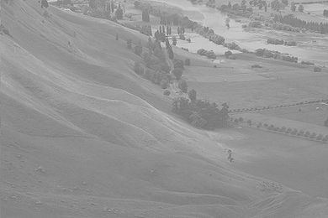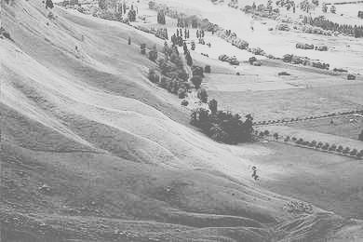

(a): original image (b): after histogram equalization

## 1.2 Definition

The histogram of a digital image with gray levels from 0 to L-1 is a discrete function:

 (1-1)

And  is the kth gray level,  is the pixels in the image with that gray level, k = 0, 1, 2, …, L-1.

Normalized histogram:

 (1-2)

n is the total number of pixels in the image, the sum of all components = 1.

The basic idea of histogram equalization is to find a map T(r) such that the histogram of the modified (equalized) image is flat (uniform).

Consider for a moment continuous system, and let r represent the gray levels, which has been normalized to the interval [0,1], with r=0 representing black and r=1 representing white. For any r, define a transformation:

 (1-3)

That produce a level s for every pixel value r in the input image. We assume that the transformation function T(r) satisfies the following conditions:

1. T(r) is single-value and monotonically increasing in the interval 0≤r≤1;
2. 0≤T(r)≤1 for 0≤r≤1.

The condition (1) preserves the increasing order from black to white in the output image. And The condition (2) guarantees that the output gray levels will be in the same range as the input levels.

Let and denote the probability density function of random variables r and s, respectively. A basic result from probability theory is that, if  and T(r) are known and  satisfies condition (a). Then ps(s) can be obtained using a rather simple formula:

 (1-4)

Thus the probability density function (PDF) of s is determined by the gray level PDF of input image and by the chosen transformation function.

So for a given input image, we can change its histogram by some transformation, it is the idea of histogram equalization

## 1.3 Steps

1. Calculate the number of occurrence of pixel of level i, 
2. Calculate the probability of pixel of level i, , n is the total number of all pixel.
3. Calculate the cumulative distribution of , 
4. Calculate the new pixel of level i, , maxp and minp is the highest and lowest level of the image.

## 1.4 Results

I process the image with python, after I run the program, I get the follow image.

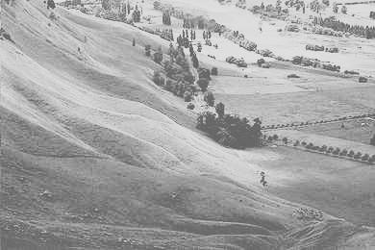

# Median Filter

## 2.1 Task

Remove the noise from the image (c).

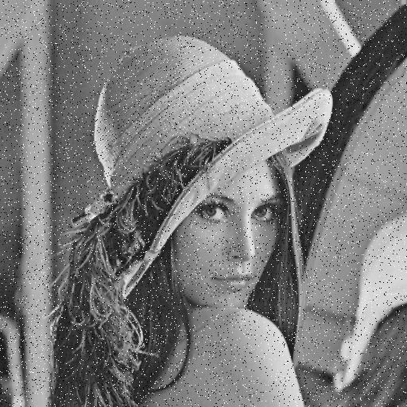 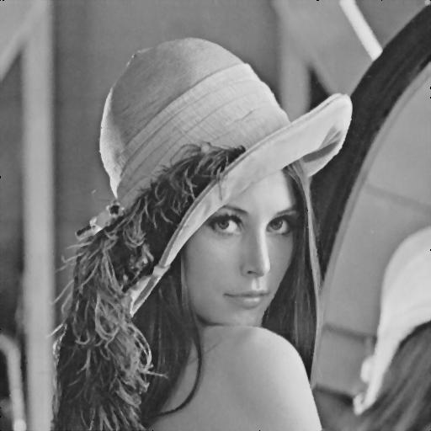

(c): before (d):after

## 2.2 Definition

Median Filter is nonlinear Spatial filters whose response is based on ordering the pixels in the area of filter.

The main idea of the median filter is to run through the signal entry by entry, replacing each entry with the median of neighboring entries. The pattern of neighbors is called the "window", which slides, entry by entry, over the entire signal. For 1D signals, the most obvious window is just the first few preceding and following entries, whereas for 2D (or higher-dimensional) signals such as images, more complex window patterns are possible (such as "box" or "cross" patterns). Note that if the window has an odd number of entries, then the median is simple to define: it is just the middle value after all the entries in the window are sorted numerically. For an even number of entries, there is more than one possible median, see median for more details.

## 2.3 Steps

We assume that pixels[width][height] represent an image

1. Determine the filter window’s size N\*N, N should be a odd number
2. For a pixels[i][j], find its neighboring entries according to the filter window
3. Calculate its neighbors’ median value, px
4. Replace the origin pixel of pixels[i][j] with px
5. Repeat 2-4 until all pixel in the image have been processed.

## 2.4 Results

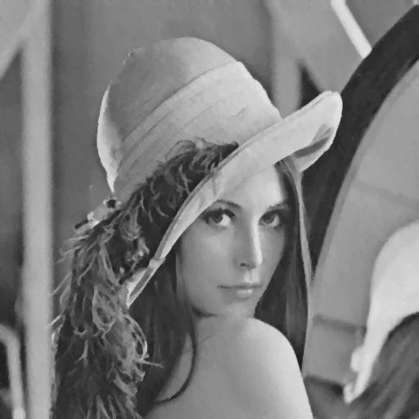

# Gaussian Highpass Filtering

## 3.1 Task

Filtering in the Frequency Domain: Implement the Gaussian highpass filters on test image (e).

**C:\Users\XIN\Desktop\test_image1\test_image\4.41(a).tif 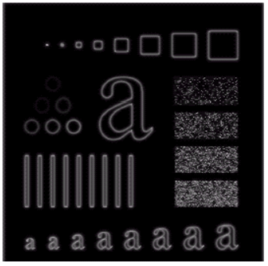**

(e): before (f): after

## 3.2 Definition

The Gaussian highpass filter is a filter that process the image in frequency domain. So we have to transform an image from spatial domain to frequency domain. We use the discrete Fourier Transform(DFT) to do this job. But it’s not our focus point here.

The lowpass Gaussian filter function:

 (3-1)

The the lowpass Gaussian filter function:

 (3-2)

We assume an image after DFT would be , and Filter 

 (3-3)

The the filter image would be

 (3-4)

represents the inverse operation of DFT.

## 3.3 Steps

We assume the image as pixels[width][height]

1. Enlarge the image temp[2\*width][2\*height], we put the original image on the temp[0..width][0...height], and put 0 on the rest of temp.
2. Multiply the input image by (-1)x+y to center the transform.
3. Compute F(u,v) the DFT of the image in (1).
4. Multiply F(u,v) by a filter function H(u,v)
5. Compute the inverse DFT of the result.
6. Obtain the real part of the result in (4).
7. Multiply the result in (5) with (-1)x+y .
8. pixels[width][height] = temp[0...width][0...height]

## 3.4 Results

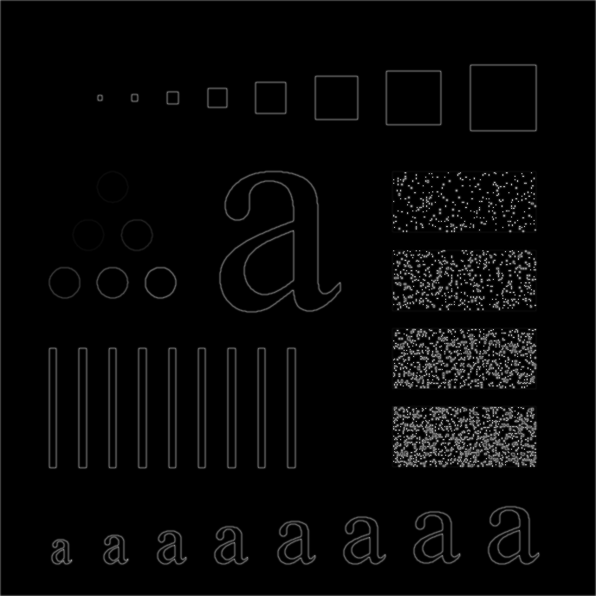

# 4. Conclusion

Histogram equalization usually increases the global contrast of many images, especially when the usable data of the image is represented by close contrast values. Through this adjustment, the intensities can be better distributed on the histogram. This allows for areas of lower local contrast to gain a higher contrast. Histogram equalization accomplishes this by effectively spreading out the most frequent intensity values.

Histogram equalization is useful in images with backgrounds and foregrounds that are both bright or both dark. In particular, the method can lead to better views of bone structure in x-ray images, and to better detail in photographs that are over or under-exposed. A key advantage of the method is that it is a fairly straightforward technique and an invertible operator. So in theory, if the histogram equalization function is known, then the original histogram can be recovered. The calculation is not computationally intensive.

Median Filter is often used to remove noise from images. Sometimes a median filter works better than an averaging filter. Median filter are particularly effective in the presence of impulse noise, also called salt-and-pepper noise.

In Fourier transform, low frequencies are responsible for the general gray level appearance of an image over smooth areas. High frequencies are responsible for detail, such as edges and noises. So Gaussian highpass filter is used to display the detail of an image.