Vision and Scope Document

for

<Planning for Future You>

Version 1.0 approved

Prepared by Jiangchuan Luo, Lei Huang, Mengyao Zhang, Wei Wei, Yunlong Pi, Yuxi Chen

Australian National University

2017/08/13

Table of Contents

Table of Contents ii

Revision History ii

1. Business Requirements 1

1.1. Background 1

1.2. Business Opportunity 1

1.3. Business Objectives 1

1.4. Success Metrics 1

1.5. Vision Statement 1

1.6. Business Risks 2

1.7. Business Assumptions and Dependencies 2

2. Scope and Limitations 2

2.1. Major Features 2

2.2. Scope of Initial and Subsequent Release 3

2.3. Limitations and Exclusions 3

3. Business Context 4

3.1. Stakeholder Profiles 4

3.2. Project Priorities 4

3.3. Deployment Considerations 5

Revision History

|  |  |  |  |
| --- | --- | --- | --- |
| **Name** | **Date** | **Reason For Changes** | **Version** |
| *Future for You* team | 14/8/2017 | Draft | Version1.0 |
|  |  |  |  |

# Business Requirements

## Background

ANU Student Careers Gamification Project (Planning for Future You) aims to create early awareness and engagement with career development among students. It’s a web-based application that is designed and communicated a high-level narrative that helps to set expectations and tracks progress of the students’ career planning. The purposes of the project are engaging students with Careers Consultants early in their university career, helping student to set a goal and achieve it, and offering student a base level of preparation before seeing Careers Consultants.

## Business Opportunity

The existing Career Centre services are not well known among undergraduate students and they do not start to plan for their career until they realize the need to find a job. The current services are not used regularly by students for several reasons- they do not realize the importance of it, they do not know the existence of the service, they are discouraged by the formal process. The development of new platform can provide more effective way for students to set expectations and tracks progress and give recommendation for jet interaction points.

## Business Objectives (TBD)

BO-1 Increase the ANU Career Center interview appointments among students by 300% percent following initial release.

BO-2 Increase the monthly total number of ANU Career Center web site visit by 500% percent within 6 months following initial release.

BO-3: Having 80% or above of users on the platform connecting with the Careers Center.

## Success Metrics

SM-1: Having 60% of ANU students used our platform within 12 months following the initial release.

SM-2: Achieving 70% or above satisfaction after 6 months following the initial release.

SM-3: Reducing 50% of the redundant work of Careers Center staff.

SM-4: Increasing 50% of the time of students matching with Careers Center advisers.

## Vision Statement

Planning for Future You is an Internet-based platform designed for ANU students who want to make plans for their futures or seek professional advice from ANU careers center. The platform automatically provides student with redirection through students’ information (e.g. skills, experience and goals) analyzing. Student can make personal career plan in the platform. Career Consultant can view the student information before consulting, which can help consultant and improve efficiency. Gamification is an important feature to attract student applying the platform.

## Business Risks

RI-1: Only few students use the platform. (Probability=0.3, Impact=8)

RI-2: Platform may occur security problem. Such as user information reveal, hacking. (Probability=0.8, Impact=4)

## Business Assumptions and Dependencies

AS-1: Only ANU currently students and person who graduate within one year can use the platform.

AS-2: Platform can have access to students’ basic information.

AS-3: Student graduated longer than one year can still review the information of him.

# Scope and Limitations

## Major Features

Figure1. Feature Tree

FE-1: User login: user can use UID to login the platform.

FE-2: Management: only the staff in career office can use this function. In the management, there are two functions, change the content of billboard and view the students’ information (individual or analysis of statistical data)

FE-3: Career Plan: this function is for students to plan their career. The basic design model (talent tree) is shown as figure2. Student can create, read, update and delete his personal data.

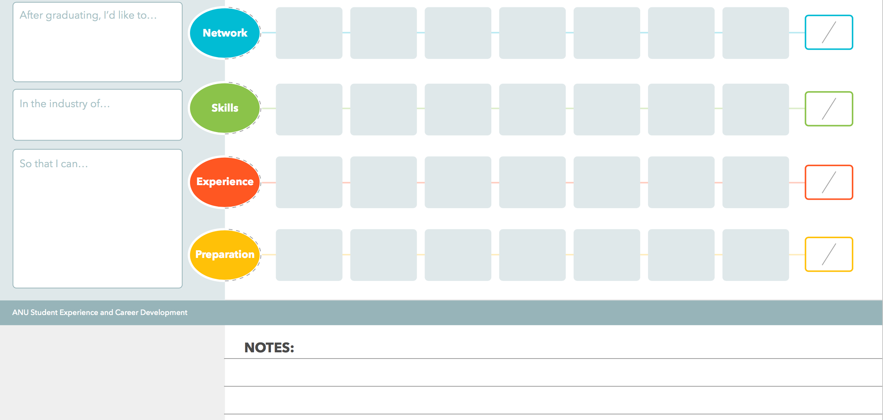FE-4: Gamification: the purpose of gamification is to attract students using the platform.

Figure2. Talent Tree

## Scope of Initial and Subsequent Release

|  |  |  |  |
| --- | --- | --- | --- |
| **Feature** | **Release 0.0** | **Release 1.0** | **Release 1.1** |
| FE-1: User login |  | Fully implemented |  |
| FE-2: Management |  | View demo data and edit billboard. (implement all functions of management) | Add gamification into the management page. (Fully implemented) |
| FE-3: Career Plan | Implement the functions of career plan. |  | Add gamification into the career plan page. (Fully implemented) |
| FE-4: Gamification |  | Design Gamification | Implement the ideas in the platform. (Fully implemented) |

Table1.

## Limitations and Exclusions

LI-1: In the first two releases, the platform will only be focused on the functions.

LI-2: Platform is designed as a form of website for computer.

EX-1: Platform can be used though mobile phone or tablet device.

# Business Context

## Stakeholder Profiles

|  |  |  |  |  |
| --- | --- | --- | --- | --- |
| **Stakeholder** | **Major Value** | **Attitudes** | **Major Interests** | **Constraints** |
| Career Center Stuff | Increased career plan interview | See product as avenue to increase awareness among ANU students | Interesting and gamification application interface; rich feature set; time to release | Output should be attractive to ANU students |
| Planning for Future You Techlauncher Project team | Educational value | Consider project an opportunity to apply academic and co-op expertise | Completion of objectives using learned software programming and engineering disciplines; chance to access and handle with big data | Time (2 semester project duration) |
| Current Students | Planning for future career | Require ease of use and maximization of usefulness in career plan process | Excellent gamification user interface; simple to use and provide powerful career plan functions | Time efficiency and utility of the platform. |
| Service/Marketing | User survey and data collection for the product | Supportive to make survey among ANU students and collect feedback | The impact of this platform on career center user quantity | N/A |

Table2. Stakeholder analysis

## Project Priorities

|  |  |  |  |
| --- | --- | --- | --- |
| ***Dimension*** | ***Driver*** | ***Constraint*** | ***Degree of Freedom*** |
| Schedule |  | release 0.0 to be available by 17th Sep. 2017.  release 1.0 by 1st Oct. 2017.  release 1.1 by 22nd October |  |
| Features |  |  | 70-80% of high priority features must be included in release 1.0 |
| Quality | 70-80% of user acceptance tests must pass for release 1.0, 80-90% for release 1.1 |  |  |
| Staff |  | Project team size is 6 students. |  |

Table3. Project Priorities

## Deployment Considerations

The Planning for Future You is a network platform that only offers career planning service for ANU students. To improve the system user experience, the system could be multilingual and provide different choice for students from all nations. What’s more, the released vision of Planning for Future You needs to be stable in consideration of its maintenance. The platform will also have to be able to run on different operation system, such as windows operation system and UNIX operation system. The mobile application will be taken into consideration in further release.