# 数据库第二次实验

## Content

1、SQL queries on university database

2、Write SQL queries that answer the questions below and run them on the Microsoft ACCESS Database System using its SQL interpreter.

3、The SQL interpreter in ACCESS is not quite the same as the one described in the textbook.

## Questions

1. **Print the names of professors who work in departments that have fewer than 50**

**PhD students.**

1. **分析：**本题是打印在博士生少于50人的系工作的教授的姓名。只需要将Prof和Dept两张表连接即可。

**（2）查询语句：**SELECT P.pname

FROM Prof P, Dept D

WHERE P.dname=D.dname AND D.numphds<50

**（3）查询结果：**

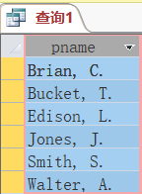

1. **Print the name(s) of student(s) with the lowest gpa.**
2. **分析：**打印gpa最低的学生姓名。可用嵌套子查询实现,最低的成绩点可以在student表中通过函数min(gpa)获得。

**（2）查询语句：**SELECT S.sname

FROM Student S

WHERE S.gpa = (SELECT min(gpa)

FROM Student)

**（3）查询结果：**

IMG_256

1. **For each Computer Sciences class, print the cno, sectno, and the average gpa of**

**the students enrolled in the class.**

1. **分析：**对于每门计算机科学课程，打印cno、sectno和该课程注册学生的平均gpa。所以可用三个表的连接查询,由cno, sectno进行分组，并用函数avg(gpa)，获得每组的平均成绩。
2. **查询语句：** SELECT Section.cno, Section.sectno, avg(gpa) AS avgpa

FROM Section, Enroll, Student

WHERE Section.cno =Enroll.cno

AND Section.sectno=Enroll.sectno

AND Enroll.sid=Student.sid

AND Section.dname=’Computer Sciences’

GROUP BY Section.sectno,Section.cno

**（3）查询结果：**

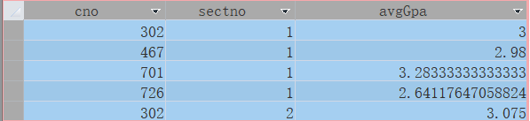

1. **Print the course names, course numbers and section numbers of all classes with**

**less than six students enrolled in them.**

1. **分析：**打印所有班级人数少于6的课程名、课程号和分班号。

**（2）查询语句：**SELECT E.cno,E.sectno,C.cname

FROM Course C, Enroll E

WHERE C.cno=E.cno AND C.dname=E.dname

GROUP BY E.cno,E.sectno,C.cname

HAVING COUNT(\*)<6

**（3）查询结果：**

IMG_256

1. **Print the name(s) and sid(s) of the student(s) enrolled in the most classes.**
2. **分析：**打印加入班级数最多的学生名字、学号。建立一个Temp临时表包括字段学生名字、学号和加入班级的数目（num）。再对这个临时表进行查询加入班级数最多的同学。
3. **查询语句：**WITH Temp（sid,sname,num）AS

(SELECT S.sid,S.sname,COUNT(\*)

FROM Student S,Enroll E

WHERE S.cno=E.cno AND S.sectno=E.sectno

GROUP BY Student.sid)

SELECT sid,sname

FROM Temp T

WHERE T.num = (SELECT max(num)

FROM Temp)

**（3）查询结果：**

IMG_256

1. **Print the names of departments that have one or more majors who are under 18**

**years old.**

1. **分析：**打印所含学生至少有一个年龄小于18岁的系的名称。可以用带有EXISTS的嵌套子查询实现要求。
2. **查询语句：**SELECT dname

FROM Major M

WHERE EXISTS( SELECT \*

FROM Student S

WHERE S.sid = M.sid AND S.age<18)

**（3）查询结果：**

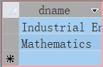

1. Print the names and majors of students who are taking one of the College Geometry courses. (Hint: You'll need to use the "like" predicate and the string

matching character in your query.)

**（1）分析：**本题查询所有选了College Geometry courses的学生的姓名和所在系名。此题对课程名需要用通配符进行模糊查询。学生的限制条件是存在一门College Geometry course为他所选。

**（2）查询语句：**SELECT S.sname,M.dname

FROM Student S,Major M,Enroll E,Course C

WHERE M.sid = S.sid AND E.sid =S.sid AND E.cno=C.cno

AND C.cname LIKE ‘College Geometry\*’

**（3）查询结果：**

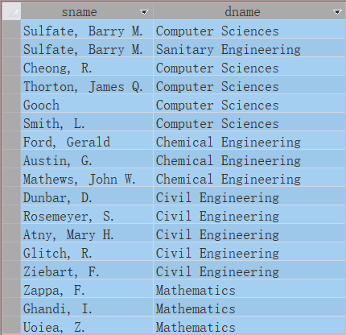

1. **For those departments that have no majors taking a College Geometry course,**

**print the department name and the number of PhD students in the department.**

1. **分析：**对于没有学生选了'%Geometry%'课程的院系，查出它们的院系名称和博士人数。
2. **查询语句：**SELECT dname,numphds

FROM Dept

WHERE dname NOT IN(SELECT D.dname

FROM Dept D,Major M,Enroll E,Course C

WHERE D.dname=M.dname

AND M.sid = E.sid

AND E.cno=C.cno

AND C.cname LIKE ‘College Geometry\*’)

1. **查询结果：**

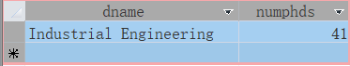

1. **Print the names of students who are taking both a Computer Sciences course and**

**a Mathematics course.**

**（1）分析：**本题是查询既选了计算机科学系课程又选了数学系课程的学生姓名。可以通过自连接。

**（2）查询语句：**SELECT S.sname

FROM Student S,Enroll E1,Enroll E2,Course C1,Course C2

WHERE S.sid = E1.sid AND E2.sid=S.sid

AND E1.cno=C1.cno AND E2.cno=C2.cno

AND (C1.dname =’Computer Sciences ’

AND C2.dname=’Mathematics’)

1. **查询结果：**

IMG_256

**10、Print the age difference between the oldest and youngest Computer Sciences**

**major(s).**

**（1）分析：**打印主修Computer Sciences的学生的最大年龄差。

**（2）查询语句：**SELECT max(age) - min(age) AS difference

FROM Student

WHERE sid IN (SELECT sid

FROM Major

WHERE dname = 'Computer Sciences'

)

**（3）查询结果：**

IMG_256

**11、For each department that has one or more majors with a GPA under 1.0, print**

**the name of the department and the average GPA of its majors.**

1. **分析：**本题是查询系里有学生绩点小于1.0的系的系名和该系学生的平均绩点。本题主要是将Major， Student两张表按sid做连接，连接后再按dname分组，同时将min(gpa)<1的分组剔除。
2. **查询语句：**SELECT M.dname, avg(gpa) AS avggpa

FROM Major M, Student S

WHERE M.sid=S.sid

GROUP BY M.dname

HAVING min(gpa)<1

**（3）查询结果：**

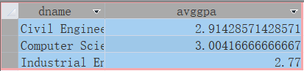

**12、 Print the ids, names, and GPAs of the students who are currently taking all of**

**the Civil Engineering courses.**

**（1）分析：**打印选修了所有Civil Engineering系课程的学生的学号、姓名、绩点。可以使用双重否定，即没有一门Civil Engineering系的课程该学生是没有选的。

**（2）查询语句：**SELECT S.sid,S.sname,S.gpa

FROM Student S

WHERE NOT EXISTS(SELECT C.cno

FROM Course C

WHERE NOT EXISTS(SELECT E.sid

FROM Enroll E

WHERE E.cno=C.cno

AND E.sid=S.sid)

AND C.dname='Civil Engineering')Engineering’))

**（3）查询结果：**

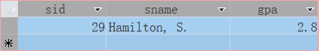

1. **Experience**

通过此次实验，使我更加熟悉了对SQL语句及其应用，虽然是第一次上机调试但并不感到陌生。在SQL语句调试的过程中虽错误总是千奇百怪，很快的得以纠正，完成了本次实验。我深刻的意识到自身的不足，也明白了理论与实践的差距，同时自己学过的知识也得以加深理解与巩固，感谢老师给予我们机会，使我们的知识更加牢固！