## CSC311

## Project2

## Lei Cao

1. This project use java Serialization feature to save the serialized version of the StockExCenter objects.
   1. Pros: There’s no need to worry about how to output the data to txt files and retrieve and parse the strings from txt files
   2. Cons: The data stored inside the serialized object are not as visible as what is stored in a txt file. We need further write method to display the data.

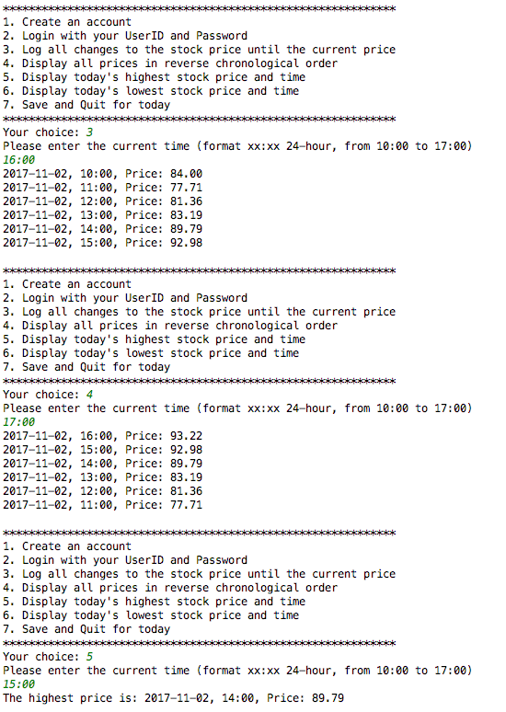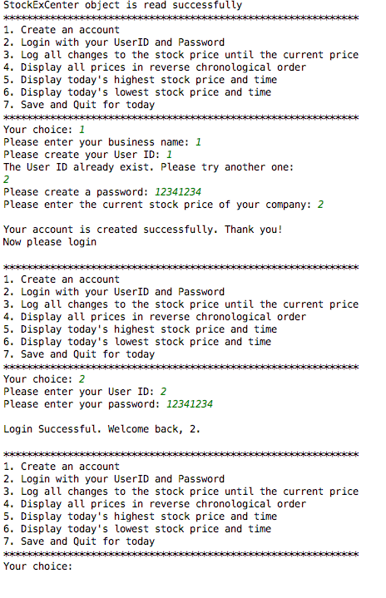

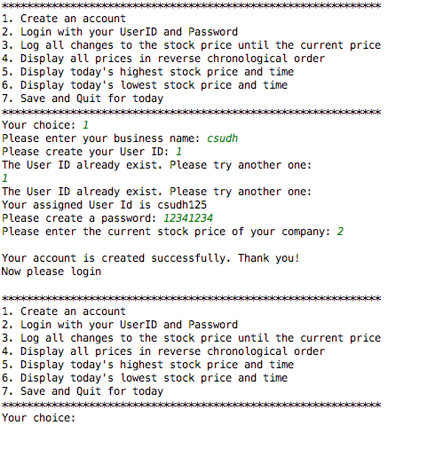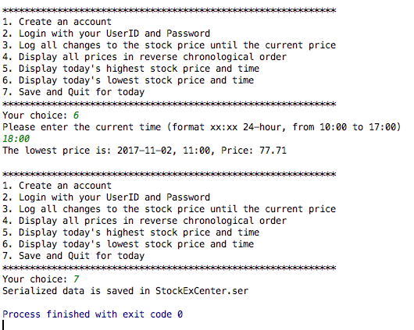

auto – generate username: