Contents
Version 1
Introduction 1
Core files 2
Starting the map 2
Features and functions 2
Data and fields 5
Multi-user access and date safety 6
Cautions 6
Test has been done during the develop work 6
Known limitations and next steps 7

Version

Version | Date of Issue | Comments | Author(s) | Sign Off
V1.0 | 02/11/2026 | Initial development done, including tests | Lei Ding

Introduction
The Geophysics internal map shows all past Geophysics project boundaries in a browser, so the team can check whether a new survey area overlaps earlier work. It runs from a shared folder on Datto and can be easily launch by double-clicks a launcher, a small local server starts on their own PC, and the map opens in their default web browser (Chrome/Edge/…).
It does two jobs:
- Tender preview – load a client boundary (SHP-Zipped, GPKG-single layer, KML, GeoJSON) temporarily and see it in red against existing boundary data. Nothing is saved and only for a quick overlap check.
- Permanent records – save a confirmed project boundary into the shared boundary dataset, and delete records you created yourself.
Shared location: M:\Data\Geophysics\GIS and Maps\GEO_Internal_Map (Q: in the office, M: or A: when working from home).

Core files
All files sit in the same folder, please do not change file name or move file location.
File | Role | Edited by
Open RLB Map.bat | Double-click launcher. | GIS team
serve.py | Local web server. Serves the page, converts tender files to WGS84 (GDAL), saves and deletes records with locking and backups. | GIS team
geophys_internal.html | The map page (Leaflet): search, labels, legend, tender preview, save form, delete. | GIS team
geophys_rlb.geojson | The RLB dataset, EPSG:4326. Written by the server on save/delete. | Geophys user through the web interface; GIS team
backups/ | Timestamped copy of the GeoJSON before every write; newest 10 kept. Created automatically. | Server
geophys_rlb.geojson.lock | Exists only while a save/delete is in progress. Removed automatically; a lock older than 2 minutes is treated as stale. | Server

Starting the map
Users double-click Open RLB Map.bat; the browser opens the map automatically and the black window must stay open while it is used.
- The launcher looks for QGIS's Python first (C:\Program Files\QGIS*\bin\python-qgis(-ltr).bat, then C:\OSGeo4W), because it includes GDAL, which tender preview needs. Every Headland PC has QGIS, so nothing extra is installed.
- If QGIS is not found it falls back to system Python. The map still works but tender preview is disabled.
- serve.py picks the first free port from 8000 upwards, so an old server left running does not block a new one.
- The window shows the URL, the Windows user name, GDAL: OK / NOT FOUND and the Python path, which is the first thing to check when troubleshooting.
- Closing the window stops the map.
The page must be opened through the server (http://127.0.0.1:<port>/geophys_internal.html). Double-clicking the HTML file directly cannot load the data.

Features and functions
Map display
- Zoomed out (zoom ≤ 10): numbered clusters show groups of boundaries; click to zoom in. Single boundary show as a dot.
- Zoomed in more: polygon boundary displayed; hover turns the outline to red.
- From zoom 11: one project-code label per project in view, placed on its largest polygon.
- Legend (bottom left) and basemap switcher (greyscale, OpenStreetMap, satellite; top right).
- Popup on click: Project Code, Sub Label, Description, Notes, Last edited by, Last edited at (shown as dd/mm/yyyy hh:mm). Project Code always show, the others only visible if there is value in the field.
Search
- One box in the top bar; matches project code or sub label as you type.
- Dropdown lists the first 5 matches; arrow keys and Enter, or click, to zoom to one.
- The × in the box clears the search.
Tender preview (temporary)
- Preview tender file accepts zipped SHP (must contain exactly one .shp and its .prj), GPKG (exactly one spatial layer), KML/KMZ, GeoJSON. Limit 50 MB.
- The server reprojects the source data to WGS84 using the CRS in the file, then the page draws it in red. If no clear CRS, it will fail.
- Clear errors for: unsupported type, missing .prj or CRS, several layers or shapefiles, coordinates out of range after conversion. A warning appears if the data falls outside the UK and Ireland.
- Nothing is written to disk; Clear preview, a refresh or closing the server removes it.
Save as permanent RLB
- Click a red preview polygon, then Save as permanent boundary. Only shown when every feature in the file is a polygon (the server also rejects lines and points, though you can check lines when it is just temporary).
- Form: Project code (required, upper-cased), Sub label, Description, Notes.
- Warnings before saving if the code is not 4 letters + 2 digits, or already exists on the map.
- All polygons in the file are saved as separate records of the same project. The map reloads and zooms to the new records.
Delete
- Delete this RLB appears in the popup only when the record's CreatedBy matches your Windows user name. The server checks this again. Or ask GIS member to amend the source geojson in QGIS to remove or modify data. Any geophys member can also import the geojson into a QGIS project for higher level edits, but for data safety concern, please check with GIS member first.
- Older records with no CreatedBy cannot be deleted from the web page; edit those in QGIS.
- The bottom bar shows Signed in as <user>.

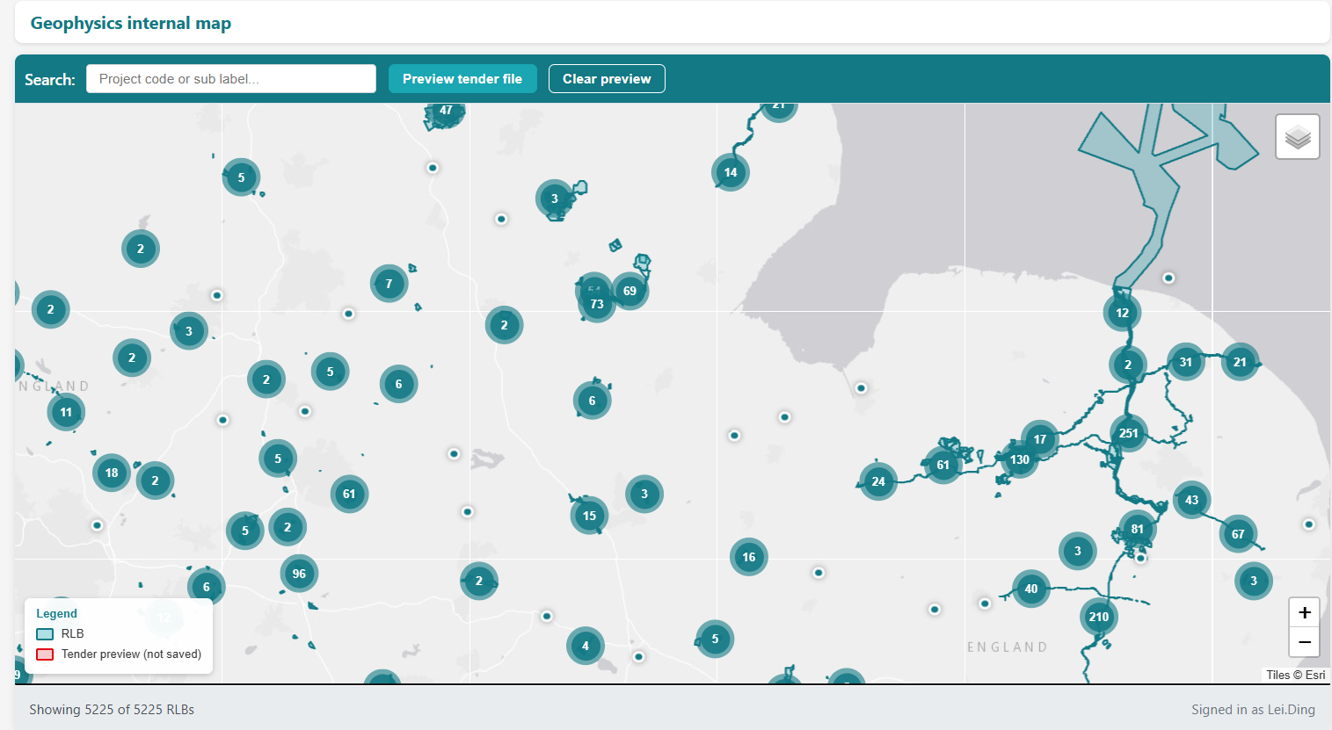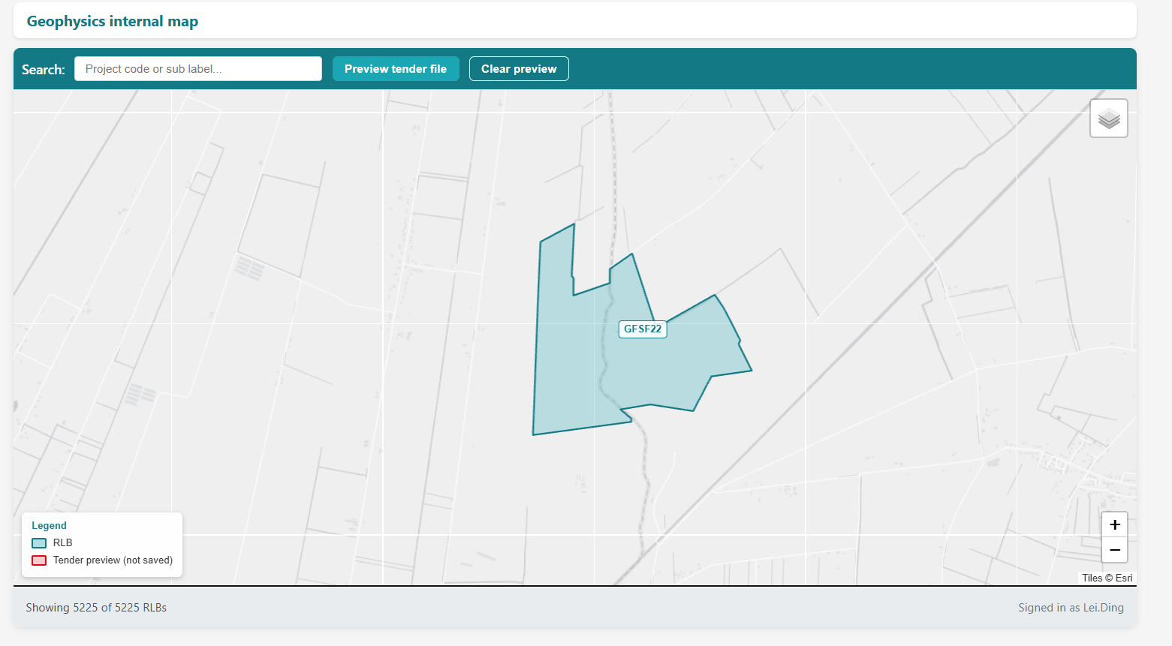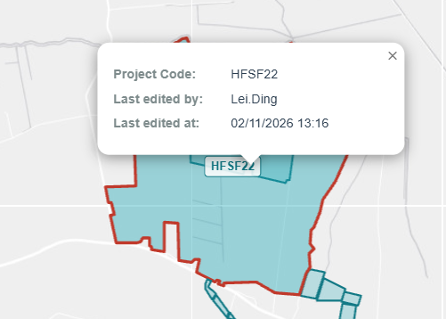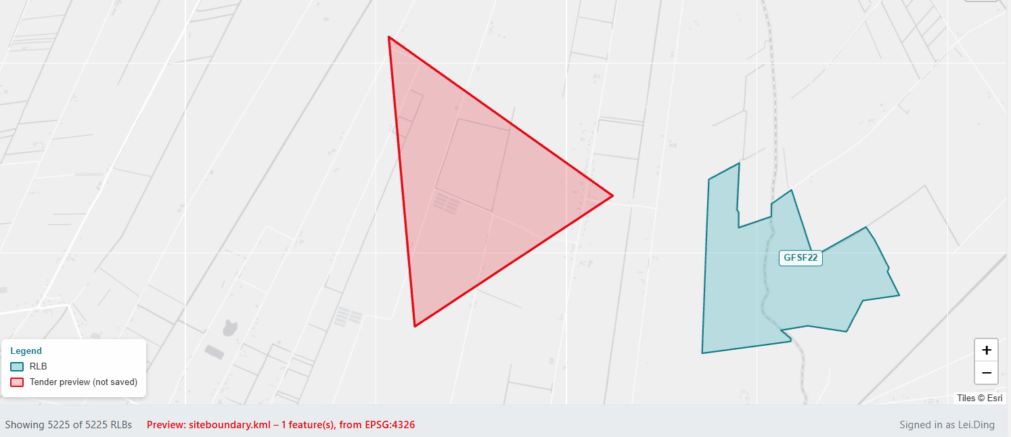
Figure 1.1 Insert Description

Data and fields
Field | Meaning | Filled by
fid | Unique record ID, used for delete | Automatic
proj_code | Project code, e.g. SPAG26 | When user add new boundary (required)
sub_label | Area, phase or option within the project | When user add new boundary
descriptio | Description | When user add new boundary (
Notes | Free notes | When user add new boundary
CreatedBy / CreatedAt | Windows user and time of creation | Automatic  @user_account_name / now()
EditedBy / EditedAt | Last editor and time | Server on save; QGIS default on update

Multi-user access and date safety
Each user runs their own server, so several people can write to the same file. Every save and delete therefore goes through these steps:
- Lock – when multiple user trying to save at the same time, locker create geophys_rlb.geojson.lock (atomic create). If it exists, wait up to 20 s, then tell the user who is saving. A lock older than 2 minutes is treated as left over from a crash.
- Re-read the latest GeoJSON inside the lock, never a copy loaded earlier in the browser.
- Backup the current file to backups/geophys_rlb_<date>_<time>_<user>.geojson.
- Write to a temporary file, then replace the original in one step, so the file is never half-written. If the file is held by another program, retry for 10 s, then report that nothing was changed.
- Unlock.
The server window also logs each save and delete with user, project code and fid.

Cautions
- Do not edit geophys_rlb.geojson in QGIS while others may be saving from the web page; QGIS rewrites the whole file and ignores the lock.
- The lock is reliable on the Datto drives (Q:/M:/A:).
- To restore, copy a file from backups/ back over geophys_rlb.geojson.
- It is still better to save permanent data at different time since Datto is not that trustworthy. We may adopt the new GIS infrastructure for the server in the future.

Test has been done during the develop work
All tests below were run on the local C: copy on 2 November 2026.
Test | Expected | Result
Tender preview: unzipped SHP | Rejected, nothing drawn | Pass
Tender preview: KML | Drawn in red at correct location | Pass
Tender preview: GeoJSON | Drawn in red at correct location | Pass
Tender preview: SHP in EPSG:27700 | Reprojected to WGS84, correct location | Pass
Tender preview: line data | Drawn correctly | Pass
Save as permanent RLB and delete own record | Record added, popup shows Last edited; own record deletable, older records not | Pass (behaviour checked as expected)

Known limitations and next steps
- DXF is not accepted for tender preview (no CRS, often broken lines); convert it in QGIS first.
- Records without CreatedBy (the merged historic data) can only be changed in QGIS. An admin list in serve.py could let the GIS team delete any record from the web page if needed.
- Editing an existing record's attributes or geometry from the web page is not supported; delete and re-save, or edit in QGIS.
- Some DXF-derived polygons have invalid geometry. They display, but may cause problems in QGIS tools. Have tried to fix all ‘bad’ geometries that ca be identified.

