## Prepare data

For ROC curve, the dataset should include tpr(i.e. sensitivity) and fpr (i.e. 1-specificity). Optional variables for ROC curve are marker and title.

For other curve, the dataset should include tpr, prob, and specificity. Other optional variables include: youden, xy_labels, and title.

**Roc dataset:**

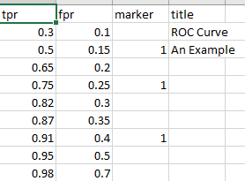

**Dataset for sensitivty, specificity, or youden’s index:**

## 

## Select file

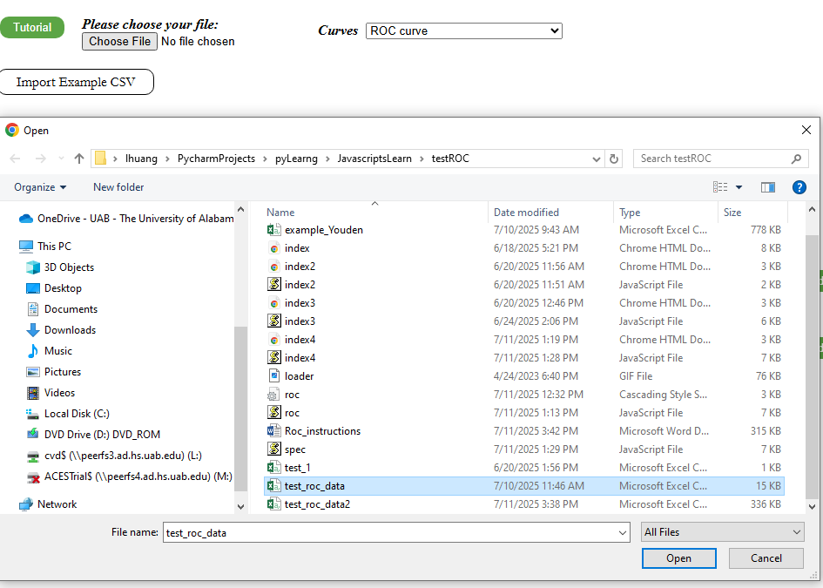

**Roc curve is the default chart.**

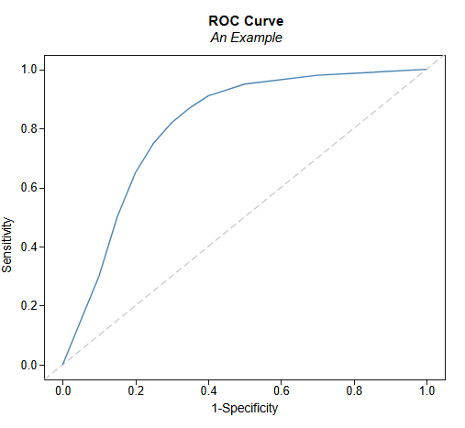

## Add markers on ROC plot.

If you want to add some markers on the plot, add variable marker in the dataset.

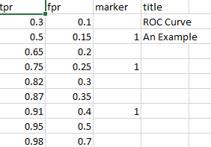

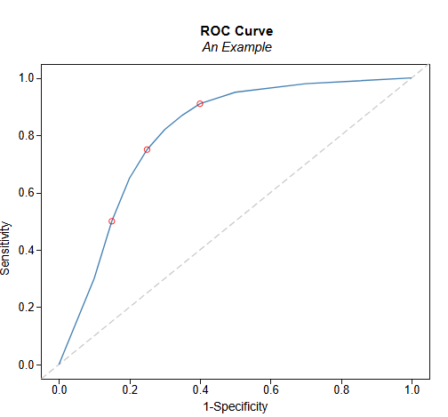

You can put mouse on the “marker” to see more details.

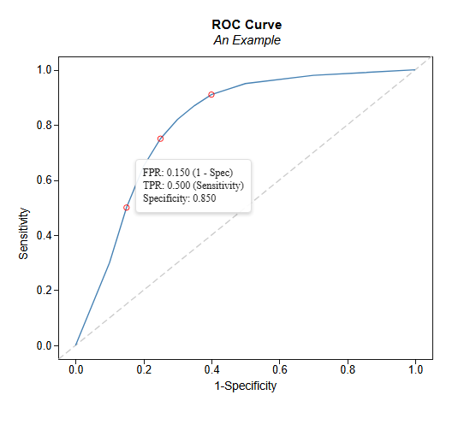

## Change plot type

If you have “specificity” in the dataset, you can change the type of curves.

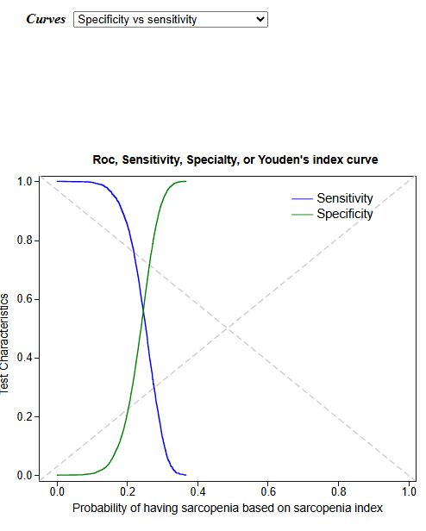

Or

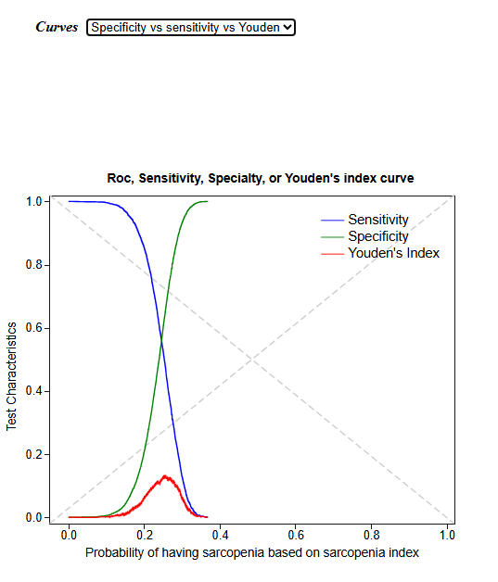

## X and Y labels

In the dataset, the first value under “xy_label” is x label, the second is Y label.