AI Assignment #2
CISC3024 Pattern Recognition
University of Macau
Monte Carlo Dropout as a Bayesian Approximation for Fashion-MNIST Image Classification
October 2026
Algorithm: Gal & Ghahramani, ICML 2016 (arXiv:1506.02142)
Source code: https://github.com/LeiManLam/CISC3024-AI-Assignment2

1. How the AI Finds the Algorithm
The assignment requires a recent classification/recognition method based on probability or Bayes theory for computer vision / pattern recognition, with the AI performing algorithm search, programming, and report writing.
Search process. Queries used included: “Bayesian neural network computer vision classification 2020–2023 MC Dropout variational inference”, “Monte Carlo Dropout Bayesian approximation Gal Ghahramani image classification”, and “Mobiny Monte Carlo DropConnect Bayesian deep networks”. Sources consulted: arXiv, NeurIPS proceedings, and Scientific Reports.
Candidates: (1) MC Dropout (Gal & Ghahramani, ICML 2016, arXiv:1506.02142); (2) MC-DropConnect (Mobiny et al., Scientific Reports 2021, arXiv:1906.04569); (3) Variational Structured Dropout (NeurIPS 2021); (4) Function-space VI / MC-DropBlock (NeurIPS 2022 / 2021).
Selection. We chose Monte Carlo Dropout because it has a clear Bayes/variational foundation, applies to CNN image classification, remains widely used after 2020, and is implementable on CPU with Fashion-MNIST. MC-DropConnect (2021) was a strong recent alternative.

2. Algorithm Description
Reference: Yarin Gal and Zoubin Ghahramani. “Dropout as a Bayesian Approximation: Representing Model Uncertainty in Deep Learning.” ICML 2016, pp. 1050–1059. arXiv:1506.02142.
Core idea. Training with dropout (and L2 weight decay) is approximate variational inference for a deep Gaussian process. The variational distribution q(ω) uses Bernoulli masks on units. Minimising the dropout objective approximates KL[q(ω) || p(ω | data)].
Predictive inference. At test time, keep dropout on, draw T stochastic forward passes, and average softmax outputs: q(y*|x*) ≈ (1/T) Σ Softmax(f_ω̂_t(x*)). From this we get class predictions, NLL, and predictive entropy. This is a probability/Bayes method for CV classification with uncertainty.

3. How the AI Implements the Algorithm
All code was written by the AI (Python + PyTorch). The student did not write source code. model.py defines BayesianCNN with Dropout and mc_predict(x, T). train_eval.py trains on Fashion-MNIST (Adam, 8 epochs) and evaluates deterministic vs MC Dropout (T=30). metrics.py computes accuracy, NLL, and ECE. Figures include training curves, confusion matrix, reliability diagram, and entropy histograms. Source: https://github.com/LeiManLam/CISC3024-AI-Assignment2

4. Experiment Settings and Results
Dataset: Fashion-MNIST (60k train / 10k test). Settings: dropout p=0.25, T=30, epochs=8, batch=128, Adam lr=0.001, weight_decay=0.0001, device=cpu.
Results: Deterministic accuracy 91.11%; MC Dropout accuracy 91.07%; NLL 0.2450; ECE 0.0199; mean entropy correct 0.2385 vs incorrect 0.8910.
Discussion: MC Dropout matches point-estimate accuracy while providing calibrated probabilities and higher entropy on mistakes — useful uncertainty for pattern recognition.
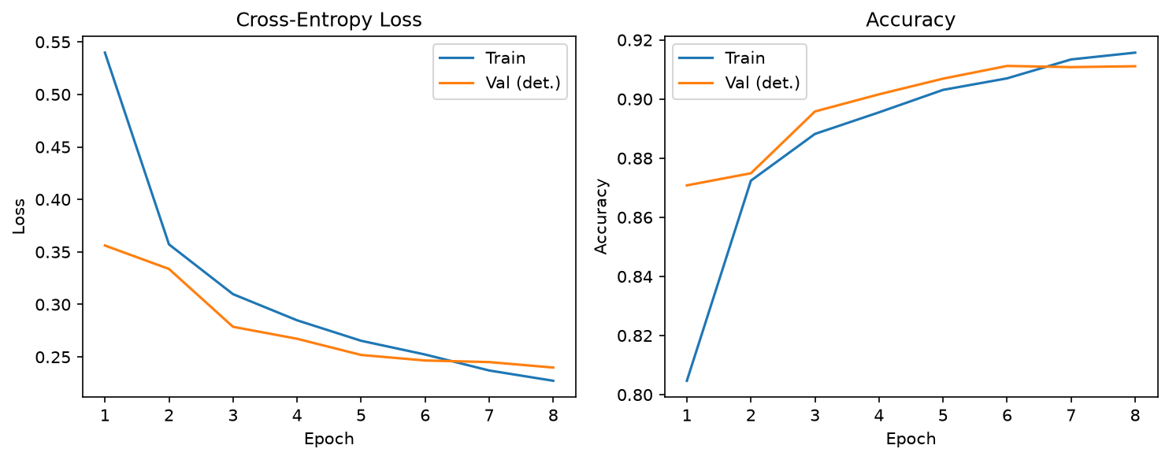
Figure 1. Training curves
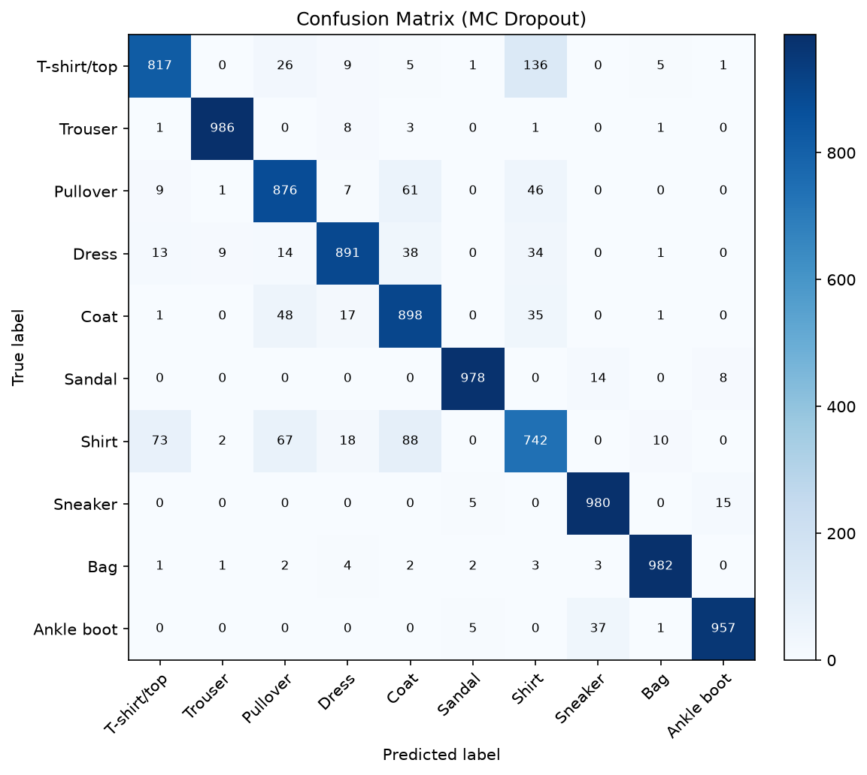
Figure 2. Confusion matrix
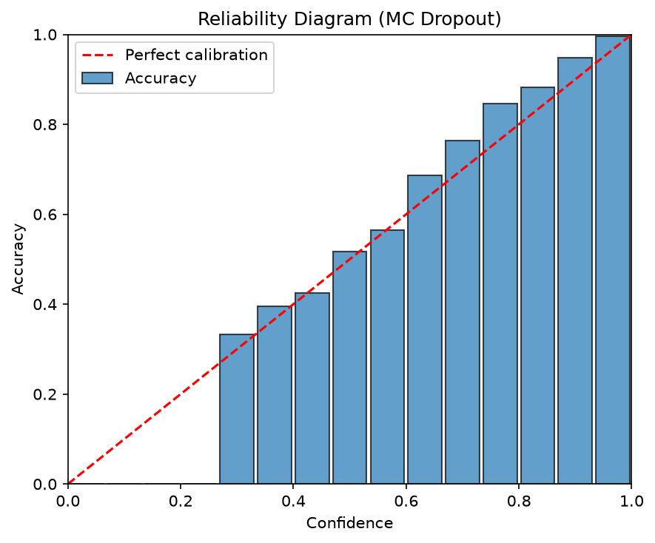
Figure 3. Reliability diagram
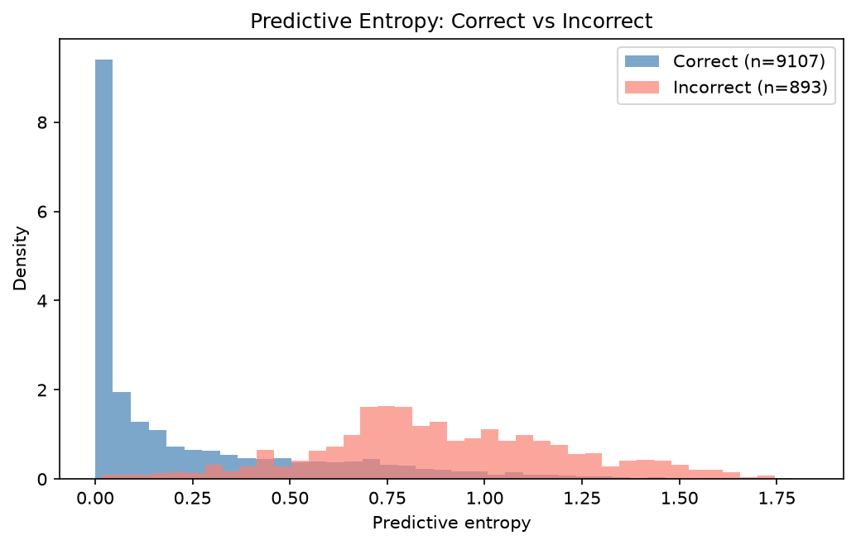
Figure 4. Predictive entropy

5. What the Student Has Learned from This AI Assignment
（本節以學生第一人稱、繁體中文撰寫。）
透過這次 AI 作業，我學到如何把課堂上的貝氏／機率概念連接到現代深度學習。以前接觸貝氏分類器時，多半是較簡單的生成模型；這次用 Monte Carlo Dropout，才理解「對權重做近似後驗推論」也可以套在 CNN 上，讓影像分類不只給出類別，還能估計模型有多不確定。
我也體會到「查論文」與「能實作」之間的差別。AI 幫我搜尋 2020 年後仍常用的貝氏深度學習方法，比較 MC Dropout、MC-DropConnect、結構化變分 Dropout 等候選後，選了理論清楚、資源需求適中的方案，並在 Fashion-MNIST 上跑出真實的準確率、NLL、ECE 與混淆矩陣，而不是虛構數字。
最重要的是，作業規定學生不可自行寫程式，整段實作與報告由 AI 完成。我學到如何清楚下達需求、檢查實驗設定是否合理、解讀不確定度指標（例如錯誤樣本的預測熵明顯較高），以及把原始碼整理成可公開的專案。這讓我更明白在模式識別中，機率思維不只是公式，而是可以落地成可重現實驗的工程流程。

6. Webpage Link to the Source Codes
All source code for this assignment is available at:
https://github.com/LeiManLam/CISC3024-AI-Assignment2
The repository includes src/, requirements.txt, README.md, results/, figures/, and report/.

References
[1] Y. Gal and Z. Ghahramani, “Dropout as a Bayesian Approximation…,” ICML, 2016. https://arxiv.org/abs/1506.02142
[2] A. Mobiny et al., “DropConnect is effective in modeling uncertainty of Bayesian deep networks,” Scientific Reports, 2021. https://arxiv.org/abs/1906.04569
[3] H. Xiao et al., “Fashion-MNIST…,” arXiv:1708.07747, 2017.

