**Modern Theory of Banking and Finance (ECON5023)**

JUNTING LIU 2670275L

LEI WANG

ZHERUI SHEN

**Qualitative analysis**

During the Global Financial Crisis, the increase in corporate credit risk significantly raised external finance premiums, further impairing financial intermediation. This phenomenon, observed in advanced economies in the United States provides a clear example of how heightened uncertainty and credit risk can affect corporate financing and the broader financial system.

Increased credit risk among corporations leads to higher external finance premiums because lenders and investors demand additional compensation for the heightened risk of default. For instance, during the 2008 Financial Crisis, the uncertainty in the market and the bankruptcy of several large firms led to a noticeable increase in credit risk in the U.S. economy. This was evidenced by the sharp rise in the yield rates of AAA-rated corporate bonds, which are generally considered low risk.From the **figure 1** from the Fed’s database,  The Moody's Seasoned Aaa Corporate Bond Yield surged to a peak of 6.28% in October 2008, indicating a significant drop in the prices of these bonds and a market expectation of a higher default rate among top-rated firms.

The additional evidence and example is **figure (2),** The ICE BofA AAA US Corporate Index Effective Yield, which represents the effective yield of all AAA bonds, rose to 8% during 2008, almost doubling from its stable pre-crisis rate of 4-6%. This aslo indicated that bond issuers had to pay higher interest rates to compensate for the increased credit risk.

As a result of rising external financing costs, many firms opted to reduce their reliance on external financing, favoring internal financing due to the high premiums. This shift led to a substantial reduction in commercial and industrial loans towards the end of 2008. In terms of example of **figure (3)** of commercial and industrial loans in Fed’s database **,**The decline loans from the peak of $1,586 billion to $1,436 billion highlights the reduced demand for loans from firms facing higher external finance premiums.

([https://fred.stlouisfed.org/series/DFF#](https://fred.stlouisfed.org/series/DFF))

Furthermore, from the financial immdefiateris prospective, During the financial crisis, the lending capacity of financial intermediaries was significantly impacted, primarily due to heightened liquidity pressures following the bankruptcy of Lehman Brothers, which notably eroded market confidence in short-term bank creditors. This scenario was vividly illustrated by the widening of Credit Default Swap (CDS) spreads for banks and insurance firms in **figure (4)** ,

It clears shows that before the financial crisis , the CDS spread was around 10 basis point , but after 2008 ,the banks and insurance firms CDS spread are widen which signifying an increased market expectation of default. The CDS spreads, particularly for the "CDS USD SR 5Y D14 Corp," reflect the cost of insuring against default by these corporations, and their expansion underscores the rising apprehension about the creditworthiness of financial entities. Consequently, this apprehension made refinancing short-term debts more challenging, a crucial factor for maintaining liquidity and ensuring operational continuity. The increased perception of credit risk, indicated by the broader CDS spreads, led to higher borrowing costs or a reluctance among lenders to provide credit. Thus, the heightened expectation of default rates not only undermined confidence in financial institutions but also exerted extra liquidity pressure, curtailing their ability to lend. (应该具体解释一下)

Moreover, the financial accelerator mechanism, as detailed by Gilchrist and Himmelberg (1995), delineates the cyclical nature of how uncertainty and credit risk can aggravate economic downturns by reducing investment and hindering economic activity. This concept highlights the intertwined relationship between the lending capabilities of financial intermediaries and the wider economic landscape. Essentially, during periods of economic recession, financial institutions often tighten their lending policies and increase borrowing costs, a situation exacerbated by the falling value of collateral. Such tightening has a direct impact on businesses and individuals, forcing them to scale back their investment endeavors, thus initiating a self-sustaining cycle of economic decline. Consequently, following the bankruptcy of Lehman Brothers in the United States, the collapse of the subprime mortgage market and the ensuing plummet in the value of mortgage-backed securities profoundly affected the financial statements of numerous financial institutions. This situation precipitated a significant tightening of credit standards, perpetuating a vicious cycle that led to an increase in the external finance premium. This cycle was exacerbated by the banking system's inability to adjust, creating an environment where the cost of external financing continued to climb, further straining economic conditions.

In summary, the interplay between liquidity constraints and elevated credit risk perceptions among financial intermediaries has fostered a conservative lending environment. This cautious stance, aimed at safeguarding their financial health, has significantly curtailed banks' willingness to lend. Concurrently, for manufacturing sectors and non-financial firms, the steep increase in the cost of external financing, driven by the financial accelerator mechanism, has hindered their ability to secure loans.

This dynamic has intensified the adverse effects on the lending capabilities of financial institutions and the borrowing capacities of non-financial entities, exacerbating the impact on the economy.

**Qualitative analysis**

To quantitatively measure the external financing premium for corporations, a framework that incorporates both equity and debt financing perspectives is essential. Following the insights of Aswath Damodaran, the implied Equity Risk Premium (ERP) serves as a pivotal parameter for assessing the cost of equity financing. The ERP is calculated as the difference between the market return and the risk-free rate, typically represented by the yield on U.S. Treasury bonds. This approach assumes that retained earnings, which could be invested in risk-free assets, represent an opportunity cost. The formula for ERP can thus be stated as:

\[ \text{ERP} = \text{Return of the market} - \text{Risk-free rate} \]

For equity financing, this risk premium reflects the additional return investors demand over the risk-free rate to compensate for the risk of investing in the stock market. An increase in ERP suggests a rise in the cost of equity financing, indicating higher expectations of risk by investors.

To measure the external financing premium from a debt perspective, we can use the spread between the interest rates of AAA corporate bonds and U.S. Treasury bonds. This spread reflects the additional yield investors demand for bearing the credit risk associated with corporate debt compared to risk-free government securities. The formula for the debt financing spread (DFS) is:

\[ \text{DFS} = \text{Interest rate on AAA corporate bonds} - \text{Risk-free rate} \]

Combining these perspectives, the overall external financing premium for a corporation can be quantified by weighting the ERP and DFS according to the firm's capital structure, i.e., the mix of equity and debt. If \(E\) represents the proportion of equity and \(D\) represents the proportion of debt in the company's capital structure, with \(E + D = 1\), the weighted external financing premium (WEFP) can be calculated as:

\[ \text{WEFP} = E \times \text{ERP} + D \times \text{DFS} \]

This formula provides a comprehensive measure of the external financing premium, accounting for both equity and debt financing costs. By analyzing changes in the WEFP, companies can gain insights into the dynamics of their financing environmen

t, including shifts in investor risk perceptions and the cost implications of their capital structure choices.

外部融资溢价：假设内部融资成本是指，国债收益率（因为假设在金融危机的时候留存利润会全部投入到国债中），所以用公司发债的利率-国债的收益率，就是外部融资成本溢价，

Damodaran, Aswath, Equity Risk Premiums (ERP): Determinants, Estimation and Implications - The 2023 Edition (March 23, 2023). Available at SSRN: <https://ssrn.com/abstract=4398884> or [http://dx.doi.org/10.2139/ssrn.4398884](https://dx.doi.org/10.2139/ssrn.4398884)

或者用ERP的sp500 - 国债的来代表通过股权融资的外部溢价

According to Damodaran, Aswath, Equity Risk Premiums (ERP) article , the formula of the implied ERP can be represented as the Return of the market - Risk free rate , the assumption is that the internal financing rate would be the U.S Tresuaty Bond rate as the risk free rate. In oder to qualitative measure the External Preimum, we assumed that the Reatined earning from U.S firm will be fully invested in Risk free asset , as the opportunity cost , as for the cost of capital we assumed that the equity financing and debt financing will equally weight , so in this case , the conclusion is that the U.S market the external premium are dramatically increasing from 2000 to 2008 during the financial crsis , the external premium is around 3% ,after the 2008 , the external  premium was back to normal which is around 1-2% .

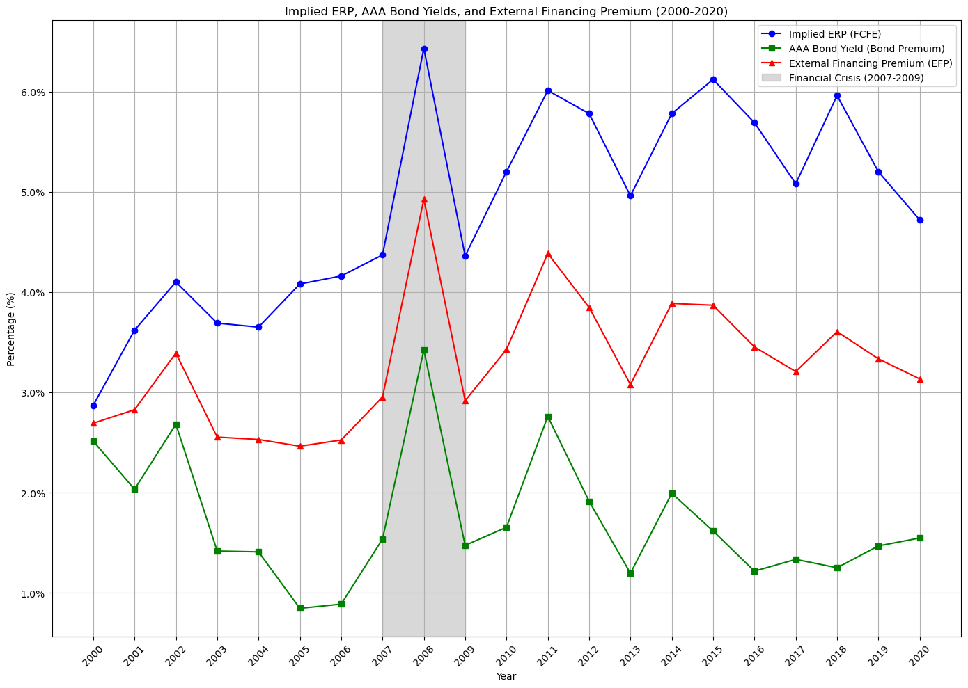

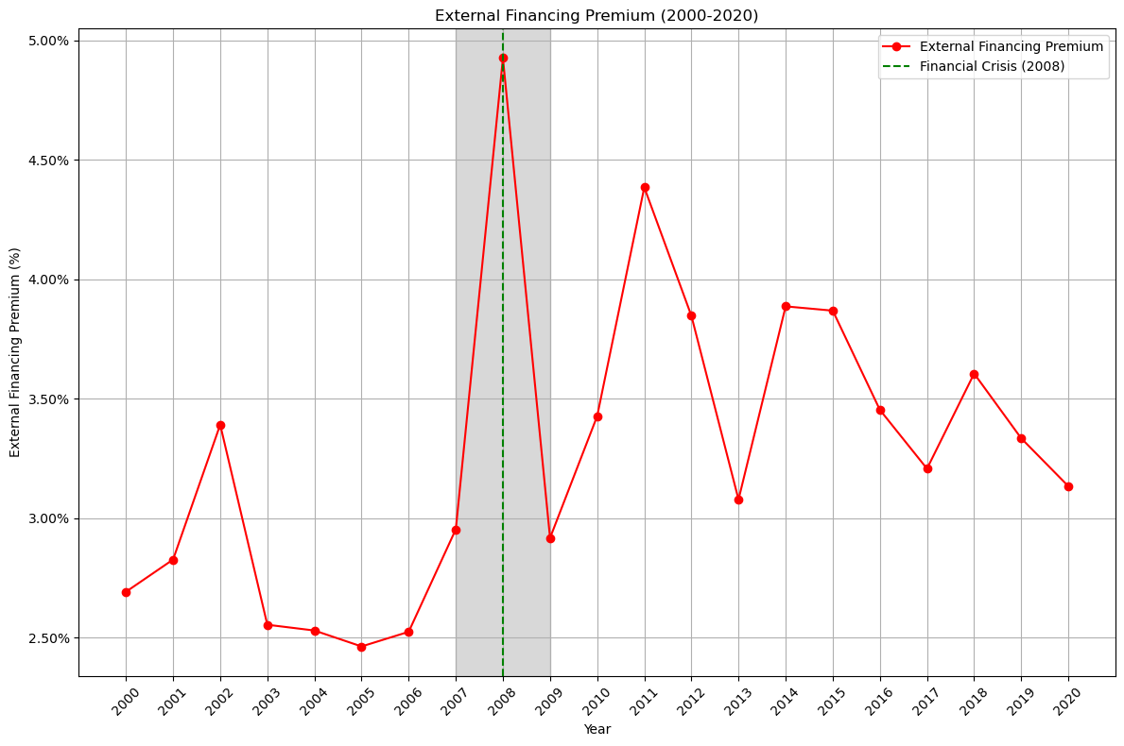

Qns2

So , during 2008 , the Fed announced and excauted Monetary policy in responses to such situations can include lowering interest rates, providing liquidity support, and implementing quantitative easing measures to reduce financing costs, encourage lending, and support economic activity.

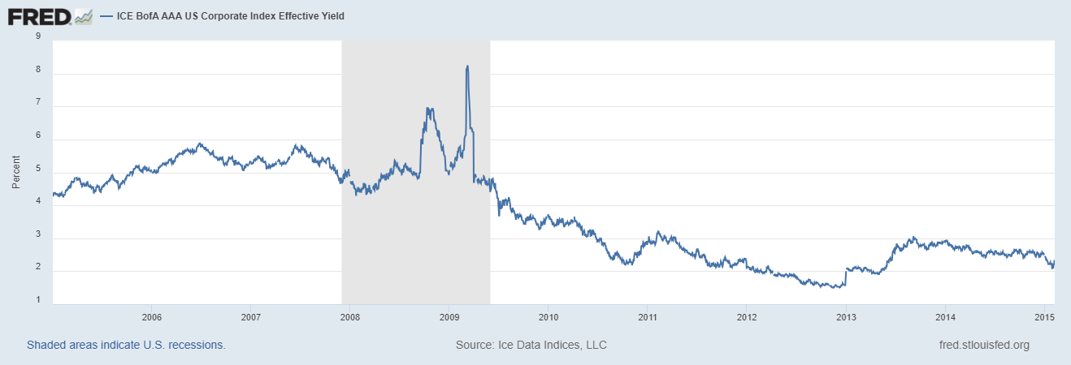

(Madigan, B. (2008) *Material for FOMC Briefing on Monetary Policy Alternatives.* Accessed: 19 July 2024)

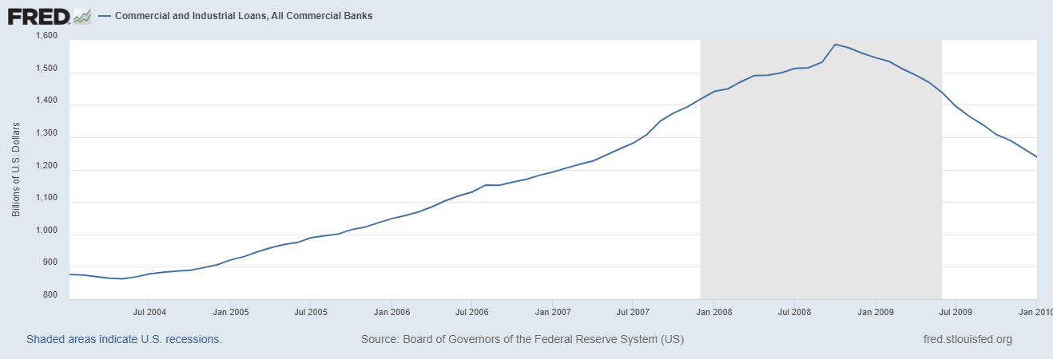

(FRED (no date) *Contributions to the Cleveland Financial Stress Index: Asset-Backed Security Spread (DISCONTINUED)* Accessed: 19 July 2024)

**Blommberg：VIX Index**

**蓝色背景下有许多鸟

**

**SPX**

(FRED (no date) *Federal Funds Effective Rate 1954-2024 (FEDFUNDS)* Accessed: 19 July 2024)

**US CDS EUR SR 5Y D14 Corp**

**Rreferences**

FRED (no date) *Federal Funds Effective Rate 2019-2024 (DFF)* Available at: <https://fred.stlouisfed.org/series/DFF> (Accessed: 19 July 2024)

Madigan, B. (2008) *Material for FOMC Briefing on Monetary Policy Alternatives.* Available at: <https://www.federalreserve.gov/monetarypolicy/files/FOMC20080805material.pdf> (Accessed: 19 July 2024)

FRED (no date) *Contributions to the Cleveland Financial Stress Index: Asset-Backed Security Spread (DISCONTINUED)* Available at: <https://fred.stlouisfed.org/series/ABSSD678FRBCLE> (Accessed: 19 July 2024)

FRED (no date) *Federal Funds Effective Rate 1954-2024 (FEDFUNDS)* Available at: <https://fred.stlouisfed.org/series/FEDFUNDS> (Accessed: 19 July 2024)