**Modern Theory of Banking and Finance (ECON5023)**

JUNTING LIU 2670275L

LEI WANG 251062144

ZHERUI SHEN

**Qualitative analysis**

During the Global Financial Crisis, the increase in corporate credit risk significantly raised external finance premiums, further impairing financial intermediation. This phenomenon, observed in advanced economies in the United States provides a clear example of how heightened uncertainty and credit risk can affect corporate financing and the broader financial system.

Increased credit risk among corporations leads to higher external finance premiums because lenders and investors demand additional compensation for the heightened risk of default. For instance, during the 2008 Financial Crisis, the uncertainty in the market and the bankruptcy of several large firms led to a noticeable increase in credit risk in the U.S. economy. This was evidenced by the sharp rise in the yield rates of AAA-rated corporate bonds, which are generally considered relatively low risk. From the **figure 1** from the Fed’s database,  The Moody's Seasoned Aaa Corporate Bond Yield surged to a peak of 6.28% in October 2008, indicating a significant drop in the prices of these bonds and a market expectation of a higher default rate among top-rated firms.

The additional evidence and example is **figure (2),** The ICE BofA AAA and BBB US Corporate Index Effective Yield, which represents the effective yield of most of AAA and BBB bonds, rose to 8% and 10% resepctivtly during 2008, almost doubling from its stable pre-crisis rate of 4-6%. This aslo indicated that bond issuers had to pay higher interest rates to compensate for the increased credit risk.

As a result of rising external financing costs, many firms opted to reduce their reliance on external financing, favoring internal financing due to the high premiums. This shift led to a substantial reduction in commercial and industrial loans towards the end of 2008. In terms of example of **figure (3)** of commercial and industrial loans in Fed’s database **,**The decline loans from the peak of $1,586 billion to $1,436 billion highlights the reduced demand for loans from firms facing higher external finance premiums.

([https://fred.stlouisfed.org/series/DFF#](https://fred.stlouisfed.org/series/DFF))

Furthermore, from the financial immdefiateris prospective, During the financial crisis, the lending capacity of financial intermediaries was significantly impacted, primarily due to heightened liquidity pressures following the bankruptcy of Lehman Brothers, which notably eroded market confidence in short-term bank creditors. This scenario was vividly illustrated by the widening of Credit Default Swap (CDS) spreads for banks and insurance firms in **figure (4)** ,

It clears shows that before the financial crisis , the CDS spread was around 10 basis point , but after 2008 ,the banks and insurance firms CDS spread are widen which signifying an increased market expectation of default. The CDS spreads, particularly for the "CDS USD SR 5Y D14 Corp," reflect the cost of insuring against default by these corporations, and their expansion underscores the rising apprehension about the creditworthiness of financial entities. Consequently, this apprehension made refinancing short-term debts more challenging, a crucial factor for maintaining liquidity and ensuring operational continuity. The increased perception of credit risk, indicated by the broader CDS spreads, led to higher borrowing costs or a reluctance among lenders to provide credit. Thus, the heightened expectation of default rates not only undermined confidence in financial institutions but also exerted extra liquidity pressure, curtailing their ability to lend.

Moreover, the financial accelerator mechanism, as detailed by Gilchrist and Himmelberg (1995)[1], delineates the cyclical nature of how uncertainty and credit risk can aggravate economic downturns by reducing investment and hindering economic activity. This concept highlights the intertwined relationship between the lending capabilities of financial intermediaries and the wider economic landscape. Essentially, during periods of economic recession, financial institutions often tighten their lending policies and increase borrowing costs, a situation exacerbated by the falling value of collateral. Such tightening has a direct impact on businesses and individuals, forcing them to scale back their investment endeavors, thus initiating a self-sustaining cycle of economic decline. Consequently, following the bankruptcy of Lehman Brothers in the United States, the collapse of the subprime mortgage market and the ensuing plummet in the value of mortgage-backed securities profoundly affected the financial statements of numerous financial institutions. This situation precipitated a significant tightening of credit standards, perpetuating a vicious cycle that led to an increase in the external finance premium. This cycle was exacerbated by the banking system's inability to adjust, creating an environment where the cost of external financing continued to climb, further straining economic conditions.

In summary, the interplay between liquidity constraints and elevated credit risk perceptions among financial intermediaries has fostered a conservative lending environment. This cautious stance, aimed at safeguarding their financial health, has significantly curtailed banks' willingness to lend. Concurrently, for manufacturing sectors and non-financial firms, the steep increase in the cost of external financing, driven by the financial accelerator mechanism, has hindered their ability to secure loans.

This dynamic has intensified the adverse effects on the lending capabilities of financial institutions and the borrowing capacities of non-financial entities, exacerbating the impact on the economy.

**Quantitative analyses on External Premium**

The Implied Equity Risk Premium (ERP), [2]as elucidated by Professor Aswath Damodaran of New York University, stands as a crucial metric for gauging the supplementary costs associated with equity financing within financial markets. This premium encapsulates the additional return that investors necessitate over the risk-free rate to compensate for the inherent risks of investing in the stock market. In our model, the risk-free rate is posited as the baseline cost of internal financing, assuming firms have the option to allocate retained earnings to risk-free assets as opportunity cost. The ERP is calculated through the formula:

This framework presumes that S&P 500 firms engage in both equity and debt financing while maintaining AAA credit ratings, thereby simplifying the analysis by omitting the effects of tax shields. The Bond Financing Premium (BFP) is thus identified by the yield differential between AAA corporate bonds and risk-free U.S. Treasury bonds:

Integrating these elements, the Weighted Average External Premium (WAEP) harmonizes these costs, assuming an equitable distribution between equity and debt within the company's capital structure:

The analysis reveals that the external financing premium in the U.S. market escalated to about 4.9% during the crisis, subsequently stabilizing to approximately 3% post-crisis in **figure(5)(6).** This graph shows the credit risk on financial intermediaries and market risk perception which caused a sharp increased the financing cost for firms during the crisis.

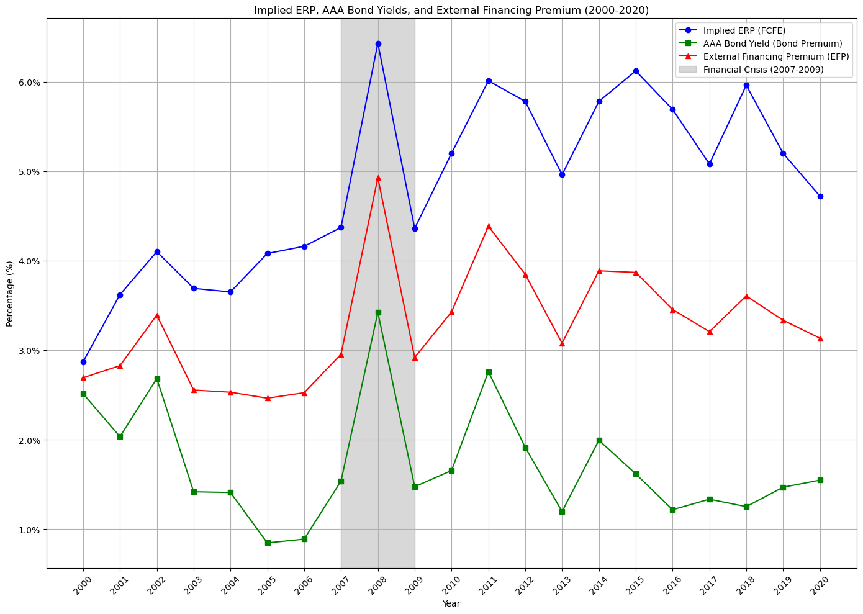

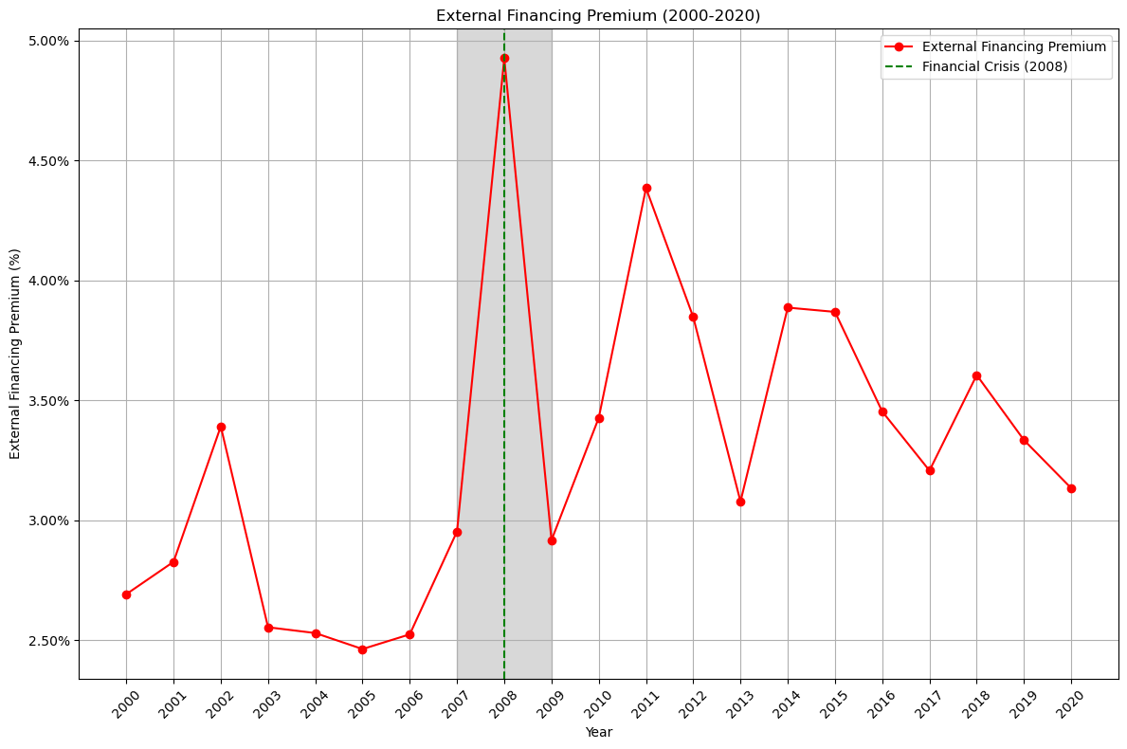

The monetary policies to mitigate the decline in financial intermediation could be divided into two monetary policy tools, including conventional monetary policy and unconventional monetary policy. During 2008, the Fed's conventional monetary policies were lowering interest rates and providing liquidity support. Meanwhile, the Fed announced and executed the unconventional monetary policy, including implementing quantitative easing policies.

The first conventional monetary policy tool the Fed implemented was lowering interest rates. According to figure (4), before economic and financial downturns, interest rates had continued to rise from 2005 to 2007 until they reached the 5.25% level. High-interest rates represented high borrowing and investment costs for financial intermediaries. During economic and financial downturns, if interest rates remain at the same level, financial intermediaries would suffer a liquidity crisis due to their inability to pay high-interest rates. In response to the financial crisis, the Fed adjusted the federal fund effective rate several times between 2008 and 2009, from 5.25 to almost 0. Reducing interest rates amid the financial crisis served to potentially diminish borrowing expenses for both households and businesses, thus fostering ongoing expenditure. This strategy aimed to soften the economic blow and alleviate financial strains. By pushing policy interest rates towards near-zero levels, the Federal Reserve sought to enhance the affordability of borrowing for households and businesses. In summary, the first conventional monetary policy tool the Fed implemented was lowering interest rates in 2008. The potential roles of adjusting interest rates for financial intermediaries are decreasing borrowing and investment costs and solving the potential liquidity crisis.

The second conventional monetary policy response to the financial crisis is providing liquidity support. According to figures (5) and (6), during economic and financial downturns, The S&P 500 index declined rapidly while the VIX index rose simultaneously. The decline in the index indicated that the market was full of concerns about the development of the U.S. economy and also expressed concern about the performance of the companies included in the index. In other words, the increased VIX index, which stands for market volatility, indicated the options market's negative attitude toward the U.S. economy and companies. In response to the conditions in the stock and options markets, the Fed provided liquidity support to the financial intermediaries. Following is an example of the Fed providing liquidity support to a financial intermediary. On Tuesday, the Federal Reserve Board, in collaboration with the Treasury Department, granted authorisation for the Federal Reserve Bank of New York to extend a loan of up to $85 billion to the American International Group (AIG) under section 13(3) of the Federal Reserve Act. The Fed provided liquidity support to AIG because AIG's disorderly failure could exacerbate the already severe fragility in financial markets, leading to significantly higher borrowing costs, decreased household wealth, and a markedly weakened economic performance. Unfavourable market conditions were mitigated with investors reassessing the company's operations after the Fed provided short-term loans and offered liquidity support to some companies. According to figures (5) and (6), the S&P 500 index began to rise in 2009. Although the VIX index increased several times from 2008 to 2009, it did not reach the same level as in 2008. From these data, monetary policy is a positive signal for the stock and options market, indicating that these companies can maintain their operations during the economic downturn through short-term loans and liquidity support. To conclude, another monetary policy tool is providing liquidity support. The potential roles of providing liquidity support for financial intermediaries are promoting the stable functioning of financial markets and restoring investor confidence in the stock and options markets.

Other than conventional monetary policy tools, the Fed also executed unconventional monetary policy tools during economic and financial downturns. The quantitative easing policy is an essential part of the unconventional monetary policy. During economic and financial downturns, the financial intermediaries experienced a liquidity crisis due to insufficient cash reserves. Meanwhile, negative growth in the financial market caused those companies to become more cautious about lending and investing activities. And these negative factors also had a negative impact on investors and consumers. In November 2008, the Fed announced its intention to commence a program aimed at acquiring the direct obligations of government-sponsored enterprises related to housing and mortgage-backed securities backed by Fannie Mae, Freddie Mac, and Ginnie Mae. The quantitative easing policy increased the money supply and reduced the liquidity crisis's impact. With the increase in money supply and low-interest rate policies, the borrowing costs of companies and individuals were significantly reduced. In that case, the borrowing activities of companies and individuals would increase, which could reduce the impact of liquidity issues. Meanwhile, the quantitative easing policy was also conducive to market stability and restoring investor confidence. The announcement of the purchase of long-term financial assets encouraged financial institutions to carry out lending and investment activities. In conclusion, the quantitative easing policy is the main unconventional monetary policy tool during economic and financial downturns. The potential roles of the quantitative easing policy for financial intermediaries are reducing borrowing costs and encouraging lending and investment activities. Also, the quantitative easing policy helps restore investor confidence and bring positive information to the financial market.

Although the monetary policy tools mentioned above in the essay had positive effects on the economy and financial markets, they could also have adverse effects in the long term. According to figure (7), consumer prices in the United States increased from -0.36% in 2009 to 3.15% in 2010. With the implementation of monetary policy, the inflation rate gradually increased, and the purchasing power of currency decreased. Monetary policy also pushed up the prices of stocks and options, causing investors to bear more significant risks for higher returns, potentially leading to instability in financial markets. An increase in the money supply would also cause a depreciation of the exchange rate. In the end, the depreciation of the exchange rate would affect exports and foreign investment. In short, in response to the economic crisis, the monetary policy implemented by the Fed would have some adverse effects in the long term. Purchasing large amounts of financial assets and increasing the money supply can lead to inflation, a decrease in the purchasing power of currency, exchange rate depreciation, and instability in financial markets.

**Rreferences**

FRED (no date) *Federal Funds Effective Rate 2019-2024 (DFF)* Available at: <https://fred.stlouisfed.org/series/DFF> (Accessed: 19 July 2024)

Madigan, B. (2008) *Material for FOMC Briefing on Monetary Policy Alternatives.* Available at: <https://www.federalreserve.gov/monetarypolicy/files/FOMC20080805material.pdf> (Accessed: 19 July 2024)

FRED (no date) *Contributions to the Cleveland Financial Stress Index: Asset-Backed Security Spread (DISCONTINUED)* Available at: <https://fred.stlouisfed.org/series/ABSSD678FRBCLE> (Accessed: 19 July 2024)

FRED (no date) *Federal Funds Effective Rate 1954-2024 (FEDFUNDS)* Available at: <https://fred.stlouisfed.org/series/FEDFUNDS> (Accessed: 19 July 2024)

1. https://www.sciencedirect.com/science/article/pii/0304393295012230#aep-abstract-id3
2. Damodaran, Aswath, Equity Risk Premiums (ERP): Determinants, Estimation and Implications - The 2023 Edition (March 23, 2023). Available at SSRN: https://ssrn.com/abstract=4398884 or http://dx.doi.org/10.2139/ssrn.4398884