|  |
| --- |
| **SOUTHERN CROSS UNIVERSITY** |

**ASSIGNMENT COVER SHEET**

For use with online submission of assignments

Please complete all of the following details and then make this sheet the **first page of each file of your assignment – do not send it as a separate document.**

Your assignments must be submitted as either **Word documents, text documents with .rtf extension or as .pdf documents**. If you wish tosubmit in any other file format please discuss this with your lecturer well before theassignment submission date.

|  |  |
| --- | --- |
| Student Name: | **Wenshuo Lei** |
| Student ID No.: | **23811612** |
| Unit Name: | **Developing the User Experience** |
| Unit Code: | **PROG2001** |
| Tutor’s name: | **Viettrung Luong** |
| Assignment No.: | **Assignment 2, Design Documentation** |
| Assignment Title: | **Grey box** |
| Due date: | **Wednesday 30th March 2022** |
| Date submitted: | **Wednesday 30th March 2022** |

Declaration:

*I have read and understand the Rules Relating to Awards (*[*Rule 3 Section 18 – Academic Misconduct Including Plagiarism*](http://policies.scu.edu.au/view.current.php?id=00140#s18)*) as contained in the SCU Policy Library. I understand the penalties that apply for plagiarism and agree to be bound by these rules. The work I am submitting electronically is entirely my own work.*

|  |  |
| --- | --- |
| Signed:  (please type your name) | Wenshuo Lei |
| Date: | Wednesday 30th March 2022 |

Table of Contents

Assignment 2 project links: 1

Chat logs: 1

Translated chat: 1

# Assignment 2 project links:

**GitHub Link:**

https://github.com/LeiWenshuo/WenShuoLeiAss2_23811612

**Itch.io Link:**

https://wenshuolei.itch.io/lei-assignment2

# Chat logs:

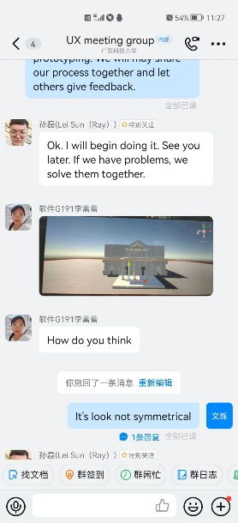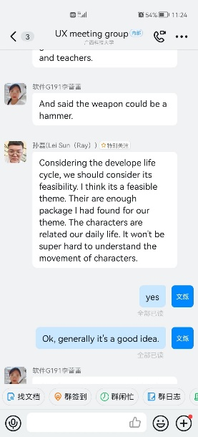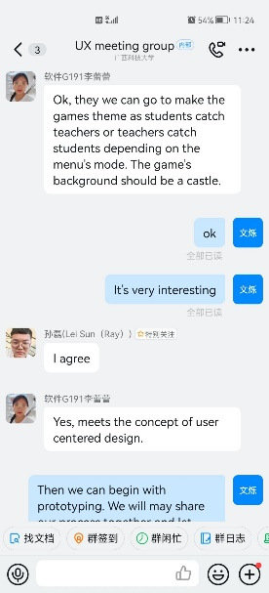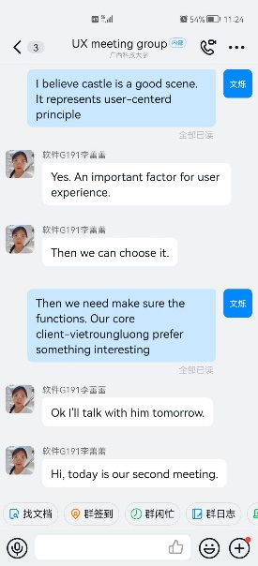

only a part of our discussion

# Translated chat:

Unnecessary