**CHAPTER 2**

**IMPLEMENTATION AND TESTING**

**Functional Decomposition Diagram**

This diagram shows the breakdown of the Fitness Planner System from the high – level function, process, and organization down to the lower level.

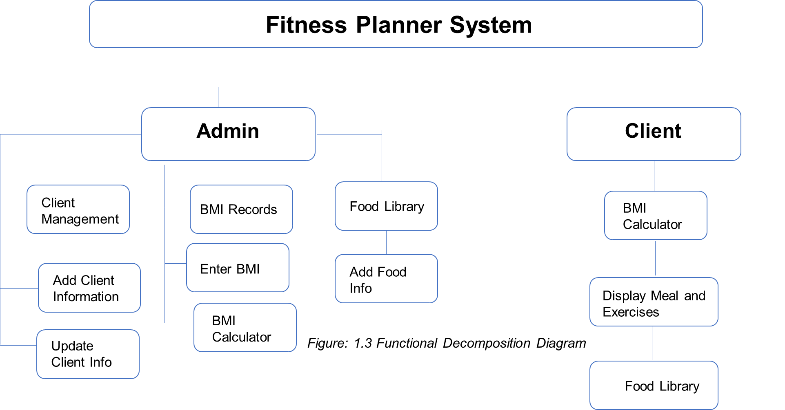

# Analysis Design Phase

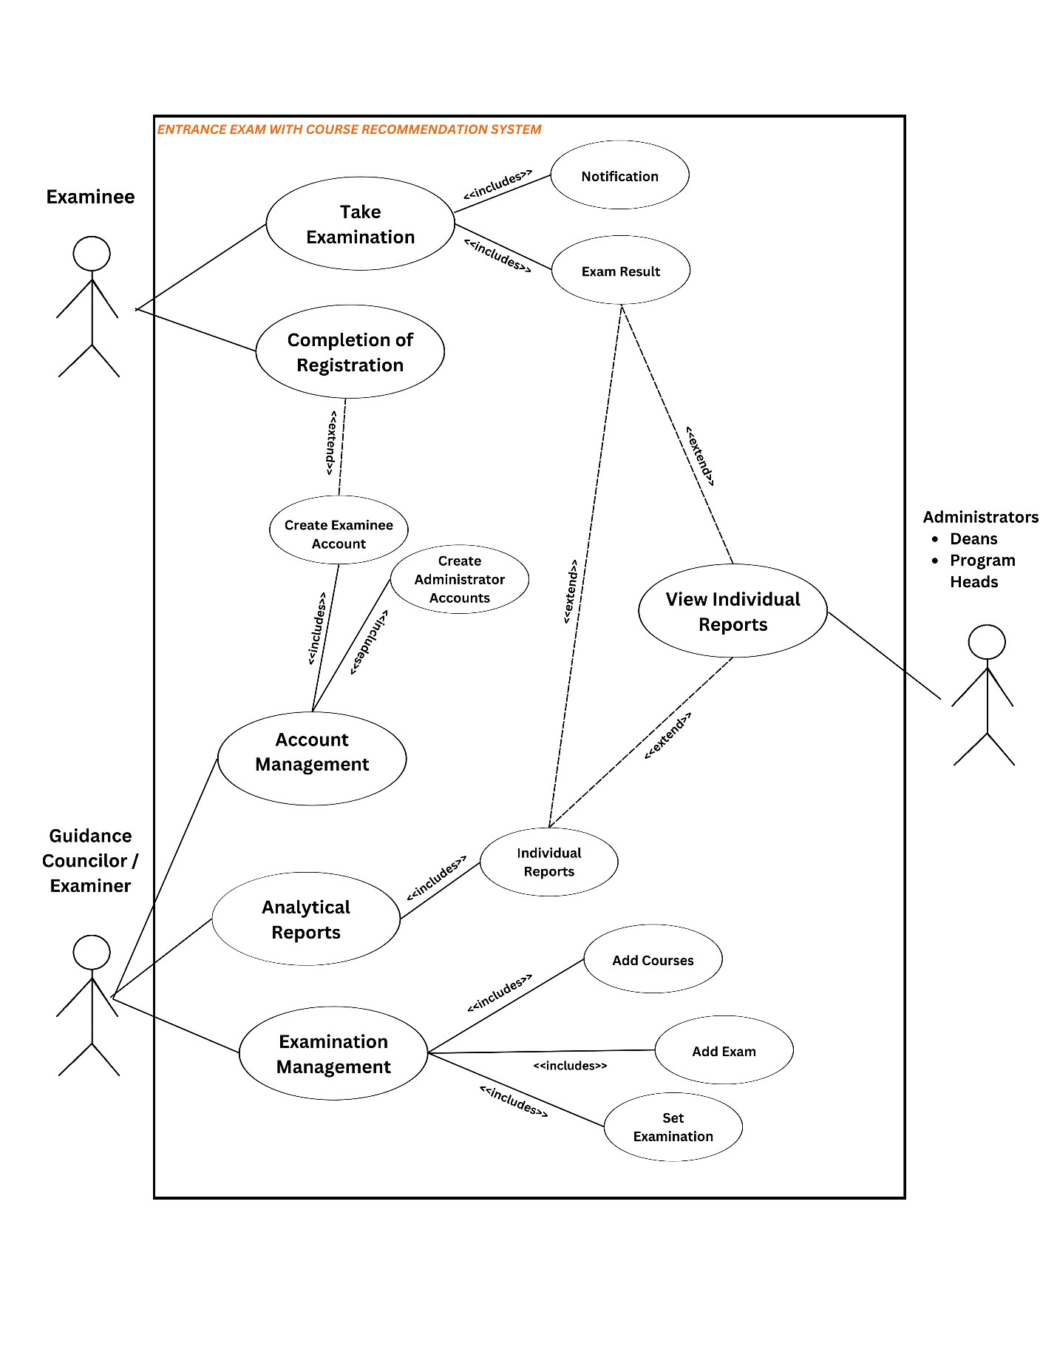

**Activity Diagram**

|  |  |  |
| --- | --- | --- |
| User/Actors |  | Use Cases |
| Examinee | • | Take the entrance examination. |
| Guidance  Counselor/  Exam  Administrator | • •  • | Register Examinees & Administrator Accounts.  Generate Analytical Reports.  Manage the entrance examination. |
| Program  Heads,  Deans,  School  Administrator | • | Access Analytical Reports. |

**Entity Relationship Diagram**

## A. Logical Entity Mapping Design

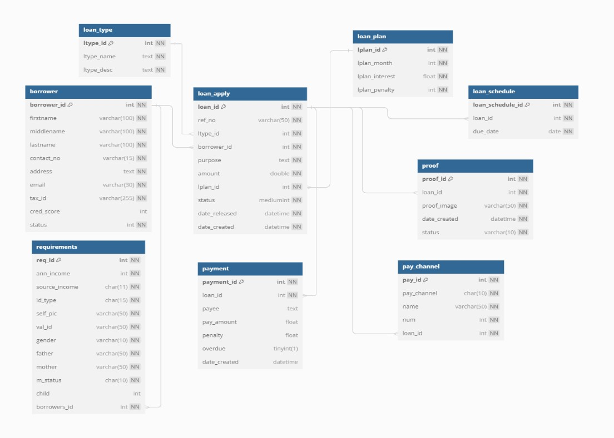

**B. Physical Entity Mapping Design**

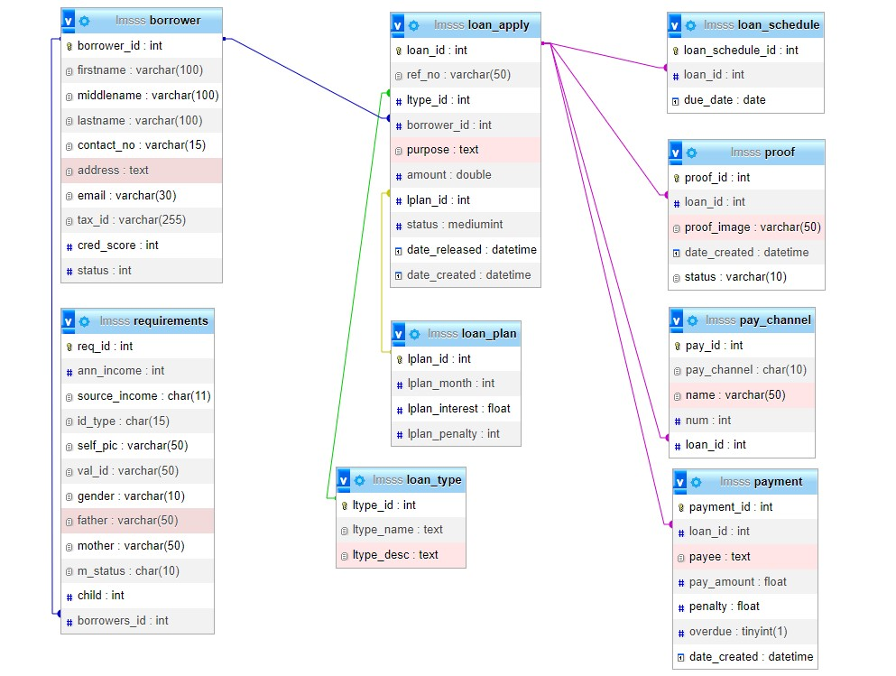

**USER INTERFACE OF THE SYSTEM**

# BORROWER INTERFACE

## Borrower index (index, login, registration)



## Borrower dashboard



## Borrower Loan Application (Display Current Credit Score and Credit Limit)

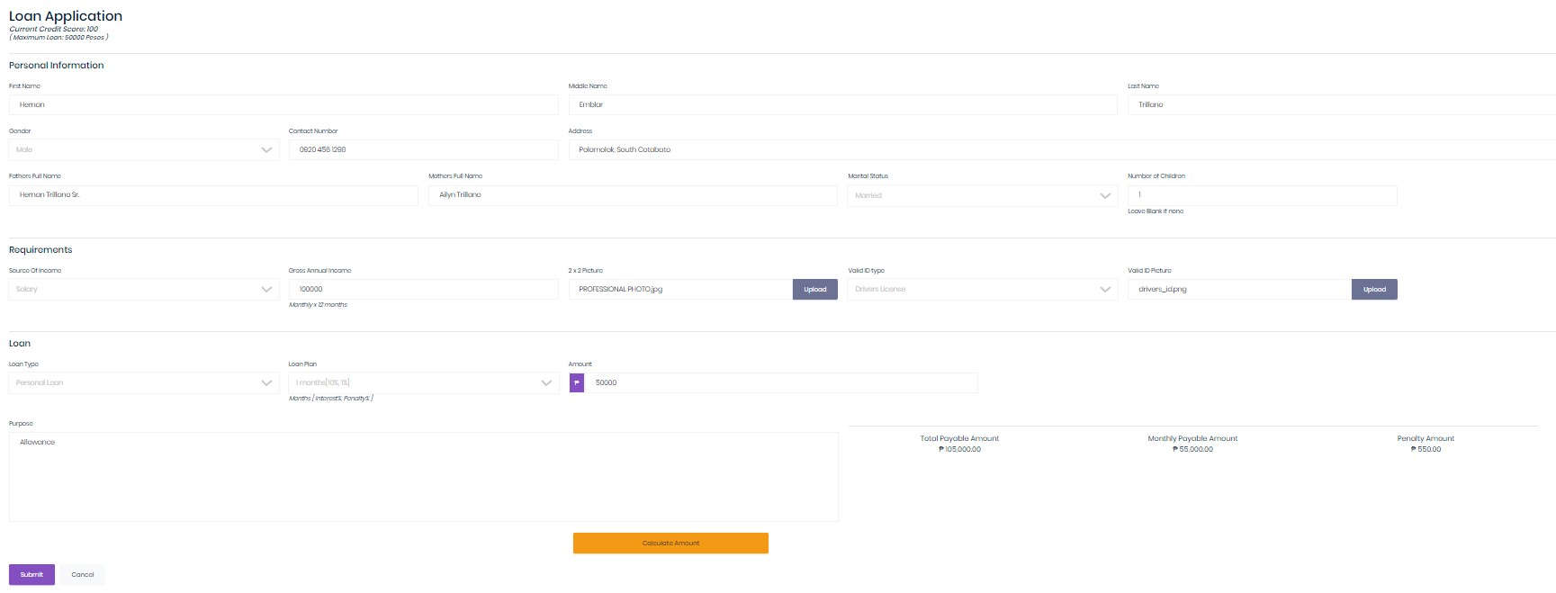

# ADMIN PANEL INTERFACE DESIGN

**DASHBOARD/ HOME**

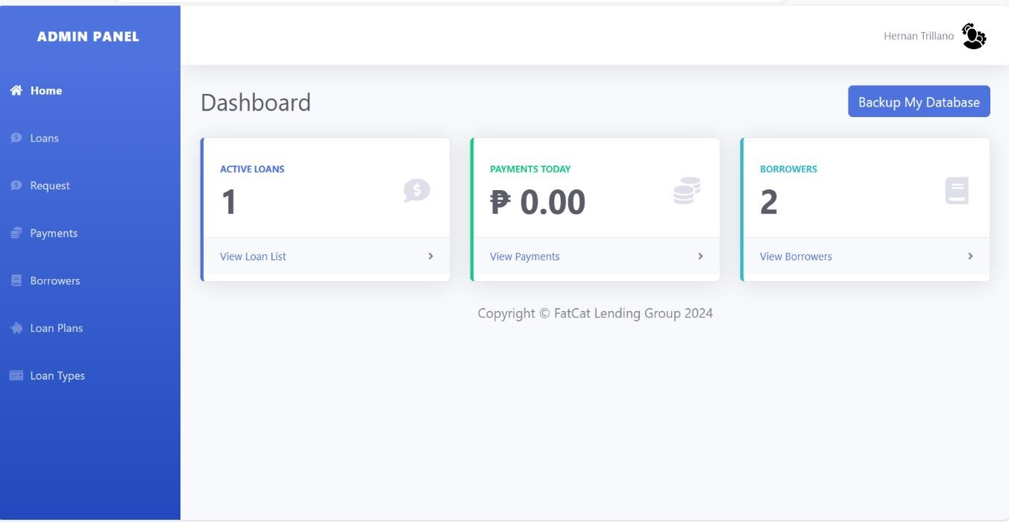

# LOAN MODULE

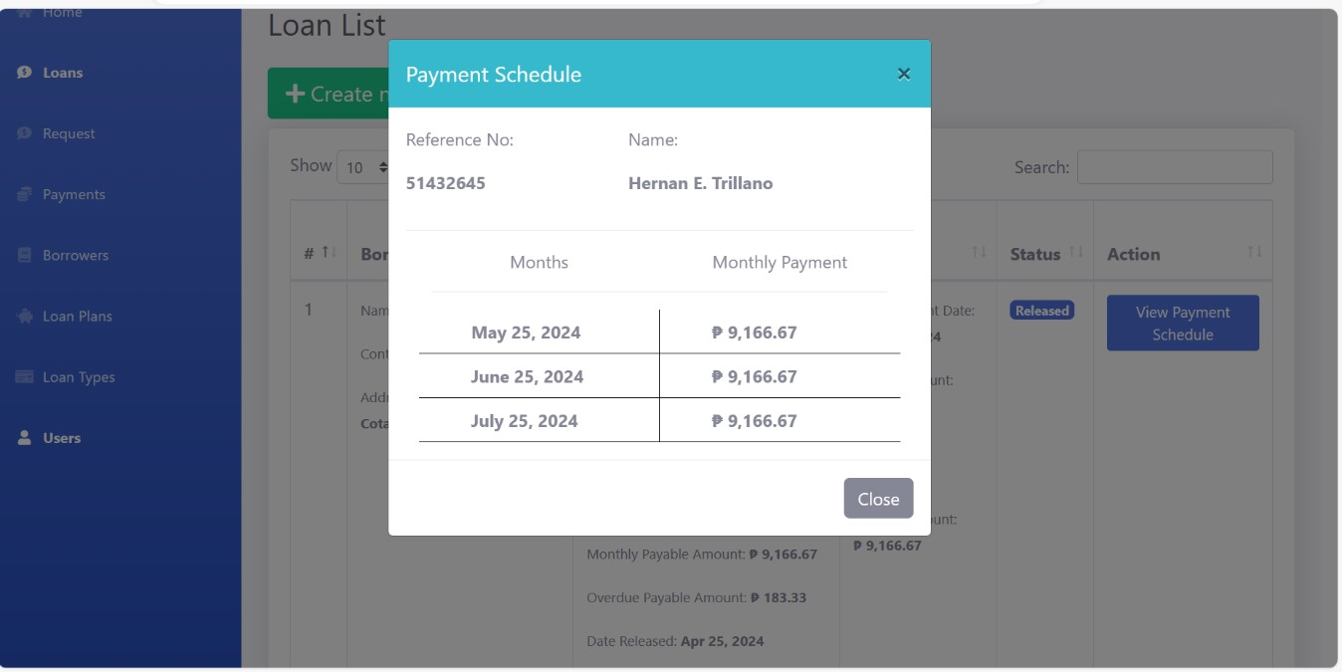

**LOAN APPLY MODULE**

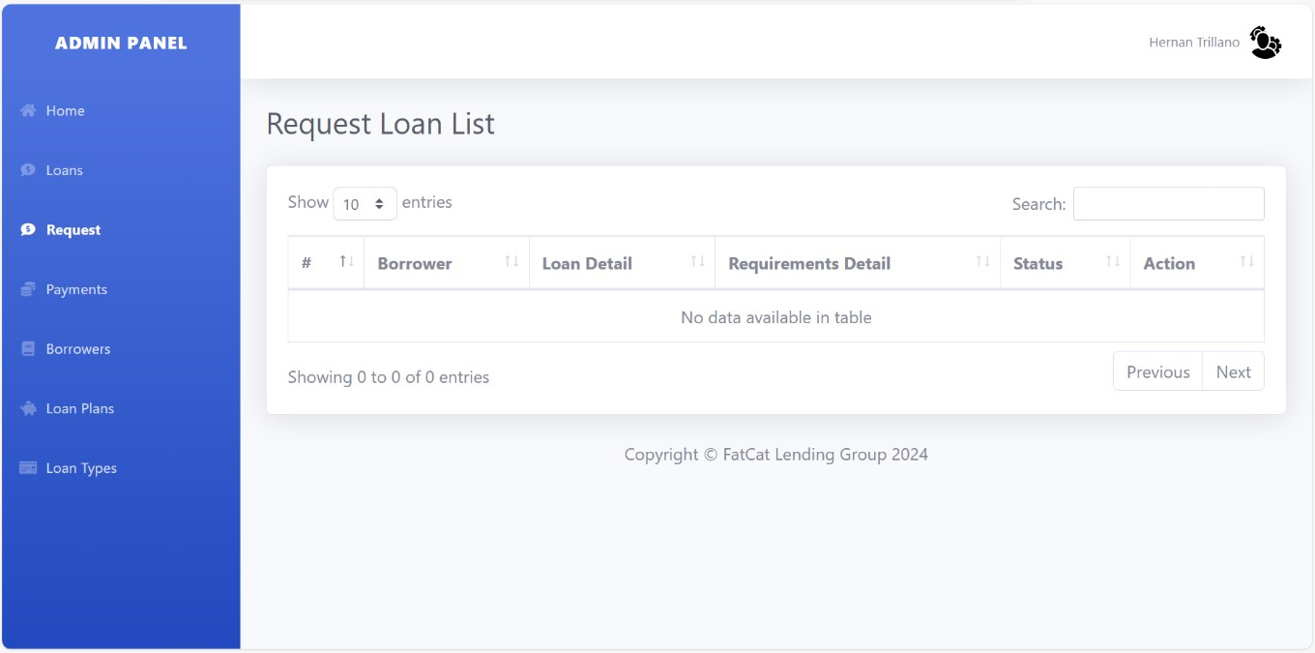

# PAYMENT MODULE

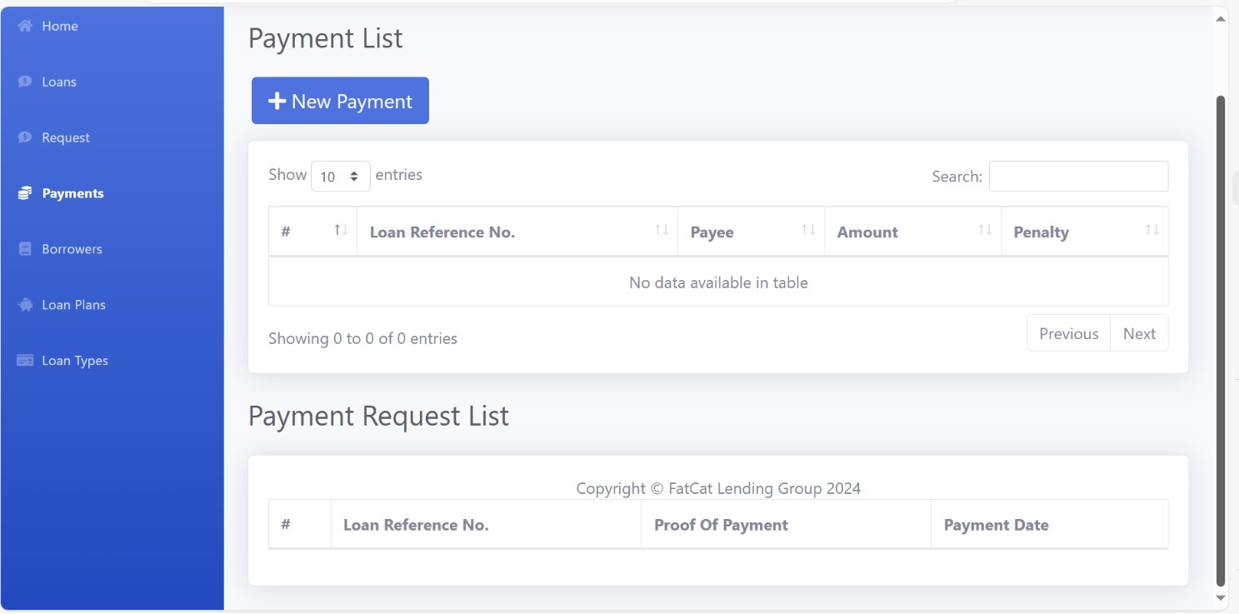

**BORROWER INFORMATION MODULE**

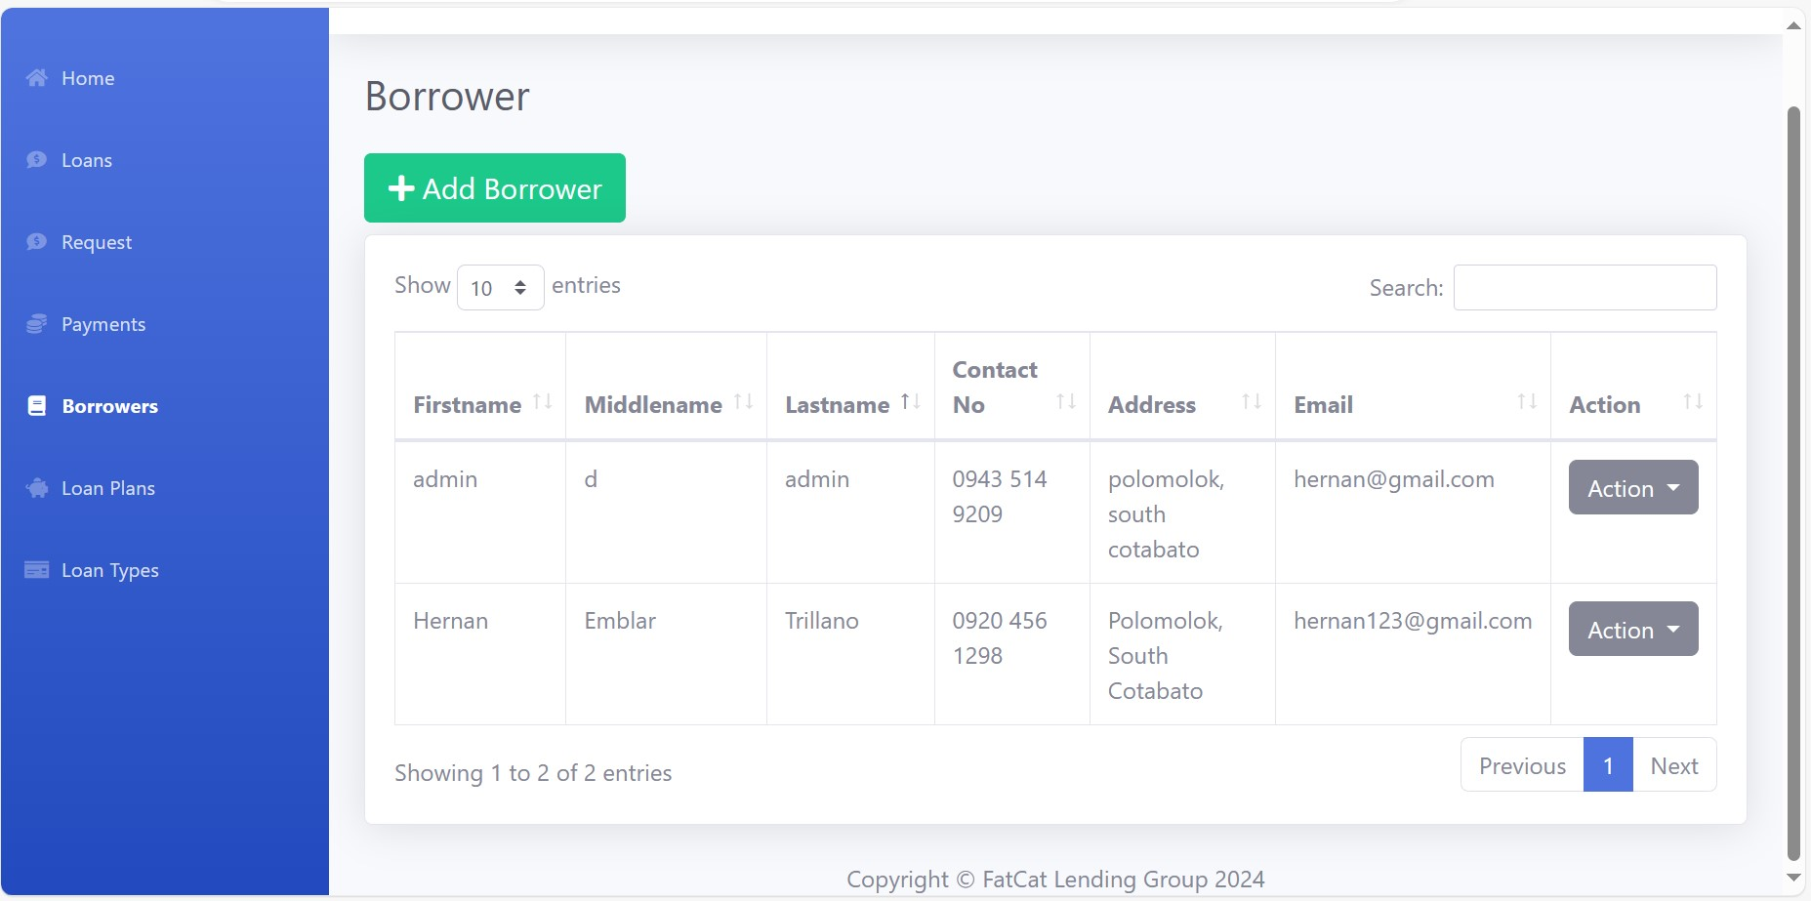

# LOAN PLAN MODULE

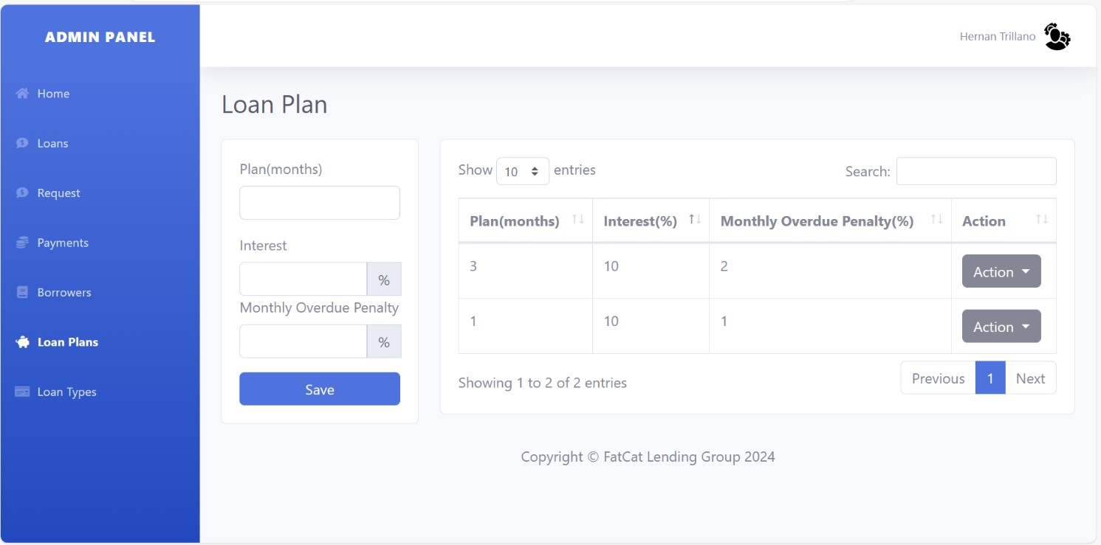

**LOAN TYPE MODULE**

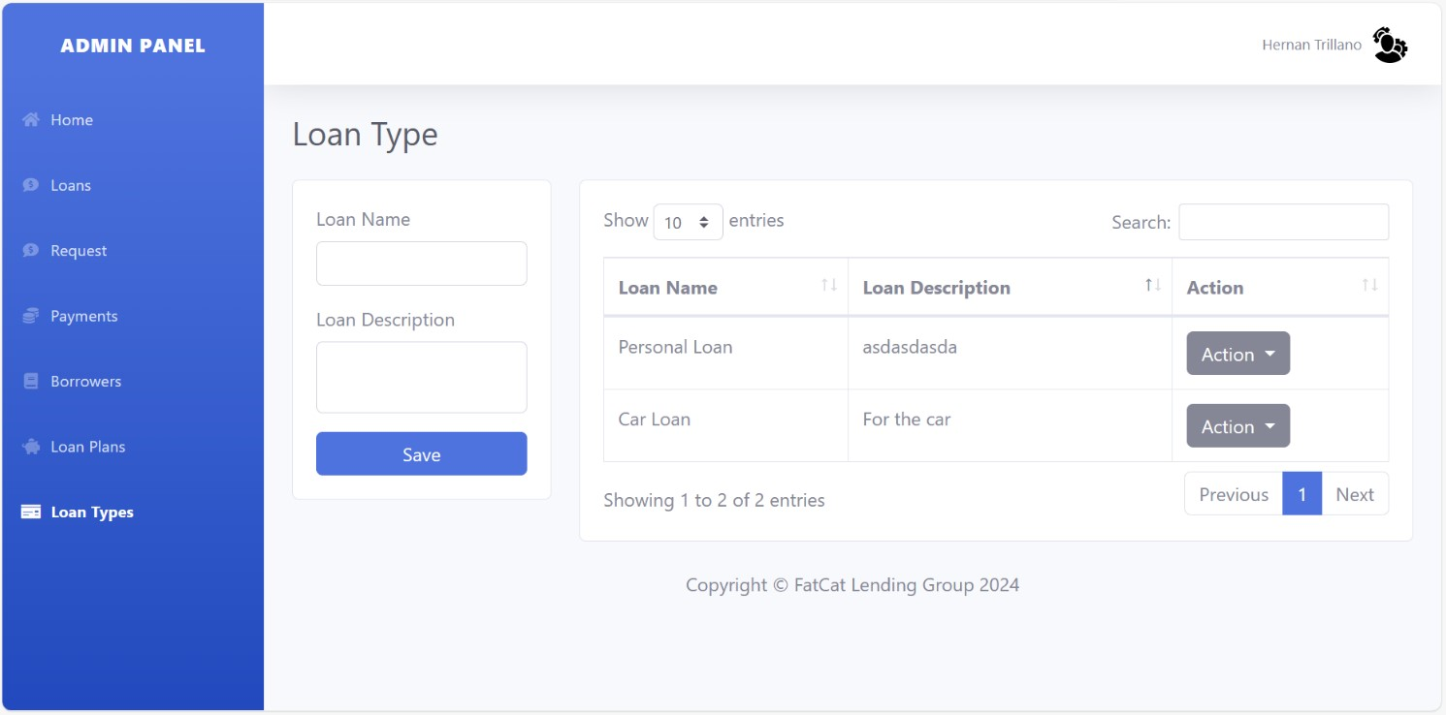

## Chapter IV

**SUMMARY, CONCLUSION AND RECOMMENDATION**