|  |  |
| --- | --- |
| **Laboratory Activity No. 10** | |
| **The Selection Widgets using Pycharm** | |
| **Course Code:** CPE103 | **Program:** BSCPE |
| **Course Title:** Object-Oriented Programming | **Date Performed:** March 29, 2025 |
| **Section:** 1 – A | **Date Submitted:** March 29, 2025 |
| **Name:** Hermosura, Leigh B. | **Instructor:** Maria Rizette M. Sayo |
| **1. Objective(s):** | |
| This activity aims to familiarize students with the Pycharm framework and selection widget | |
| **2. Intended Learning Outcomes (ILOs):** | |
| The students should be able to:   * 1. To create a Python program that use selection widget like Combobox   2. To use ttk function as part of Tk ( ) in the Tkinter module | |
| **3. Discussion:** | |
| A Graphical User Interface (GUI) application is a program that the user can interact with through graphics (windows, buttons, text fields, checkboxes, images, icons, etc..) such as the Desktop GUI of Windows OS by using a mouse and keyboard unlike with a Command-line program or Terminal program that support keyboard inputs only.  Pycharm is an integrated development environment used for programming in Python. It provides code analysis, a graphical debugger, an integrated unit tester, integration with version control systems, and supports web development with Django. | |
| **4. Materials and Equipment:** | |
| Desktop Computer with Anaconda Python or Pycharm Windows Operating System | |
| **5. Procedure:** | |

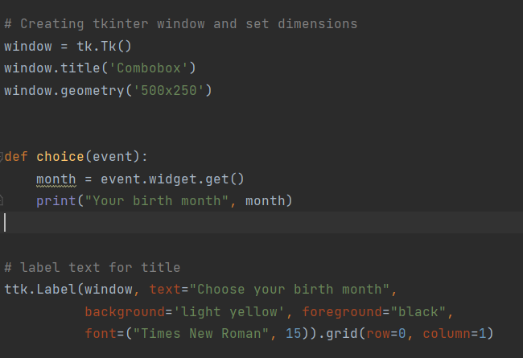

|  |
| --- |
| 1.   1. Run the program and observe the output.   **Adding an icon**   1. Download any .ico picture from <https://icon-icons.com/> or any similar sites. 2. Place the icon in your folder (ex. Oopfa1<lastname>_lab10)     5. Run the program again, the program should now have an icon similar to the program below. |
| **6. Supplementary Activity:** |
| **Task**  1. Create label widgets below to label your birth date <dd>, birth year <yyyy>  2. Create combobox to drop down your birth date <dd>, birth year <yyyy>  3. Create another method to show info about your birth date <dd>, birth year <yyyy>  Note: You may also use additional selection(listbox, radio button, check button) or common widgets to improve the design of your GUI. |
| **Questions**   1. What are selection widgets?   Selection widgets are interactive parts of graphical user interface (GUI) where we can choose from a set of options. Its examples include combo boxes, drop-down menus, check boxes, list boxes, and so on.   1. Which Python libraries provide selection widgets?   Python libraries that provide selection widgets are Tkinter, PyQt, Kivy, wxPython, Dear PyGui, and PySimpleGUI.  3. How do selection widgets enhance user interaction in GUI applications?  It enhances user interaction as selection widgets provide a user-friendly interface by making the GUI simpler and easier to navigate by utilizing drop-down menus, buttons, radio buttons, etc. |
| **7. Conclusion:** |
| Selection widgets are essential components of graphical user interfaces (GUIs), allowing users to choose from a predefined set of options. Examples of selection widgets include combo boxes, drop-down menus, checkboxes, and list boxes. Several Python libraries, such as Tkinter, PyQt, Kivy, wxPython, Dear PyGui, and PySimpleGUI, offer these interactive elements to improve user experience. These widgets enhance user interaction by providing a streamlined and intuitive interface, making it easier for users to navigate and select options. By reducing complexity, offering clear choices, and improving accessibility, selection widgets significantly contribute to creating efficient, user-friendly applications. |
| **8. Assessment Rubric:** |