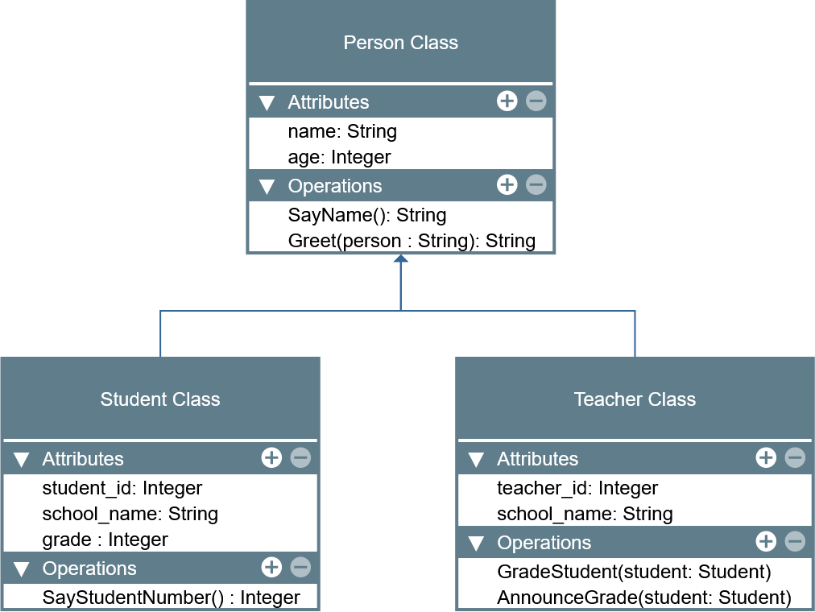

LABORATORY MANUAL

Object-Oriented Programming (CPE 103)

|  |  |
| --- | --- |
| **Laboratory Activity No. 2.1** | |
| **Literals, Operators, and Variables** | |
| **Course Code:** CPE103 | **Program:** BSCPE |
| **Course Title:** Object-Oriented Programming | **Date Performed:** 01/25/2025 |
| **Section:** 1 - A | **Date Submitted:** 01/25/2025 |
| **Name:** Hermosura, Leigh B. | **Instructor:** Maria Rizette M. Sayo |
| **1. Objective(s):** | |
| This activity aims to familiarize students in the various data types of Python, assign values to variables, and perform operations in a Python program. | |
| **2. Intended Learning Outcomes (ILOs):** | |
| The students should be able to:   * 1. Assign different values to variables in Python   2. Perform different operations available with variables in Python | |
| **3. Discussion:** | |
| The **Python** programming language is an interpreted language meaning the lines are evaluated line -by-line at runtime because there is no compile time at Python. This means that Python can dynamically allocate memory to variables as needed depending on the line of code that it interprets that is why Python is also referred to as a Dynamically typed language.  Like other programming languages such as C/C++ and Java, Python can also assign values to specific blocks of memory through variables as well as perform operations such as but not limited to Addition, Subtraction, Multiplication, Division, and Modulo(remainder). This activity will focus on assigning values and performing operations in Python.  Recall that a **variable** is a name that points to a specific location in memory where the data is stored. A variable can be allocated memory based on the data type it is assigned with which in Python can be: **Integer**, **Float**, **Complex Number**, **Boolean**, and **String**. In Python, **lists**, **tuples**, and **dictionaries** are also referred to as data types specifically sequences. More information can be found here ([https://docs.python.org/3.8/reference/datamodel.html?highlight=data%20type#objects -values-and-types](https://docs.python.org/3.8/reference/datamodel.html?highlight=data%20type&objects-values-and-types)). These will be discussed further in lab activities.  Variables in Python are assigned in the following manner:  variable_name = value  **Literals** refers to the raw data given in a variable or constant. Literals can be some of the following: Numeric, Complex, String, Boolean, Special. Other literals are list, tuple, dict, set, and Unicode literals. | |
| **4. Materials and Equipment:** | |
| Desktop Computer with Anaconda Python /Python Colab Windows Operating System | |
| **5. Procedure:** | |
| **Perform the activity using the Jupyter Notebook**  This activity can be done either locally on Anaconda’s Jupyter Notebook or online through Google Collaboratory which offers a free Jupyter Notebook environment for Google Users. IPython Notebook files (.ipynb) that are saved in the Google Drive can be opened on Google Collaboratory. Additional guides are available on the IPython Notebook template file that is provided wit h  this activity. If the template is not present, these are the valuable links for reference: | |

|  |
| --- |
| <https://jupyter-notebook.readthedocs.io/en/stable/examples/Notebook/Notebook%20Basics.html> <https://colab.research.google.com/notebooks/welcome.ipynb> <https://colab.research.google.com/notebooks/markdown_guide.ipynb>  **Assigning variables of different data types in Python**   1. In an empty cell, declare a variable **value** and assign it the value of 5 then display its value using print(). 2. Create a new cell and type the command: type(value) then run the cell. The output should be like the image below.      1. In a new cell, use the same variable **value** and assign it the value of 5.0 then print the value. 2. Repeat step 2.   **Note:** You may choose to decide how you execute the code in the cells for the next tasks in the procedure.   1. Repeat these steps for the following values:    1. 2+3j    2. ‘Hello World’    3. “Hello World”    4. True    5. False    6. [1,2,3,4,5]    7. (1,2,3,4,5)    8. { ‘name’: ‘Your_name’ }    9. None 2. Re-assign the **value** variable to be equal to 5. 3. Declare a new variable named **value2** to be equal to -6.   **Performing Operations with Python**   1. Using **value** and **value2**. Type the command: print(**value**+**value2**) 2. Repeat step 1 for the following values of **value** and **value2**:   Hint: You may try using this assignment ***value, value2 = 5, -6*** in the Notebook for the following steps:   * 1. value, value2 = 5.0, 6   2. value, value2 = -5, 6.1   3. value, value2 = “Hello”, ‘world’   Note: Modify the code so that hello and world would be separated.   * 1. value, value2 = [1,2,3], [4,5,6]   2. value, value2 = (1,2,3), (4,5,6)   3. value, value2 = {"name":"Royce"}, {"age":2}   Note: Observe the outputs carefully and try repeating them using subtraction. |
| 1. Using value, value2 = 30, 4. Type the commands:    1. print(value*value2)    2. print(value2**2)    3. print(value2**3)    4. print(value*value2+value2**2+1)    5. print(value/value2)    6. print(value%value2)   **Receiving Input Data using Python**  Data can be received through keyboard input in Python by using the input() function. The input function has the following syntax:  **input(“Message Name”)**  The “Message Name” is an optional String parameter that can be customized to prompt the user for a message instead of having to print a message prompt separately. The default return value of the input() function is a String containing the value received from the keyboard. This value can be assigned to a variable shown in the example below:  **name = input(“Enter your name: “)**  **Assigning Input Data to a Variable**  Finding a person’s BMI (metric)   1. Declare a new variable named **name** and assign it the value **input(“Enter your name”)** 2. Create another variable named **weight** and assign it the value **input(“Enter your weight(kg): “)** 3. Create another variable named **height** and assign it the value **input(“Enter your meters(m): “)** 4. Declare another variable called **bmi** and assign it the formula 𝑏𝑚𝑖 = 𝑤𝑒𝑖𝑔ℎ𝑡   ℎ𝑒𝑖𝑔ℎ𝑡2   1. Address the errors displayed step#4. You can accomplish this by converting the String input to another data type. An example would be:   **weight** = input(“Enter your weight(kg)”)  **weight** = float(weight)  Or simply **weight** = float(input(“Enter your weight(kg): “))  There are many functions available that can convert one data type to another. Some of which are the following:  int(), float(), str()  Other functions which maybe used in the later lab activities are: complex(real, imaginary), list(), tuple(), set(), dict(), ord(), bin(), hex(), oct().   1. Print the persons’s name, weight, height, and bmi Name: John Ray   Weight: 60  Height: 1.6764  BMI = 21.3499  **Guide:** 5.5 feet ~ 1.6764 m |
| **Hint:** You can combine two values by converting the output value to String and Concatenating (Addition) the operator on two strings.  print(“Value: “+str(12))  You may explore many other methods to format values onto the print() function in Python. Another example is the following:  print(“Value: “, 12) |
| **6. Supplementary Activity:** |
| **Tasks**   1. **Write the Python equivalent code of the following C code:**   int main(){  float base = 0, height = 0, area = 0; printf(“Enter the base of the triangle: “); scanf(“%f”, &base);  printf(“Enter the height of the triangle: “); scanf(“%f”, &height);  area = (1/2)*base*height;  print(“The area of the triangle is %f”, area);  }  For number 1, please refer to this link <https://colab.research.google.com/drive/1J8QzJXqdssdXcKUvk7rfOB_DOnnSNmje#scrollTo=8acy2qKHzVnN&line=2&uniqifier=1>   1. **Write a program that would convert Celsius to Fahrenheit given the formula: F = (C × 9/5) + 32 Example of conversion:**   **0°C = 32 °F**  **-20°C = -4 °F**  For number 2, please refer to this link  <https://colab.research.google.com/drive/1J8QzJXqdssdXcKUvk7rfOB_DOnnSNmje#scrollTo=ivH6gRQ91TNu&line=1&uniqifier=1>   1. **Write a program that can determine the distance between two points given the coordinates using the formula:**   𝒅 = √(𝒙𝟐 − 𝒙𝟏)𝟐 + (𝒚𝟐 − 𝒚𝟏)𝟐 **Hint/Rule: No library or package is needed to implement this equation. Example: x2, y2 = -3, 3 and x1, y1 = 2, 2 d = 5.099019514**  For number 3, please refer to this link  <https://colab.research.google.com/drive/1J8QzJXqdssdXcKUvk7rfOB_DOnnSNmje#scrollTo=LtC8NiPj2n-V&line=1&uniqifier=1>  **Questions:**   * 1. **Give one major difference in syntax that Python has with other languages such as C?**   In other languages such as C, their codes start with preprocessor directives like “#include<iostream>” and the main function “int main()” whereas in Python such steps are not required.   * 1. **How does variable assignment differ in Python compared with other languages such as C?**   In C, you must declare the type of variable before assigning a value (ex. int z = 5, char y[] = “Hi”) while in Python, the type is concluded when the value is assigned (ex. z = 5, y = “Hello”).   * 1. **Try assigning variable names that start with numbers, and special characters. Is the assigning of variables that start with numbers accepted by Python? For Special Characters? Is there an exception for variables special characters?**   Python does not accept variable names that start with numbers and special characters. Most special characters are also not allowed (such as @, #, !, $) with the exception of underscores (_).   * 1. **Do the assignment operators (+, -, *, /, %, **) work for all data types? Why or Why not?**   It doesn’t work on all data types as we can’t use non-numeric data types (string, bool, list, etc.) for computations in Python.   * 1. **How does the * operator differ from the ** operator?**   The “*” operator stands for multiplication. It multiplies the first value to the second value (ex. 2*5 = 10) while the “**” operator stands for exponential. It raises the first value to the second value (ex. 2**5 = 32). |

|  |
| --- |
|  |
| **7. Conclusion:** This supplementary activity helps students become familiar with essential arithmetic operators such as +, -, *, **, /, //, and %. Mastering these operators is crucial for solving a variety of problems, such as creating unit converters, building calculators, and performing mathematical tasks in general. Additionally, the activity introduces students to Python's different data types (such as int, float, and str) and teaches how to manipulate data through operations like concatenation and repetition. Overall, these foundational skills are essential for developing more complex programs and enhancing problem-solving abilities in Python. |
|  |
| **8. Assessment Rubric:** |