Research

For our project we broke our research down into two parts, the first was to research articles and papers online, this provided us with a base of knowledge in the market our project would be present in. We also looked up and completed surveys for babies sleeping patterns and baby monitoring devices and noted the most frequently asked questions. We combined this information to then write our own survey. We got 15 responses in total. One of our team members also translated the survey into Arabic, to diversify the data we ended up with. The responses we received gave us the hard, firsthand data we needed to inform our design ideas.

Online Research of Babies Sleep Cycles.

Sleep-movement and Noise

Over a 24-hour period a baby can sleep for 14-15 hours, this is broken up into 2-to-3-hour periods, as you can see from the below graph the sleep cycle of a child changes rapidly as they get older. Just after being born the child will almost sleep equally through the night and day. As they get older there sleeping cycle will closer resemble a normal pattern, that being sleeping mostly during the night.

Newborn babies are very active sleepers. The move and wake up a lot, this is down to the fact that that they spend half their sleep in REM (Rapid Eye Movement) or active sleep. The baby’s eyes move around (while closed), They move their arms and legs and open and close their mouths. The other half of their sleep is spent in NREM (Non-rapid Eye Movement) or quiet sleep. This is where the baby is fully asleep and does not move and make noise as frequently. As they get older there sleeping becomes sounder and they sleep better through the night.

Parallel to movement Newborn babies are also quite noisy sleepers, there breathing can be irregular and they may wake up briefly and whimper. It is recommended by doctors to wait out the babies first whimpers. It is very likely that the baby is still in a light sleep. The child should only be picked up and comforted if it’s clear that they are awake.

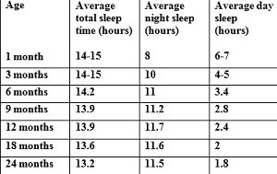

Baby sleep chart based on Swiss study (Iglowstein et al 2003)

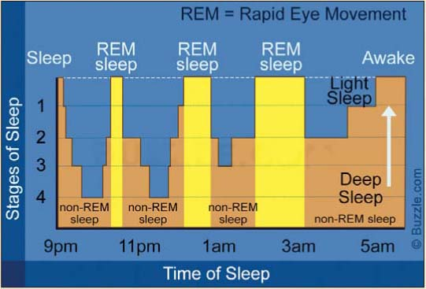

Music/ White noise

As a newborn baby is still getting used to the world, they may not be used to silence. Before they are born, they were constantly hearing noises made by their mother most importantly her heartbeat. Newborn babies may find silence mildly distressing.

Studies have shown that, the hum of a fan/ soft music or white noise being immitted through a speaker may ease this discomfort.

Again, as with movement and noise this eases as they get older, as there sleeping pattern becomes more regular.

Applying research to the scope of our project

My research has highlighted areas which may prove to be problematic.

* There is a big difference in the sleep cycles of newborn babies and babies as they get older, this will have to be considered when designing the prototype, A one size fits all strategy will not work.
* There are also quite varied differences between one baby to the next. A configuration that accurately monitors and comforts one baby may not be suitable for another.
* For example, as outlined in the research I have read, soft music or a lullaby playing may comfort some babies and it may also hinder another child’s sleep. This can also be said for white noise, this may aid or damage a newborns ability to fall asleep, depending on the specific baby.
* Differentiating between a baby that is in a very light REM sleep and a baby that is awake will prove very difficult as while in light sleep, they baby may move around and make noise.

Possible solutions

* The main takeaway from the research was that there is a great need to be able to adjust the device and its responses based on both the babies age and individuality.
* We could do this by having two are three different configurations built into the devices, With the tolerances for the sensor’s tailer to a specific age group.

E.g., Greater tolerances for newborns as not to trigger the responses while the baby is still light sleeps and tighter tolerances for when the baby gets older as he or she will not be moving around as much nor making as much noise.

* The noise that should be played when the baby wakes up should be able to be changed. The parents may then choose the noise that souths their baby the most. Lullaby’s/ heartbeats and white noise all could be including in the device.
* A further iteration of the device could include a report of the baby’s night sleep, similar to a smart watch, giving information on how long the child slept for, when the baby was in REM or EREM sleep, what noise soothed that child most. This would help inform the parents decision of what configuration would suit their child. Using data analytics, over time the device may also be able to suggest the optimal setting based on the sleeping data over a period.

Sources:

[Amy O’Connor, medically reviewed by Marvin Resmovits (01/05/20), “Newborn and baby sleep basics”, Viewed 13/02/21, <https://www.whattoexpect.com/first-year/newborn-sleep.aspx>]

[Danielle Pacheco (17/12/20), “How your baby’s sleep cycle deferrers from your own”, viewed 13/02/21, <https://www.sleepfoundation.org/baby-sleep/baby-sleep-cycle>]

[Author unknown, (date unknown), “What is white noise and how can it help your baby sleep?” viewed 13/02/21, <https://www.motherandbaby.co.uk/first-year/baby/sleep/white-noise-baby>]

[Emily DeJeu (28/09/19), “Your Baby’s Changing Sleep Patterns: Birth-12 Months”, viewed 16/02/20, https://www.babysleepsite.com/baby-sleep-patterns/baby-sleep-patterns-birth-to-12-months/]

Analysis of Survey

Link to survey’s responses: https://docs.google.com/forms/d/1SgEr8XRSmZtLHh8sDCJoe2gv4oWSCZ6ZpbeG1d4LPZE/edit#responses

Q1- Users name

* This question just asks the user to fill out their name.

Q2

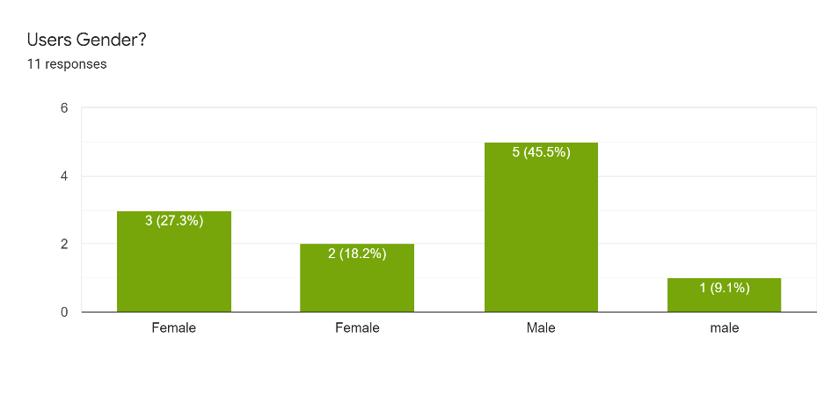

* As you can see from the above bar chart, we have 5 female and 6 male responses.

Q3

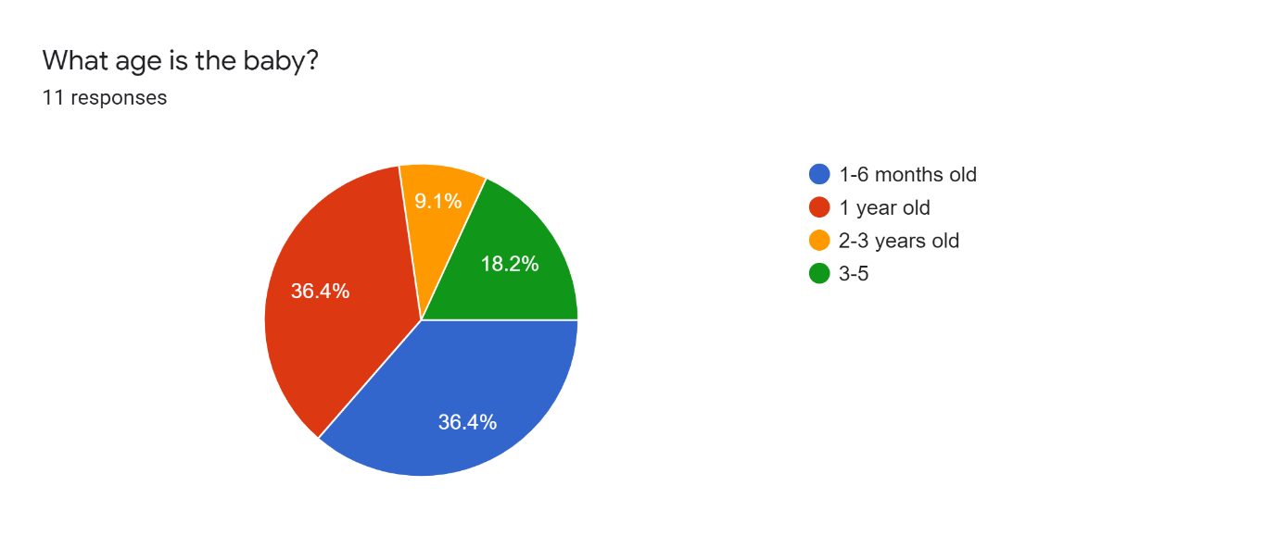

* This was vitally important question as outlined in the above research, a baby’s sleeping pattern changes vapidly as they get older. The age of the babies add context to the rest of the answers in the survey.

Q4- 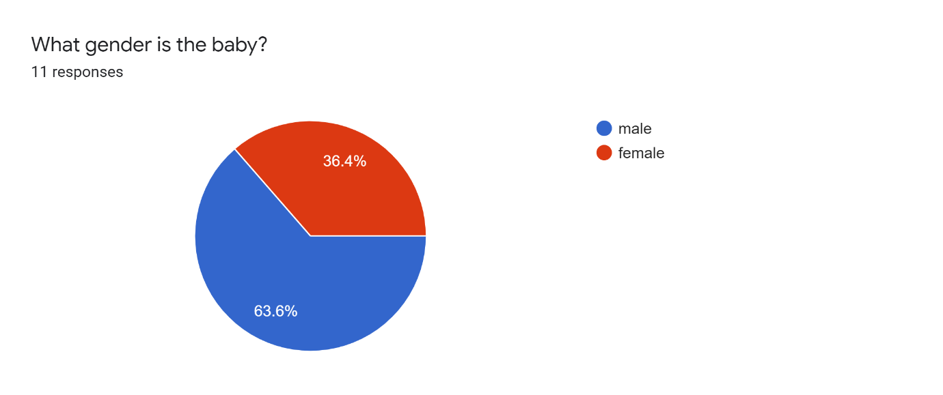

* Most of the people who answered this survey had male babies.

Q5-

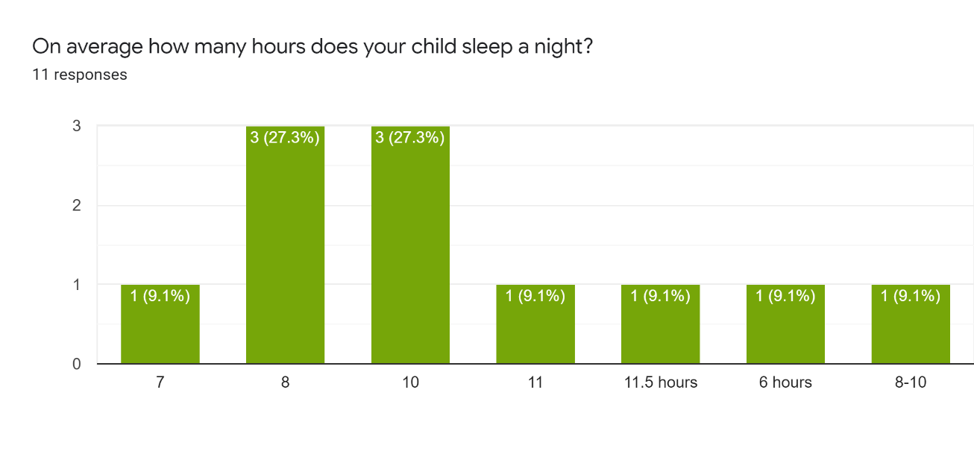

Q6- 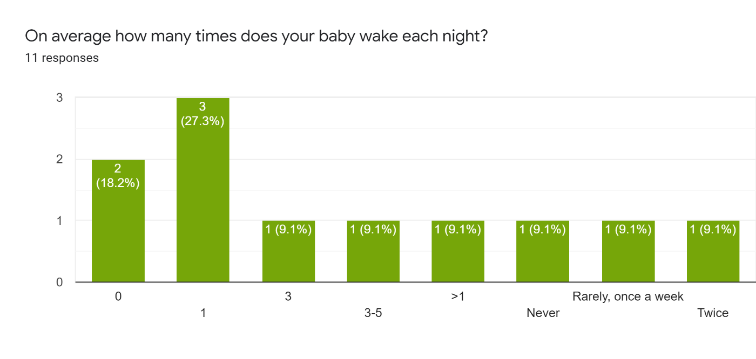

* As you can see from the above graph there is a huge variation in the amount of sleep each child is getting per night and the number of times they wake. A factor in this is the individuality of the child, some babies will sleep more or less than others. A factor to be examined is also the age of each baby. Breaking this down to the different age ranges we can examine this information more accurately.
* 1–6-month age range

The average number of hours sleep per night for the babies in this age range is 7.6, With each baby waking on average 1.6 times per night.

* 1 year old

The average sleep for babies at this range is 8.75 hours per night with each baby waking up on average 1 time per night.

* 2-3 years

Babies on average slept for 10 hours per night with waking during the night being a very rare occurrence.

* 3-5

The sleeping pattern on average matches very closely to that of the 2–3-year age range with babies sleeping for about 10 hours and waking up in the night being a rare occurrence.

Q7- Is your house usually noisy?

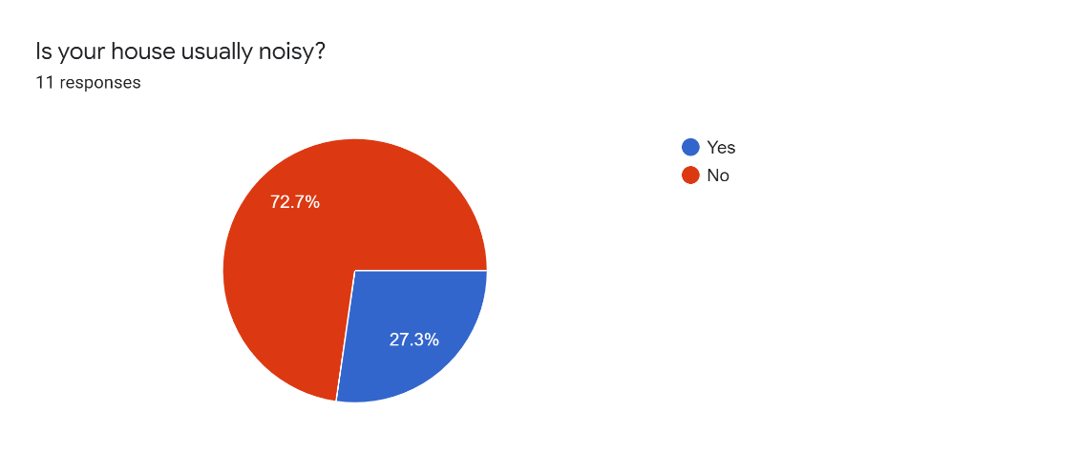

Q8

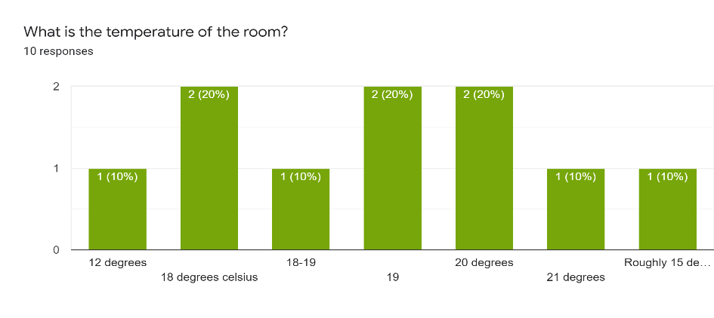

* During our research for survey questions, we discovered that the noise levels and temperature’s in a house may affect how well a baby sleep’s. Examining the data, it is difficult to draw a clear conclusion as the sample size of answers is too small. They may be something we examine further for a major project.

Q9- 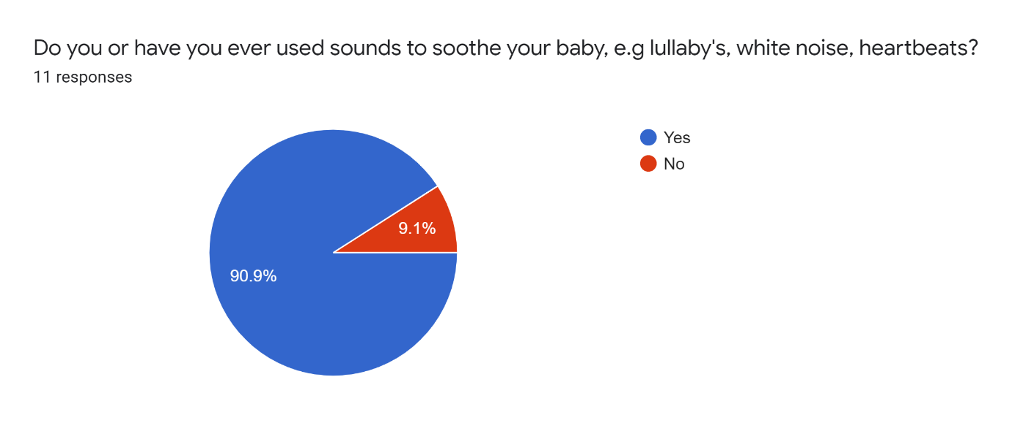

* As you can see from the above graph the number of parents who use sounds/lullabies to soothe their babies is very high, this confirms the research we carried out.

Q10- Can you tell us what do you usually use to stop your child from crying?

* holding their hand, soother
* White noise machine
* Rocking
* walk her in my arms, sing, dance gently.
* lift and sooth if necessary but will allow a certain amount of crying when getting used to getting themselves to sleep.
* Lift and soothe, check for anything wrong - nappy etc...
* Technique called verbal reassurance.
* Cuddles
* Pick up the baby and comfort her. Breast feed if very unsettled
* Sing
* Her mother’s breast, alternatively some bobbing and gentle shaking while whispering or singing soothing noises to her.
* Above you can see a list of ways parents comfort their babies, again an audio function is highlighted both white noise and singing are listed as ways of soothing their babies. Confirming the need for this feature on our project.

Q11- If your baby wakes briefly during the night how often will he/she fall back asleep without being picked up/comforted?

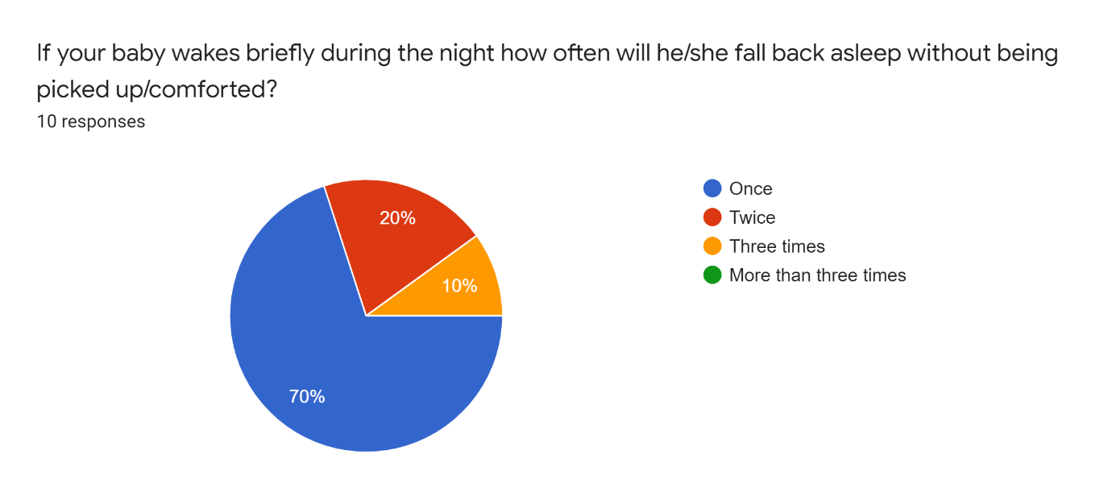

* As you can see 70% of parents confirmed that their baby will fall back asleep the first time after waking, with some babies falling back to sleep two or three times without being comforted. This is very important data, the tolerances for our sensors will have to be set very carefully. If they trigger a response too early, they may wake the baby further.

Q12- Do you use a baby monitor, if so what features of it do you find most valuable/What features do you wish it had?

- No

- the base board that monitors the child's heartbeat and sound

- Ability to talk to into the monitor to comfort baby, also has music and video

a movement alert if it cannot feel heartbeat or breathing or weight it alarms.

* Yes - music option.
* yes – music.
* We used the projector and timed music. We were able to put the music on from parent handset.
* Audio
* Temperature of room talk features. I would rather it had a mat to monitor breathing.

Wonderful for hearing every sound.

* Several features are outlined here both relevant to our minor project and some we may choose to research and develop for our major project.

Again audio/music function is mentioned heavily.

A sensor to monitor the baby’s heartbeat and breathing.

A video or projector function which could play soothing shapes, pictures.

A way to communicate with the baby.

Q13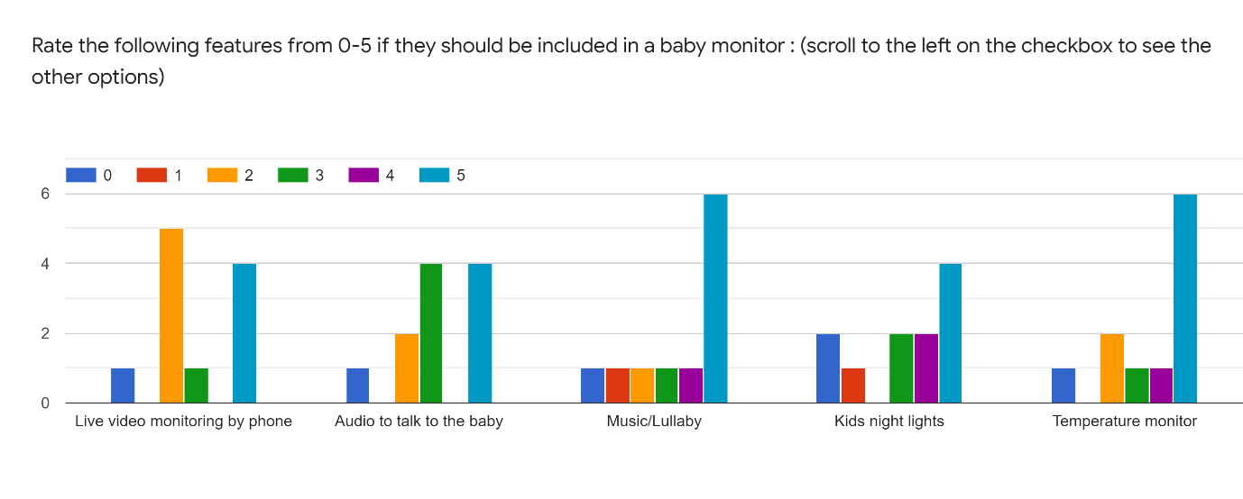

* Outlining what features are most important to parent we can see that again a music and nightlight function rank very highly, temperature monitoring also is ranked and important.
* Two-way audio function is something we may look at in a further iteration of our project. After discussion we feel for security reason and live video function would not be possible to do safely (outlined further in security analysis).

Q14- Other thoughts or comments?

* the angel base monitor was a huge reassurance especially during the first 6 months.

Hard to have definitive answer with younger baby as sleep patterns can change form one night to the next.

* Is it possible that any breathing difficulty could be detected? colourful reflections in the room/ceiling would be good?
* The movement alert was amazing, would rate over all other features.
* The batteries gave up and we had to replace them.
* Would be great if a monitor could give the child a bottle.
* Babies are cool.
* Although entertaining, ignoring the humours answers we can see in our further taught and comments section again some interesting areas are highlighted.
* The ever-changing sleep cycle of babies is highlighted again.
* A breathing monitoring function and ability to project colourful shapes in the room is also mentioned again.

Conclusion

One over-sight in the survey was not asking how many hours each child sleeps during the day and asking for a combined total, if this were done, I feel the total hours of sleep per 24hour period would closer resemble the average number of hours sleep per child outlined in our online research. As outlined above newborn babies will sleep for large parts of the day, as they get older, they do more of their sleeping at night, this change in their sleeping cycle as they get older is recording accurately in the data we gathered. Our survey did however highlight many areas which went on to inform both or physical and conceptual design ideas. Limiting this to what is feasible for our minor project. The main features outline by the parents are.

* A sound/movement sensor
* A night light with patterns/shapes
* An ability to play sounds/lullaby’s/white noise.

Each of these features were mentioned multiple times with a sound/lullaby function ranking the most important among them. Using both our online research and our survey we were able to bring these functions forward to the design stage and begin to conceptually put together our prototype.

// design sketches, fritzing drawing etc//