2021

Rhys Gilmartin Leigh McGuinness Stephen Meehan Abdul Rahman Saif Al Adhubi

Cradle-Care Baby Monitor

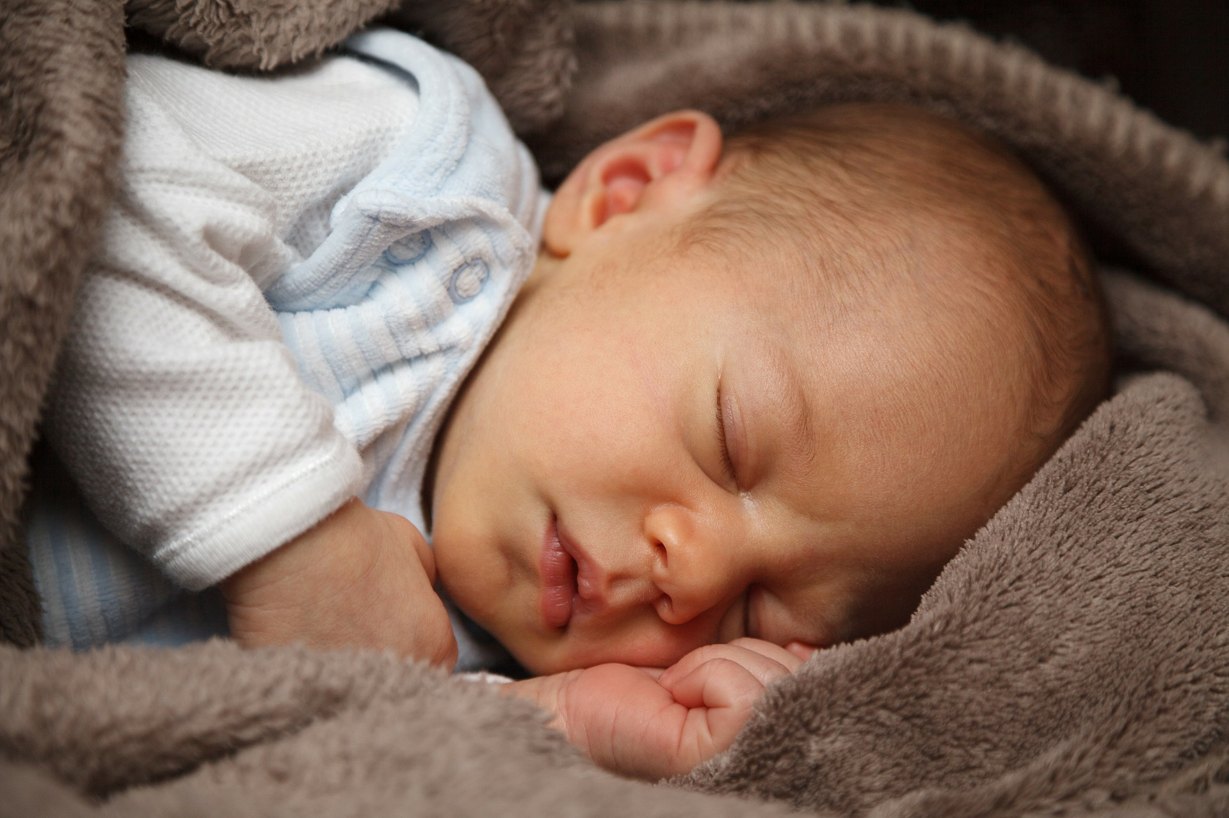

Table of Contents

TABLE OF FIGURES 5

LINKS TO GITHUB & TRELLO 6

LINKS TO RESERCH DATA 3

OUTLINE OF THE PROBLEM 3

REQUIREMENTS 4

1.RESEARCH 5

1.1 Online Research of Babies Sleep Cycles. 5

1.1.1 Sleep-movement and Noise 5

1.1.2 Music / White noise 6

1.1.3 Applying research to the scope of our project 6

1.1.4 Possible solutions 7

1.2 EXTERNAL SURVEY 7

1.3 USER SURVEY 7

1.4 RESEARCH ANALYSIS 8

1.4.1 SURVEY ANALYSIS 8

1.4.2 CONCLUSION 16

2. INITIAL DESIGN 16

2.1 INITIAL CONCEPTUAL SKETCHES 17

2.3 HARDWARE SETUP 18

2.4 HARDWARE SCHEMATICS 19

3. IMPLEMENTATION PLAN 21

3.1 EQUPIMENT USED 21

3.2 CODE DESIGN 22

3.2.1 EARLY CODE FLOWCHART 23

3.2.2 FINAL-CODE FLOWCHART 24

4. TESTING 26

4.1 TESTING APPROACH 26

4.2 TEST DATA 28

4.2.1 INITIAL INPUT / OUTPUT TESTING 28

4.2.2 FINAL TEST DATA 31

ETHICS AND SECURITY ANALYSIS 40

Internet of Things, Brief Technology Overview 40

Ethics and security in a baby monitoring device 41

FUTURE IMPROVEMENTS 42

Motorised LED Globe 42

Baby Cot Mobile 43

TEMPERATURE SENSOR 44

PIR SENSOR 45

PUSHING BOX 46

BLYNK & ARDUINO IOT CODE 46

NEGATIVE POINTS 46

MAKING YOUR OWN WEBSITE 46

TECHNOLOGIES USED 46

CONCLUSION 47

REFERENCES 48

# TABLE OF FIGURES

Figure 1 Baby sleep chart based on 5

Figure 2 Baby Sleep patterns 6

Figure 3 8

Figure 4 9

Figure 5 9

Figure 6 10

Figure 7 10

Figure 8 11

Figure 9 12

Figure 10 12

Figure 11 14

Figure 12 15

Figure 13 Sketch of Baby monitor in-situ 17

Figure 14 Proposed layout of Arduino Yun and components 17

Figure 15 – Early schematic sketch 18

Figure 16 – Led and Buzzer connected to the Arduino Yun 18

Figure 17 – Led, Buzzer and ……. connected to the Arduino Yun 19

Figure 18 – Led, Buzzer, and Sound Sensor connected to the Arduino Yun 19

Figure 19 – Schematic diagram of LED, and Buzzer connected to The Yun via a breadboard. 20

Figure 20 – Schematic diagram of LED, and Buzzer connected to The Yun via a breadboard. 20

Figure 21 – Schematic diagram of LED, Buzzer, Mic and Vibration sensor connected to The Yun via a breadboard. 21

Figure 22 Early Code Design Flowchart 23

Figure 23 Flowchart for our final working code 25

[Figure 24 - Grove Rptary Angle Sensor vertical movement test data 28](https://mailitsligo-my.sharepoint.com/personal/s00183063_mail_itsligo_ie/Documents/Software%20Development/Internet%20of%20Things/projects/minor_project/project_report/report_FinalDraft.docx#_Toc67645959)

Figure 25– Grove Rotary Angle Sensor horizontal 28

Figure 26 - Potentiometer Test 28

[Figure 27 29](https://mailitsligo-my.sharepoint.com/personal/s00183063_mail_itsligo_ie/Documents/Software%20Development/Internet%20of%20Things/projects/minor_project/project_report/report_FinalDraft.docx#_Toc67645962)

[Figure 28 - LED sketch code 29](https://mailitsligo-my.sharepoint.com/personal/s00183063_mail_itsligo_ie/Documents/Software%20Development/Internet%20of%20Things/projects/minor_project/project_report/report_FinalDraft.docx#_Toc67645963)

Figure 29 - LED is working, this will represent the Night Light 29

[Figure 30 - Sound sensor readings on the Serial Monitor 30](https://mailitsligo-my.sharepoint.com/personal/s00183063_mail_itsligo_ie/Documents/Software%20Development/Internet%20of%20Things/projects/minor_project/project_report/report_FinalDraft.docx#_Toc67645965)

Figure 31 - Sound sensor sketch code 30

Figure 32 - Arduino sketch with sound and movement 30

[Figure 33 31](https://mailitsligo-my.sharepoint.com/personal/s00183063_mail_itsligo_ie/Documents/Software%20Development/Internet%20of%20Things/projects/minor_project/project_report/report_FinalDraft.docx#_Toc67645968)

Figure 34 Sound Sensor Test code 31

Figure 35 Serial Monitor Log 32

Figure 36 3D image of child's cot and CradleCare baby monitor 44

Figure 37 Temperature sensor 45

Figure 38 PIR Sensor 45

# LINKS TO GITHUB & TRELLO

[GitHub Project Repository](https://github.com/LeighMcG83/Arduino-IoT-projectBabyMonitor)

[Team Project Trello Board](https://trello.com/b/WPP4Ebdd/iot-project)

# LINKS TO RESERCH DATA

[Baby sleep Survey - Google Docs](https://docs.google.com/forms/d/1SgEr8XRSmZtLHh8sDCJoe2gv4oWSCZ6ZpbeG1d4LPZE/edit%23responses)

[Research Data Folder on GitHub](https://github.com/LeighMcG83/Arduino-IoT-projectBabyMonitor/tree/main/research)

(Do we need to reorganize all data from design and research into this before submission?)

# OUTLINE OF THE PROBLEM

The problem our team has set out to solve is a problem faced by people of all race, creed, and social standing in all parts of the world. There are very few things as universally important to humankind as the care of our children. In the technological age of today, people are increasingly turning to gadgets and tech to help solve our everyday problems.

Parents worldwide are using baby monitors as they can provide peace of mind around the comfort of their children, easing parental anxiety(Harwell, 2021). ­This anxiety leads to parents experiencing broken sleep patterns, due to getting out of bed to check on their children. An effect of this is circadian rhythm disruption,

“Insufficient sleep and circadian rhythm disruption are associated with negative health outcomes, including obesity, cardiovascular disease, and cognitive impairment” (Möller-Levet *et al.*, 2013).

In light of mental health having implications on physical health, such as BMI, further highlighted in a report on Social Jetlag and Obesity by Roenneberg *et al.*, 2012, the use of a baby monitor can reassure, and lead to lower levels of anxiety in parents increased physical health.

Another negative effect of disrupted sleep are elevated levels of tiredness, reducing people’s productivity in the workplace, leading to more stress and anxiety and a repeat of the cycle.

As a solution to the above-mentioned problems, our group propose the installation of an IoT baby monitor featuring a crying-alert, night-light and a speaker which will play a lullaby. These components of the device will be triggered by a sound, and in later iterations, perhaps a movement sensor and temperature sensor.

The peace of mind provided by having this device can lead to a reduction in anxiety and a reduced need to get up to check on a child, thus alleviating some of the negative physical and metal health effects experienced by people.

While not a new development, baby monitors are still a useful tool used by many, and with the rise of the Internet of Things, they can now take on a new dimension. The ability to produce a report on nightly activity of a child through the use of an API will allow a parent or career to monitor the child nighttime behavior, further enforcing their comfort in not always rising to check on the child.

# REQUIREMENTS

1. The device has to detect sound.

Using the Grove sound-sensor the device will detect when a child is crying and alert parent if required to do so.

1. Device will detect and record room temperature
2. Print sensor data to Arduino serial monitor.

The device will send data read from all sensors to the serial monitor for analysis.

1. Activate a nightlight.

If the sound-threshold value in our code is breached, the monitor will activate a Night Light in a initial attempt to sooth the child.

1. Play sound / lullaby / white noise.

Baby monitor will play sound / lullaby / white noise to comfort the child

when both the code’s sound and movement threshold values are broken.

1. Have all components working together.

# 1.RESEARCH

## 1.1 Online Research of Babies Sleep Cycles.

### 1.1.1 Sleep-movement and Noise

Over a 24-hour period a baby can sleep for 14-15 hours, this is broken up into 2-to-3-hour periods, as you can see from the below graph the sleep cycle of a child changes rapidly as they get older. Soon after being born the child will sleep almost equally through the night and day. As they get older there sleeping cycle will closer resemble a normal pattern, that being sleeping mostly during the night.

Newborn babies are very active sleepers. The move and wake up a lot, this is down to the fact that that they spend half their sleep in REM (Rapid Eye Movement) or active sleep when the baby’s eyes move around. They move their arms and legs and open and close their mouths. The other half of their sleep is spent in NREM (Non-rapid Eye Movement) or quiet sleep. This is where the baby is fully asleep and does not move and make noise as frequently. As they get older there sleeping becomes sounder and they sleep better through the night.

Parallel to movement Newborn babies are also quite noisy sleepers, their breathing can be irregular, and they may wake up briefly and whimper. It is recommended by doctors to wait out the babies first whimpers without lifting or comforting the child. It is very likely that the baby is still in a light sleep. The child should only be picked up and comforted if it’s clear that they are awake.

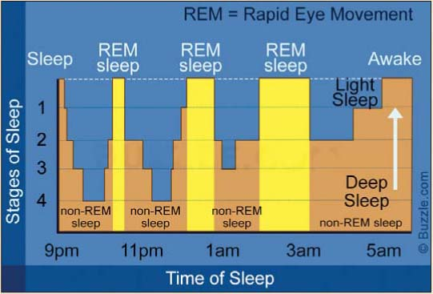

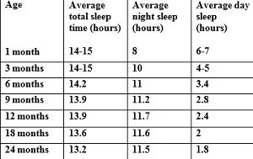

Figure 1 Baby Sleep patterns

Figure 2 Baby sleep chart based on Swiss study (Iglowstein et al 2003)

### 1.1.2 Music / White noise

As a newborn baby is still getting used to the world, they may not be used to silence. Before they are born, they were constantly hearing noises made by their mother most importantly her heartbeat. Newborn babies may find silence mildly distressing.

Studies have shown that, the hum of a fan/ soft music or white noise being immitted through a speaker may ease this discomfort.

Again, as with movement and noise this eases as they get older, as their sleeping pattern becomes more regular.

### 1.1.3 Applying research to the scope of our project

Our research has highlighted areas which may prove to be problematic.

* There are big differences in the sleep cycles of newborn babies and babies as they get older. This will need to be considered when designing rue prototype, A one size fits all strategy will not work.
* There are also quite varied differences between one baby to the next. A configuration that accurately monitors and comforts one baby may not be suitable for another.
* For example, as outlined in the research I have read, soft music or playing a lullaby may comfort some babies whilst hindering another child’s sleep. This can also be said for white noise, this may aid or damage a newborn’s ability to fall asleep, depending on the specific baby.
* Differentiating between a baby that is in a very light REM sleep and a baby that is awake will prove very difficult as while in light sleep, they baby may move around and make noise.

### 1.1.4 Possible solutions

* The main takeaway from the research was that there is a great need to be able to adjust the device and its responses based on both the babies age and individuality.
* We could do this by having two are three different configurations built into the device, with the tolerances for the sensors tailored to specific age groups.

E.g., Greater tolerances for newborns as not to trigger the responses while the baby is still lightly sleeping, and tighter tolerances for when the baby gets older as he or she will not be moving around as much nor make as much noise.

* The noise that should be played when the baby wakes up should be able to be changed. The parents may then choose the noise that souths their baby the most. Lullaby’s / heartbeats and white noise all could be included in the device.
* A further iteration of the device could include a report of the baby’s night sleep, similar to a smart watch, giving information on how long the child slept for, when the baby was in REM or EREM sleep, what noise soothed that child most. This would help inform the parents decision of what configuration would suit their child. Using data analytics, over time the device may also be able to suggest the optimal setting based on the sleeping data over a period.

## 1.2 EXTERNAL SURVEY

As part of our secondary research process, the group decided to complete some surveys online to get a feel for the type of questions that we could ask in our own survey of parents and baby monitor owners. We noted the most frequently asked questions and pooled our research findings to populate our own survey

[Link to survey research analysis](https://docs.google.com/document/d/1X5mCKldsCBvVHQidKqP2ac1tUgatLovcxw8Flll2gJQ/edit?ts=60310f9e)

## 1.3 USER SURVEY

For our project we broke our research down into two parts, the first was to research articles and papers online, this provided us with a base of knowledge in the market our project would be present in. We also looked up and completed surveys for babies sleeping patterns and baby monitoring devices and noted the most frequently asked questions. We combined this information to then write our own survey. We got 15 responses in total. One of our team members also translated the survey into Arabic, to diversify the data we ended up with. The responses we received gave us the hard, firsthand data we needed to inform our design ideas.

## 1.4 RESEARCH ANALYSIS

### 1.4.1 SURVEY ANALYSIS

**Q1.**

Users name

* This question just asks the user to fill out their name.

**Q2.**

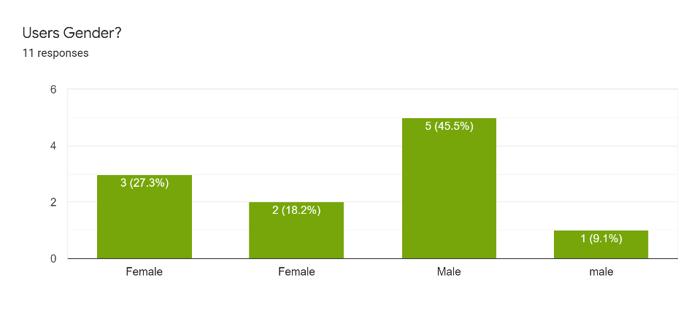

Figure 3

* As you can see from the above bar chart, we have 5 female and 6 male responses.

**Q3.**

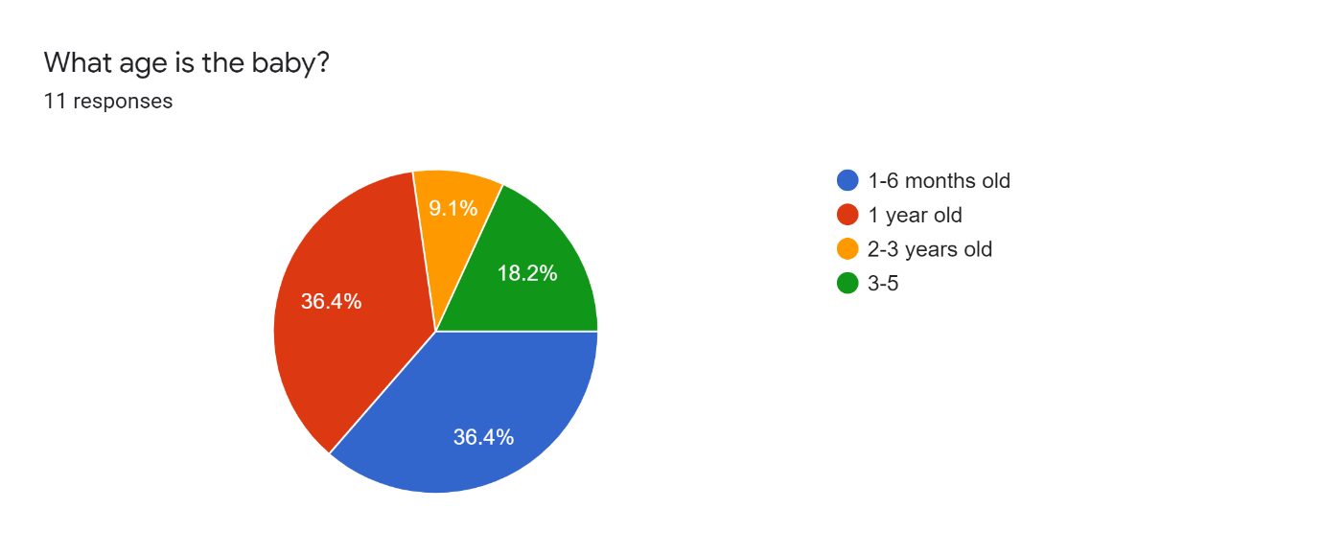

Figure 4

* This was a vitally important question, as outlined in the above section. A baby’s sleeping pattern changes rapidly as they get older. The age of the babies add context to the rest of the answers in the survey.

**Q4.**

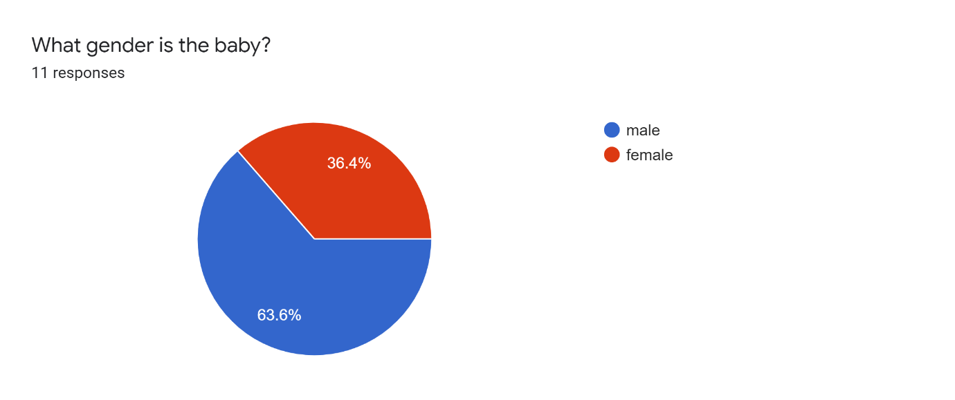

Figure 5

* Most of the people who answered this survey had male babies.

**Q5.**

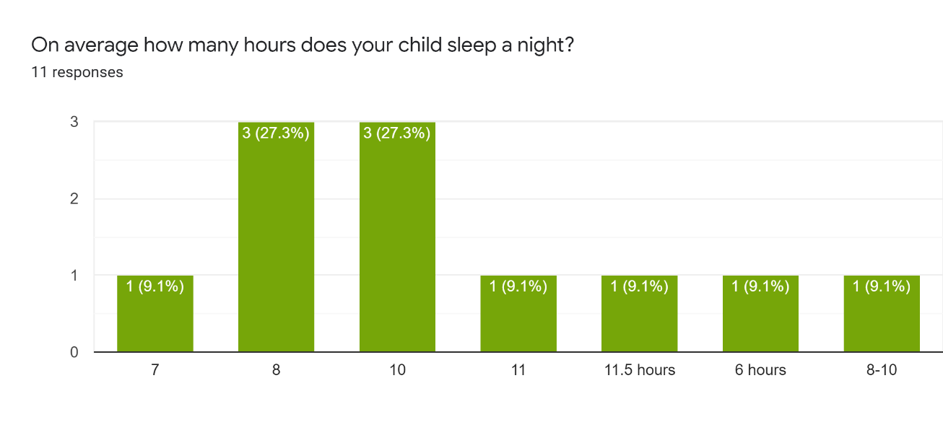

Figure 6

**Q6.**

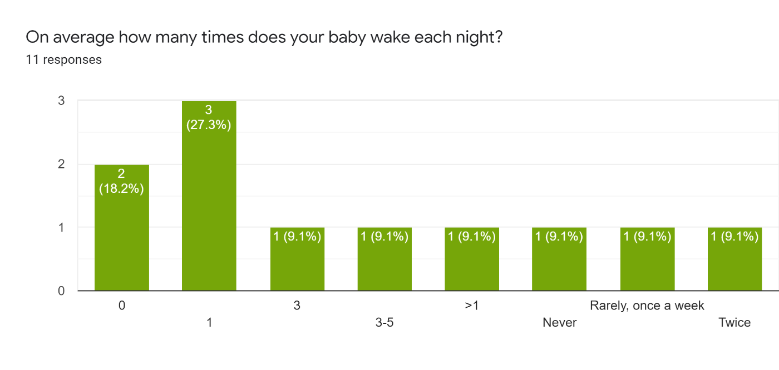

Figure 7

* As seen from the above graph there is a huge variation in the amount of sleep each child is getting per night and the number of times they wake. A factor in this is the individuality of the child resulting in some babies sleeping more than others. This primary research also highlighted that another factor to be examined is the age of each baby. Breaking this down to the different age ranges we can examine this information more accurately.
* 1–6-month age range
  + The average number of hours sleep per night for the babies in this age range is 7.6, With each baby waking on average 1.6 times per night.
* 1 year old
  + The average sleep for babies at this range is 8.75 hours per night with each baby waking up on average 1 time per night.
* 2-3 years
  + Babies on average slept for 10 hours per night with waking during the night being a very rare occurrence.
* 3-5
  + The sleeping pattern on average matches very closely to that of the 2–3-year age range with babies sleeping for about 10 hours, and waking up during the night being a rare occurrence.

**Q7.**

Is your house usually noisy?

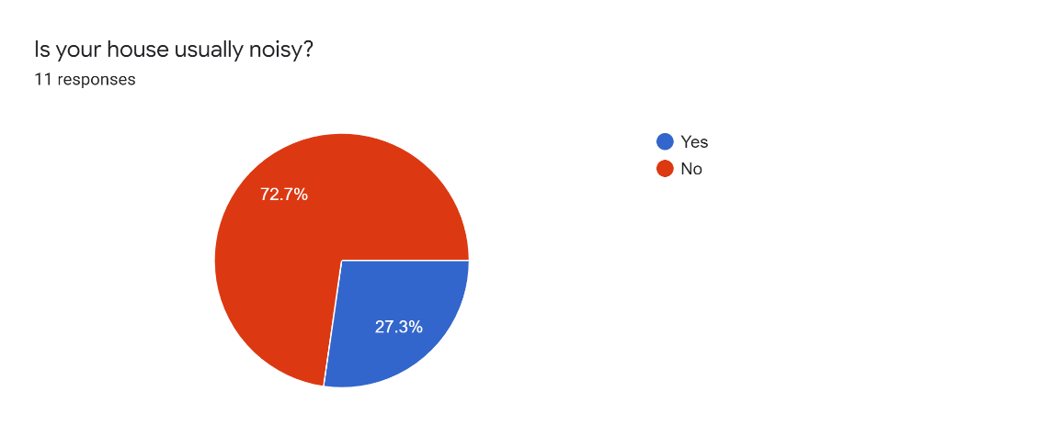

Figure 8

**Q8.**

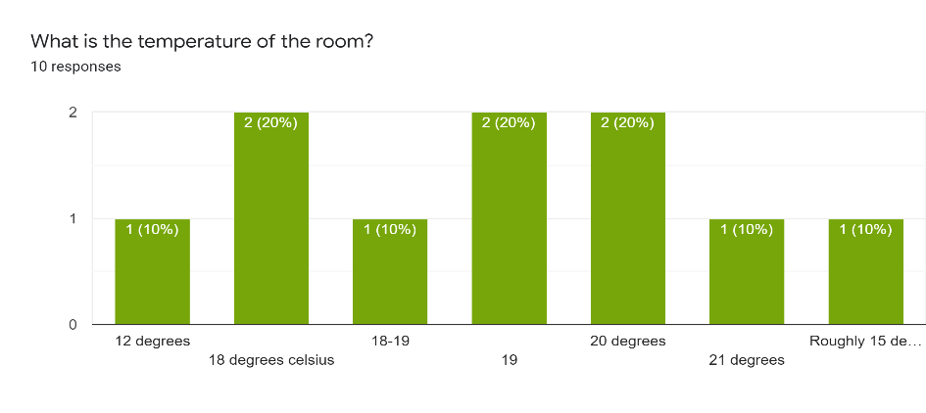

Figure 9

* During our survey research, we discovered that the noise levels and temperatures in a house may affect how well a baby sleeps. Examining the data, it is difficult to draw a clear conclusion as the sample size of answers is too small. They may be something we examine further for a major project.

**Q9.**

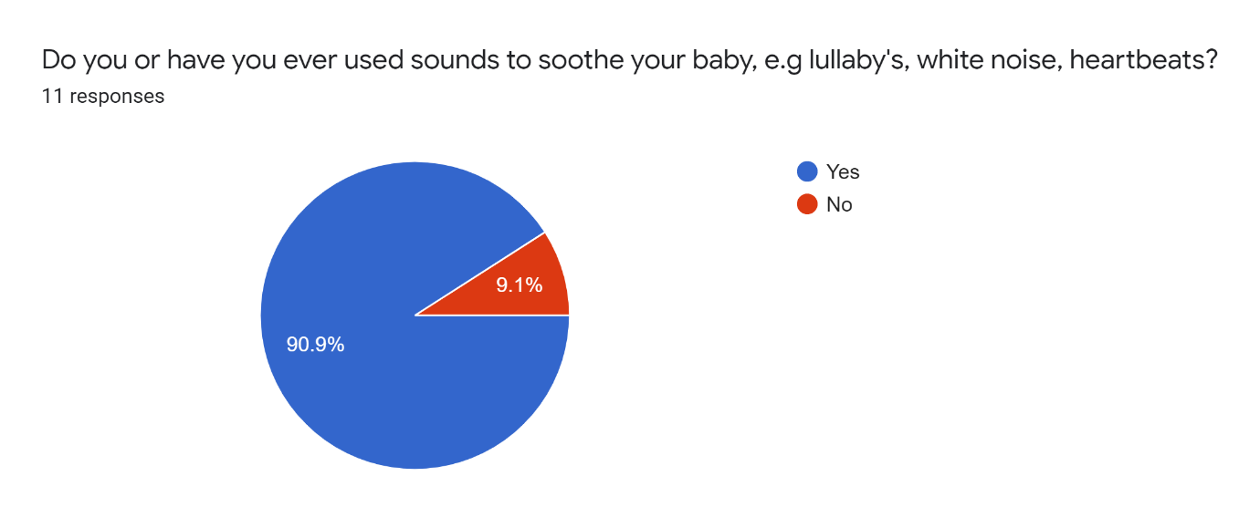

Figure 10

* As you can see from the above graph the number of parents who use sounds/lullabies to soothe their babies is very high, this confirms the research we carried out.

**Q10.**

Can you tell us what do you usually use to stop your child from crying?

* holding their hand, soother
* White noise machine
* Rocking
* walk her in my arms, sing, dance gently.
* lift and sooth if necessary but will allow a certain amount of crying when getting used to getting themselves to sleep.
* Lift and soothe, check for anything wrong - nappy etc...
* Technique called verbal reassurance.
* Cuddles
* Pick up the baby and comfort her. Breast feed if very unsettled
* Sing
* Her mother’s breast, alternatively some bobbing and gentle shaking while whispering or singing soothing noises to her.

Above you can see a list of ways parents comfort their babies, again an audio function is highlighted. Both white noise and singing are listed as ways of soothing their babies. Confirming the need for this feature on our project.

**Q11.**

If your baby wakes briefly during the night how often will he/she fall back asleep without being picked up/comforted?

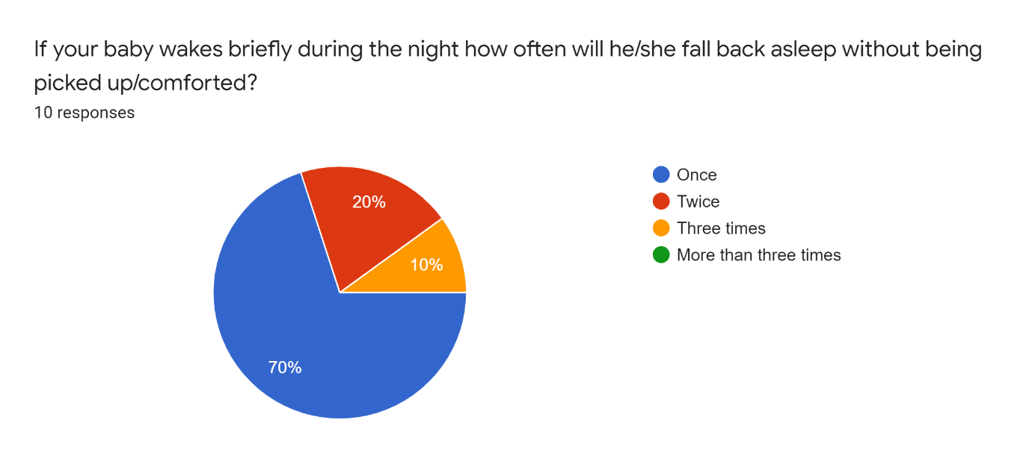

Figure 11

* As you can see 70% of parents confirmed that their baby will fall back to sleep the first time after waking, with some babies falling back to sleep two or three times without being comforted. This is very important data, the tolerances for our sensors will have to be set very carefully. If they trigger a response too early, they may wake the baby further.

**Q12.**

Do you use a baby monitor, if so what features of it do you find most valuable/What features do you wish it had?

* No
* the base board that monitors the child's heartbeat and sound
* Ability to talk to into the monitor to comfort baby, also has music and video
* a movement alert if it cannot feel heartbeat or breathing or weight it alarms.
* Yes - music option.
* yes – music.
* We used the projector and timed music. We were able to put the music on from parent handset.
* Audio
* Temperature of room talk features. I would rather it had a mat to monitor breathing.
* Wonderful for hearing every sound.

Several features are outlined here both relevant to our minor project and some we may choose to research and develop for our major project.

* Again audio/music function is mentioned heavily.
* A sensor to monitor the baby’s heartbeat and breathing.
* A video or projector function which could play soothing shapes, pictures.
* A way to communicate with the baby.

**Q13.**

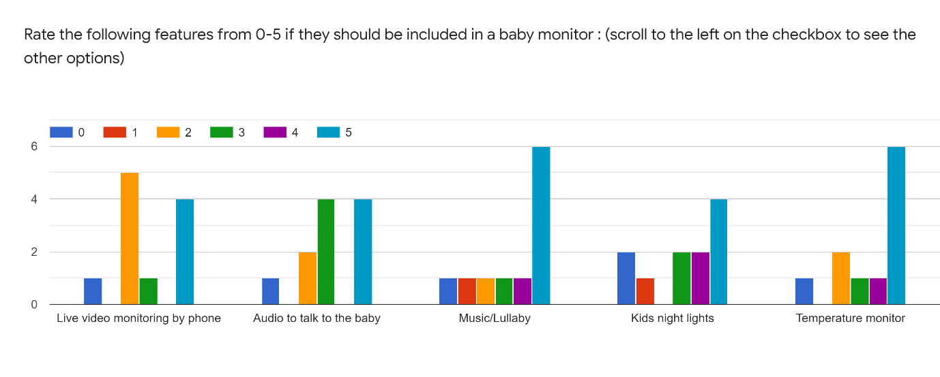

Figure 12

* Outlining what features are most important to parent we can see that again a music and nightlight function rank very highly, temperature monitoring also is ranked and important.
* Two-way audio function is something we may look at in a further iteration of our project. After discussion we feel for security reason and live video function would not be possible to do safely (outlined further in security analysis).

**Q14.**

Other thoughts or comments?

* the angel base monitor was a huge reassurance especially during the first 6 months.
* Hard to have definitive answer with younger baby as sleep patterns can change form one night to the next.
* Is it possible that any breathing difficulty could be detected? colourful reflections in the room/ceiling would be good?
* The movement alert was amazing, would rate over all other features.
* The batteries gave up and we had to replace them.
* Would be great if a monitor could give the child a bottle.
* Babies are cool.
* Although entertaining, ignoring the humorous answers we can see in our further taught and comments section again some interesting areas are highlighted.
* The ever-changing sleep cycle of babies is highlighted again.
* A breathing monitoring function and ability to project colourful shapes in the room is also mentioned again.

### 1.4.2 CONCLUSION

One over-sight in the survey was not asking how many hours each child sleeps during the day and asking for a combined total, if this were done, I feel the total hours of sleep per 24hour period would closer resemble the average number of hours sleep per child outlined in our online research. As outlined above newborn babies will sleep for large parts of the day, as they get older, they do more of their sleeping at night, this change in their sleeping cycle as they get older is recording accurately in the data we gathered. Our survey did however highlight many areas which went on to inform both or physical and conceptual design ideas. Limiting this to what is feasible for our minor project. The main features outline by the parents are.

* A sound/movement sensor
* A night light with patterns/shapes
* An ability to play sounds/lullaby’s/white noise.

Each of these features were mentioned multiple times with a sound/lullaby function ranking the most important among them. Using both our online research and our survey we were able to bring these functions forward to the design stage and begin to conceptually put together our prototype.

# 2. INITIAL DESIGN

After our initial primary and secondary research, a set of sketches were produced in order to give us some direction in starting our implementation phase. These eary sketches succeeded in giving the project the first breath of life, as we could start to envisage something tangible.

## 2.1 INITIAL CONCEPTUAL SKETCHES

Figure 13 Sketch of Baby monitor in-situ

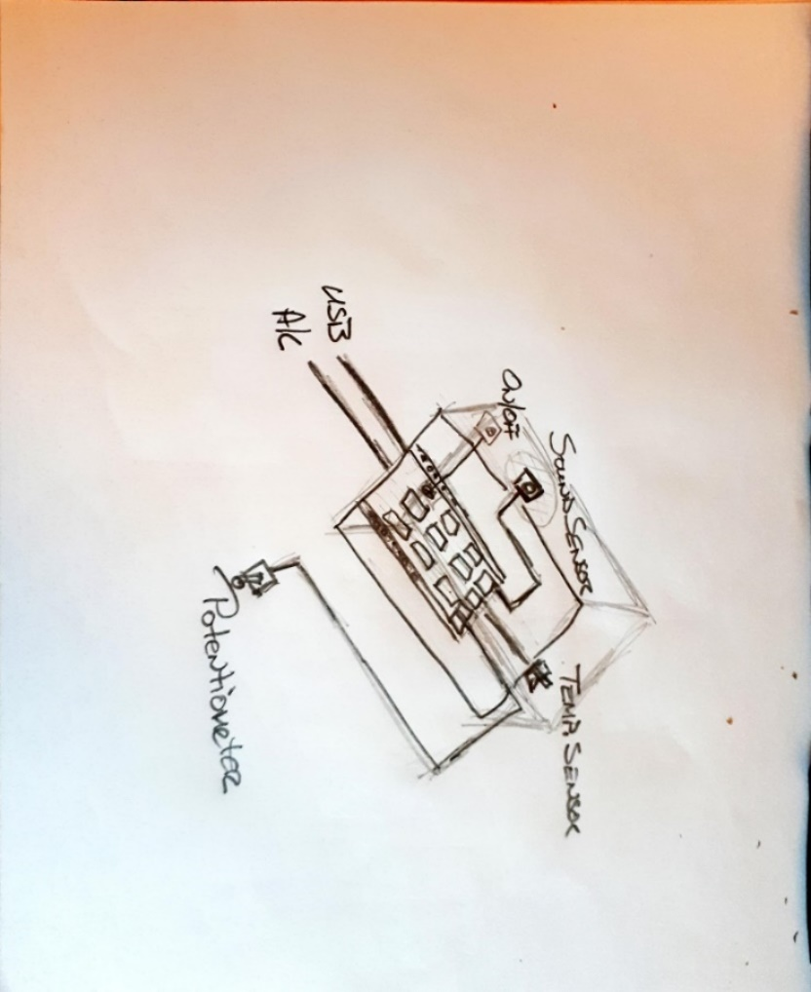

Figure 14 Proposed layout of Arduino Yun and components

Figure 15 – Early schematic sketch

## 2.3 HARDWARE SETUP

Many of our team were undertaking their first project of this type and so had little experience of circuitry and components. As an aid in remaining focused on a setup that was achievable and technically accurate, the team used the Fritzing software package in order to build our layouts and schematic drawings. Below are the results we came up with.

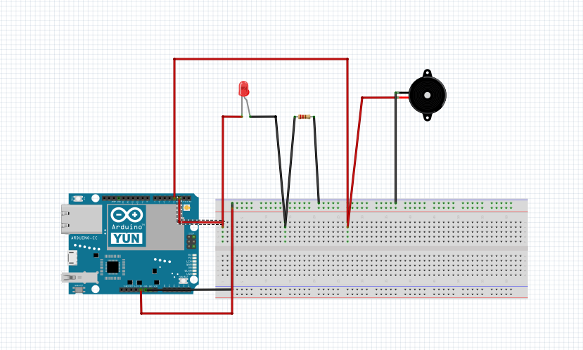

Figure 16 – Led and Buzzer connected to the Arduino Yun

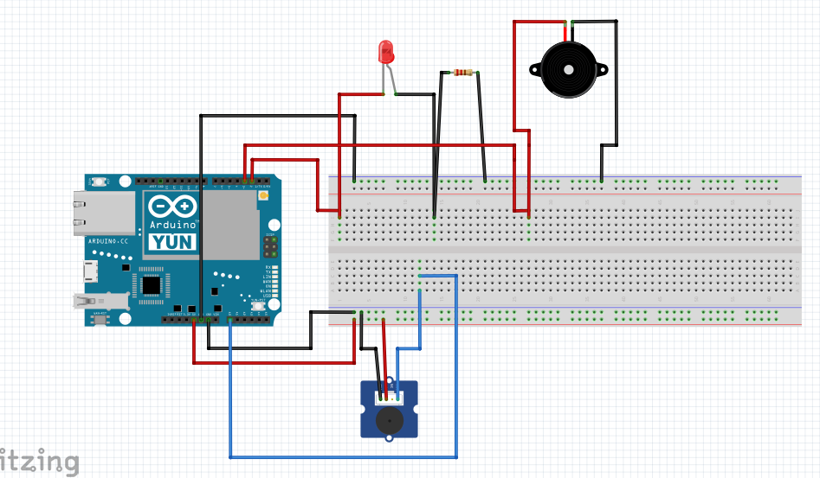

Figure 17 – Led, Buzzer and ……. connected to the Arduino Yun

Figure 18 – Led, Buzzer, and Sound Sensor connected to the Arduino Yun

## 2.4 HARDWARE SCHEMATICS

As with our layouts above, our schematic drawing increased in complexity alongside the teams confidence and competence with circuitry.

Figure 19 – Schematic diagram of LED, and Buzzer connected to The Yun via a breadboard.

Figure 20 – Schematic diagram of LED, and Buzzer connected to The Yun via a breadboard.

Figure 21 – Schematic diagram of LED, Buzzer, Mic and Vibration sensor connected to The Yun via a breadboard.

# 3. IMPLEMENTATION PLAN

## 3.1 EQUPIMENT USED

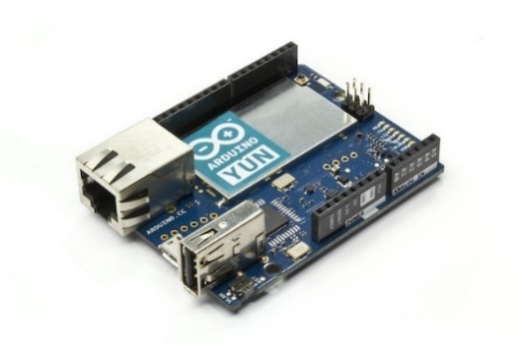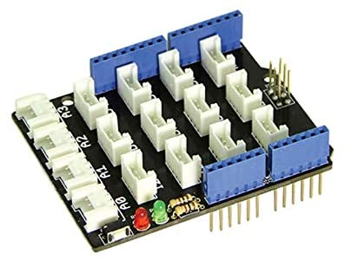

Arduino Yun Grove Base Shield V2

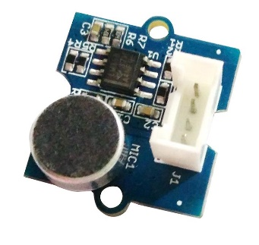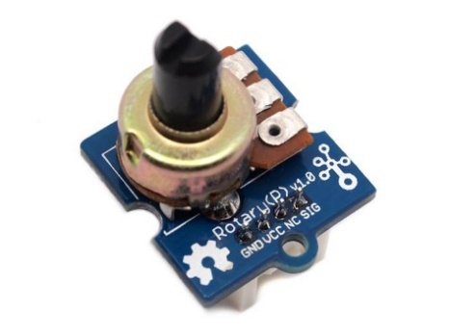

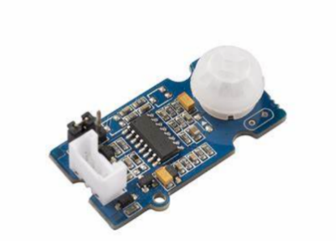

Grove Rotary Angle Sensor Grove Sound Sensor Grove PIR motion sensor

– not used in final design

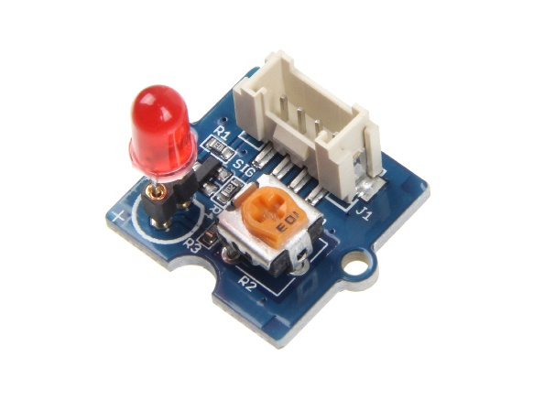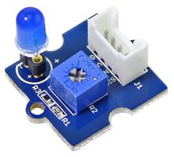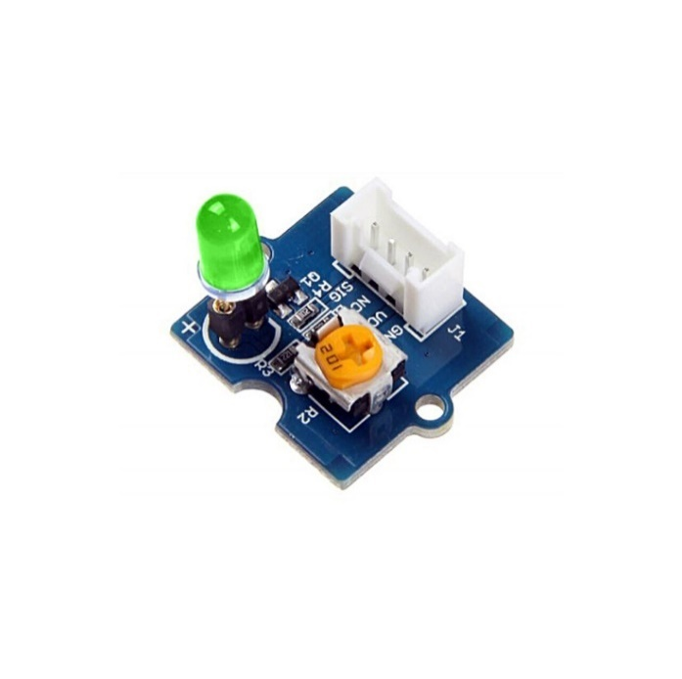

Grove Green LED Bulb Grove Red LED Bulb Grove Blue LED Bulb

Laptop Computer

## 3.2 CODE DESIGN

After the initial Design stage of the project, the team got together to plan the logic of how our IoT device would achieve our desired result. We found flowcharts a useful tool in planning how our code would work.

### 3.2.1 EARLY CODE FLOWCHART

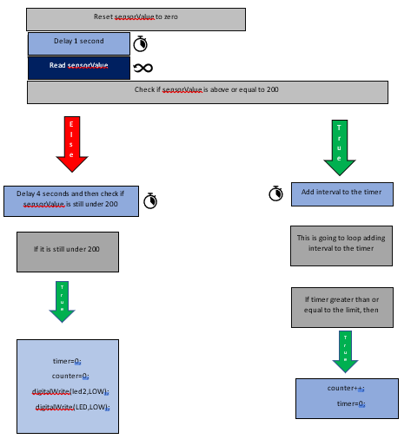

Figure 22 Early Code Design Flowchart

### 3.2.2 FINAL-CODE FLOWCHART

Figure 23 Flowchart for our final working code

# 4. TESTING

## 4.1 TESTING APPROACH

Upon approach to this project the team thought that an Agile Development approach would be ideally suited to the group and project at hand. As first venture into the world of IoT, we felt that there was always the chance of unforeseen challenges to arise. The Agile development model allowed best for changes in direction at later stages of the project, such as in implementation or testing. This line of thinking was indeed borne out, as we encountered issues with a rotary angle sensor late in the project. As we had adopted Agile methodologies, it was a simple process to swap out the rotary angle sensor for a PIR sensor, test the new sensor, before eventually deciding that the motion sensor aspect of the project was flawed and removing it altogether. This flexibility in design, implementation and testing was crucial at this late stage.

Our Agile approach consisted of the following steps:

1. First, we tried to test each component so we can get use to the code for each component.
2. We tried the sound sensor and we tested what is the perfect value we need for our threshold.
3. We were having values, but we found out that the values we were getting are not accurate and the sound sensor we were using is broken.
4. The we looked at how we can use a speaker and link it to our Arduino but we had no speaker and because of Covid-19 and lockdown we could not buy a speaker from any of the shops in town because all the electronic shops are closed
5. So instead of using a speaker we decided to use a buzzer but the issue we had with using a buzzer is that the sound the buzzer produce has limited harmonics.
6. We tried to make the buzzer sound better and we did research around it, but we could not make it sound any better ,so we used it(to at least show our idea) although the sound it produces will wake the child and will not help it to sleep.
7. Also there was another issue with making the buzzer produce a melody is that we need to have a for loop for all the notes which effected on the our code and the logic in our code , so we decided to break it down to simple and short loops and we finally made the buzzer produce a nice melody(note that we tried to look for melodies for children like “twinkle twinkle little star” but we did not find so we used The game of thrones song theme instead to prove our concept
8. We also found that the delay methods were the issue in so many places where we were not getting values from the Arduino or the Arduino is resetting the values to zero and all that was because of the delay methods.
9. We faced a logical issue in our code , so we decided to have a meeting and break the code to parts, and we made a flowchart so we can have a plan to follow and we finally fixed the logical issue.
10. Then we tried to add more than one sensor to the spread sheet , so we changed the API link and the token id as well and also the API request link in the Arduino to match the API link we adjusted in the “my scenario “ in the pushing box website.
11. We had an issue with not getting values from the Arduino and we were not getting values in the Serial monitor as well, we tried to do all the steps in Lab5 sheet again to make sure we did the right steps ,but the problem is still not fixed ,finally after 3 more attempts on trying to get the Serial monitor work we found out that the Arduino is the problem and it was not running well, so we changed the Arduino and it did work totally fine and we our values in our spread sheet .
12. Finally, we added comments in our code and deleted the extra stuff that we do not need, and we left some of the code that we are not using in this minor project in the project file because we are going to need it for our major project.

## 4.2 TEST DATA

### 4.2.1 INITIAL INPUT / OUTPUT TESTING

#### 4.2.1.1 TEST DATA - MOVEMENT

Figure

Figure 24 - Grove Rptary Angle Sensor vertical movement test data

Figure 25– Grove Rotary Angle Sensor horizontal

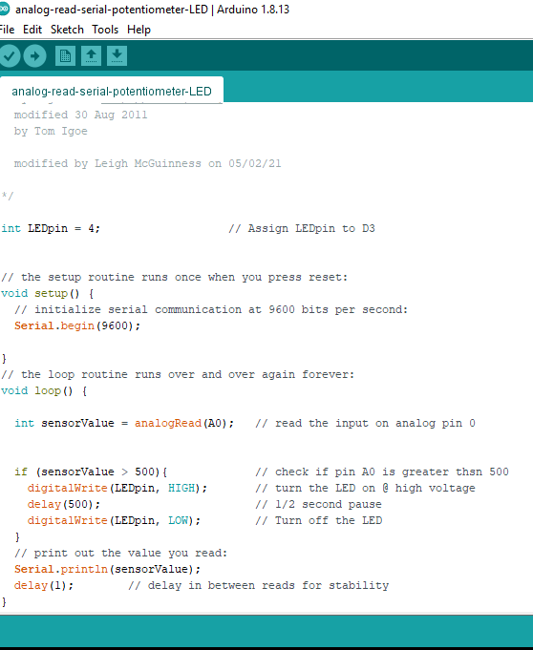

Figure 26 - Potentiometer Test

#### 4.2.1.2 TEST DATA - LED

Our testing began by running sketches on the Arduino using the different sensors, I done this to get a general idea of the Arduino functionality and how the device could potentially work.

In the below screenshots you can tests that I conducted on the Arduino. Uploading a basic blink sketch, you can see the Blink every second.

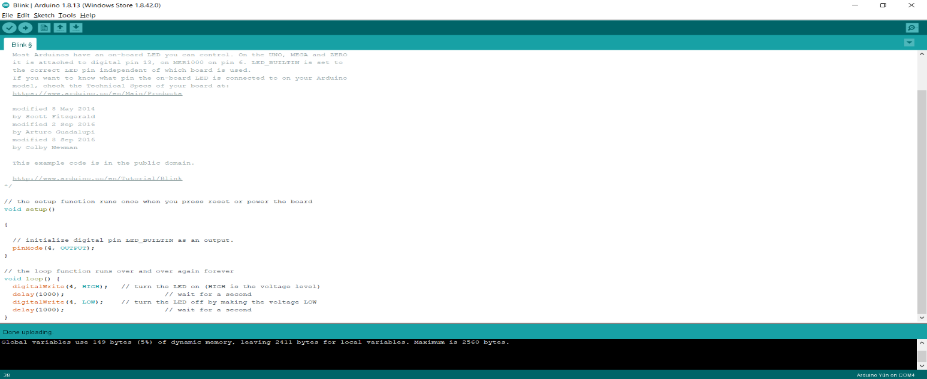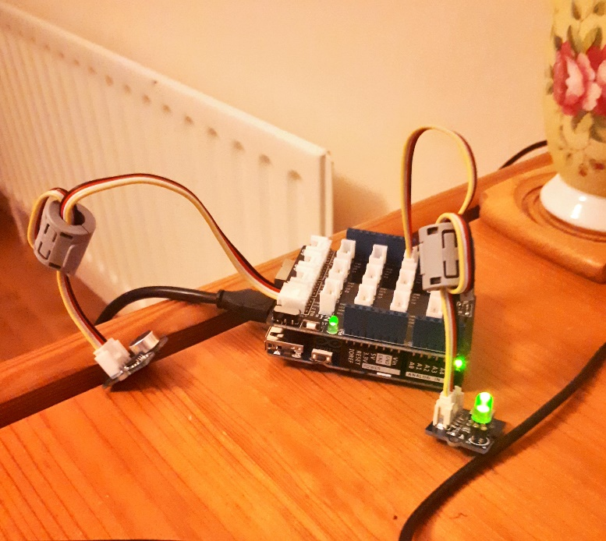

Figure 27

Figure 28 - LED sketch code

Figure 29 - LED is working, this will represent the Night Light

#### 4.2.1.3 TEST DATA -LED / SOUND SENSOR

The second test I conducted was using the sound sensor with the LED. As you can see from the code, every time the sound sensors gets a value greater than 100 the LED will turn on.

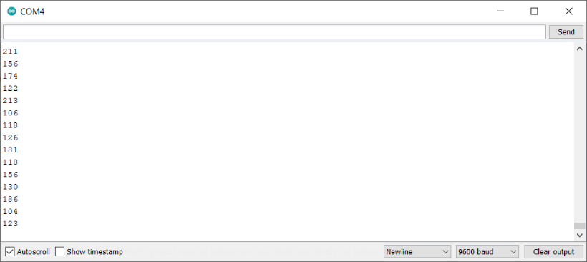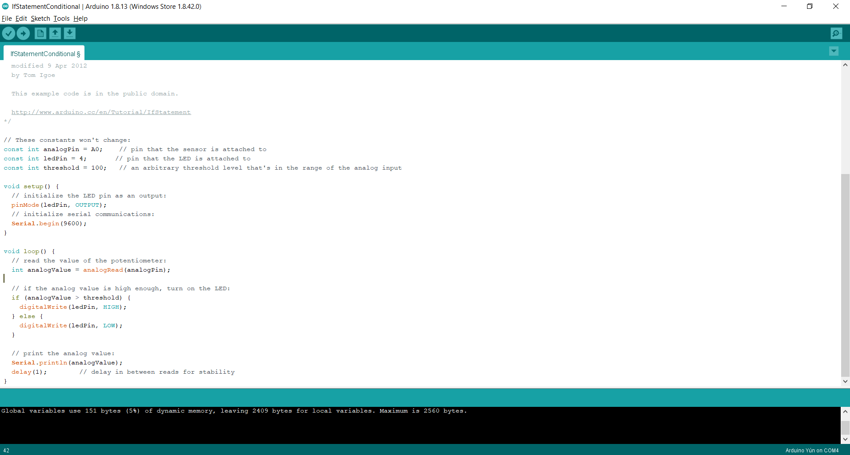

Figure 30 - Sound sensor readings on the Serial Monitor

Figure 31 - Sound sensor sketch code

#### 4.1.1.4 TEST DATA – SOUND / MOVEMENT SENSOR

The third test I carried out was the sound sensor and the buzzer, like the sketch including the LED, every time the sound sensor had a value greater then 200 the buzzer would sound.

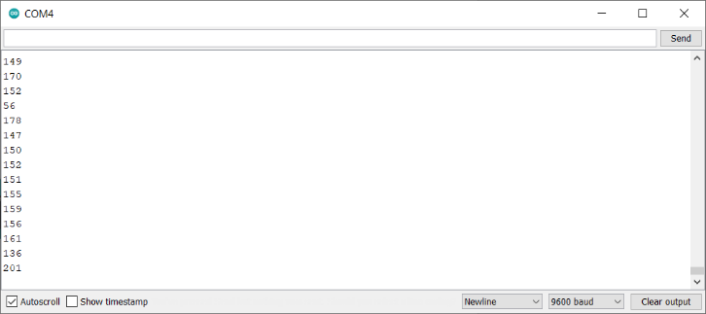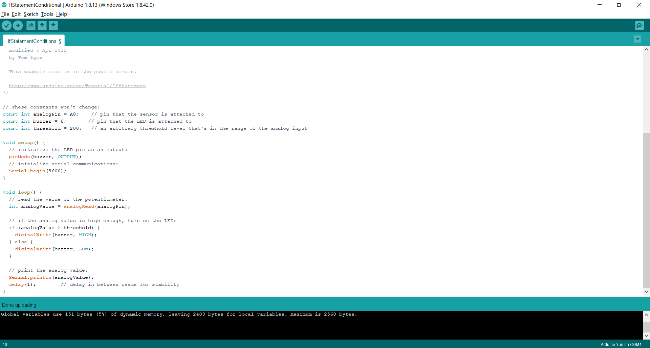

Figure 32 - Arduino sketch with sound and movement

An identical test was also carried out for the movement sensor, using a very similar script the led would light when the movement sensor got a value greater than 200.

### 4.2.2 FINAL TEST DATA

#### 4.2.2.1 SOUND AND TEMPERATURE DATA

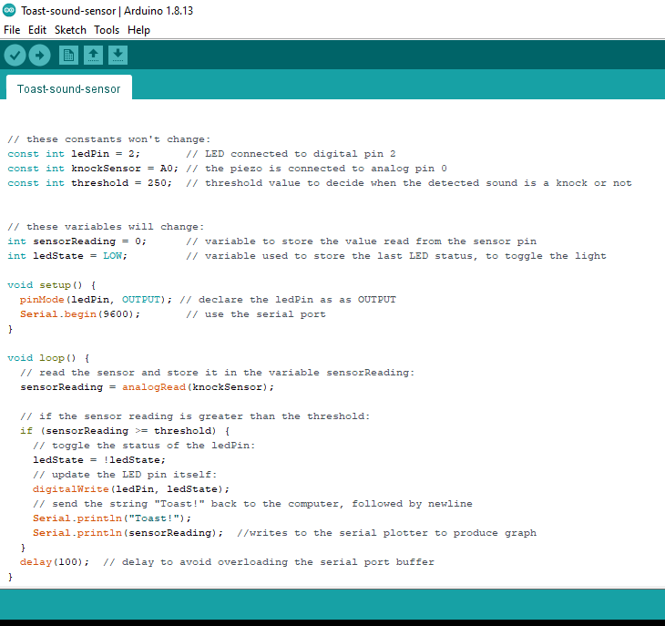

Figure 33

Figure 34 Sound Sensor Test code

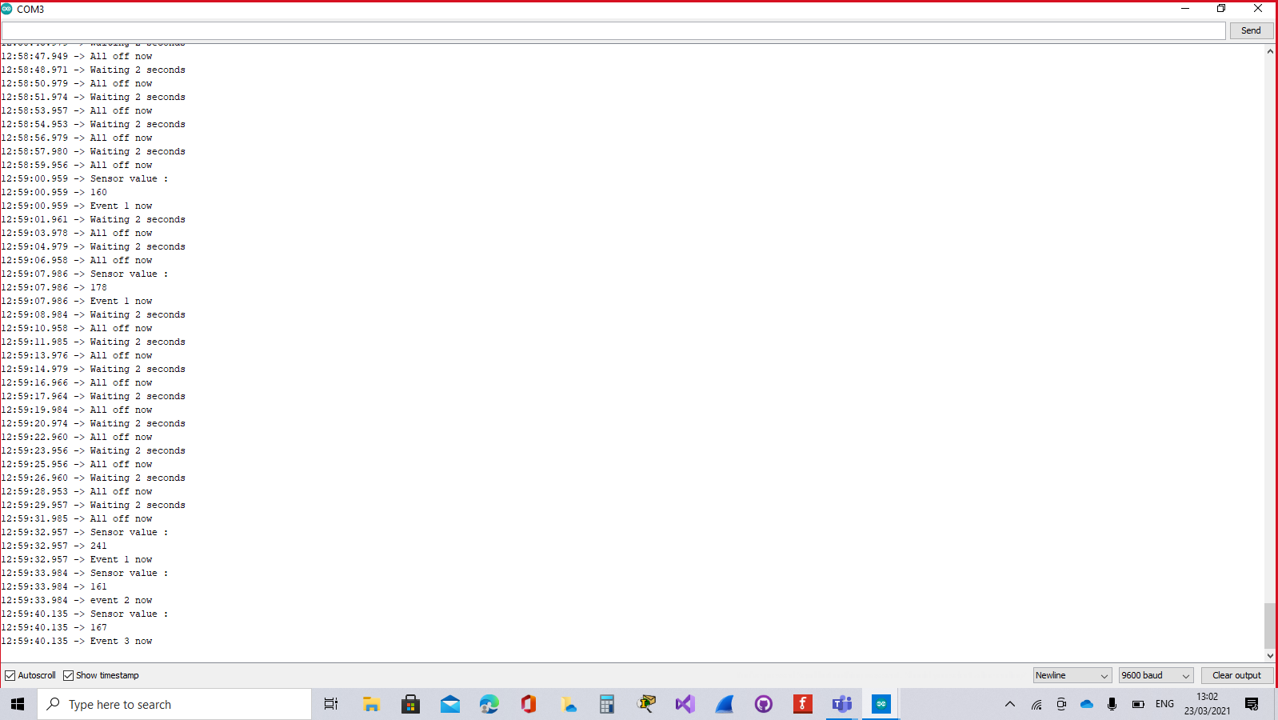

Figure 35 Serial Monitor Log

## FINAL ITERATION OF THE CODE

const int LED=3; //Led to approve that the first event happened

const long interval=1000; //interval at which to blink (miliseconds)

const long limit=2000; //time limit -after which user will get a message

const int led2=4; //Led to approve that the second event happened

const int led3=5; //Led to approve that the third event happened

const int speakerPin=7; //the buzzer pin

//Speaker this code will be for the speaker ... we are not usingit in this project because we don't have a speaker /we are using a buzzer instead

//#include <PCM.h>

//const unsigned char kidsong[] PROGMEM = {

//123, 119, 120, 120, 119, 119, 124, 129, 130, 125, 119, 116, 118, 121, 123, 124, 121, 117, 117, 119, 120, 118, 118, 123, 128, 127, 120, 115, 117, 122, 124, 120, 118, 120, 123, 124, 125, 125, 123, 119, 115, 115, 118, 122, 122, 120, 120, 121, 123, 122, 122, 123, 125, 127, 127, 124, 121, 120, 120, 119, 117, 118, 124, 130, 130, 126, 123, 124, 126, 125, 124, 126, 129, 130, 129, 128, 128, 124};

//Variables that will change:

unsigned long timer=0;

unsigned long myTime; //checking the time since the programe is started

int sound=A0;

int temp=A1;

int sensorValue=0;

int counter=0;

int value=200;

int tempValue=0;

int speakerValue=0;

//tones for the buzzer song

#define NOTE_B0 31

#define NOTE_GS2 104

#define NOTE_A2 110

#define NOTE_AS2 117

#define NOTE_B2 123

#define NOTE_C3 131

#define NOTE_CS3 139

#define NOTE_D3 147

#define NOTE_DS3 156

#define NOTE_E3 165

#define NOTE_F3 175

#define NOTE_FS3 185

#define NOTE_AS1 58

#define NOTE_B1 62

#define NOTE_C2 65

#define NOTE_CS2 69

#define NOTE_D2 73

#define NOTE_DS2 78

#define NOTE_E2 82

#define NOTE_F2 87

#define NOTE_FS2 93

#define NOTE_G2 98

#define NOTE_C1 33

#define NOTE_CS1 35

#define NOTE_D1 37

#define NOTE_DS1 39

#define NOTE_E1 41

#define NOTE_F1 44

#define NOTE_FS1 46

#define NOTE_G1 49

#define NOTE_GS1 52

#define NOTE_D5 587

#define NOTE_DS5 622

#define NOTE_E5 659

#define NOTE_F5 698

#define NOTE_FS5 740

#define NOTE_G5 784

#define NOTE_GS5 831

#define NOTE_A5 880

#define NOTE_AS5 932

#define NOTE_B5 988

#define NOTE_C6 1047

#define NOTE_CS6 1109

#define NOTE_D6 1175

#define NOTE_DS6 1245

#define NOTE_E6 1319

#define NOTE_F6 1397

#define NOTE_FS6 1480

#define NOTE_G6 1568

#define NOTE_GS6 1661

#define NOTE_A6 1760

#define NOTE_AS6 1865

#define NOTE_B6 1976

#define NOTE_C7 2093

#define NOTE_CS7 2217

#define NOTE_D7 2349

#define NOTE_DS7 2489

#define NOTE_E7 2637

#define NOTE_F7 2794

#define NOTE_FS7 2960

#define NOTE_G7 3136

#define NOTE_GS7 3322

#define NOTE_A7 3520

#define NOTE_AS7 3729

#define NOTE_B7 3951

#define NOTE_C8 4186

#define NOTE_CS8 4435

#define NOTE_D8 4699

#define NOTE_DS8 4978

#define NOTE_A1 55

#define NOTE_G3 196

#define NOTE_A3 220

#define NOTE_AS3 233

#define NOTE_B3 247

#define NOTE_C4 262

#define NOTE_CS4 277

#define NOTE_D4 294

#define NOTE_DS4 311

#define NOTE_E4 330

#define NOTE_F4 349

#define NOTE_FS4 370

#define NOTE_G4 392

#define NOTE_GS4 415

#define NOTE_A4 440

#define NOTE_AS4 466

#define NOTE_B4 494

#define NOTE_C5 523

#define NOTE_CS5 554

// PushingBox Scenario DeviceID:

char devid[] = "v29410E458598D6A";

char serverName[] = "api.pushingbox.com";

boolean DEBUG = true;

#include <Bridge.h>

#include <HttpClient.h>

void setup() {

// put your setup code here, to run once:

//Set the pins as input and output:

pinMode(sound,INPUT);

pinMode(LED,OUTPUT);

pinMode(led2,OUTPUT);

Bridge.begin();

pinMode(led3,OUTPUT);

pinMode(tempValue,INPUT);

// Serial.begin(115200);

Serial.begin(9600);

while (!Serial); // wait for a serial connection

}

void loop() {

// Initialize the client library

HttpClient client;

sensorValue=0;

delay(1000);

// put your main code here, to run repeatedly:

sensorValue=analogRead(sound); //Reading the sound sensor

tempValue=analogRead(temp);

if(sensorValue>=200){ //Checking if sensor value is greater than 200

Serial.println("Sensor value :");

Serial.println(sensorValue);

timer=timer+interval; //if the sensor value is >200 it will add an interval which is equal to 1000

if(timer>=limit)

counter++;

timer=0;

}

}else{

Serial.println("Waiting 2 seconds");

delay(2000);

if(sensorValue<200){

timer=0;

counter=0;

digitalWrite(led2,LOW);

digitalWrite(led3,LOW);

digitalWrite(LED,LOW);

}

// Serial.println("Value after else:");

// Serial.println(sensorValue);

// Serial.println(counter);

}

if(counter==1){ //Event 1

digitalWrite(LED,HIGH);

Serial.println("Event 1 now");

}else if(counter==2){ //Event 2

digitalWrite(led2,HIGH);

Serial.println("event 2 now");

speakerValue=0;

// Make a HTTP request:

String APIRequest;

APIRequest = String(serverName) + "/pushingbox?devid=" + String(devid)+ "&NoiseValue="+sensorValue+"&Temperature="+tempValue+"&Speaker="+speakerValue;

client.get (APIRequest);

// if there are incoming bytes available

// from the server, read them and print them:

while (client.available()) {

char c = client.read();

}

Serial.flush();

String UploadMessage;

//Serial.print("\n Uploaded temp value: ");

delay(4000);

if(sensorValue>=200){

counter++;

}else{ //////////Working here

digitalWrite(led2,LOW);

digitalWrite(led3,LOW);

counter=0;

timer=0;

}

}else if(counter>=3){ //Event 3

digitalWrite(led3,HIGH);

Serial.println("Event 3 now");

speakerValue=1;

// Make a HTTP request:

String APIRequest;

APIRequest = String(serverName) + "/pushingbox?devid=" + String(devid)+ "&NoiseValue="+sensorValue+"&Temperature="+tempValue+"&Speaker="+speakerValue;

client.get (APIRequest);

// if there are incoming bytes available

// from the server, read them and print them:

while (client.available()) {

char c = client.read();

}

Serial.flush();

String UploadMessage;

// Serial.println("\n Uploaded temp value: "); //implement in major project

// Serial.print(sensorValue); //implement in major project

GameOfThrones();

delay(4000);

if(sensorValue<200){

digitalWrite(led2,LOW);

digitalWrite(led3,LOW);

Serial.println(tempValue);

counter=0;

timer=0;

}

}}//End of loop

//Methods

void GameOfThrones()

{

for(int i=0; i<4; i++)

{

tone(speakerPin, NOTE_G4);

delay(500);

noTone(speakerPin);

tone(speakerPin, NOTE_C4);

delay(500);

noTone(speakerPin);

tone(speakerPin, NOTE_DS4);

delay(250);

noTone(speakerPin);

tone(speakerPin, NOTE_F4);

delay(250);

noTone(speakerPin);

}

for(int i=0; i<4; i++)

{

tone(speakerPin, NOTE_G4);

delay(500);

noTone(speakerPin);

tone(speakerPin, NOTE_C4);

delay(500);

noTone(speakerPin);

tone(speakerPin, NOTE_E4);

delay(250);

noTone(speakerPin);

tone(speakerPin, NOTE_F4);

delay(250);

noTone(speakerPin);

}

tone(speakerPin, NOTE_G4);

delay(500);

noTone(speakerPin);

tone(speakerPin, NOTE_C4);

delay(500);

tone(speakerPin, NOTE_DS4);

delay(250);

noTone(speakerPin);

tone(speakerPin, NOTE_F4);

delay(250);

noTone(speakerPin);

tone(speakerPin, NOTE_D4);

delay(500);

noTone(speakerPin);

for(int i=0; i<3; i++)

{

tone(speakerPin, NOTE_G3);

delay(500);

noTone(speakerPin);

tone(speakerPin, NOTE_AS3);

delay(250);

noTone(speakerPin);

tone(speakerPin, NOTE_C4);

delay(250);

noTone(speakerPin);

tone(speakerPin, NOTE_D4);

delay(500);

noTone(speakerPin);

}

tone(speakerPin, NOTE_G3);

delay(500);

noTone(speakerPin);

tone(speakerPin, NOTE_AS3);

delay(250);

noTone(speakerPin);

tone(speakerPin, NOTE_C4);

delay(250);

noTone(speakerPin);

tone(speakerPin, NOTE_D4);

delay(1000);

noTone(speakerPin);

tone(speakerPin, NOTE_F4);

delay(1000);

noTone(speakerPin);

tone(speakerPin, NOTE_AS3);

delay(1000);

noTone(speakerPin);

tone(speakerPin, NOTE_DS4);

delay(250);

noTone(speakerPin);

tone(speakerPin, NOTE_D4);

delay(250);

noTone(speakerPin);

tone(speakerPin, NOTE_F4);

delay(1000);

noTone(speakerPin);

tone(speakerPin, NOTE_AS3);

delay(1000);

noTone(speakerPin);

tone(speakerPin, NOTE_DS4);

delay(250);

noTone(speakerPin);

tone(speakerPin, NOTE_D4);

delay(250);

noTone(speakerPin);

tone(speakerPin, NOTE_C4);

delay(500);

noTone(speakerPin);

}//End of GameOfThrones Method

# ETHICS AND SECURITY ANALYSIS

## Internet of Things, Brief Technology Overview

The benefits of internet of things technology are obvious, across every industry applying these technologies could revolutionize how they operate, be it through means of automation or machine learning. For example, a baby monitoring system taking advantage of internet of things technology may bring peace of mind to new parents during the night, knowing that their baby is safely asleep. Use of the internet through a video or audio function may also help connect distant family members with the new member of their family. The dangers of such technologies from an ethical or security standpoint however may prove quite worrying.

The ability of systems to function independently from humans while connected to the .,security and privacy standards. For example, A health device while connected to the internet could be a target for a cyberattack, which could obviously have serious consequences for the user. Patching known security flaws in such devices may also prove difficult. Even though it is the connection to a network that makes these devices useful, it is very difficult to deliver patches using this connection in a safe and reliable way. Once these devices leave the factory the flaws or oversights made by the production team often prove detrimental down the road as computing technology improves and these mistakes become more obvious.

Data collection is the other pitfall of internet of things technology. In a world where already, we offer up so much of our personal data to search engines and social media companies, and we have a computer which can monitor what we say and where we go already in our pockets, the idea of having another device gathering our data may not be that attractive of a concept. Users’ data is a gold mine in todays market with big tech company’s making vast sums of money selling it to third party companies and advertisers. It is this same data that proves to be an IoT technology-based device’s biggest asset, as this data through modeling and statistics can feed machine learning or AI. This has the potential to improve the functionality and potential use for this device greatly.

So, our data is an asset that can be sold for huge sums of money or can be used to improve technology. This decision is controlled completely by the manufacturer. The trust therefore needed in these manufactures by the public is great. Using recent history as a marker, the money which can be generated from this data may prove to be too attractive to companies moving into the internet of things space.

## Ethics and security in a baby monitoring device

As our first iteration of this device, for our minor project, will not be connected to the internet, a lot of these concerns are not valid until we incorporate this functionality. During our meetings, ethics and security concerns have come up many times. While focused on this first proof of concept design, we are looking ahead to what a future iteration of this device may look like and what problems we may encounter.

Examining our chosen project idea with the issues outlined in the above paragraphs in mind, there are some definite areas which may cause us alarm.

* In the survey, in which we gathered information from our target market, many parents reported that they would find a live camera a beneficial feature of a baby monitoring device. While its benefits are obvious, we as a team, discussed the risks from an ethical and security standpoint and decided that we would not be able to implement a camera in our project on the grounds of safety.
* We have discussed having real time alerts and information on how the baby’s level of activity whilst sleeping being sent to the parent’s phone via email and text. This data may prove very powerful in improving the device further and provide information to the parents on possible setting and configuration adjustments which could improve the effectiveness of the device. However, like any device connected to the internet, moving this information across of network may prove to be a security risk. This is something we will have to examine in detail before implementing this functionality.

In conclusion, the greater the amount of research and discussion we complete as a team, the clearer it becomes that while internet of things technology is a very exciting and an inevitable evolution for computing it throws up a huge number of ethical questions. How these technologies are used is based completely on the moral compass of the companies that are creating them and may prove to become an area of great challenge for governments and authorities to police. Going through the various stages of developing our idea concerns have been raised and going forward we will be trying to address this issue and create a project which is balanced from and ethical and security standpoint. Our hope is that the companies moving into this expanding space will do likewise.

# FUTURE IMPROVEMENTS

After weeks of researching, studying our project and its market, thinking thoroughly about what features we could improve in our baby monitor. We have discovered some brilliant ideas in which will transform our minor project into the baby-monitor every family will want in their home, utilizing Internet of Things to interconnect objects that can collect and transfer data with aided by the help of Application Programming Interfaces. In the following document we will list the ideas which we believe will not only be future improvements for our project but will be some of the reasons as to why this will be the ideal baby-monitor for every home.

## Motorised LED Globe

During our survey that we conducted on several parents and a local crèche, it was brought to our attention that there was a want in parents for colourful reflections in the room or on the ceiling to help soothe the baby. Our research showed that greater than 50% of the people who took part in the survey rated the feature of a nightlight either 4 or 5 out of a possible 5.

This will ideally be a globe made from plastic with different shape’s cut from paper which will have a re-adherable strip of glue on its back, similar to a post-it note. These shapes can then be fixed onto the plastic globe and when the LED emits light it will also project a shadow of a shape. This shape can then be changed depending on the child’s likes and interests. This scalability could open another market for our device which would then include accessories.

The globe itself will be attached to a motor which will spin at different speeds depending on the setting chosen by the user. The different speed settings will be chosen through our application’s UI and will include three different options.

A lot of babies when they are growing older can start developing a fear of darkness. Nightlights can help with this, in turn helping them to feel safer and more secure in their bedroom. Our colourful LED’s and shapes will also help in teaching foundational skills to young children, allowing the parents to choose shapes such as numbers and letters. The best age to teach children colours and shapes is between 18-30 months which represents a large proportion of our target audience. Most children are unable to differentiate between colours until 18 months or so, this is because it is a cognitively complex task for them, and as adult’s we sometimes forget this. (Cassidy, 2013) The nightlight can be as equally beneficial to parents, allowing them to carefully navigate their way through the children’s room for night feeds. In cases where one of the children in the room that the nightlight is being used in is toilet trained, they can safely make their way to the toilet without standing on any dreaded Lego.

The motor that we will be using to rotate our LED globe will be an ordinary DC motor, connected to the Arduino. Below I have attached a copy of a 3D concept sketch which I created using 3D Paint.

## Baby Cot Mobile

Our second idea for developing our project further is to add a mobile feature. This will include hanging toys such as animals, amongst other favourites. The mobile will be operated by a motor, to allow it to rotate slowly at the top of the cot so the child can easily see the shapes moving and can interact with them. It will however be out of the child’s reach so that they cannot harm themselves. The user will be given the choice, using our API, as to whether they want the mobile to remain static, or to rotate slowly. Our mobile provides many similar benefits to our LED Globe including visual stimulation and promotes brain development early on for users. “Cot mobiles are proven to help with baby’s motor skill development at an early age, a baby’s brain is constantly developing and learning new things. Invest in a baby gym with dangling toys. Placing your baby under the arch and encouraging them to bat at the toys helps improve hand-eye coordination.” (Mcgovern, no date)

Even when laying on its back observing the mobile and toys which are attached to it, a baby is learning spatial awareness as the shapes move closer and further away from it. As the child grows and begins to move a lot more, the mobile will also help with the child’s hand eye co-ordination as it reaches to try and grab the mobile. Over time the child’s accuracy and eye muscle strength will increase when it is trying to point, grasp or hold toys and objects that interest them.

A lot of kids can get quite restless at bedtime. According to a survey that we conducted on parents over 45.5% of parents said that their baby awoke a minimum of once per night. The mobile will help with this as their brains will be stimulated, if it is a case that they do wake for an unnecessary reason they will fall back to sleep shortly after.(*Will Crib Toys Ruin Your Baby’s Sleep? - The Baby Sleep Site®*, 2014)

The motor that we will be using to rotate our mobile will be an ordinary DC motor which will be attached to the Arduino. Below I have attached a 3D concept sketch I created using windows 10 software.

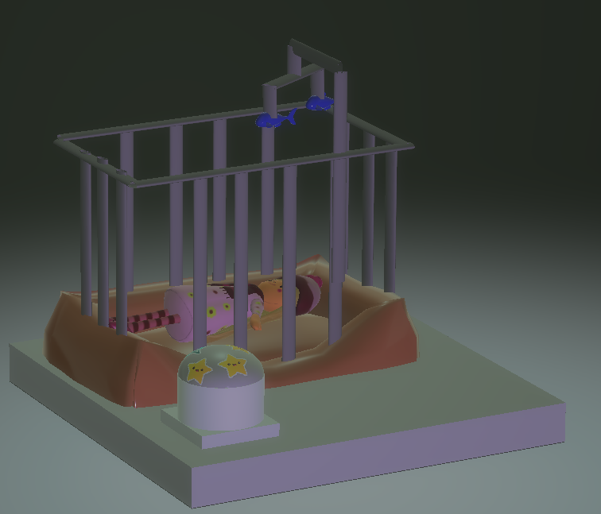

Figure 36 3D image of child's cot and CradleCare baby monitor INCLincluding the mobile

## TEMPERATURE SENSOR

During the research stage of our project, we created a survey which we sent out to 15 sets of parents and a local crèche who were kind enough to take part. Exactly 50% of parents rated 5 out of 5, the need for a temperature sensor as a feature in the baby monitor which they would buy for their child’s room. This information told us that parents would look for the temperature monitor feature as one of the key features that the baby monitor must have, according to our survey this feature was as important to parents as the ability of it to play a lullaby.

It is for this reason that the third future improvement which we have decided to add to our project is an added temperature sensor. This sensor will allow the user to monitor the temperature of the baby’s room and if there is a sudden drop or rise in temperature in the room the parents will be alerted on a device of their choosing, via our downloadable baby monitor application. When setting up the baby monitor app the user will be asked to input what temperature the room is and how sensitive they want the sensor to be to temperature change. For example, in our survey the rooms varied from 12-21 degrees. We also need to allow the user to input how sensitive that they want the monitor to be so if there is a drop of 5 degrees or a rise of 4 degrees for example they will be notified by the monitor. There may also be scope for designing a temperature sensor which will measure not only the temperature of the room but also the baby, however, further research will have to be undertaken on this topic, but it is a possible future improvement. This information could then be connected to the thermostat control using our API. (Jabbar *et al.*, 2019)

The grove temperature sensor that we have been using inputs an analog signal and can detect ranges from -40 to 125 degrees.

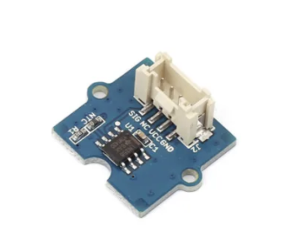

Figure 37 Temperature sensor

## PIR SENSOR

The fourth future improvement that we have chosen as a possibility to use in our project is the Passive Infrared Sensor. This sensor utilizes the infrared light radiating from objects in its field of view to detect motion, one of the key elements is that this sensor is passive therefore does not emit any energy that could cause harm to the child. This sensor will be used to detect the baby’s motion and can be set incrementally to avoid unnecessary activation. As a secondary use or benefit for this sensor could be utilized to detect increases in heat generated by electrical devices and predict possible device failure. (Ramesh *et al.*, 2019)

The PIR sensor could be placed at the top of the cot and will detect movement from a 120-degree angle, it also has a measuring range of up to 6 metres. The PIR motion sensor works of a digital port in the Arduino and requires a 3.3/5V supply voltage.

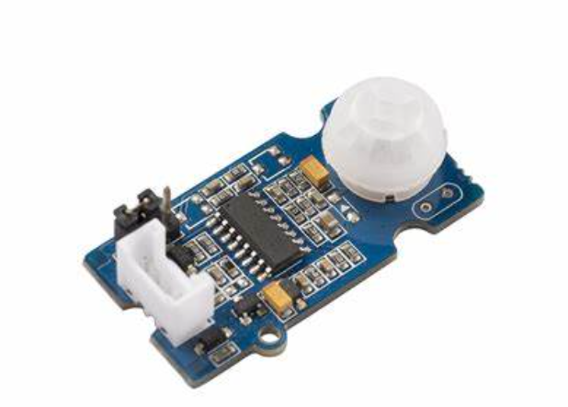

Figure 38 PIR Sensor

We have 3 options to connect our Arduino to API to monitor our data from the Arduino which will be our data provider from the different equipments we are using in our project . To get the data from our Arduino we can use one of the following 3 options: Arduino IOT cloud , Blynk and Making our own website.

## PUSHING BOX

For our minor project we are going to use the pushing box to monitor the data about the child and print the status on a line graph or a pie chart and we can get the sum and average of the values we are getting.

## BLYNK & ARDUINO IOT CODE

Which are two powerful services that allow anyone to create IoT applications, they were designed for the internet of things . they can control hardware remotely ,they can display sensor data, they can store data, visualize it and do many other cool things .

## NEGATIVE POINTS

We only have 100 notifications which most of them will be wasted in the prototyping process then we will have to wait till next day or pay for more notifications.

## MAKING YOUR OWN WEBSITE

We can make our own website to control the Arduino and get the data from the Arduino to the website using HTML ,CSS and C++, by making variables in C++ and add them in the HTML code .We can adjust the look of our website the way we want and

# TECHNOLOGIES USED

| NAME | Source |
| --- | --- |
| GitHub | [www.github.com/](https://github.com/) |
| Trello | [www.trello.com/](https://trello.com/) |
| Fritzing | [www.fritzing.org/](https://fritzing.org/) |
| Arduino IDE | Available from [www.store.arduino.cc/digital/create](http://www.store.arduino.cc/digital/create) |
| Pushing Box | [www.pushingbox.com/index.php](https://www.pushingbox.com/index.php) |
| Bonitasoft | [www.bonitasoft.com/](https://www.bonitasoft.com/) |
|  |  |

# CONCLUSION

The main aims of this project were to work as a coherent team to achieve our goals. We utilized the power of various collaboration tools such as Trello and GitHub. This made the division of labor and assignation of tasks easy. With regular meetings and timely sharing of information and ideas our team set out to create a proof-of-concept for an IoT device which would be of benefit of everyday people, the CradleCare baby monitor.

After secondary research of many papers and articles into functionality and security risks in comparative baby monitors, we decided device security would be central to our approach. This was due to the potential for security risks we wanted to produce a baby monitor while being responsible in relation to others’ security. After solving many issues around components and code we succeeded in completing our goal.

# REFERENCES

*Baby Monitor Market Size, Share & Demand | Research Report 2027* (no date) *Allied Market Research*. Available at: https://www.alliedmarketresearch.com/baby-monitor-market (Accessed: 18 February 2021).

*Baby monitors in the U.S. 2017* (no date) *Statista*. Available at: https://www.statista.com/forecasts/987427/ownership-of-baby-monitors-in-the-us (Accessed: 18 February 2021).

‘Baby Monitors: Purchase, Usage & Influence Survey’ (no date). Available at: https://www.surveymonkey.com/r/RTJ2ZHK (Accessed: 18 February 2021).

cassidy (2013) *Discover how to use this guide on when to teach what for your toddler.*, *Teach My Toddlers*. Available at: https://teachmytoddlers.com/when-to-teach-what-a-guide-for-teaching-your-toddler-colors-shapes-letters-and-more/ (Accessed: 12 March 2021).

*Crying Baby Detector Using 1Sheeld - Arduino Project Hub* (no date a). Available at: https://create.arduino.cc/projecthub/kirollosawad/crying-baby-detector-using-1sheeld-9f23c9?ref=search&ref_id=baby%20monitor&offset=1 (Accessed: 19 February 2021).

‘Crying Baby Detector Using 1Sheeld - Arduino Project Hub’ (no date b). Available at: https://create.arduino.cc/projecthub/kirollosawad/crying-baby-detector-using-1sheeld-9f23c9?ref=search&ref_id=baby%20monitor&offset=1 (Accessed: 19 February 2021).

‘Fulltext PDF’ (no date a). Available at: https://patentimages.storage.googleapis.com/f7/9a/21/a8c8e230b4ae5b/US7049968.pdf (Accessed: 18 February 2021).

‘Fulltext PDF’ (no date b). Available at: https://patentimages.storage.googleapis.com/2c/a2/02/c325e8af74bb6d/US20060103522A1.pdf (Accessed: 18 February 2021).

Harwell, D. (2021) ‘AI baby monitors attract anxious parents: “Fear is the quickest way to get people’s attention”’, *Washington Post*, 18 February. Available at: https://www.washingtonpost.com/technology/2020/02/25/ai-baby-monitors/ (Accessed: 18 February 2021).

Harwell, D. (no date) ‘AI baby monitors attract anxious parents: “Fear is the quickest way to get people’s attention”’, *Washington Post*. Available at: https://www.washingtonpost.com/technology/2020/02/25/ai-baby-monitors/ (Accessed: 18 February 2021).

Jabbar, W. A. *et al.* (2019) ‘IoT-BBMS: Internet of Things-Based Baby Monitoring System for Smart Cradle’, *IEEE Access*, 7, pp. 93791–93805. doi: 10.1109/ACCESS.2019.2928481.

Ramesh, S. *et al.* (2019) ‘A Smart Baby Cradle’, *Global Journal of Computer Science and Technology*. Available at: https://computerresearch.org/index.php/computer/article/view/1815 (Accessed: 14 March 2021).

*Sensor Data Streaming with Arduino* (no date) *Arduino Project Hub*. Available at: https://create.arduino.cc/projecthub/8bitkick/sensor-data-streaming-with-arduino-683a6c (Accessed: 19 February 2021).

*Skill Builder: Advanced Arduino Sound Synthesis | Make:* (no date) *Make: DIY Projects and Ideas for Makers*. Available at: https://makezine.com/projects/make-35/advanced-arduino-sound-synthesis/ (Accessed: 22 February 2021).

*Survey Says: Owlet and Better Sleep* (2016) *Owlet’s Blog*. Available at: https://blog.owletcare.com/survey-says-owlet-and-better-sleep/ (Accessed: 18 February 2021).

TechMartianFollow (no date) *Crying Baby Monitor With Email Notification*, *Instructables*. Available at: https://www.instructables.com/Crying-Baby-Monitor-With-Email-Notification/ (Accessed: 22 February 2021).

*Which baby monitor brand to buy in 2021* (no date) *Which?* Available at: https://www.which.co.uk/reviews/baby-monitors/article/top-baby-monitor-brands-a1f945O1DmFC (Accessed: 18 February 2021).

White, E. G. and Abrams, D. R. (2018) ‘Baby monitor’. Available at: https://patents.google.com/patent/US20180053392A1/en (Accessed: 18 February 2021).

*Will Crib Toys Ruin Your Baby’s Sleep? - The Baby Sleep Site®* (2014) *The Baby Sleep Site - Baby / Toddler Sleep Consultants*. Available at: https://www.babysleepsite.com/baby-sleep-patterns/baby-sleep-crib-toys/ (Accessed: 13 March 2021).

Amy O’Connor, medically reviewed by Marvin Resmovits (01/05/20), “Newborn and baby sleep basics”, Viewed 13/02/21, <https://www.whattoexpect.com/first-year/newborn-sleep.aspx>

Danielle Pacheco (17/12/20), “How your baby’s sleep cycle deferrers from your own”, viewed 13/02/21, <https://www.sleepfoundation.org/baby-sleep/baby-sleep-cycle>

Author unknown, (date unknown), “What is white noise and how can it help your baby sleep?” viewed 13/02/21, <https://www.motherandbaby.co.uk/first-year/baby/sleep/white-noise-baby>

Xu Zou, (unknown), “IoT devices are hard to patch: Here's why—and how to deal with security” viewed 02/3/21[, https://techbeacon.com/security/iot-devices-are-hard-patch-heres-why-how-deal-security](https://mailitsligo-my.sharepoint.com/personal/s00183063_mail_itsligo_ie/Documents/Software%20Development/Internet%20of%20Things/projects/minor_project/project_report/,%20https:/techbeacon.com/security/iot-devices-are-hard-patch-heres-why-how-deal-security)

Sci-force, (28/02/19), “How Does the Internet of Things Work?”, viewed 02/03/21, <https://www.iotforall.com/what-is-the-internet-of-things>

Mark Stanislav & Tod Beardsley, (09/15), “Hacking IOT: A Case Study on Baby Monitor Exposures and Vulnerabilities”, viewed 02/03/21, <https://media.kasperskycontenthub.com/wp-content/uploads/sites/63/2015/11/21031739/Hacking-IoT-A-Case-Study-on-Baby-Monitor-Exposures-and-Vulnerabilities.pdf>

author unknown, (14/02/20), “Ethics in the World of the Internet of Things”, viewed 02/03/21, <https://iotscoe.att.com/stories/ethics-in-the-world-of-the-internet-of-things/>